# FRANCHISE DISCLOSURE DOCUMENT

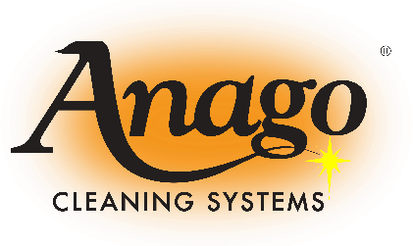FDD#:

Anago Franchising, Inc. (A Florida Corporation)

20 SW 27th Ave, Suite 300, Pompano Beach FL, 33069 800-213-5857; 954-752-1200 (fax)

[www.anagocleaning.com](http://www.anagocleaning.com/)

MSJC, INC., d.b.a Anago of Baltimore (A Delaware Corporation) 1406 B Crain Highway South, Suite 103

Glen Burnie, MD 21061 [mcashman@anagomd.com](mailto:mcashman@anagomd.com) [www.AnagoMD.com](http://www.AnagoMD.com/)

The franchisee operates a business under the mark “Anago®” that provides janitorial and

other facilities-related services to commercial establishments.

The total investment necessary to begin operation of an Anago® cleaning business ranges from $11,690.00 to $68,910.00. This includes the initial fees of $5,440 to $26,775 (cash) or $6,400 to over $31,500 (plus financing as outlined in Item 10) that must be paid to the subfranchisor or an affiliate.

This disclosure document summarizes certain provisions of your franchise Agreement and other information in plain English. Read this disclosure document and all accompanying agreements carefully. You must receive this disclosure document at least 14 calendar days before you sign a binding agreement with, or make any payment to, the subfranchisor or an affiliate in connection with the proposed franchise sale. **NOTE, however, that no governmental agency has verified the information contained in this document.**

You may wish to receive your disclosure document in another format that is more convenient for you. To discuss the availability of disclosures in different formats, contact Mark Cashman, Anago of Baltimore, 1406 B Crain Highway South, Suite 103, Glen Burnie, MD 21061. Phone #

(410) 760-6306.

The terms of your contract will govern your franchise relationship. Don't rely on the disclosure document alone to understand your contract. Read all of your contract carefully. Show your contract and this disclosure document to an advisor, like a lawyer or an accountant.

Buying a franchise is a complex investment. The information in this disclosure document can help You make up your mind. More information on franchising, such as, “A Consumer’s Guide to Buying a Franchise,” which can help you understand how to use this disclosure document, is available from the Federal Trade Commission. You can contact the FTC at 1-877-FTC-HELP or by writing to the FTC 600 Pennsylvania Avenue NW., Washington D.C. 20580. You can also visit the FTC’s homepage at [www.ftc.gov](http://www.ftc.gov/) for additional information. Call your state agency or visit your public library for other sources on franchising.

There may also be laws on franchising in your state. Ask your state agencies about them.

The date of issuance of this Disclosure Document is June 12th, 2025.

# HOW TO USE THIS FRANCHISE DISCLOSURE DOCUMENT

Here are some questions you may be asking about buying a franchise and tips on how to find more information:

|  |  |
| --- | --- |
| **QUESTION** | **WHERE TO FIND INFORMATION** |
| **How much can I earn?** | Item 19 may give you information about outlet sales, costs, profits or losses. You should also try to obtain this information from others, like current and former unit franchisees. You can find their names and contact information in Item 20 or Exhibit C. |
| **How much will I need to invest?** | Items 5 and 6 list fees you will be paying to the franchisor or at the franchisor’s direction. Item 7 lists the initial investment to open. Item 8 describes the suppliers you must use. |
| **Does the franchisor have the financial ability to provide support to my business?** | Item 21 or Exhibits D & E include financial statements. Review these statements carefully. |
| **Is the franchise system stable, growing, or shrinking?** | Item 20 summarizes the recent history of the number of company-owned and franchised outlets. |
| **Will my business be the only Anago business in my area?** | Item 12 and the “territory” provisions in the franchise agreement describe whether the franchisor and other franchisees can compete with you. |
| **Does the franchisor have a troubled legal history?** | Items 3 and 4 tell you whether the franchisor or its management have been involved in material litigation or bankruptcy proceedings. |
| **What’s it like to be an Anago**  **franchisee?** | Item 20 or Exhibit C lists current and former unit franchisees. You can contact them to ask about their experiences. |
| **What else should I know?** | These questions are only a few things you should look for. Review all 23 Items and all Exhibits in this disclosure document to better understand this franchise opportunity. See the table of contents. |

## What You Need To Know About Franchising *Generally*

**Continuing responsibility to pay fees**. You may have to pay royalties and other fees even if you are losing money.

**Business model can change**. The franchise agreement may allow the franchisor to change its manuals and business model without your consent. These changes may require you to make additional investments in your franchise business or may harm your franchise business.

**Supplier restrictions**. You may have to buy or lease items from the franchisor or a limited group of suppliers the franchisor designates. These items may be more expensive than similar items you could buy on your own.

**Operating restrictions**. The franchise agreement may prohibit you from operating a similar business during the term of the franchise. There are usually other restrictions. Some examples may include controlling your location, your access to customers, what you sell, how you market, and your hours of operation.

**Competition from franchisor**. Even if the franchise agreement grants you a territory, the franchisor may have the right to compete with you in your territory.

**Renewal**. Your franchise agreement may not permit you to renew. Even if it does, you may have to sign a new agreement with different terms and conditions in order to continue to operate your franchise business.

**When your franchise ends.** The franchise agreement may prohibit you from operating a similar business after your franchise ends even if you still have obligations to your landlord or other creditors.

## Some States Require Registration

Your state may have a franchise law, or other law, that requires franchisors to register before offering or selling franchises in the state. Registration does not mean that the state recommends the franchise or has verified the information in this document. To find out if your state has a registration requirement, or to contact your state, use the agency information in Exhibit A.

Your state also may have laws that require special disclosures or amendments be made to your franchise agreement. If so, you should check the State Specific Addenda. See the Table of Contents for the location of the State Specific Addenda.

## Special Risks to Consider About *This* Franchise

Certain states require that the following risk(s) be highlighted:

1. **Out-of-State Dispute Resolution:** The franchise agreement requires you to resolve disputes with us by arbitration only in Maryland. Out-of-state arbitration may force you to accept a less favorable settlement for disputes. It may also cost you more to arbitrate with us in Maryland than in your own state.
2. **Additional Accounts**: Once the franchisor’s contractual obligation to offer you initial customer accounts has been fulfilled, the franchisor is under no contractual obligation to expand your business with additional customer accounts, even if you are willing to pay for them.
3. **Location of Customers:** You may have to accept and service multiple customers even though the customers may be located far apart from each other or from you. You may lose any accounts you can’t properly service, and the franchisor is under no obligation to replace them.
4. **No Right to Reject Customer:** The size, number, and location of accounts offered to you are solely within the franchisor’s discretion. If you reject an account that the franchisor offers you, the franchisor is under no obligation to replace that account.
5. **Loss of Customers:** If you lose a customer account for any reason, the franchisor is under no obligation to replace it.
6. **Billing for Customers:** The franchisor performs billing and collection for all services that you provide to your customers, whether you obtain the customer or the franchisor provides that customer to you. If accounts you service do not pay, you suffer the loss of nonpayment. If the franchisor takes action to collect payments, the franchisor does so solely at your expense.
7. **Pricing of Customer Accounts:** The franchisor determines the amount to be charged for your services by bidding on customer accounts. You have no say in that determination. If the franchisor prices a customer account too low, even by mistake, you still must service the customer under the price the franchisor negotiates, even if you will lose money doing so.
8. **Spousal Liability:** Your spouse must sign a document that makes your spouse liable for all financial obligations under the franchise agreement even though your spouse has no ownership interest in the franchise. This guarantee will place both your and your spouse’s marital and personal assets, perhaps including your house, at risk if your franchise fails.

Certain states may require other risks to be highlighted. Check the “State Specific Addenda” (if any) to see whether your state requires other risks to be highlighted.

# TABLE OF CONTENTS

**ITEM 1 - THE FRANCHISOR, AND ANY PARENTS, PREDECESSORS AND AFFILIATES 1****ITEM 2 - BUSINESS EXPERIENCE 3**

**ITEM 3 - LITIGATION 6**

**ITEM 4 - BANKRUPTCY 6**

**ITEM 5 - INITIAL FEES 6**

**ITEM 6 - OTHER FEES 11**

**ITEM 7 - ESTIMATED INITIAL INVESTMENT 19**

**ITEM 8 - RESTRICTIONS ON SOURCES OF PRODUCTS AND SERVICES 21**

**ITEM 9 - FRANCHISEE’S OBLIGATIONS** **25**

**ITEM 10 - FINANCING 26**

**ITEM 11 - THE FRANCHISOR’S ASSISTANCE, ADVERTISING, COMPUTER SYSTEMS**

**AND TRAINING 27**

**ITEM 12 - TERRITORY 36**

**ITEM 13 -TRADEMARKS 37**

**ITEM 14 - PATENTS, COPYRIGHTS AND PROPRIETARY INFORMATION 40**

**ITEM 15 - OBLIGATION TO PARTICIPATE IN THE ACTUAL OPERATION OF THE****FRANCHISE BUSINESS 42**

**ITEM 16 - RESTRICTIONS ON WHAT THE FRANCHISEE MAY SELL 42**

**ITEM 17 - RENEWAL, TERMINATION, TRANSFER AND DISPUTE RESOLUTION 43**

**ITEM 18 - PUBLIC FIGURES 51**

**ITEM 19 - FINANCIAL PERFORMANCE REPRESENTATIONS 51**

**ITEM 20 - OUTLETS AND FRANCHISEE INFORMATION** Error! Bookmark not defined.

**ITEM 21 – FINANCIAL STATEMENTS 63**

**ITEM 22 – CONTRACTS 63**

**ITEM 23 – RECEIPTS 63**

**EXHIBIT A – STATE ADMINISTRATORS/AGENTS FOR SERVICE OF PROCESS 1**

**EXHIBIT B – ANAGO UNIT FRANCHISE AGREEMENT 4**

**EXHIBIT C – LIST OF SUBFRANCHISOR’S UNIT FRANCHISEES** **1**

**EXHIBIT D – FINANCIAL STATEMENTS OF MSJC, Inc. 1**

**EXHIBIT E – FINANCIAL STATEMENTS AND GUARANTEES OF ANAGO CLEANING****SYSTEMS, INC. AND ANAGO FRANCHISING, INC 1**

**EXHIBIT F – TABLE OF CONTENTS FOR UNIT FRANCHISE OPERATING MANUAL 1**

**EXHIBIT G – ADDENDUM TO THE FRANCHISE DISCLOSURE DOCUMENT AS****REQUIRED BY MARYLAND LAW 1**

**EXHIBIT H – ACKNOWLEDGMENT OF RECEIPT 1**

**EXHIBITS**

**Exhibit A - List of State Administrators/Agents for Service of Process Exhibit B - Anago Unit Franchise Agreement**

**Exhibit C - List of MSJC Inc’s Unit Franchisees Exhibit D - Financial Statements of MSJC, Inc.**

**Exhibit E - Financial Statements and Guarantees of Anago Cleaning Systems, Inc. and Anago Franchising, Inc.**

**Exhibit F - Table of Contents for Operations Manuals**

**Exhibit G - Addendum to the Franchise Disclosure Document Required by Maryland Law Exhibit H - Acknowledgment of Receipts**

i

FDD – MSJC, Inc. - 2025

# ITEM 1 - THE FRANCHISOR, AND ANY PARENTS, PREDECESSORS AND AFFILIATES

To simplify the language in this Franchise Disclosure Document (Subfranchisor – Single Unit) “We,” “Our,” “Us,” the “Subfranchisor” or the “Company” means MSJC, Inc., a Delaware Corporation. “You” or the “Franchisee” means the person who buys the unit franchise from us. If You are a corporation, partnership, limited liability company or other entity, “You” also includes Your owners. The “Franchisor” or “AFI” *means* Anago Franchising, Inc.

Under a Subfranchise Rights Agreement between AFI and Us (the “Subfranchise Rights Agreement”), AFI granted Us the right to offer subfranchises for Anago unit franchises in the Counties of Anne Arundel, Baltimore, Calvert, Charles, Harford, St. Mary’s, and Baltimore City in the state of Maryland.

Many items of information in this Franchise Disclosure Document are stated twice where necessary, once for Us and separately for AFI. This duplicate disclosure is required by federal regulations because We are a Subfranchisor. You should be aware that We are an independent business from AFI, and operate under the Subfranchise Rights Agreement with AFI that obligates Us to adhere to various requirements that AFI establishes and modifies periodically. AFI and ACS guarantees the performance of Our obligations to You. Your Unit Franchise Agreement is a contract solely between You and Us. AFI has no liability to You.

## AFI and ACS

AFI is a Florida corporation, incorporated on February 15, 1995. Its principal address is 20 SW 27th Avenue, Suite 300, Pompano Beach, FL 33069. AFI grants to subfranchisors the right to sell unit franchises to operate a janitorial and other facilities-related services business under the service mark “Anago.” As of December 31, 2024, AFI has 49 subfranchises, 46 of which are located in the United States and 2 of which are located internationally. Of the 49 subfranchises, 47 are operated by subfranchisees and 2 are operated by affiliates of AFI. AFI does not sell unit franchises, like the one you will operate, directly to unit franchisees.

AFI began selling Subfranchise rights in February 1995. AFI was formed for the purpose of offering and selling Anago Subfranchises and for administering the Anago franchise System. AFI does not do business nor does it offer franchises under any other name. In addition, AFI has never operated businesses of the type being franchised by Us.

Anago Cleaning Systems, Inc. (“ACS”) is a Florida corporation that was incorporated on December 5, 2000, and is the parent company of AFI. ACS maintains its principal business address at 20 SW 27th Avenue, Suite 300, Pompano Beach, FL 33069. ACS owns the Proprietary Marks (as defined in Item 13), including the mark “Anago,” and has granted a license to AFI to use and to sublicense the right to use the Proprietary Marks and other Proprietary Property (“Proprietary Property” means AFI’s, ACS’s or their affiliates’ Proprietary Marks, Confidential Information (as defined in Item 14) and copyright information.). ACS has never operated or offered franchises for the type of business you will operate, nor has it offered franchises in any other line of business.

## The Subfranchisor

The legal name of the Subfranchisor is MSJC, Inc. We do business under the name MSJC, Inc., d/b/a “Anago of Baltimore”. We do not do business under any other name. We maintain Our principal business address at 1406 Crain Highway South, Suite 103, Glen Burnie, Maryland 21061. We are a Delaware corporation formed in 2004.

We offer and sell franchises to operate a janitorial and other facilities-related services business using the Proprietary Marks (the “Unit Franchise”), and we provide services to franchisees as required under the Anago Unit Franchise Agreement, the current form of which is attached to this Disclosure Document as Exhibit B (the “Unit Franchise Agreement”). AFI granted Us a license to use the Proprietary Marks and to sublicense the Proprietary Marks and the business system for operating an Anago-branded businesses (the “System”) for franchises in the Counties of Anne Arundel, Baltimore, Calvert, Charles, Harford, St. Mary’s, and Baltimore City, state of Maryland (the “Area”) pursuant to Our Subfranchise Rights Agreement with AFI.

We have been offering and selling franchises, and serving as Subfranchisor, under the name “Anago of Baltimore” in the Area since 2005. We do not operate any Unit Franchises. We are not in any other line of business, except for the sale of the type of franchise offered under this Franchise Disclosure Document and providing services to our Unit Franchisees. Our agent for service of process in this state may be found on Exhibit A.

## Our Predecessors

We have no predecessors.

## Our Affiliates

We have no Affiliates that provide products or services to You or that offer franchises in any line of business or that operate the type of business you will operate.

## AFI’s Predecessors

AFI’s predecessor is Anago International, Inc. (“AII”). AII was formed in 1989, and began offering franchises in 1991. AII operated businesses of the type We operate from 1989 to 1995 and ceased doing business as of December 31, 2023. AII has offered franchises for the type of business You will operate, but it has not offered franchises in other lines of business.

## AFI’s Affiliates

As of December 31, 2024, AFI has 2 Affiliates (the “AFI Affiliates”). The AFI Affiliates are as follows: (i) Estrellita, Inc., d/b/a Anago of South Florida, which operates a subfranchise business and directly sells unit franchises like the one you will operate located at 20 SW 27th Ave. Suite 100, Pompano Beach, FL 33069; and (ii) APLR, Inc. which shares AFI’s principal address and acts as an Anago subfranchisor in geographical areas where there are no Anago subfranchisors or where the Anago Subfranchisor refuses or is unable to so act. None of the AFI Affiliates provides products or services to you, and none has offered franchises in any other line of business. Except as disclosed in this Disclosure

Document, AFI does not have any parents, predecessors or Affiliates offering franchises in any line of business or providing products or services to System Franchisees.

## Description of the Franchise

The business You will conduct is a service franchise focused primarily on janitorial services but offering other facilities-related services that are, from time to time, approved to be part of the portfolio of services offered by Anago-branded businesses (your “Business”). You will provide the services and related products to commercial businesses and properties in a designated Area of operation under the “Anago” mark and in accordance with System standards and specifications. All janitorial and other service contracts (“Accounts”) will initially be between us and the Client, but we will either assign the Account to you or allow you, by joinder, to become a party to the Account so that you are able to maintain a contractual relationship with the Accounts to whom you provide services. If and when we assign or you join as a party to the Account, you will be appointing us to act as your agent for purposes of, as your agent, providing Client relations, invoicing and collections with respect to the Client, and not for purposes of providing the services (which is entirely your business and not ours). We will be responsible for collecting all payments made by a Client. You may also negotiate various types of janitorial and other facilities-related services and pricing with Clients; however, if you do so using the Anago name, you must submit all information to the Regional Office and those accounts will be Anago Clients and all Client payments will be sent directly to Anago. You may not sign on behalf of Anago for any service contracts. You may only use the “Anago” mark to solicit janitorial and other facilities-related contracts as part of your Anago business.

## Industry Specific Regulations

There are no statutes or regulations known to us that are specific to the provision of janitorial and related services or the operation of the type of business offered under this Disclosure Document. You are required to comply with all local, state and federal laws, regulations, and government orders in the operation of Your Anago Franchise. There may be other laws applicable to Your business and We urge You to make additional inquiries about these laws.

## Competition

You will have to compete with other businesses selling similar products and services. Competitors include national chains, regional chains and independently owned commercial cleaning service providers. This business is not seasonal and is specific to commercial janitorial and other facilities-related services only. Any similar services which you perform outside of Your Business, may contribute to competition with Your Anago business.

# ITEM 2 - BUSINESS EXPERIENCE

## MSJC’s Officers, Directors and Other Executives

**Susan L. Cashman – Officer/Director/Owner**

Mrs. Cashman has been President of MSJC, Inc. since its inception in June 2004.

## Mark A. Cashman – Officer/Director/Owner

Mr. Cashman has been Vice President of MSJC, Inc. since its inception in June 2004.

## John Darren Williams, Franchise Sales

Mr. Williams has been President of CHEX, Inc., d/b/a Anago of Washington, DC since its inception in 2003. In addition to his role as President of CHEX, Inc., beginning on September 1, 2009 Mr. Williams became employed by MSJC, Inc as a Sales Representative.

## AFI’s Officers, Directors and Other Executives

**Adam D. Povlitz, CFE; CEO & President**

Mr. Povlitz joined AFI in September 2009 and has served as AFI and ACS’s President since April 2015 and was appointed their CEO in May 2018. From January 2013 to April 2015, he served as AFI’s Executive Vice President; from September 2010 to January 2013, he was AFI’s Vice President – Operations; and from January 2010 to September 2010, he served as AFI’s Director of Human Resources

/ Franchise Development. Mr. Povlitz also serves as a President of Estrellita, Inc. d/b/a Anago of South Florida (January 2006 – present). He previously served as President of AFI’s other Affiliates: EHLB, Inc. d/b/a Anago of Las Vegas (January 2023 – December 2024), CCTD, Inc. d/b/a Anago of Delaware (August 2017 – August 2021), and PBTR, Inc. d/b/a Anago of Denver (May 2018 – December 2020).

## Peter J Sheldon, Sr.; Chief Strategy Officer

Mr. Sheldon joined AFI in June of 2022 and currently serves as the organization’s Chief Strategy Officer. Prior to joining AFI, he held the role of President and Chief Executive Officer from December 2018 to May 2022 with Atalian Global Services North America, Inc. where he also held the role of Chief Operating and Revenue Officer from November 2017 to December 2018. From April 1994 to November 2017, Mr. Sheldon held various Executive leadership roles in the facility services sector with Capital Contractors Inc, Coverall North America Inc. and Jani-King International, Inc.

## Jay Benge; Chief Operating Officer

Mr. Benge joined AFI in September of 2023 as Chief Operating Officer. Prior to joining AFI, he held leadership roles at Theory Wellness as their Executive Vice President from August 2022 to June 2023. At SunFlora, he was President of Franchise Systems from July 2020 to February 2021 when he was promoted to President and served in that role until July 2022. From July 2008 to July 2020, he held several leadership roles at Jackson Hewitt, most notably as their VP of Development and Divisional Vice President of Retail and Franchise Operations. Mr. Benge brings over 20 years of senior leadership and business development experience in both small and large companies, specializing in franchise, retail, and corporate operations. He also holds an MBA and Bachelor of Science in Business Management from California Coast University.

## Judy Walker, CFE; Senior Vice President – Sales

Ms. Walker was promoted to Senior Vice President – Sales in June of 2022. Previously, she served

as Senior Vice President – Marketing in November 2018 and had served as AFI’s Vice President –

Marketing since February 2005.

## Shawn McIntosh; Senior Vice President – Operations

Shawn McIntosh has served as Senior Vice President – Operations of AFI since November 2022. Mr. McIntosh held the title of COO at Atalian Global Services from 2019 to 2022. He previously served as the Regional Manager at Capital Contractors Inc. from 2016 to 2019.

## Lisa Ritenour, CFE; Vice-President – Internal Operations

Mrs. Ritenour has served as AFI’s Vice President – Internal Operations since January 2013. She was appointed its Director as of March 2023. Previously, she served as AFI’s Director of Financial Systems/Human Resource Manager from September 2012 to January 2013, and Compliance Banking Officer from January 2010 to September 2012. Mrs. Ritenour has also serves as a Director of Estrellita, Inc. d/b/a Anago of South Florida (January 2006 – present).

## Ana Hernandez; Vice President – Marketing

Ms. Hernandez joined AFI in June of 2022 and currently serves as Vice President of Marketing. Prior to joining Anago she was Chief Marketing Office at Growth Hacker Marketing Agency from October 2020 to May 2022. From February to September of 2020, she was Chief Marketing Officer and Vice President of International Marketing at Focus Brands, LLC. In January 2018 she started as Vice President of Marketing for Zonin 1821 until February 2020. She has held leading roles including Chief Marketing Officer and Vice President of Marketing for multiple global brands such as The Coca-Cola Co., Wendy’s International, Menchie’s Frozen Yogurt and DINE. She has an extensive background working in franchising systems, harnessing collaboration, driving brand strategy and digital marketing performance.

## Juan Catoni, CFE; Vice President – Franchise Operations

Mr. Catoni was appointed AFI’s Vice President – Franchise Operations in December 2014. He joined Estrellita, Inc. d/b/a Anago of South Florida in September 1995 and has held numerous positions, most recently as its Regional Director since 2002.

## Christopher Cunius; Vice President– Franchise Development

Mr. Cunius was appointed AFI’s Vice President – Franchise Development in December 2019

and previously served as AFI’s Senior Director Franchise Operations since December 2014.

## Adam Yazejian; Director of Sales

Mr. Yazejian joined AFI in July of 2020. He serves as Director of Sales. Prior to joining Anago he was President of his own sales consulting firm, A&K Yazejian Inc. for the previous 12 years. Before that he was an executive in the hospitality industry with the title of Vice President for multiple companies.

## Gioconda Morales, CFE; Corporate Support Manager

Ms. Morales was appointed Corporate Support Manager in June 2020 after joining AFI as a Franchise Developer in August 2014.

# ITEM 3 - LITIGATION

## Our Litigation

None.

## AFI’s Litigation

**Pending Actions**

None.

## Prior Actions

No litigation is required to be disclosed in this item.

# ITEM 4 - BANKRUPTCY

## Our Bankruptcy

At this time there is no bankruptcy information required to be disclosed in this Item.

## AFI’s Bankruptcy

At this time there is no bankruptcy information required to be disclosed in this Item.

# ITEM 5 - INITIAL FEES

## Initial Fees

The Initial Fees for a single-unit Franchise ranges from $5,440 (if paid in cash) to over $31,500 (if financed) as shown in the table below. You have the right to select any of the Programs listed in the table below. The Initial Fees are payable to Us in full upon signing the Unit Franchise Agreement. Except as disclosed in this Item under Refunds of Initial Fees, the Initial Fees are fully earned and non- refundable upon signing the Franchise Agreement. The Initial Fees as stated below are uniform for all Franchisees that are offered franchises under this Disclosure Document.

If you select a Program for which supplies and minor equipment are included as part of the Initial Fee (see the Initial Fees chart below) and you have all of the necessary supplies and minor equipment and they meet Our standards and specifications, then You will not be required to purchase such minor equipment and supplies from Us and We will provide You a credit towards the Initial Fees in the amount of the then current prices for the minor equipment and supply packages.

We participate in the International Franchise Association’s VetFran Program, which provides a 10% discount on initial franchise fees to veterans of the U.S. Armed Forces who otherwise meet the requirements of the VetFran Program.

## Referral Program for Franchisees

We currently operate a program where you can receive a referral fee ranging from $300 or a ProTeam BackPack (depending on purchased program) in cash for referring a third-party franchise prospect to us who ultimately becomes an Anago Franchisee. You are authorized only to present a prospect with our informational brochure and to identify the prospect to our management; you are not authorized to act as our agent or franchise broker and are instructed not to provide any information to prospects other than our information brochure. If you are entitled to receive a referral fee, notice will be given to the prospective franchisee receiving the FDD. We retain the right in our sole discretion to modify or terminate this referral program at any time with or without notice.

*(Remainder of page intentionally blank)*

# INITIAL FEES CHART

|  |  |  |  |  |  |  |  |
| --- | --- | --- | --- | --- | --- | --- | --- |
| **Program** | **Program Offering** | | **Financing Option** | | | | **Cash Option** |
| **Gross Monthly Billing\*** | **Initial Offering Period+** | **Initial Fee** | **Down Payment** | **Amount Financed** | **Monthly Payment** | **Initial Fee (15%**  **Discount)** |
| **X4** | $10,000 | 210 Days | 31,500 | 24,000 | 7,500 | 204.95 | 26,775.00 |
| **IX** | $9,000 | 210 Days | 29,000 | 21,500 | 7,500 | 204.95 | 24,650.00 |
| **VIII** | $8,000 | 180 Days | 26,000 | 18,500 | 7,500 | 204.95 | 22,100.00 |
| **VII3** | $7,000 | 180 Days | 23,500 | 16,000 | 7,500 | 204.95 | 19,975.00 |
| **VI** | $6,000 | 180 Days | 21,000 | 13,500 | 7,500 | 204.95 | 17,850.00 |
| **V** | $5,000 | 180 Days | 18,500 | 11,000 | 7,500 | 204.95 | 15,725.00 |
| **IV** | $4,000 | 150 Days | 17,000 | 9,500 | 7,500 | 204.95 | 14,450.00 |
| **III** | $3,000 | 150 Days | 14,500 | 8,000 | 6,500 | 177.62 | 12,325.00 |
| **IIA** | $2,500 | 150 Days | 12,750 | 6,250 | 6,500 | 177.62 | 10,837.50 |
| **II** | $2,000 | 120 Days | 12,000 | 5,500 | 6,500 | 177.62 | 10,200.00 |
| **IA** | $1,500 | 120 Days | 10,125 | 3,625 | 6,500 | 177.62 | 8,606.25 |
| **I2** | $1,000 | 120 Days | 8,750 | 2,750 | 6,000 | 163.96 | 7,437.50 |
| **5001** | $500 | 120 Days | 7,825 | 1,925 | 5,900 | 137.28 | 6,651.25 |
| **01** | $0 | n/a | 6,400 | 1,500 | 4,900 | 114.01 | 5,440.00 |
| 1 | Financing for Programs 0 and 500 is for 60-months. Financing Programs 0 – 1A is for 48-months and Program II – X is for 42-months. Financing for all Programs is at 14% compound interest. | | | | | | |
| 2 | Minor Equipment and Supply Packages are included in Programs I and higher. | | | | | | |
| 3 | Franchisee receives 2 Minor Equipment and Supply Packages in Programs VII and higher. | | | | | | |
| 4 | For each $1,000 of Gross Monthly Billing over $10,000, the Initial Fee is increased by  $2,500. The Initial Offering Period will increase by 30 days for the first $1,000 of Gross Monthly Billing over $10,000, then for every $2,000 thereafter. | | | | | | |
| **\*** | “Gross Monthly Billing” means the gross amount of receipts from services and products  provided by you to all clients billed, before any deductions. | | | | | | |
| **+** | The “Initial Offering Period” refers to the maximum amount of time allowed to offer  you accounts totaling the Gross Monthly Billing for the Program you purchased. | | | | | | |

Under certain circumstances, We may finance a portion of the Initial Fees. See ITEM 10 for an explanation of financing arrangements. The Initial Offering Period is defined as the amount of time allotted for MSJC to provide you with all of your accounts. We must provide you with all of your accounts within 120 days of the date you complete the Anago orientation program to the complete satisfaction of Anago in its sole discretion. The initial offering periods are as follows:

|  |  |
| --- | --- |
| **Gross Monthly Billing** | **Initial Offering Period** |
| $0 – 2,000 per month | 120 days |
| $2,001 - $4,000 per month | 150 days |
| $4,001 – 8,000 per month | 180 days |
| $8,001 - $12,000 | 210 days |
| $12,001 - $15,000 | 240 days |
| $15,001 - $25,000 | 360 days |
| The Offering Period will increase by 30 days per $1,000 of Monthly Gross Billing over $10,000 | |

# LIST OF OFFICE AND MARKETING MATERIALS PROVIDED TO YOU

THE FOLLOWING LIST OF MATERIALS IS INCLUDED IN THE INITIAL FEE UNDER THE FRANCHISE AGREEMENT REGARDLESS OF THE FRANCHISE PROGRAM PURCHASED

|  |  |
| --- | --- |
| Business cards | 500 |
| Anago letterhead | 100 |
| Envelopes | 50 |
| Marketing brochures | 75 |
| T-Shirt | 1 |
| Anago inspection sheets | 100 |
| Anago message reply | 100 |
| Anago performance | 100 |
| Guide to Housekeeping | 1 |
| Guide to Operating a Janitorial Business | 1 |
| Guide to Floor Care (optional) | 1 |
| Guide to Policies & Procedures | 1 |
| Guide to Bookkeeping | 1 |
| Guide to Biohazards | 1 |
| Guide to Security | 1 |
| Anago Recommended Cleaning Procedures Video | 1 |

# LIST OF SUPPLIES PROVIDED TO YOU

THE FOLLOWING LIST OF SUPPLIES IS INCLUDED IN THE INITIAL FEE UNDER THE FRANCHISE AGREEMENT FOR PROGRAMS I THROUGH X+. PURCHASERS OF PROGRAMS 0 AND 500 WILL NOT RECEIVE THESE SUPPLIES AND MUST PURCHASE THEM SEPARATELY. PURCHASERS OF PROGRAM 7 OR HIGHER WILL RECEIVE 2 COMPLETE SETS OF SUPPLIES

1 Disposable Gloves-Pair

4 Microfiber Cloths 4 /12 Pkg.

5 Microfiber Wave Pocket

1 Economy Bowl Mop White

1 1 CADDY PACK ( 4 spray bottles with chemicals in caps)

1 Microfiber wave dust

1 All Purpose Cleaner/Gal

1 Window Cleaner

1 Stainless Steel Cleaner/Can

1 Soft Scrub Cleaner/Qt.

1 Bowl Cleaner/Qt.

1 Carpet Stain Remover

# LIST OF MINOR EQUIPMENT SUPPLIED TO YOU

THE FOLLOWING LIST OF MINOR EQUIPMENT IS INCLUDED IN THE INITIAL FEE UNDER THE FRANCHISE AGREEMENT FOR PROGRAMS I THROUGH X+. PURCHASERS OF PROGRAMS 0 AND 500 WILL NOT RECEIVE THESE SUPPLIES AND MUST PURCHASE THEM SEPARATELY. PURCHASERS OF PROGRAM 7 OR HIGHER WILL RECEIVE 2 COMPLETE SETS OF MINOR EQUIPMENT

1 Back Pack Vacuum 1

2 1 6 Gallon Mop Bucket with Lid

1 Brute Mobile and Wheels

1 Dust mop 24” Complete Microfiber

1 Telescoping Mop Handle

1 Pocket Mop Frame

1 Microfiber Glass Cleaning Pad with Foam

1 Toilet Bowl Brush

1 Wisk Broom/Toy Broom

1 Lobby Dust Pan Plastic

2 Microfiber Dust Mop Blue & Red

4 Red Pocket Mop Heads

4 Blue Pocket Mop Heads

4 Green Pocket Mop Heads

## Refunding of Initial Fee

The Initial Fee is fully earned and non-refundable upon signing the Franchise Agreement, except as described in the following paragraph:

If we are unable to secure and offer you the full amount of Initial Business within the time frame allocated for the Initial Offering Period in the program you purchase, an amount equal to 3.00 times the amount of Initial Business not offered to you will be refunded. Any refund will be first applied to any outstanding balance on your Promissory Note you owe us, with the remaining sum, if any, paid to you. A refund under this provision will fulfill our obligations to offer any remaining portion of the Initial Business.

# ITEM 6 - OTHER FEES

|  |  |  |  |
| --- | --- | --- | --- |
| **Type of Fee1** | **Amount** | **Due Date2** | **Remarks** |
| Royalty Fee | 10% of monthly Gross Revenues | Monthly on the 20th of every month. | “Gross Revenues” means all amounts, in whatever form and however characterized, that are received for or attributed to services provided to Clients, regardless of (1) how or by whom the Client was procured, (2) the type or nature of the service or the frequency with which it is provided, and (3) whether the service is provided by You directly or by Your employees or other contractors excepting only the amount of any sales taxes that are collected and paid to the taxing authority. Gross Revenues includes the proceeds of any business interruption insurance. Cash refund and credit given to Clients (except credit for missed cleaning days) and receivables uncollectable from Clients will be deducted in computing Gross Revenues to the extent that the cash, credit or receivables represent amounts previously included in Gross Revenues where Royalty Fees and other amounts were paid. Gross Revenues are deemed received by You at the time the goods, products, merchandise or services from which they derive are delivered or rendered or at the time the relevant sale takes place, whichever occurs first. Gross Revenues consisting of property or services (for example, “bartering” or “trade outs”) are valued at the prices applicable, at the time the Gross Revenues are  received, and to the products or services exchanged for the Gross Revenues. |
| Administration Fee | 8% of monthly Gross Revenues | Monthly on the 25th of every month. | The Administration Fee is charged to reimburse us for Our costs as your agent, to invoice, receive, and disburse funds from your Clients. We will retain the Administration Fee from the payments the Client remits to Us. |
| Advertising Contributions to Marketing Fund | 2% of monthly Gross Revenues | Monthly on the 25th of every month. | Advertising contributions are being imposed at this time. |

|  |  |  |  |
| --- | --- | --- | --- |
| **Type of Fee1** | **Amount** | **Due Date2** | **Remarks** |
| Technology Fee | Not currently assessed, but if initiated, up to 1.5% of monthly Gross Revenues. | Monthly on the 25th day of each month | Consideration for computer system hardware and/or the development, license, and/or use of proprietary or third-party software, whether for AFI’s, Our, or Your use in connection with services provided by AFI or Us to You. This fee is a pass-through; We pay it directly to AFI for its technology services. |
| Credit Card Charges for Client payments | Up to 6.15% of the actual Client invoice excluding sales tax if any | When assessed by the processing bank | Paid out of the Gross Revenues generated from the operation of your Business. Franchisee will be notified on the 25th of every month if there are any client payments by credit card  payments and the amount charged by the processing bank. |
| C-Fees | Currently 3.0 times the Gross Monthly Billing of additional Accounts, but We reserve the right, on 30 days’ notice to You, to increase it up to 5.0 times the Gross Monthly Billing of additional  Accounts | Payable in full at the time of the assumption of the Account, but may be financed upon request (See ITEM 10  for explanation of financing). | A fee is payable for the assignment and assumption of each additional Account You agree to service under the Franchise Agreement. Supplies are not included. |
| Guaranteed Payment Option | 5% of total Gross Revenues | Monthly on the 25th of every month | You may opt to participate in the guaranteed payment option plan under which We will pay You for amounts invoiced to clients, less amounts owed to Us in connection with such invoice, regardless of whether the Client has paid the invoiced amount. If You participate in this program, You pay Us 5% of Your total Gross Revenues. This fee is assessed only on contracts and products You have provided to the client. |
| Account Transfer Fee | $50 to $150 per Account | Immediately upon receipt of invoice. | If a Client gives notice of pending cancellation or requests a transfer due to poor performance on Your part or poor Client relations, We will assign the Account to another Franchisee or if We have received 3 or more complaints from a Client or from Our Brand Standards Department within any 30-day period |

|  |  |  |  |
| --- | --- | --- | --- |
| **Type of Fee1** | **Amount** | **Due Date2** | **Remarks** |
|  |  |  | concerning Your performance and We elect to transfer the Account, an Account Transfer Fee of $100 will be assessed. If the transferred Account requires additional work to bring the cleanliness up to acceptable standards, You will be given an opportunity to provide labor and materials, at Your expense and You will be assessed an additional Account Transfer Fee of  $50 or a total of $150. If You cannot or elect not to provide labor and materials, We will provide necessary labor and materials to the Client and deduct the expense from monies due You. If inspections by Our Brand Standards Department show a continuous lack of proper service and/or poor quality of service, then, regardless of whether the Client has submitted a complaint, We have the right to terminate the Account without notice and assess a $100 transfer fee and You will continue to pay the C- Fees on this Account as if it were current for the balance of the original contract term. All  other transfers will be assessed a $50 fee. |
| Standards Enforcement Fees | $50 per complaint | Within 20 days of invoice. | If, regardless of discovery through a Client complaint or a Brand Standards department inspection, a lack of performance is found, We will notify You immediately and You will have 2 hours to respond to the complaint. If We are unable to make contact with You and Our Brand Standards department must respond to the complaint, the Standards Enforcement Fee will also be assessed to You. If a complaint is made known to You by Our Brand Standards department and You fail to correct the deficiency to the Client’s satisfaction on or before Your next contractually scheduled visit, Our Brand Standards Department will correct the deficiency. You will be assessed all costs We incur to correct the complaint. |
| Handling Fees | $100 per payment not forwarded to the Anago Regional Office | Immediately upon receipt of invoice | Client payments sent or given directly to You must be forwarded to the Anago Regional Office for processing. Failure on Your part to forward any payments will result in a Handling Fee charge of $100 for each payment You fail to forward to Us. |

|  |  |  |  |
| --- | --- | --- | --- |
| **Type of Fee1** | **Amount** | **Due Date2** | **Remarks** |
| Advanced Payment Fee | $25 processing fee plus 18% per annum interest | Immediately upon receipt of invoice. | If We advance collected funds, but the funds are not yet payable to You, You will pay a processing fee of $25. If We loan You uncollected funds, You will pay a processing fee of $25 plus interest at the rate of 18% per annum until fully paid. |
| Corrective Measures Fees | $0 to $500 | Within 20 days of invoice. | If You receive unsatisfactory inspection reports from Us and fail to promptly remedy the deficiencies, We may require Your representatives we designate to attend refresher corrective measures classes as soon as reasonably possible. You are solely responsible for all expenses associated with these programs including the then prevailing standard Corrective Measures Fee We charge for these programs and all travel, meals and lodging costs of Your attendees. If You fail the Anago Orientation Program, You must attend corrective measures classes in the areas the Orientation officer feels are necessary for You to successfully complete the Anago Orientation Program. If You lose or are transferred from an Initial Business Account due to non-performance or Client dissatisfaction and We deem it in Your best interest for You to attend corrective measures classes, You must attend corrective measures classes and pay the then current corrective measures fee. If We require You to attend corrective measures classes offered by a designated vendor rather than offering the class Ourselves, you will pay the fee charged by the designated vendor directly to such vendor. |

|  |  |  |  |
| --- | --- | --- | --- |
| **Type of Fee1** | **Amount** | **Due Date2** | **Remarks** |
| Insurance Coverage through Us | Cost of the insurance and a reasonable fee or percentage of Gross Revenues Currently 8%  (5% for General Liability & 3% for Workers’ Compensation) plus a fee for the surety bond of $2.00 per  Client per invoice | Within 20 days of invoice. | If You choose to obtain insurance through Us, if available, We will charge You the cost of the insurance and a reasonable fee for Our efforts. You are responsible for payment of all deductibles, should a claim arise. If You do not obtain insurance through Us, You are still liable for a charge of 2% of Gross Revenues for insurance administration and policy verification. |
| Insurance Coverage (Failure of Franchisee to maintain coverage) | Cost of the insurance, interest on the monies advanced and a reasonable fee or percentage of Gross Revenues Currently 8%  (5% for General Liability & 3% for Workers’ Compensation) plus a fee for the surety bond of $2.00 per Client per invoice | Upon Invoice. | If You fail to maintain the insurance required by the Franchise Agreement, We may (but are not required to) obtain the required insurance and charge You the cost of the insurance, interest on the monies We advance and a reasonable fee for Our efforts. You are responsible for payment of all deductibles, should a claim arise. |
| Deficiencies | Actual cost to Us | Immediately upon receipt of invoice. | If You do not satisfy Your obligations under the Franchise Agreement, We may (but are not obligated to) perform Your obligations for You. You must reimburse Us for Our costs in performing Your obligations. |

|  |  |  |  |
| --- | --- | --- | --- |
| **Type of Fee1** | **Amount** | **Due Date2** | **Remarks** |
| Transfer Fee | The greater of  $2,000 or 10%  of the sales price | At the time of transfer. | Upon a transfer of your Business, You or Your personal representative or other legal representative must pay a Transfer Fee in lieu of an Initial Fee. If the transferee is a spouse or child of the transferor, or a wholly owned entity, no Transfer Fee will be charged, but a reasonable administrative fee (currently $250) will be charged. |
| Testing and/or Inspection of unapproved products and/or services | Not to exceed reasonable cost of inspection and actual testing (estimated  $100-$500) | Payable by invoice, within thirty  (30) days of receipt of same by You | You are required to purchase or lease equipment, supplies, advertising materials and other products and services used for the operation of Your Business only from authorized manufactures, contractors and other suppliers who demonstrate, to Our continuing reasonable satisfaction: (i) the ability to meet Our reasonable standards and specifications for the items; (ii) possess adequate quality controls and capacity to supply Your needs promptly and reliably; and (iii) have been approved in  writing by Us and not later disapproved. |
| Liquidated Damages for Premature Termination | Will vary under the circumstances | Immediately upon receipt of invoice. | If termination is the result of Your default, You will pay to Us a lump sum payment (as liquidated damages for causing the premature termination of the Unit Franchise Agreement and not as a penalty) equal to the net present value of the total of all Royalty Fees, advertising contributions and Administration Fees that would have become due from the date of termination to the earlier of: (i) 36 months following termination; or (ii) the scheduled expiration date of the Unit Franchise Agreement. time of termination. For this purpose, the Royalty Fees, advertising contributions and Administration Fees shall be calculated based on the average Gross Revenues of your Unit Franchise for the 12 months preceding the termination date. In the event your Unit Franchise has not been in operation for at least 12 months preceding the termination date, then the calculation will be based on the average Gross Revenues of your Unit Franchise for the number of full calendar  months your Unit Franchise was in operation. |

|  |  |  |  |
| --- | --- | --- | --- |
| **Type of Fee1** | **Amount** | **Due Date2** | **Remarks** |
| Fee for Lost Manual | $500 for lost Manual | Immediately upon receipt of invoice. | Upon the theft, loss or destruction of the Manual, a replacement copy will be loaned to You at a fee of $500. A partial loss or failure to update the Manual is considered a complete loss. “Manual” means all manuals produced by, or for the benefit of, ACS, AFI or Us and loaned to You, as periodically revised. |
| Liquidated Damages for Sale of Prohibited Products or Services | $100 per day that unauthorized products or services are  offered | Immediately upon receipt of invoice. | You agree that the offer to sell or the sale of unauthorized or prohibited products and services will result in damages to Us, those damages You agree to be measured as being  $100 for each day of the prohibited offer or sale. |
| Liquidated Damages for Violation of Non- Compete | $1,000 per week | Immediately upon demand. | If you violate the in-term or post-term covenant not to compete, you will pay us this fee so long as you continue to compete with us in violation of the covenant. |
| Indemnity | Actual cost to Us | Immediately upon receipt of invoice. | You must reimburse us if we are held liable for claims resulting from the operation of Your Business or from the breach of your Unit Franchise Agreement. You must also reimburse us and AFI if We or AFI are alleged to be the employer or joint employer of you or your employees. |
| Enforcement Costs | Actual cost to Us | Immediately upon receipt of invoice. | If any legal action or other proceeding is begun for the enforcement of Your Franchise Agreement, or because of an alleged dispute, breach, default or misrepresentation under any provision of Your Franchise Agreement, the prevailing party in such action or proceeding is entitled to recover reasonable pre-institution and post-institution attorneys’ fees, court costs and all expenses even if not taxable as court costs. If, short of filing a legal proceeding or action, We take measures to enforce Your compliance with Your obligations to pay when due any monies owed under Your Franchise Agreement or submit when due any reports, information or supporting Records (as defined in Item 11), or for any failure otherwise to comply with Your Franchise Agreement, You must reimburse Us for all of the costs and expenses (including reasonable attorneys’ fees)  We incur in doing so. |

|  |  |  |  |
| --- | --- | --- | --- |
| **Type of Fee1** | **Amount** | **Due Date2** | **Remarks** |
| Mandatory Continuing Education | Up to $500 per session | Upon receipt of invoice | If You receive an unsatisfactory inspection report from Us and fail to promptly remedy the deficiencies, We may require Your representatives we designate to attend corrective measures classes as soon as reasonably possible. You are solely responsible for all expenses associated with these programs, including Our then-prevailing standard fee for the programs and all travel, meals and lodging costs for Your attendees. |
| Operations Fee | $50 plus any labor and materials cost | Upon receipt of invoice | If We elect to procure service to an Account You are currently servicing in order to comply with the Account's requirements or You are unable or unwilling to provide the services,  You will be assessed the Operations Fee. |
| House Account Finance Fee | 5.25% of  supplies purchased through House Account | Immediately upon receipt of invoice. | Anago may designate a supplier where a Franchisee may go and buy supplies and pay cash or charge to the Anago "House Account." All supplies charged to the House Account will be subject to a five and twenty-five one-  hundredths percent (5.25%) finance charge. |
| Key Return Fee | $500 for each day that you do not return client keys | On demand | When your Unit Franchise Agreement expires or terminates, you must immediately return to Us all keys, security passes, security codes, and other means of access to clients’ premises. You also must do this if you are to stop servicing any client. Failure to return any of these items shall result in a $500 per day fee. If a key is lost and cannot be returned, You will be charged the full cost of the replacement for each key lost and /or for the re-keying /reprogramming  any locks. |

1. The fees in this Item are non-refundable, unless provided otherwise above. The fees may not be uniform for all franchisees as some existing franchisees may pay these fees at different rates.
2. The Royalty Fee, Administration Fee, Advertising Contributions, and C-Fee will be deducted by Us by the 25th day of each month for the services rendered during the previous calendar month. You will receive payment on all collected billing by mail, which typically will be mailed on or around the 25th day of each month, following the month in which services were rendered. You will also receive payment up to the last day of actual service to the Client if the Account is lost or transferred. All other amounts due to Us from You will be paid on or around the 25th day of each month. If no time is specified, these amounts are due upon receipt of an invoice from Us. Any payment We do not actually receive on or before the due date is overdue.

# ITEM 7 - ESTIMATED INITIAL INVESTMENT

|  |  |  |  |  |
| --- | --- | --- | --- | --- |
| **ESTIMATED INITIAL INVESTMENT** | | | | |
| **Type of Expense** | **Amount1** | **Method of Payment** | **When Due** | **To Whom Payment Is To Be Made** |
| Initial Fees2 | $5,440 to  $31,500 | Lump Sum (if cash) or 48-60 monthly installments (if financed as outlined in Item 10) | On signing the Franchise Agreement or 48-  60 monthly installments. | Subfranchisor |
| Major Equipment3 | $1,750 to  $3,750 | Lump Sum | Before beginning business | AFI, Subfranchisor or Approved  Supplier |
| Vehicle4 | $0 to  $20,000 | Lump Sum | Before beginning business | Third Party |
| Cleaning Supplies5 | $0 to  $190.00 | Lump Sum | Before beginning business | AFI, Subfranchisor or Approved Supplier |
| Minor Equipment6 | $0 to $570 | Lump Sum | Before servicing Your first Account | AFI, Subfranchisor or Approved Supplier |
| Insurance7 | $3,000 to  $6,000 | Lump Sum or Monthly | Before beginning business | Third Party, AFI, or Subfranchisor |
| Fictitious Name Registration,  Incorporation and Legal Review8 | $500 to  $1,200 | Lump Sum | Before beginning business | Third Parties |
| Travel, Meals, Etc. for Initial Training9 | $0 to $200 | As Incurred | Before beginning business | Third Parties |
| Miscellaneous Start-up Costs10 | $0 to $500 | As Incurred | Before beginning business | Third Parties |
| Additional Funds11 (3 months) | $1,000 to  $5,000 | As Incurred | Before beginning business | Third Parties |
| **TOTALS12** | **$11,690.00 to $68,910** | | | |

1 Unless otherwise indicated, payments are not refundable.

2See Item 5 for a description of the Initial Fees.

3You must lease or purchase the Major Equipment before You will be offered Initial Accounts. The Major Equipment includes: 1 Floor Machine (buffer) 17"-20", 1 Wet/dry vacuum, and 1 Hand Held Vacuum. You also are required to have a cellular phone and Internet (e-mail) access.

4You can use Your existing vehicle in Your Business. The estimated cost of a van is up to

$20,000. However, you are not required to use a van. If you use a vehicle for Your Business which

displays the Marks, you may not use this vehicle when servicing customers outside of Your Business, unless the Marks are removed.

5 We will only allow cleaning supplies that support the image and positioning of the System in the marketplace. These costs are established based upon Our estimate of the initial supplies, including cleaning chemicals and cleaning cloths. These must be purchased before servicing Your first Account. Cleaning supplies are included in the Initial Franchise fee for Programs I and higher. Cleaning supplies that meet this standard will be provided for your reference. All products must comply with OSHA standards for labeling and submission of SDS sheets at the client site, delivered by You.

6 We will only allow equipment that supports the image and positioning of the System in the marketplace. These costs are established based upon Our estimate of the initial Minor Equipment, including a vacuum cleaner, broom, mop and bucket. These must be purchased before servicing Your first Account. Minor Equipment is included in the Initial Franchise fee for Programs I and higher.

7As discussed in Item 8 and Section 9.1 of the Franchise Agreement, We require that You carry certain specified insurance. The method and timing of payments is a matter to be resolved between You and Your insurer. Because the selection of the carrier, amount of wages and other related conditions vary considerably, it is difficult to estimate the ultimate cost to any given Franchisee. Therefore, We, in light of the volatility of the insurance industry, estimate the total cost with the caution that You should obtain quotes from carriers of choice before proceeding. If You elect to participate in Our insurance program, if available, rather than purchase on Your own the required insurance, You agree to pay Us a fee for our efforts (currently 8%, which is comprised of 5% for General Liability & 3% for Workers’ Compensation of monthly Gross Revenues), plus

$2.00 per invoice per client serviced. You are still liable for a charge of 2% of Gross Revenues for insurance administration and policy verification.

8Your Business must be operated by a legal entity. If You sign the Unit Franchise Agreement in Your individual capacity, then, within 30 days of signing the Anago Unit Franchise Agreement and before You begin operating Your Business, You must set up a corporation or other legal entity whose sole purpose is to operate Your Business. You may have to comply with the fictitious, assumed, or trade name statutes of the state where the Business will be located. We estimate that the attorneys’ fees, publication fees, filing fees and other costs will total $500 to

$1,200 for incorporation, compliance with the applicable fictitious name statute, if any, and review of this Franchise Disclosure Document, depending on the scope of legal services rendered. These fees may vary from state to state depending on each state’s laws and the prevailing rate of attorneys’ fees. These costs are paid to attorneys, newspapers and governmental agencies, are typically not refundable and usually incurred before beginning business.

9Some costs of Orientation that You may bear are transportation and meals. The estimate is for items that are non-discretionary in nature. Generally, these costs will vary widely as a function of the distance traveled, the restaurants eaten in, and the transportation selected. Considering different lifestyles, distances and compensation assumption, the estimates are from

$0 to $200.

10In every business start-up there are numerous unanticipated costs, for example, additional licenses and permits, professional fees for accountants, attorneys, utility deposits, miscellaneous supplies and many others. We have not included an estimate for rent, utilities, furniture, fixtures or other costs associated with buying or renting an office location as most unit franchisees do not maintain an office location.

11You should have adequate working capital before beginning operation of Your Business. These additional funds should be sufficient to keep the Business in operation for 3 months and capable of covering the excess of expenses over cash flow covering employee wages and taxes, cleaning supply replenishment, insurance premiums and other normal expenses that are associated with the day-to-day business operation of the Business. You must be able to meet operating expenses from pre-opening, including hiring and training expenses, until the Business develops sufficient cash flow to cover all costs. This estimate does not include any payments to You, nor does it cover your personal living expenses, during the start-up period. You are encouraged to fill out a personal/family cash flow budget and determine if there is sufficient revenue on the personal level to provide for Your family through the start-up period. You must have additional sums available, whether in cash or through unsecured credit lines, or have other assets that you may liquidate, or that you may borrow against, to cover your personal living expenses and any operating costs after the initial phase. The additional funds requirements will be a function of Your decisions regarding nearly every aspect of Your Business, for example, the size of the payroll, size of the operation and many other expenses that You decide to incur.

12 The figures in the above chart are estimates only based on Our experience, and the experience of AFI, its principals and affiliates. Your costs will depend on Your management skill, experience and business acumen; local economic conditions; the local market for Anago services; competition; and the Gross Revenues reached during the initial period. You should review these figures carefully with a business advisor, such as an attorney, accountant or financial advisor, and develop a business plan and financial projections for Your Business, before making any decisions to purchase the Business.

## Financing

If You submit an application for financing and meet Our credit standards, We will finance a portion of the Initial Fees as shown on the table in Item 5 with a required down payment. Financing is available at an Annual Percentage Rate of 14%, using the standard form promissory note in Exhibit 7 to the Unit Franchise Agreement. Please see Item 10 for a discussion of available financing.

# ITEM 8 - RESTRICTIONS ON SOURCES OF PRODUCTS AND SERVICES

## Restrictions on Products and Services

We require You to purchase or lease the Major Equipment, minor equipment and supplies for the establishment of Your Business from Us, AFI or an approved supplier. The “Major Equipment” includes: 1 Floor Machine (buffer) 17"-20", 1 Wet/dry vacuum, and 1 Hand Held Vacuum. A list of the minor equipment is included as Exhibit 4 to the Unit Franchise Agreement. A list of the supplies is included as Exhibit 3 to the Unit Franchise Agreement. You must perform the cleaning services contracted for in the Account using the products and supplies We approve

and you must keep the required products and supplies in proper working condition, and in such quantities as we designate in order to properly service your Anago Accounts. You may perform any other non-Anago services outside of Your Business using products and supplies that you choose.

## Specifications and Standards

To help retain the uniform and high standards necessary to maintain and enhance the goodwill of the System and Your acceptance in Your market, You are required to purchase or lease certain products, services, signs, supplies, equipment and other items from designated or approved suppliers and under System specifications, as identified by Us and/or AFI, in the Franchise Agreement, Manual or otherwise in writing. Specifications may include standards for enhancing the System’s image and minimum standards for safety, appearance and other factors. AFI formulates and may modify specifications based upon the uniform and high standards necessary to maintain and enhance the goodwill of the System. Specifications are issued to You in the Manual or otherwise in writing.

## Insurance

You must obtain and maintain insurance, at Your expense, as We require, in addition to any other insurance that may be required by applicable law, Your landlord, and lender or otherwise. The policies must be written by an insurance company reasonably satisfactory to Us with a Best rating of “A” or better, and must include at a minimum:

1. Commercial general liability insurance and completed operations coverage in the amount of $1,000,000 per person/per occurrence for bodily injury and property damage combined with a general aggregate of $2,000,000, and naming Us as an additional insured in each policy;
2. Workers’ compensation insurance in accordance with state law covering bodily injury by accident or disease in an amount not less than $500,000 for each accident/employee;
3. Automobile liability insurance. You agree to require that vehicles used by Your employees in the Business as well as yourself have coverage, with a combination of primary and excess limits of at least $100,000/$300,000;
4. Surety bond of $50,000; and
5. All other insurance, and in the amounts, We reasonably require for Our and Your protection or are required by statute or rule of the state where the Business is located or servicing Accounts.

You are not required to purchase insurance from Us, AFI or any of Our or their affiliates. We, AFI, and/or its Affiliates may, either ourselves or through a Designee, in Our sole discretion, offer and make available to You, the insurance coverage required under the Unit Franchise Agreement, or a portion thereof. If you elect to purchase any insurance coverage from AFI, Us and/or Our Designees, We have the right to charge You fees and to derive revenue from Your purchase, including fees for administering the insurance program. The cost of this insurance may include, in addition to the premium, a management fee and administrative service charge as We

determine. These fees will be paid to Us or Our Designee. Premiums for any such insurance plans may vary in different states and may change from year to year. The plans, if offered, will be subject to change, modification, and/or cancellation. Future changes in premiums, coverages and other changes will be set forth in the Manual or in writing. The premiums You pay to participate in these programs may exceed Our costs. We have the right to retain these excess funds. If you provide services outside of Your Business, you must purchase separate insurance for that work and may not use the insurance you purchase for Your Business to cover work performed outside of Your Business.

If you obtain insurance through Us, we will charge you the cost of the insurance, interest on the monies we advance and a reasonable fee for our efforts. At this time, we utilize Harford and Antrust as our Insurance supplier. Coverage includes, commercial general liability and Workers' compensation coverage and unemployment insurance. The amounts of coverage are 1,000,000 per person/per occurrence for bodily injury and property damage combined with a general aggregate of $2,000,000 and Workers' compensation coverage required by statute or rule of the applicable state. There is no deductible for liability claims and there is a 1,000-property deductible. Claims are processed by submitting the required paperwork regarding the applicable claim to the insurance company; the franchisee is liable up to the extent of the deductible. 100% of Unit Franchisees participate in the Insurance Program, totaling 29.

## Approved Supplies and Suppliers

You are required to purchase or lease equipment, supplies, advertising materials and other products and services used for the operation of Your Business only from authorized manufacturers, contractors and other suppliers who demonstrate, to Our continuing reasonable satisfaction: (i) the ability to meet Our and AFI’s standards and specifications for the items; (ii) possess adequate quality controls and capacity to supply Your needs promptly and reliably; and (iii) have been approved in writing by Us and not later disapproved. We may approve a single supplier for any brand and may approve a supplier only as to a certain brand or brands. In approving suppliers for the System, We may take into consideration the price and quality of the products or services and the reliability of the supplier and other factors. We may concentrate purchases with 1 or more suppliers to obtain the lowest prices and/or the best advertising support and/or services for any group of Anago Franchisees or Company Units within the System. Approval of a supplier may be conditioned on requirements for the frequency of delivery, standards of service, including prompt attention to complaints, and concentration of purchases, as stated above, and may be temporary, pending Our additional evaluation of the supplier. If We later disapprove a supplier, We will notify You in writing of the disapproval. You must immediately cease purchasing from that supplier within 30 days after Your receipt of Our notice of disapproval. You may purchase supplies from any supplier you choose for the services that you perform outside of Your Business.

We are one of the approved suppliers for the List of Supplies and Minor Equipment as described in Exhibit 3 and 4 of the Unit Franchise Agreement and advertising materials.

Except as disclosed in this Item, neither We, nor AFI are the only approved suppliers of products or services. As of the issuance date of this Disclosure Document, none of (a) Our officers, or (b) AFI’s officers, owns any interest in any approved supplier of products or services.

## Approval of New Suppliers

If You propose to purchase or lease any equipment, supplies, advertising materials, or other products or services from an unapproved supplier, You must submit to Us a written request for approval, or request the supplier to do so itself. We have the right to require, as a condition of Our approval, that Our representatives are permitted to inspect the supplier’s facilities, and that samples from the supplier be delivered, at Our option, either to Us or to an independent, certified laboratory We designate for testing. We will not be liable for damage to any sample that may result from the testing process. You will pay a charge, not to exceed the reasonable cost of the inspection, and actual cost of the testing. We reserve the right, at Our option, to re-inspect the facilities and products of any approved supplier and continue to sample the products at the supplier’s expense and to revoke approval upon the supplier’s failure to continue to meet Our standards and specifications. We may also require as a condition to Our approval, that the supplier present satisfactory evidence of insurance, for example, product liability insurance, protecting Us, and Our Franchisees from all claims from the use of the item within the System. We will notify You in writing of the approval or disapproval of the supplier within 30 days. Our criteria for supplier approval are not available to You or proposed suppliers, as We, AFI and its Affiliates have developed these criteria through the expenditure of extensive work and time and the criteria are considered Confidential Information (as defined in Item 14).

## System Modifications

We and/or AFI have the right to supplement, improve and otherwise change the System at any time and for any reason, and You must comply with all such requirements, including offering and selling new or different products or services specified by Us and/or AFI and discontinuing the offer and sale of products and services we and/or AFI no longer approve.

## Revenue from Approved Supplies and Suppliers

We, AFI and its affiliates may derive revenue, income and other benefits from Your purchase or lease of any products, services, supplies or other items. This income may be derived as a rebate from various suppliers based on the quantity of Franchisees’ purchases. Currently, we receive a 5% to 20% rebate from franchisee purchases of branded items such as apparel and stationery, and AFI currently receives a 5% to 20% rebate from franchisee purchases of branded items such as apparel and stationery. During Our fiscal year ended December 31, 2024, We derived $17,697.00, or 2.6% of Our total revenue of $691,042.00, from required Franchisee purchases. During AFI’s fiscal year ended December 31, 2024, it derived $201,497.78, or 2.14% of its total revenue of $9,420,144.00, from required Franchisee purchases.

## Magnitude of Required Purchases or Leases

We estimate that the required purchases or leases described in the above paragraphs are approximately 3% - 5% of the cost to establish Your Business and approximately 3% - 5% of Your total annual operating expenses. Except as disclosed in this Item 8, there are no goods, services, supplies, equipment, computer hardware and software, or real estate, which You must purchase or lease from Us, AFI, Our designees, or from suppliers approved by Us or AFI.

## Cooperatives

There are currently no purchasing or distribution cooperatives that You must or may participate in at this time. We reserve the right to establish national or regional purchasing programs in the future. If a national or regional purchasing program is established for the region where Your Business is located, You must participate in the program. You will not receive any material benefit from purchasing particular products or services or from using approved or designated suppliers.

## Arrangements with System Suppliers

As of the issuance date of this Disclosure Document, We have negotiated a purchasing arrangement with Fitch CO and Oderite a supplier of chemicals. Under this arrangement, Fitch CO and Oderite pays us 10% on Account of Franchisee purchases.

# ITEM 9 - FRANCHISEE’S OBLIGATIONS

## This table lists your principal obligations under the franchise and other agreements. It will help you find more detailed information about your obligations in these agreements and in other items of this disclosure document.

|  |  |  |
| --- | --- | --- |
| **Obligation** | **Section In Agreement(1)** | **Disclosure Document Item** |
| a. Site selection and acquisition /lease | Not applicable. | Not applicable. |
| b. Pre-opening purchase /leases | Sections 4.1, 4.4, 4.5 and 4.6 | ITEMS 5, 7, 8 and 11 |
| c. Site development and other pre- opening requirements | Sections 4.1, 4.2, 4.4 and 4.6 | ITEMS 7, 8 and 11 |
| d. Initial and ongoing training | Sections 2.1, 2.2, 2.5, 2.8 (J) | ITEMS 6, 7and 11 |
| e. Opening | Section 4.1 | ITEMS 7, 8 and 11 |
| f. Fees | ARTICLE 3 | ITEMS 5, 6 and 7 |
| g. Compliance with standards and policies /operating manual | Sections 8.1, 8.2, 9.1, 9.2,  18.3 and ARTICLES 4, 6  and 7 | ITEMS 8, 11 and 14 |
| h. Trademarks and proprietary information | ARTICLES 5, 6 and 13 | ITEMS 13 and 14 |
| i. Restrictions on products /services offered | Sections 4.1, 4.4 and 4.5 | ITEMS 8 and 16 |
| j. Warranty and customer service requirements | Section 4.7, 4.8 | ITEM 8 |
| k. Territorial development and sales quotas | Not applicable. | ITEM 12 |
| l. Ongoing product /service purchases | Sections 4.1 and 4.4 | ITEMS 6 and 8 |
| m. Maintenance, appearance and remodeling requirements | Sections 4.1 and 4.2 | ITEMS 6, 7 and 8 |
| n. Insurance | ARTICLE 9 | ITEMS 6, 7 and 8 |
| o. Advertising | ARTICLE 7 | ITEMS 6 and 11 |
| p. Indemnification | Section 14.2 | ITEMS 6 and 8 |

|  |  |  |
| --- | --- | --- |
| **Obligation** | **Section In Agreement(1)** | **Disclosure Document Item** |
| q. Owner’s participation  /management/staffing | Sections 4.2 and 4.3 | ITEMS 6 and 15 |
| r. Records and reports | ARTICLE 8 | ITEM 8 |
| s. Inspections and audits | ARTICLE 8 | ITEMS 6, 8 and 11 |
| t. Transfer | ARTICLE 10 | ITEMS 6 and 17 |
| u. Renewal | Section 16.2 | ITEMS 6 and 17 |
| v. Post-termination obligations | ARTICLE 12 | ITEM 17 |
| w. Non-competition covenants | ARTICLE 13 | ITEM 17 |
| x. Dispute resolution | ARTICLE 18 | ITEMS 6 and 17 |

(1)All references are to the Anago Unit Franchise Agreement attached as Exhibit B.

# ITEM 10 - FINANCING

## Initial Fees

If You submit an application for financing and meet Our credit standards, We will finance a portion of the Initial Fees as shown on the table in Item 5 with a required down payment. Financing is available at an interest rate of 14%, using the standard form promissory note attached as Exhibit 7 to the Unit Franchise Agreement. The unsecured promissory note will be repayable in 48 or 60 monthly installments, depending on the Program you choose, but can be prepaid without penalty at any time during its term. (Promissory Note Exhibit B of FDD, FA Exhibit 7). If You do not pay on time, We can call the loan and demand immediate payment of the full outstanding balance and obtain court costs and attorneys’ fees if a collection action is necessary. (Promissory Note Sections 3 and 5). Any default under the Note constitutes a default under the Unit Franchise Agreement; further, upon any default under the Unit Franchise Agreement the entire unpaid principal and accrued interest under the Note will become immediately due and payable. You waive Your rights to notice of a collection action and to assert any defenses to collection against Us. (Promissory Note Section 4). If You are an entity, at least one of your owners must personally guaranty your obligations. We currently do not sell, assign or discount these notes to a third party, but reserve the right to do so.

## C-Fees

For the assignment and assumption of any additional Accounts You agree that You will pay to Us a non-refundable fee (“C-Fee”). Currently, the C-Fee is equal to 3.0 times the Gross Monthly Billing of additional Accounts, but we reserve the right, on 30 days’ notice to You, to increase it up to 5.0 times the Gross Monthly Billing of additional Accounts. The C-Fee is payable in full at the time of the assumption of the Account or may be financed by Us, at Our sole discretion, under the Terms listed below in Subsections (i) through (viii).

* 1. For any additional Account You agree to service having Gross Monthly Billing of up to and including $2,000, the C-Fee is payable: (1) 20% upon assumption of the Account; and

(2) the balance payable in 11 equal monthly installments including interest at 14% per year.

* 1. For any additional Account You agree to service having Gross Monthly Billing from up to $2,001 and including $3,000, the C-Fee is payable (1) 20% upon assumption of the Account; and (2) the balance payable in 11 or 17 equal monthly installments including interest at 14% per year. Should, for any reason the contract not be renewed after 12 months, and the financing was for 17 months, the remaining balance is immediately due.
  2. For any additional Account You agree to service having Gross Monthly Billing of

$3,001 and above, the C-Fee is equal to repayable as negotiated by the parties as stated in the Account Assignment & Assumption Agreement (Exhibit 6 to Anago Unit Franchise Agreement). Should, for any reason, the contract not be renewed after 12 months, and the financing was for 18 months, the remaining balance is immediately due.

* 1. If the C-Fee is paid in full at the time of assumption, the C-Fee will be reduced by 15%.
  2. If the C-Fee is paid in full within 90 days of assumption, no interest charges will accrue. The C-Fee may be prepaid in full at any time without a prepayment penalty.
  3. If You lose an additional Account for the reasons stated in either Subsection 2.1 (c) of the Unit Franchise Agreement or if You abandon Your Business (for more than 2 days without at least 10 days’ written notice and Our consent) and the C-Fee was financed, the entire unpaid amount becomes immediately due.
  4. We do not require that anyone other than You personally guarantee the C-Fee if financed nor do we obtain a security interest in connection with providing C-Fee financing.
  5. We will deduct C-Fees at the same time and in the same manner as Royalty Fees.

Upon default of payment of C-Fees, we may demand immediate payment of the entire amount of the financed C-Fees, and we may terminate the Unit Franchise Agreement. You are not required to waive defenses or other legal rights in connection with C-Fee financing. We do not sell, assign or discount any part of the C-Fee financing arrangement to a third party.

Except as disclosed above, we do not offer direct or indirect financing, nor do we guarantee your note, lease or obligations.

# ITEM 11 - THE FRANCHISOR’S ASSISTANCE, ADVERTISING, COMPUTER

**SYSTEMS AND TRAINING**

## Except as listed below, We are not required to provide You with any assistance.

**Pre-Opening Assistance**

After the Unit Franchise Agreement is signed and before You begin to operate Your Business, We provide the following:

* + 1. **Assignment of Accounts.** (Section 2.1 (a) of the Unit Franchise Agreement.) We will offer to You Accounts generating Gross Monthly Billing under the Program You select within

the Initial Offering Period identified in the Franchise Agreement, after You satisfy the conditions described in Section 2.1(a) of the Unit Franchise Agreement. You are not permitted to offer, exchange or transfer Accounts without Our prior written consent. All Accounts will be between Us and the Client. All payments made by a Client under an Account will be sent directly to Us. You understand that each Account offered to You as Initial Business may be located anywhere within the Area as designated by the Franchise Agreement. You are under no obligation to accept or decline Initial Business offered, as Our obligation is only to “offer” Initial Business to You within the Initial Offering Period. Should You decline an offer, then We have satisfied Our obligation to offer that portion of Initial Business offered during the Initial Offering Period, a refusal to sign a statement of decline is a material breach under this Agreement and We then have the option of immediately terminating this Agreement with You. If We terminate the Unit Franchise Agreement, We will keep all fees You paid to Us and, if You financed a portion of the Franchise Fee, the unpaid portion will be forgiven. If We do not exercise the right to terminate the Unit Franchise Agreement and You have financed a portion of the Initial Fees, the unpaid balance becomes immediately payable.

If We are unable to offer You the full amount of Initial Business within the time frame allocated for the Initial Offering Period in the Program You purchase, an amount equal to 3.00 times the amount of Initial Business not offered to You will be refunded. Any refund will be first applied to any outstanding balance on Your Promissory Note You owe Us, with the remaining sum, if any, paid to You. A refund under this provision will fulfill Our obligations to offer any remaining portion of the Initial Business. Factors determining the amount of bids are based on Our experience in cleaning commercial Accounts. All bids are based on time and materials.

* + 1. **Offering Period of Initial Business.** We will offer to you Accounts generating gross monthly billings under the Program you select in Subsection 3.1(a) of the Unit Franchise Agreement within the time period described, after the conditions described below have been satisfied. These Accounts will not be offered nor will the Initial Offering Period begin until you have satisfied the following conditions:
       1. You have successfully completed the Anago Orientation Program having obtained an 85% or better on the examinations;
       2. Our orientation officer, has certified you as qualified to operate an Anago Unit Franchise.
       3. You have signed an Orientation Acknowledgment form as stated in Exhibit 1 to the Unit Franchise Agreement.
       4. You have obtained all necessary business licenses, general liability, and workman’s

compensation insurance and permits and have forwarded copies to us.

* + - 1. You have purchased or leased the major equipment described in Exhibit 5 to the Unit Franchise Agreement and have furnished proof of purchase (for example, serial numbers and sales slips) to us.

## Replacement of Initial Business.

* + - 1. If you lose or transfer an Initial Account due to circumstances beyond your reasonable control (such as an Account going out of business or ceasing business for more than 7 days due to a natural disaster) within the first year, we will replace the remaining portion of this Account with a new Account having the same or greater gross monthly billings for the remainder of the term of the Initial Account and no additional C-Fee will be due on the Initial Business portion.
      2. If you lose or transfer an Initial Account for the following reasons:
         1. Your poor service; or
         2. The Client's dissatisfaction;

Then, we will replace the remaining portion of this Account with another account or combination of accounts equal to the remaining portion of the annual amount in the same manner as described in paragraph (i) and Illustration 1 provided, you attend and successfully complete corrective measures (fees apply) and have been certified by our Orientation Officer as qualified to resume normal Unit Franchise operations. Upon notification by us of your requirement to attend corrective measures classes your initial offering period is still in effect, will be suspended until you have been certified by out orientation officer as qualified to resume normal Unit Franchise operation. There is no specific time period in which we are obligated to offer this replacement business.

* + - 1. If you lose or transfer an Initial Account for the following reasons:
         1. Theft or willful destruction of a Client's property;
         2. Abandonment of service without notice to us;
         3. Use or selling of illegal drugs while performing services;
         4. Use of alcoholic beverages while performing services;
         5. Continuing to service an Account after we have terminated the Account; or
         6. Any other Event of Default has occurred;

Then, we have no obligation to replace the Account and may elect to terminate this Agreement and keep all fees you paid, with the right to demand immediate payment of all amounts owed to us.

* + 1. **Anago Orientation Program.** We will make available to three individuals designated by You, one of whom must be a party to or a guarantor of the Unit Franchise Agreement, Our then-current initial Anago Orientation Program. (Section 2.2 of the Unit Franchise Agreement.) Details of the Anago Orientation Program are described below under the heading “Orientation Program.”
    2. **Loan of the Manual.** We will loan You 1 copy of the Unit Franchise Operating Manual. (Section 2.3 of the Unit Franchise Agreement.)
    3. **Lists, Forms, and Schedules.** We will supply to You: (i) a list of equipment, supplies, materials, inventory and other items You are required to purchase; (ii) an initial set of forms You are required to use in the operation of Your Business, including standardized periodic

reporting forms for reporting performance, evaluation, inspection and communication; and (iii) a schedule of items that must be purchased from Us or a designated or approved System supplier. (Section 2.4 of the Unit Franchise Agreement.) We need not provide You with any other assistance or service before You open Your Unit franchise.

* + 1. **Equipment and Supplies**. We will provide to you an initial quantity of cleaning supplies as stated in Exhibit 3 of the Unit Franchise Agreement and minor equipment as stated in Exhibit 4 of the Unit Franchise Agreement. However, the cleaning supplies and minor equipment are not included with the purchase of Programs 0 and 500 and therefore must be purchased separately. All equipment and supply packages may be waived and credit will be given towards the initial fee from the program purchased amounting to the then current prices for the equipment and supply packages. (Section 2.5 of the Unit Franchise Agreement.)
    2. **Assistance in Initial Set-Up and First Time Cleaning** We will provide to you experienced field support and accompany You during the initial set-up and first-time cleaning of the very first Account You service pursuant to this Agreement. (Section 2.6 of the Unit Franchise Agreement.)
    3. **Franchisor's obligations to provide advertising materials.** Included in the price of Your Initial Package are Anago: business cards, marketing brochures, and three T-Shirts. (Exhibit 2 of the Unit Franchise Agreement.)

## Continuing Assistance

During Your operation of the Business, We will provide You with the following assistance:

1. **Invoicing and Accounting Services.** We and/or AFI currently invoice Clients for services You perform on or before the 5th of the month prior to service and We collect payment for such services directly from the Clients, on a monthly basis. We will remit to You, all Gross Revenues paid to Us for each Account You service, less all fees You are required to pay under the Unit Franchise Agreement, including Royalty Fees, Administration Fees, Advertising Contributions, C-Fees and Note Payments, on a monthly basis. We reserve the right to stop providing these services at any time and may require You to invoice Clients and collect payments directly at any time. Currently, You are not permitted to invoice Clients or collect payments directly without first obtaining Our prior written approval. If amounts billed to customers are unpaid, You will incur the loss of nonpayment except in instances where We have guaranteed payments to You in writing. You will be notified on the 25th of each month of clients that have not paid for the current month service. There are no fees deducted or owed to Anago for any billing that has not been collected. With Our prior written consent, You may take action to enforce payment of Accounts You service at Your sole cost and expense. In the alternative, at Your request, We may, in Our sole discretion, take action to enforce payment at Your sole expense. We do not invoice clients You service outside of the Anago System or clients that do not have contracts with Anago. (Section 2.8 (a) of the Unit Franchise Agreement.)
2. **Assistance with Business Development**. We may, at Our discretion and subject to availability, continue to provide You with advice regarding providing new Client estimates, custom proposals and references in order to assist development of Your Business. (Section 2.8 (d) of the Unit Franchise Agreement.)
3. **Assistance with Client Services**. We will accept service calls from accounts assigned to You and relay these service calls to You in a timely manner. (Section 2.8 (e) of the Unit Franchise Agreement.)
4. **Telephone Hotline.** We will maintain a telephone “hotline” for informational

assistance and emergencies. (Section 2.8 (f) of the Unit Franchise Agreement.)

1. **Local Advertising.** We will provide advice on Local Advertising. (Section 2.8 (g) of the Unit Franchise Agreement.)
2. **Promotional Literature**. We will make available to You promotional literature of the System and all pertinent new developments in the janitorial service and related industries including procedures for improved efficiency to the extent actually known by Us. (Section 2.8 (h) of the Unit Franchise Agreement.)
3. **Periodic Assistance.** We may provide advisory assistance in the operation and promotion of the Anago Unit Franchise as We deem advisable. Advisory assistance may include continuing education and assistance, communication of new developments, improvements in equipment and supplies, and new techniques in advertising, service and management relevant to the operation of Your Business through audio, video, and/or service manuals. (Section 2.8 (i) of the Unit Franchise Agreement.)
4. **Continuing Education.** We may provide continuing education programs, seminars or advanced management continuing education at Our principal Orientation facility. Any continuing education that is recommended by the Regional Office because you have received an unusually high number of complaints from Clients, gives us the option to suspend all further business offerings until we are satisfied that the deficiencies have been corrected. (Section 2.8 (j) of the Unit Franchise Agreement.)
5. **Replacement of Initial Business.** If You lose or transfer an Initial Account due to circumstances beyond Your reasonable control (such as an Account going out of business or ceasing business for more than 7 days due to a natural disaster) within the first year, We will replace the remaining portion of this Account with a new Account having the same or greater Gross Monthly Billing for the remainder of the term of the Initial Account and no additional C- Fee will be due on the Initial Business portion. (Section 2.1 (c) of the Unit Franchise Agreement.)

We have no obligation to develop new products or services to be offered by You to Your clients or to hire and train Your employees.

## Marketing Fund

You must pay us a monthly advertising and marketing fund (the “Fund”) advertising contribution of 2% of monthly Gross Revenues. Unit Franchises that We or our affiliates own will also be required to contribute to the Fund but may contribute at a different rate than You. We reserve the right to increase the advertising contributions provided the increased monthly advertising contribution will not exceed 2% of monthly Gross Revenues. Each advertising

contribution is due on the same date and calculated for the same periods as the Royalty, and will be payable in the same manner.

We and/or AFI will have the sole discretion over the concepts, materials, media, type, nature, scope, frequency, place, form, copy, layout and content of all national, regional and local advertising paid out of the Fund. The Fund will be maintained and administered by Us, AFI, or Our Designee as follows:

1. The Fund is intended to maximize general public recognition and acceptance of the Anago trademarks and System for the benefit of all Franchisees within the System, and neither We, nor AFI is obligated to make expenditures for You which are equivalent or proportionate to Your contribution or to ensure that You benefit directly or pro-rata from the placement of advertising or marketing.
2. The Fund, all contributions to the Fund, and any earnings by the Fund, are used exclusively to meet the costs and expenses of maintaining, administering, directing, conducting and preparing advertising, marketing, public relations or promotional programs and materials, and any other activities which We and/or AFI believes will enhance the image of the System, including the costs of preparing and conducting media advertising campaigns; direct mail advertising; marketing surveys and other public relations activities; employing advertising and/or public relations agencies; purchasing promotional items, conducting and administering visual merchandising, promotions and merchandising programs; and providing promotional and other marketing materials and services. Advertising may be regional or national, in the following types of media: print, internet, radio or television. The Fund may also be used to provide rebates or reimbursements to You for local expenditures on products, services or improvements, approved in advance by Us or AFI, which We or AFI believe promote general public awareness and favorable support for the franchise System.
3. All sums that You contribute to the Fund will be accounted for separately from Our other funds and will not be used for any of Our general operating expenses. However, We may use the advertising contributions to pay for the costs, expenses and overhead incurred by Us and/or AFI in activities related to the direction, implementation and administration of the Fund, including costs of personnel for creating and implementing advertising, merchandising, promotional and marketing programs. Neither the Fund nor its earnings will belong to Us or AFI. We do not owe any fiduciary obligation to You for administering the Fund or any other reason. Separate bookkeeping accounts will be maintained for the Fund. A statement of operations of the Fund will be prepared annually and will be made available to You at Your request. We may opt to have the Fund audited annually, at the Fund’s expense, by an independent certified public accountant.
4. If all contributions to and earnings by the Fund are not expended during the taxable year in which the contributions and earnings are received, all expenditures in the following taxable year or years are made first out of accumulated earnings from previous years, next of Our earnings in the current year and finally from contributions.
5. We and/or AFI has the right to terminate the Fund at any time, however the Fund will not be terminated until all monies in the Fund have been expended.
6. We are not required to spend any amount on advertising in Your Area of Operation.
7. We have the right, but no obligation, to use collection agents and institute legal proceedings, at the Fund’s expense, to collect contributions owed to the Fund. We also may forgive, waive, settle, and compromise all claims by or against the Fund. We assume no direct or indirect liability or obligation to You for collecting amounts due to, maintaining, directing, or administering the Fund. Neither You nor any other Unit Franchisee is a third-party beneficiary of the Fund nor has any right to enforce any obligation to contribute to the Fund.
8. We and/or AFI may at any time defer or reduce contributions of a franchisee and, upon 30 days’ prior notice to You, reduce or suspend contributions to one or more Funds and their operations for one or more periods of any length and terminate (and, if terminated, reinstate) any one or more of the Funds. If We terminate a Fund, We will spend all remaining monies in such Fund in Our sole discretion.

In fiscal year 2024, 15% of the Fund was used for production, 65% of the Fund was used for media placement, 20% of the Fund was used for administrative expenses. None of the Fund was used principally to solicit the sale of new unit franchises.

You are not required to spend any other amount for advertising for your Anago franchise. There is no advertising council composed of other franchisees. You are not required to participate in any local or regional advertising cooperatives.

## Other Advertising Funds

There are no other advertising funds.

## Advertising Committee

Currently, there is no Anago Marketing or Advertising Committees nor any Cooperatives advising Us on advertising and/or marketing policies.

## Use of Your Own Advertising Material Including Electronic Media

You may develop advertising and promotional materials for Your own use, however You must submit to Us, for Our approval, all advertising and promotional materials before You use them, unless they have been approved before or they consist only of materials We provided. All materials containing Proprietary Marks must comply with the specifications in the Manual and be used in accordance with ARTICLE 7 of the Unit Franchise Agreement. We may require that a “tag line”, stating that franchise and/or career opportunities are available, be included in any advertising.

You may not use electronic media to advertise Your Unit, including the Internet, social media, and a worldwide web page, without first obtaining Our prior written approval. You must also obtain Our prior written approval of all Your electronic media (including Internet and social media) advertisements and/or promotions.

You are authorized to use the Proprietary Marks solely in connection with the operation of Your Business. You may not use the Proprietary Marks in any advertising or promotions for non-

Anago services, or when marketing services to potential clients to be serviced outside of Your Business.

## Computer Systems

You are not required to purchase or maintain a computer system, but must have a cellular phone and access to the Internet (estimated cost of $100-$250 monthly). There is no data that Subfranchisor requires to be generated or stored. There is no Subfranchisor obligation to provide ongoing maintenance, repairs, upgrades, or updates; and there is no Franchisee obligation to upgrade or update any computer system during the term of the Unit Franchise Agreement, and no anticipated costs in connection therewith.

## Operating Manual

After You have signed Your Anago Unit Franchise Agreement and before You begin operation of Your Unit, We will loan You a copy of the Unit Franchise Operating Manual, which is composed of: Introduction to the Manual, Introduction to the Franchise System, Pre-Opening Procedures, Personnel, Policies & Procedures, Daily Operating Procedures, Floor Care, Safety and Security, Biohazards, Financial Reports, Bidding & Estimating, and Management Documents and Forms. The Manual contain proprietary information and You must keep this information confidential as described in ITEM 14.

The current Manual consists of 338 pages. The Table of Contents for the Manual is attached to this Disclosure Document as Exhibit F. The Manual is to be used solely for purposes of conducting Your Business and may not be used in connection with any services you provide outside of Your Business.

## Business Location

You must designate a location to be used to manage and administer Your Business and maintain the books, financial information, reports, files, correspondence and other records (collectively, the “Records”) of the business. You may, subject to zoning and local ordinances, establish the business office within the residence of You or a holder of a legal or beneficial interest in You; however, We have no obligation to assist You in conforming the premises to local ordinances or building codes. In addition, We have no obligation to assist You in selecting a location for the operation of Your Business or to assist You in constructing, decorating or remodeling the premises. As of the issuance date of this Disclosure Document, Anago Unit Franchises were generally operated from a home or a small office. We must approve Your office if not located at Your home residence before You can sign a lease agreement for the location.

## Time Between Signing of Franchise Agreement and the Opening of the Anago Franchise

The typical length of time between the signing of the Unit Franchise Agreement and the opening of the Business can vary from 1 to 7 months. The factors that affect this time frame usually include the time when You receive and complete satisfactorily the Anago Orientation Program, set up your corporation and its bank accounts, and obtain all licenses and permits if required.

## Training Program

We provide an orientation program for the franchisees to familiarize themselves with how the Anago franchise system should operate. The cleaning methods we recommend are based on ACS’ and AFI’s experience and expertise in the cleaning industry. The orientation program is intended to demonstrate certain methods of Anago’s recommended procedures; however, You may use any cleaning methods necessary to fulfill Your obligations and ensure the needs of Anago Accounts are being met.

1. **Anago Orientation Program (Mandatory).** We will provide the Anago Orientation Program for You (or one of your owners, if you are a legal entity) and up to two other individuals designated by You after You sign Your Unit Franchise Agreement and before You begin operations. The current Anago Orientation Program consists of 7 classroom sessions and 3 on-site sessions at one of Our existing Account buildings. Each classroom session is a maximum of 8 hours. Each on-site session will be up to 8 hours. The Anago Orientation Program currently covers the following items: orientation to the Anago system, general office cleaning, restroom cleaning, floor maintenance, customer relations and contract sales. This is provided through the use of lectures and “hands on” applications by Our experienced staff. Training materials include the Manual, handouts, and videos. There is no additional fee for Initial Orientation. You are responsible for any expenses incurred by You and Your employees in attending the Initial Orientation, including costs of transportation, lodging, meals and any wages paid to your employees. (Section 2.2 of the Unit Franchise Agreement.)

Our current Orientation instructors are Mark Cashman and Maria Rodas. They have over 29

years’ experience in the janitorial industry and 29 years of experience with Us.

The Anago Orientation Program will begin approximately 1 to 4 weeks after the Unit Franchise Agreement is signed and 4 to 17 weeks before the opening of Your Anago Unit Franchise. You are not required to complete the Orientation program within any specific time after You sign Your Anago Unit Franchise Agreement, however You must complete the Initial Orientation Program to Our satisfaction before You begin operation of Your Unit franchise. The Orientation Program is scheduled by Us, as needed, subject to the availability of Our Orientation staff.

# TRAINING PROGRAM

|  |  |  |  |
| --- | --- | --- | --- |
| **Subject** | **Hours of Classroom**  **Training** | **Hours of Training**  **On-The-Job** | **Location** |
| Orientation to Anago | 4 – 6 | 8 | Regional Office/ Local Account |
| Anago’s Recommended Office Cleaning  Methods | 4 – 6 | 8 | Regional Office/ Local Account |
| Anago’s Recommended Restroom  Cleaning Methods | 4 – 6 | 8 | Regional Office/ Local Account |
| Anago’s Recommended Floor Care  Procedures | 8 | 0 | Regional Office |

|  |  |  |  |
| --- | --- | --- | --- |
| Anago Customer Relations | 4 – 6 | 0 | Regional Office |
| Anago’s Bidding Methods for Accounts | 4 | 0 | Regional Office |
| Administration of Your Anago Franchise |  |  |  |

The Regional Office is located at 1406 B Crain Highway South, Suite 103, Glen Burnie, Maryland 21061 We will make available to You pre-opening, on-site Orientation of a minimum of 5 Sessions, in most instances to be conducted at Your Regional Office shortly before the Opening Date as We deem appropriate. The on-site Orientation program will cover material aspects of the operation of Your Anago Unit Franchise including general office cleaning, restroom cleaning and floor maintenance. Orientation includes classroom hours and on the job hours and will be held at the local office and at an available local account as specified in the chart above.

1. **Continuing Education (Mandatory).** We may provide continuing education programs, refresher courses, seminars or advanced management continuing education for You at Our principal Orientation facility. We may require those of Your representatives that we specify to attend these continuing education programs at Your expense. You are solely responsible for all expenses associated with these programs, including Our then-prevailing standard Continuing Education (currently, up to $500) for the programs and all travel, meals and lodging costs for Your attendees. (Subsections 2.8(j) of the Unit Franchise Agreement.)
2. **Corrective Measures.** If You receive unsatisfactory inspection reports from Us and fail to promptly remedy the deficiencies, We may require those of Your representatives that we specify to attend corrective measures classes as soon as reasonably possible. You are solely responsible for all expenses associated with these programs including the then prevailing standard Orientation fee We charge for these programs and all travel, meals and lodging costs of Your attendees. If You fail the Anago Orientation Program, You must attend corrective measures classes in the areas the Orientation officer feels are necessary for You to successfully complete the Anago Orientation Program. If You lose or are transferred from an Initial Business Account due to non-performance or Client dissatisfaction, and We deem it in Your best interest for You to attend corrective measures classes, in the areas of deficiency will be required.

# ITEM 12 - TERRITORY

You will not receive an exclusive territory. You may face competition from other franchisees, from outlets that AFI, its affiliates, or We own, or from other channels of distribution or competitive brands that AFI, its affiliates or We control. However, You will be offered Accounts within the Counties of Anne Arundel, Baltimore, Calvert, Charles, Harford and St. Mary’s Counties and Baltimore City, in the state of Maryland (the “Area”). All transfers and/or relocation of a Franchisee must be approved by the Franchisor which will not be unreasonably withheld providing the Franchisee is not in default of the Franchise Agreement and providing any such relocation shall not or will not infringe upon any of the rights of another holder of an Anago Franchise Agreement. You will not receive any protected territory. We may open and operate Company Units and franchise to other Franchisees the Anago Unit Franchise or engage any other method of distribution, in Our complete discretion, wherever We determine, including within the Area. Neither We, nor AFI is restricted from soliciting or accepting orders from customers

anywhere, including in close proximity to You. We, AFI and Our respective affiliates have the right to use other channels of distribution, including the Internet, catalog sales, telemarketing or other direct marketing sales, to make sales within Your Area of operation using the Proprietary Marks or other marks. We are not required to pay You any compensation for soliciting or accepting orders from any customer, including in Your Area of operation.

You are not permitted to solicit or accept orders from Clients outside of Your Area of operation without Our prior written approval. You are not permitted to use other channels of distribution, such as the Internet, catalog sales, telemarketing, or other direct marketing, to make sales outside of Your Area of operation. You are free to solicit non-Anago clients anywhere you choose and, in any manner, you choose provided that you do not use any of the Proprietary Marks or Confidential Information (including the Manual) for any purposes other than the operation of Your Business.

The maximum distance you may be required to travel is limited to our territory. The approximate distance across our territory is about 100 miles. For example, if a franchisee traveled from Baltimore, MD to Annapolis, MD to service an account, the distance would be approximately 28 miles. We will get you clients as near as your home as possible, not to exceed 60 miles from your home.

Neither We, nor any of Our affiliates, have any present plan or intention to operate or franchise a business under a different trademark that will sell goods or services similar to those You will offer. We reserve the right to do so in the future. You have no options, rights of first refusal, or similar rights to acquire additional franchises.

# ITEM 13 -TRADEMARKS

We grant You a non-exclusive license to use the Proprietary Marks under Your Unit Franchise Agreement. Your rights to use the Proprietary Marks are derived solely from Your Unit Franchise Agreement and are limited to the operation of Your Business under Your Unit Franchise Agreement and all applicable standards, specifications, and operating procedures We require during the term. Any unauthorized use of the Proprietary Marks is a breach of Your Unit Franchise Agreement and an infringement of Our, AFI’s and ACS’s rights in and to the Proprietary Marks. Your use of the Proprietary Marks and any goodwill established by Your use inures to AFI’s and ACS’s exclusive benefit.

## Registrations and Applications

The “Anago” trademark is currently owned by ACS and has been registered on the Principal Register of the United States Patent and Trademark Office (“USPTO”). All required affidavits have been filed in connection with the registered trademarks.

|  |  |  |  |
| --- | --- | --- | --- |
| **Registered Marks:** | | | |
| **Mark** | **Class** | **Registration Date** | **Registration**  **Number** |
| ANAGO | 35 | March 4, 2003 | 2,692,150 |

|  |  |  |  |
| --- | --- | --- | --- |
|  | 35 | December 31, 2013 | 4,458,199 |
|  | 35 | January 28, 2014 | 4,474,076 |
| Anago Cleaning Systems | 35 | February 18, 2014 | 4,483,947 |
| Our Mission: Our Franchisees. *Their* Success. | 35 | June 17, 2014 | 4,551,415 |
| The Superior Choice for Commercial Cleaning | 35 | July 15, 2014 | 4,567,137 |
| The Superior Choice for Commercial Cleaning | 37 | January 16, 2018 | 5,380,662 |
| ANAGO | 37 | January, 16, 2018 | 5,379,703 |
| Anago Cleaning Systems | 37 | February 13, 2018 | 5,400,456 |
|  | 37 | February 13, 2018 | 5,400,298 |
|  | 37 | February 20, 2018 | 5,405,798 |
| CleanCom | 37 | September 10, 2019 | 5,855,593 |
| Anago Protection+ Disinfection | 37 | November 24, 2020 | 6,205,507 |
| Disinfect. Protect. Maintain. | 37 | May 4m 2021 | 6,338,718 |
| Disinfect. Protect. Maintain. | 35 | July 6, 2021 | 6,407,299 |
| Anago CleanSource | 42 | September 7, 2021 | 6,475,867 |
| ELEVATE Your Cleaning Experience | 35 | December 12, 2023 | 98,310,886 |
| ELEVATE Your Cleaning Experience | 37 | December 12, 2023 | 98,310,837 |

## Proceedings

There are no currently effective material determinations of the United States Patent and

Trademark Office (“USPTO”), Trademark Trial and Appeal Board, the Trademark Administrator

of any state or any court. There are no currently pending infringement, opposition or cancellation proceedings. There is no currently pending material litigation involving the Proprietary Marks.

## Agreements

ACS owns the service mark and logo “Anago” and all other trademarks, service marks, trade names, logos and commercial symbols authorized for use as part of the System (the “Proprietary Marks”). Under a license agreement dated June 1, 2012 (the “License Agreement”), ACS granted AFI the right to use and sublicense the use of the Proprietary Marks. The License Agreement is for a ten year term, with unlimited automatic one year renewal terms. AFI has the right to renew the License Agreement if it is not in default. ACS has the right to terminate the License Agreement if AFI commits a default and does not cure the default within the specified time period, or if ACS sends AFI notice of non-renewal 45 days before the expiration of the current term. If the License Agreement is terminated, and ACS does not elect to assume Our Subfranchise Rights Agreement with AFI, You will not be permitted to use the Proprietary Marks in the operation of Your business and Your Unit Franchise Agreement may be terminated.

AFI granted us a license to use and sublicense the use of the Proprietary Marks in Anne Arundel, Baltimore, Calvert, Charles, Harford, St. Mary’s and Baltimore City in the State of Maryland, under the Terms of the Subfranchise Rights Agreement. The Subfranchise Rights Agreement is for an initial term of 10 years and may be renewed for successive 10-year periods. If the Subfranchise Rights Agreement is terminated or expires, AFI, or its designee, has the right to assume Our obligations under Your Unit Franchise Agreement. If AFI, or its designee, assumes Your Unit Franchise Agreement, You will be permitted to continue using the Proprietary Marks under the terms of Your Unit Franchise Agreement. If AFI, or its designee, does not assume Your Unit Franchise Agreement, You will not be permitted to continue using the Proprietary Marks and Your Unit Franchise Agreement may be terminated.

There are no other Agreements currently in effect that significantly limit Our rights to use or sublicense the use to Franchisees of the Proprietary Marks in any manner material to You.

## Infringing Uses

There are no infringing uses or superior prior rights actually known to Us that could materially affect Your use of the Proprietary Marks. However, ACS’s assertion of common law rights to Proprietary Marks does not prohibit others from using the Proprietary Marks or confusingly similar variations of the Proprietary Marks who may have established prior rights to the use of the Proprietary Marks, or confusingly similar variations of the Proprietary Marks, in the territories where neither We nor Our Franchisees have operated or advertised under the Proprietary Marks and that are not within the natural zone of expansion for future franchised or company- owned Units, provided others do so in good faith and without actual knowledge of Our existence or Our Franchisees’ use of the Proprietary Marks. ACS would therefore be unable to prohibit the use of the Proprietary Marks by others who had prior use of the Proprietary Marks or confusingly similar variations of the Proprietary Marks at the time ACS first used them. If others establish prior rights to the Proprietary Marks in certain territories, We may be restricted in Our ability to use the Proprietary Marks when expanding into those territories.

## Indemnification of You

Upon any claim of infringement, unfair competition or other challenge to Your right to use any Proprietary Mark, or if You become aware of any use of or claims to any Proprietary Marks by persons other than Us, ACS, AFI or their or Our franchisees, You must notify Us (within 7 days) in writing. You may not communicate with anyone except Us, ACS, AFI and Our counsel in any infringement, challenge or claim except under judicial process. We, ACS, and/or AFI have sole discretion as to whether we take any action in any infringement, challenge or claim, and the sole right to control any litigation or other proceeding involving any infringement, challenge or claim of any Proprietary Marks.

We will indemnify You against and will reimburse You for all damages that You are held liable for in any proceeding involving Your use of any Proprietary Marks in accordance with the Unit Franchise Agreement, provided that You: (a) have timely notified Us of the claim; (b) have complied with the Unit Franchise Agreement; and (c) allow Us sole control of the defense and settlement of any claim. You also must sign all instruments and documents, render all assistance, and do all acts that Our, ACS’s or AFI’s attorneys deem necessary or advisable in order to protect and maintain Our or their interest in any litigation or proceeding involving the Proprietary Marks or otherwise to protect and maintain Our and their interests in the Proprietary Marks.

## Modification

If We or AFI deem it advisable, in Our or their sole discretion, to modify or discontinue the use of any Proprietary Mark and/or use one or more additional or substitute names or marks, including due to the rejection of any pending registration or revocation or cancellation of any existing registration of any of the Proprietary Marks or the rights of senior users, You are obligated to do so within 30 days of Our request.

# ITEM 14 - PATENTS, COPYRIGHTS AND PROPRIETARY INFORMATION

## Patents

We do not own any rights in any patents material to the franchise offered under this Disclosure Document.

## Copyrights

Although an application for copyright registration for the Manual has not been filed, ACS and AFI claim a copyright in the Manual and the information contained in the Manual. The Manual contain proprietary information and trade secrets belonging to AFI and ACS. You must treat the Manual and any other manuals created by Us, AFI and/or ACS as confidential and You must use all reasonable efforts to keep this information secret and confidential. You must also promptly tell Us if You learn about any unauthorized use of this proprietary information. Neither We, nor AFI, nor ACS are required to take any action but will respond to this information as We or they think appropriate. The copyrights have not been registered in the United States Copyright Office but may be in ACS’s and/or AFI’s sole discretion.

There are currently no effective determinations of the United States Copyright Office or any court regarding any of Our, ACS’s or AFI’s copyrights, nor are there any currently effective

agreements between Us and third parties pertaining to Our, ACS’s or AFI’s copyrights that will or may significantly limit Your use of Our, ACS’s or AFI’s copyrighted materials, other than the Subfranchise Rights Agreement. Upon any infringement of or challenge to Your use of any copyrighted work, You are obligated to immediately notify Us and We have sole discretion to take any action, as We deem appropriate.

If We deem it advisable to modify or discontinue use of any copyrighted work and/or use one or more new or derivative copyrighted work, You are obligated to do so. We are not required by the Unit Franchise Agreement to defend You against any infringement, unfair competition or other claim respecting Your use of any copyrighted work. There are no infringing uses actually known to Us that could materially affect Your use of the copyrights.

You are prohibited from copying the Manual. You must keep the Manual in a secure place at all times. You must also make sure that Your copy of the Manual is kept current and up to date. If there is any dispute concerning the content of the Manual, the Terms of the master copy of the Manual maintained by Us at Our home office is controlling.

## Confidential Information

The Manual and other copyrighted materials made available to You contain confidential and proprietary information and are Our, ACS’s and/or AFI’s trade secrets. We, ACS and/or AFI possess and will continue to develop certain confidential and proprietary information and trade secrets consisting of the following categories of information, methods, techniques, procedures and knowledge, whether developed by Us, ACS, AFI, Our or their Affiliates, or Our or their franchisees (the “Confidential Information”) including: (1) methods, techniques, tools, specifications, standards, policies, procedures, information, concepts, systems, and knowledge of the experience in Our or their development, operation and franchising; (2) marketing and promotional programs;

(3) knowledge of specifications for and knowledge of suppliers of certain materials and equipment; and (4) knowledge of Our or their customer lists, operating results and financial performance.

We may disclose to You parts of the Confidential Information as are required for the operation of the Business during the Anago Orientation Program in the Manual, and in guidance and assistance furnished to You during the term of Your Unit Franchise Agreement, and You may learn additional Confidential Information during the term. You may not, at any time, communicate, divulge or use any Confidential Information, trade secrets, knowledge or know-how concerning the methods of operation of the franchise which You learn, including client information, product information, sales information, pricing information and merchandising systems. You may divulge the Confidential Information only to those of Your employees that must have access to it in order to operate the Business. Any information, knowledge, know-how or techniques, including drawings, materials, equipment, specifications, techniques and other data which We mark as confidential, and any information, knowledge or know-how which comes from an analysis of this data is confidential, except information which You can show came to Your attention before it was given to You by Us or which is or becomes publicly known (without You or a third party violating an obligation to Us).

All persons whom You permit to have access to the Manual or any other Confidential Information, must first sign Our form of confidentiality agreement. These agreements must identify Us, AFI and ACS as third-party beneficiaries with the independent right to enforce them.

# ITEM 15 - OBLIGATION TO PARTICIPATE IN THE ACTUAL OPERATION OF THE FRANCHISE BUSINESS

You are not Our employee or partner, nor does the Unit Franchise Agreement create a joint venture relationship between You and Us. Rather, you are an independent contractor subject to Our rights under Your Unit Franchise Agreement. Furthermore, nothing herein is intended to make Us an employer or co-employer of Your employees, any such relationship being expressly disclaimed. We do not control or have the right to control, decisions regarding the persons You hire, discipline or terminate as employees or agents. We do not control or have the right to control Your other day to day business activities.

If You are a Corporation, limited liability company, or partnership, each shareholder, member or partner or designated operations manager/supervisor should complete the Anago Orientation Program. We do not require that your operations manager/supervisor have an equity interest in your franchise, but he/she should sign a non-competition/confidentiality agreement. Spouse’s and family members are not required to sign the franchise agreement unless considered an owner of the business. Individual owners of a franchised entity are not required to sign or guarantee performance of the Franchise Agreement; owners, of a corporation, limited liability company, or partnership are required to sign a guarantee performance as Exhibit 10 to the Anago Unit Franchise Agreement, a copy of which is attached hereto as Exhibit B.

If participating as a manager/supervisor, spouses and family members are required to sign a non-competition/confidentiality agreement. If any owner is an individual, his or her spouse must consent in writing to that owner’s execution of the guaranty. A copy of the non- competition/confidentiality agreement is attached as Exhibit 9 to the Anago Unit Franchise Agreement, a copy of which is attached here to as Exhibit B. Either You or one of Your owners (if you are a legal entity) must personally participate in the day-to-day operation of Your Business. You understand that should We default on Our Agreement with AFI, then AFI will assume Our duties and You will meet all obligations under Your Unit Franchise Agreement the same as You would have with Us.

# ITEM 16 - RESTRICTIONS ON WHAT THE FRANCHISEE MAY SELL

You may use Your Anago Unit Franchise only for the operation of Your Business. You must keep the Anago Business open and in normal operation for the minimum hours and days as We require in the Manual or otherwise in writing except as may be limited by local governmental regulation or the landlord’s rules and regulations.

In operating Your Business, You must sell or offer for sale only the products and services that meet Our standards of quality and quantity, as We have expressly approved in the Manual or otherwise in writing. You must offer for sale all approved products and services; must refrain from any deviation from Our standards and specifications for providing or selling the approved products and services without Our written consent; and must discontinue selling and offering for sale any items as We, in Our discretion, disapprove in writing. Product and services mean janitorial and other facilities-related services, chemical, paper, and other products used in providing the services or provided to the Clients. All products and services you offer to Clients under the Anago brand or as part of your Anago Franchise must be approved by Us prior to any sale. We have the right to

change the authorized products and services at any time. Sale of products and services to Your affiliates, if any, must be on terms regularly applicable to Your nonaffiliated customers, and in all cases must be at arm’s-length. We may periodically set the maximum and minimum price that You may charge for services and products.

# ITEM 17 - RENEWAL, TERMINATION, TRANSFER AND DISPUTE RESOLUTION

**This table lists certain important provisions of the franchise and related agreements.**

**You should read these provisions in the agreements attached to the disclosure document.**

# THE FRANCHISE RELATIONSHIP

|  |  |  |
| --- | --- | --- |
| **Provision** | **Section in**  **franchise or other agreement** | **Summary** |
| a. Length of the franchise Term | Section 16.1 | The initial term of the Unit Franchise Agreement is 5 years beginning on the date the Unit Franchise Agreement is signed. |
| b. Renewal, reinstatement or extension of the term | Section 16.2, 11.2 | 1. You have the right to renew for an unlimited number of additional terms of 5 years each, if You meet the requirements for renewal. 2. If any termination or expiration of the Term would violate any applicable law, We may reinstate or extend the Term for the purpose of complying with the laws, for the duration We provide in written notice to You, without waiving any of Our rights under, or otherwise modifying, the Unit Franchise Agreement. To the extent reinstatements or extensions are permitted by Us and/or required by applicable law, You would be required to sign Our then-current form of Franchise Agreement, which may contain materially different Terms and conditions than   Your prior Agreements |

|  |  |  |
| --- | --- | --- |
| **Provision** | **Section in franchise or other agreement** | **Summary** |
| c. Requirement for franchisee to renew or extend | Section 16.2(1) | 1. You must give Us written notice of Your intention to exercise the option at least 9 months but no more than 12 months before the end of the Term; 2. You must not be in default of Your Unit Franchise Agreement or any other agreement with Us or Our affiliates; 3. You must sign and deliver to Us a Successor Anago Franchise Agreement, which may contain materially different terms or conditions than Your original contract, within 30 days before the end of the term; 4. You must comply with all other requirements We impose under the Successor Anago Franchise Agreement; and 5. You must sign a general release of all claims against Us and Our Affiliates, and Our and their respective officers, directors, shareholders, agents and employees. |
| d. Termination by Franchisee | Section 11.1 | You do not have the right to terminate the Unit Franchise Agreement prior to its expiration without written consent from Us. |
| e. Termination by Franchisor without cause | Not applicable. | Not applicable. |
| f. Termination by Franchisor with cause | Sections 11.2,  11.3 and 11.4 | We may only terminate Your Unit Franchise Agreement with cause. |
| g. “Cause” defined – curable defaults | Sections 11.3 and  11.4 | The following defaults may be cured:   1. Threat to public safety remains uncorrected for 5 days after Your receipt of notice of such threat; 2. Violation of any health, safety or sanitation law that is not corrected within 3 days of receipt of notice; 3. Any other default, other than those specified in Sections 11.2 and 11.3 of Your Unit Franchise Agreement, may be cured within 30 days of   written notice from Us of the default. |
| h. “Cause” defined – non-curable defaults (2) | Sections 11.2 and  11.3 | The following defaults may not be cured:   1. You damage the System through any violation of a federal, state or local environmental law; 2. Insolvency or general assignment for creditors; 3. Filing in bankruptcy and the petition is not dismissed within 45 days; |

|  |  |  |
| --- | --- | --- |
| **Provision** | **Section in franchise or other agreement** | **Summary** |
|  |  | 1. Adjudication of bankruptcy (A provision in Your Unit Franchise Agreement that terminates Your Anago Unit Franchise Agreement upon Your bankruptcy may not be enforceable under Title 11, United States Code Section 101 et seq.); 2. Termination upon bankruptcy of the franchisee may not be enforceable under federal bankruptcy law (11 U.S.C. Section 101 et seq.). 3. Filing for appointment of a receiver or custodian; 4. Appointment of a receiver or custodian; 5. Filing for composition with creditors; 6. Final judgment of $5,000 or more remains unsatisfied for 30 days or longer; 7. Execution of levy; 8. Filing of foreclosure suit is not dismissed within 45 days; 9. Sale of Your assets after levy; 10. Cease to perform contracted services for more than 3 consecutive days without Our consent; 11. Failure to maintain cleanliness or sanitation standards; 12. Conviction of any offense that might materially adversely affect the System or the Proprietary Property; 13. You deny Us Our right of inspection or audit; 14. You engage in deleterious conduct; 15. Unauthorized assignment; 16. Breach of confidentiality or non-competition provisions of Your Unit Franchise Agreement; 17. You knowingly maintain false books or Records; 18. You misuse any of the Proprietary Property; 19. Three or more notices of default for the same or similar defaults during any 12 consecutive months, even if the defaults are cured; 20. If You lose or voluntarily cease service to all Anago contracts You have agreed to service, and subsequently fail to complete corrective measures classes within 90 days of notice to attend corrective measures classes; 21. If You stop service to contracts assigned to You and decline all subsequent offers of contracts by Anago for a period of 360 days after the last date of service to an Anago client; or |

|  |  |  |
| --- | --- | --- |
| **Provision** | **Section in franchise or other agreement** | **Summary** |
|  |  | 1. If Anago is unable to contact You because You have vacated and failed to inform the local Anago office. 2. If Our Subfranchise Rights Agreement is terminated and AFI does not elect to assume Your Agreement. |
| i. Franchisee’s obligations on termination / non-renewal | Section 6.2, 11.2,  Article 12(2), Subsection 13.1(b), and Section 14.2 | You must:   1. Not solicit any Anago clients or otherwise engage, directly or indirectly, in a c Competitive Business for 24 months. 2. Indemnify Us from any indemnifiable losses or damages; 3. Maintain confidentiality of all Our Confidential Information; 4. Cease operating Your Business; 5. Pay all amounts You owe to Us; 6. Avoid unfair competition with Us; 7. Maryland courts may limit our ability to restrict your activity after the Franchise Agreement has ended. The general release required as a condition of assignment / transfer or renewal shall not apply to any liability under the Maryland Franchise Registration and Disclosure Law. 8. Return all Proprietary Property and other physical property containing the Proprietary Marks to Us; 9. Return any equipment We loaned to You; 10. Discontinue use of Proprietary Property and Proprietary Marks, including all stationery, signage and other materials containing the Proprietary Marks; 11. Not represent yourself as a present or former franchisee of Us or in any way affiliate yourself with the System; 12. Cease using websites, social media accounts and other printed and electronic qualifiers associated with the Business; 13. Cancel any fictitious, trade or assumed name registrations that contain the Proprietary Marks or a colorable imitation of the Proprietary Marks and furnish us evidence of compliance with this obligation within 30 days after termination or expiration; and |

|  |  |  |
| --- | --- | --- |
| **Provision** | **Section in franchise or other agreement** | **Summary** |
|  |  | 14. If the Unit Franchise Agreement was terminated as a result of your default, pay Us liquidated damages. |
| j. Assignment of contract by Franchisor | Section 10.1 | We may assign the Unit Franchise Agreement without Your consent; however, we need AFI’s written consent to do so. |
| k. “Transfer” by Franchisee - defined | Sections 10.2 and  10.3 | Transfer means any sale, assignment, transfer, conveyance or gift, whether voluntarily or involuntarily, directly or indirectly, by operation of law or otherwise, of any direct or indirect interest in Your Unit Franchise Agreement or in Your Business. A transfer of less than 25%, in the aggregate, of the voting rights or ownership interests in You is not considered a transfer. Pursuant to COMAR 02.02.08.16L, the general release required as a condition of renewal, sale, and/or assignment/transfer shall not apply to any liability under the Maryland  Franchise Registration and Disclosure Law. |
| l. Franchisor approval of transfer by Franchisee | Section 10.2 | We have the right to approve or disapprove of any transfers, except that Our consent is not required for  (i) a transfer of less than a 5% interest in a publicly held corporation; or (ii) a transfer of all or any part of  Your interest to one of Your other original owners. |

|  |  |  |
| --- | --- | --- |
| **Provision** | **Section in franchise or other agreement** | **Summary** |
| m. Conditions for Franchisor approval of transfer | Sections 10.2 and  10.3 | 1. You are not in default under any agreement You have with Us or our affiliates; 2. You must sign a general release of Us, our affiliates, and our and their respective officers, directors, shareholders, representatives, and agents; 3. The transferee may not have any other business that competes with Us or any Unit Anago Franchise; 4. The transferee must assume the obligations under Your Unit Franchise Agreement, and our election, must sign our then current form of Unit Franchise Agreement (which may contain materially different terms than your Unit Franchise Agreement); 5. The transferee must pay a transfer fee of the greater of $2,000 or 10% of the sale price; 6. The transferee must demonstrate to Our satisfaction that is has the business and personal skills, reputation and financial capacity we then require of franchisees; 7. The transferee must satisfactorily complete Our application procedures; 8. The transferee must successfully complete the Anago Orientation Program, and; 9. We must approve of the proposed terms of sale or other factors involved in the transfer. |
| n. Franchisor’s right of first refusal to acquire Franchisee’s business | Not applicable. | We have no right of first refusal to purchase Your Business. |
| o. Franchisor’s option to purchase Franchisee’s  business | Not applicable. | We have no right to purchase Your Business. |

|  |  |  |
| --- | --- | --- |
| **Provision** | **Section in franchise or other agreement** | **Summary** |
| p. Death or  disability of Franchisee | Section 10.3 | If You become disabled and are unable to perform your obligations under the Unit Franchise Agreement for a continuous period in excess of 3 consecutive months, you must provide a replacement manager satisfactory to Us.  Upon Your death (or the death of any individual who holds a 25% or greater voting or ownership interest in You, if you are a legal entity), Your interest in the Business (or their interests in You) must be transferred within 6 months of Your (or their) death  in accordance with the transfer provisions of Your Unit Franchise Agreement. |
| q. Non-competition covenants during the term of the franchise | Subsection 13.1(a) | Except as expressly permitted in Your Unit Franchise Agreement, You may not:   1. Directly or indirectly, influence any of Our parents, subsidiaries, affiliates or clients to modify their relationship with Us; 2. Directly or indirectly, as owner, officer, director, employee, agent, lender, broker, consultant, unit franchisee or in any other capacity be connected with the ownership, management, operation, control or conduct of a Competitive Janitorial or Facilities-Related Franchised Business; or 3. Interfere with Our business or the business of any of Our other franchisees.   “Competitive Janitorial Franchised Business” means a business that is engaged, wholly or partially, directly or indirectly, in the janitorial and facilities- related services business as part of a franchised or licensed brand or selling unit franchises of janitorial or other facilities-related services businesses. |

|  |  |  |
| --- | --- | --- |
| **Provision** | **Section in franchise or other agreement** | **Summary** |
| r. Non-competition covenants after the franchise is terminated or expires | Subsection 13.1(b) | Except as expressly permitted in Your Unit Franchise Agreement, You may not, for 24 months after the termination or expiration of Your Unit Franchise Agreement or, if you fail or refuse to comply with these restrictions, for 24 months following the date on which you begin to comply (whether or not pursuant to an order issued by a court or arbitrator):   1. Influence any of Our parents, subsidiaries, affiliates or clients to modify their relationship with Us; 2. Directly or indirectly, as owner, officer, director, employee, agent, lender, broker, consultant, unit franchisee or in any other capacity be connected with the ownership, management, operation, control or conduct of a Competitive Janitorial or Facilities-Related Franchised Business; or 3. Interfere with Our business or the business of any of Our other franchisees. |
| s. Modification of the Agreement | Sections 6.3, 18.2  and 18.3 and 18.7(b) | Your Unit Franchise Agreement may not be modified without the written consent of both You and Us except:   1. We may change the contents of the Manual; 2. We may modify the System; and 3. A court may modify any provision of Your Unit Franchise Agreement in accordance with applicable law. |
| t. Integration  /merger clause | Sections 15.1 and  18.17 | Only the Terms of the Unit Franchise Agreement and other related written agreements are binding (subject to state law). However, nothing in the Unit Franchise Agreement is intended to disclaim Our representations made in this disclosure document. Any representations or promises made outside the disclosure document and the Unit Franchise Agreement may not be enforceable. |
| u. Dispute  resolution by arbitration or mediation | Section 18.11 | All disputes between the parties shall be determined solely by arbitration. The arbitration shall be conducted by the American Arbitration Association within 50 miles of our then current principal place of business (currently, Glen Burnie, Maryland). Any claims arising under the Maryland Franchise  Registration and Disclosure Law must be brought within 3 years after the grant of the franchise. |

|  |  |  |
| --- | --- | --- |
| **Provision** | **Section in franchise or other agreement** | **Summary** |
| v. Choice of forum | Section 18.10 | Any action begun for the purpose of enforcing the Unit Franchise Agreement will be filed in the courts closest to where Our principal business address is located at the time of the filing of the action (currently, Glen Burnie, Maryland). (subject to state law) |
| w. Choice of law | Section 18.15 | Except to the extent governed by the United States Trademark Act of 1946 (Lanham Act, 15 U.S.C. Sections 1051 et seq.) or the United States Arbitration Act (9 U.S.C. Section 1 et seq.), the Unit Franchise  Agreement is interpreted under the laws of Maryland. |

**ITEM 18 - PUBLIC FIGURES**

Neither we nor AFI use any public figure to promote Our franchise.

# ITEM 19 - FINANCIAL PERFORMANCE REPRESENTATIONS

The FTC’s Franchise Rule permits a Franchisor to provide information about the actual or potential financial performance of its franchised and/or Franchisor owned outlets, if there is a reasonable basis for the information, and if the information is included in the disclosure document. Financial performance information that differs from that included in Item 19 may be given only if: (1) a Franchisor provides actual Records of an existing outlet You are considering buying; or

(2) a Franchisor supplements the information provided in this Item 19, for example, by providing information about possible performance at a particular location or under particular circumstances.

This is a historical representation, although You may purchase an Anago Unit Franchise that guarantees You will be offered a specific amount of monthly billing (“Initial Business”), the total gross billings and revenue for any specific month attained may not be directly related to Our offers. There are several factors that can affect revenue amounts owed to Your Anago Franchise; some examples are:

1. Initial Business may be offered at different times and at varying amounts;
2. You prioritize service to non-Anago clients, limiting the number of Accounts you can service;
3. You may, at Your option, decline some or all of the business offered; and
4. Accounts that You do service may cancel or request a change of franchise service providers due to circumstances directly under Your control.

ITEM 11 of this FDD has a detailed explanation of the conditions governing the offering of Initial Business.

Under the Terms of the Unit Franchise Agreement, We agree to secure and offer You the opportunity to service signed commercial cleaning and/or maintenance contracts that in total would provide a minimum in Gross Monthly Billing in an amount defined as the “Initial Business.”

These contracts will be secured and offered within the number of days identified below as the “Initial Offering Period,” such time period beginning on the date all required major and minor equipment and supplies have been obtained and the Orientation Acknowledgment is signed, or a later date as discussed later in this ITEM.

We will make a good faith effort to secure and offer Accounts to You as soon as possible, but We will have the total period to offer the Initial Business under each Program and We are not obligated to offer any portion of the Initial Business before the end of that time. We calculate the beginning of the Initial Offering Period from the date You sign the Orientation Acknowledgment and You obtain all required equipment and supplies. The actual time to secure and offer the Initial Business to You may, at Our sole discretion, be automatically extended if You lose or transfer an Initial Account due to Your poor service or the Client’s dissatisfaction.

All Accounts offered will apply toward the minimum amount of business as specified in Your Unit Franchise Agreement, regardless of whether the offered business is accepted or declined by You. Our obligation is to secure and offer those Accounts to You within the specified time. However, You might choose not to accept some of the Accounts offered. That is why the Unit Franchise Agreement says that We will secure and “offer” those Accounts to You. We can only make a good faith effort to offer the amount of Initial Business for the Program specified, and You must choose to accept or decline the “offer”. Under a situation where You either decline an offer of an Account or an Account cancel at no fault of You, We are relieved of Our obligation regarding the Initial Offering period for that amount of Gross Monthly Billing, however, We will at some point in the future, offer that amount of contract billings to You without C-Fees.

If an Account cancels due to no fault of yours before You service the Account for 12 full months, the remaining portion of that Account will be replaced within a reasonable period of time by another Account or combination of Accounts until a cumulative total of 12 full months of billings between both the original Account and any replacement Account(s) occur. There is no obligation for Us to replace the Account if the Accounts are canceled before the full term or canceled for reasons controllable by you.

If We are unable to secure and offer You the full amount of Initial Business within the time frame allocated for the Initial Offering Period in the Program You purchase, an amount equal to

3.00 times the amount of Initial Business not offered to You will be refunded. Any refund will be first applied to any outstanding balance on Your promissory note You owe Us, with the remaining sum, if any, paid to You. A refund under this provision will fulfill Our obligation to offer any remaining portion of the Initial Business. This is Your only remedy if We fail to meet the offering period obligations. Written substantiation for the financial performance representation will be made available to the prospective franchisee upon reasonable request.

|  |  |  |  |  |  |  |  |
| --- | --- | --- | --- | --- | --- | --- | --- |
|  | **ANALYSIS OF ACTUAL INITIAL BUSINESS OFFERING**  **January 1, 2024 to December 31, 2024** | | | | | | |
| **Range of Monthly Initial Business Purchased** | **0 to**  **500** | **1,000**  **to 1,500** | **2,000**  **to 2,500** | **3,000**  **to 3,500** | **4,000**  **to 8,000** | **9,000**  **to 15,000** | **TOTAL** |

|  |  |  |  |  |  |  |  |
| --- | --- | --- | --- | --- | --- | --- | --- |
| Time Period (days) in which  Initial Business contractually required to be offered | 0-  120 | 120 | 120 | 150 | 150 to  180 | 210-  360 |  |
| Average time period (days) in which Initial Business was actually offered | n/a | 95 | 120 | 120 | 8 | n/a | n/ |
| Number of franchisees purchasing within range | 0 | 3 | 2 | 1 | 1 | 1 | 8 |
| Percentage of franchisees in which Initial Business was  offered within required period | n/a | 100 | 100 | 100 | 100 | 100 | 100 |
| Number of franchisees with  Initial Business offered within required period | 0 | 3 | 2 | 1 | 1 | 1 | 8 |
| Number of franchises whose offering period has not expired | 0 | 1 | 0 | 0 | 0 | 0 | 1 |
| Number of franchises whose offering period has not expired but the Initial Business was  offered in 2024 | 0 | 0 | 0 | 0 | 0 | 0 | 0 |
| Number of franchises in which time period for Initial Business was extended pursuant to  franchise agreement | 0 | 0 | 0 | 0 | 0 | 0 | 0 |
| Number of franchisees who declined some Initial Business offered within the required time  period | 0 | 0 | 0 | 0 | 0 | 0 | 0 |
| Number of franchises who had some portion of the Initial Business terminate within 1st  year of cleaning contract | 0 | 0 | 0 | 0 | 0 | 0 | 0 |

# ANALYSIS OF AVERAGE GROSS BILLINGS AND ADDITIONAL BUSINESS PURCHASED

|  |  |  |  |  |  |  |  |
| --- | --- | --- | --- | --- | --- | --- | --- |
|  | **ANALYSIS FOR MARYLAND January 1 to December 31, 2024** | | | | | | |
| **Average Gross Billings** | **0 to 500** | **1,000**  **to 1,500** | **2,000**  **to 2,500** | **3,000**  **to 3,500** | **4,000**  **to 8,000** | **9,000**  **to 15,000** | **TOTAL** |
| Average monthly gross billing for each package  category, Initial Business (2024) | N/A | 625 | 1500 | 1185 | 3300 | 0 | n/a |
| Median monthly gross billing for each package category, Initial Business (2024) | n/a | 625 | 1800 | 1185 | 3300 | 0 | n/a |
| Average annual gross billing for the year 2024 | n/a | 3000 | 36000 | 5925 | 39600 | 0 | n/a |
| Median annual gross billing for the year 2024 | n/a | 1700 | 20400 | 5925 | 39600 | 0 | n/a |

|  |  |  |  |  |  |  |  |
| --- | --- | --- | --- | --- | --- | --- | --- |
| Franchisees Purchasing Initial Business** | 0 | 3 | 2 | 1 | 1 | 1 | 8 |
| Fees Paid by Franchisees for  Additional One-Time Services 2024 | 0 | 0 | 0 | 0 | 0 | 0 | 0 |
| Average number of months serviced | 0 | 6 | 6 | 5 | 10 | 0 | n/a |
| Median number of months serviced | 0 | 6 | 6 | 5 | 10 | 0 | n/a |

** The franchisees represented in this chart are all franchisees that purchased initial and additional business in 2024.

|  |  |  |  |  |  |  |  |
| --- | --- | --- | --- | --- | --- | --- | --- |
|  | **ANALYSIS FOR MARYLAND January 1 to December 31, 2024** | | | | | | |
| **Additional Business Purchased** | **0 to**  **500** | **1,000**  **to 1,500** | **2,000**  **to 2,500** | **3,000**  **to 3,500** | **4,000**  **to 8,000** | **9,000**  **to 15,000** | **TOTAL** |
| Average Dollar Amount of Additional Business Purchased (Monthly) | 0 | 0 | N/A | 0 | 0 | 0 | n/a |
| Average Dollar Amount of Additional Business Purchases (Annual) | 0 | 0 | N/A | 0 | 0 | 0 | n/a |
| Total Fees Paid for Additional Business | 0 | 0 | N/A | 0 | 0 | 0 | n/a |
| Outstanding Balance Owed Franchisor at December 31, 2024, for Financing of Additional Business  Purchased | 0 | 0 | 0 | 0 | 0 | 0 | 0 |
| Average Number of Months Serviced | 0 | 2 | 3 | 0 | 0 | 0 | 5 |
| Franchisees Purchasing  Additional Business* | 0 | 0 | 0 | 0 | 0 | 0 | 0 |

## Some [outlets] have [sold] [earned] this amount. Your individual results may differ. There

**is no assurance that you’ll [sell] [earn] as much.**

The basis of our claim that we will provide monthly Gross Billings is stated in Article 3, Section

3.1 (a)

All data and calculations shown in the 2 preceding charts were derived from the internal accounting records of the Franchisor and all franchisee monthly statements.

The average gross monthly billing was calculated by taking the total gross revenue earned by each franchisee (contract and special services revenue, including additional business purchased minus any applicable deductions such as royalty fees, administrative fees, insurance fees, financed franchisee fees, or supplies purchased) within each category and dividing it by the number of months he/she provided services.

The annual gross billing was calculated by adding the total gross revenue earned by all franchisees (contract and special services revenue, including additional business purchased minus any applicable deductions such as royalty fees, administrative fees, insurance fees, financed

franchisee fees or supplies purchased) in each package category and dividing it by the number of franchisees.

The average number of months serviced was calculated by adding the total number of months services were provided by all franchisees in each category and dividing it by the number of franchisees in the category

The formula for the purchase of additional business is described on page 16 of this document under the category c-fees.

* The franchisees represented in this chart are all franchisees that purchased initial and additional business in 2024. Other than the preceding financial performance representations, we do not make any representations about a franchisee’s future financial performance or the past financial performance of company-owned or franchised outlets. We also do not authorize our employees or representatives to make any such representations either orally or in writing. If you are purchasing an existing outlet, we may provide you with actual records of that outlet. If you receive any other financial performance information or projections of your future income, you should report it to the franchisor’s management by contacting Mark Cashman at MSJC, Inc, 1406 B Crain Highway South, Suite 103 Glen Burnie, MD 21061, phone number 410.760.6306, as well as the Federal Trade Commission and the appropriate state regulatory agencies.

# ITEM 20 - OUTLETS AND FRANCHISEES INFORMATION

**The following tables reflect information for Our unit franchisees TABLE NO. 1**

**SUBFRANCHISOR OUTLET SUMMARY FOR YEARS 2022 TO 2024**

|  |  |  |  |  |
| --- | --- | --- | --- | --- |
| **Outlet Type** | **Years** | **Outlets at the Start of the Year** | **Outlets at the End of the Year** | **Net Change** |
| Franchised | 2022 | 43 | 51 | 8 |
| 2023 | 51 | 53 | 2 |
| 2024 | 53 | 54 | 1 |
| Company Owned | 2022 | 0 | 0 | 0 |
| 2023 | 0 | 0 | 0 |
| 2024 | 0 | 0 | 0 |
| Total Outlets | 2022 | 43 | 51 | 8 |
| 2023 | 51 | 53 | 2 |
| 2024 | 53 | 54 | 1 |

**TABLE NO. 2**

**TRANSFERS OF OUTLETS FROM FRANCHISEES TO NEW OWNERS (OTHER THAN THE SUBFRANCHISOR) FOR YEARS 2022 TO 2024**

|  |  |  |
| --- | --- | --- |
| **State** | **Year** | **Number of Transfers** |
| Maryland | 2022 | 0 |

|  |  |  |
| --- | --- | --- |
|  | 2023 | 0 |
| 2024 | 0 |
| Totals | 2022 | 0 |
| 2023 | 0 |
| 2024 | 0 |

**TABLE NO. 3**

**STATUS OF FRANCHISED OUTLETS FOR YEARS 2022 TO 2024**

|  |  |  |  |  |  |  |  |  |
| --- | --- | --- | --- | --- | --- | --- | --- | --- |
| **State** | **Year** | **Outlets at Start of Year** | **Outlets Opened** | **Terminations** | **Non- Renewals** | **Reacquired by Franchisor** | **Ceased Operations Other**  **Reasons** | **Outlets at End of the**  **Year** |
| Maryland | 2022 | 42 | 5 | 0 | 0 | 0 | 4 | 43 |
| 2023 | 43 | 10 | 0 | 0 | 0 | 2 | 51 |
| 2024 | 53 | 9 | 0 | 0 | 0 | 8 | 54 |
| Totals | 2022 | 42 | 5 | 0 | 0 | 0 | 4 | 43 |
| 2023 | 43 | 10 | 0 | 0 | 0 | 2 | 51 |
| 2024 | 53 | 9 | 0 | 0 | 0 | 8 | 54 |

**TABLE NO. 4**

**STATUS OF COMPANY OWNED OUTLETS FOR YEARS 2022 TO 2024**

|  |  |  |  |  |  |  |  |
| --- | --- | --- | --- | --- | --- | --- | --- |
| **State** | **Year** | **Outlets at Start of Year** | **Outlets Opened** | **Outlets Reacquired From Franchisee** | **Outlets Closed** | **Outlets Sold to Franchisee** | **Outlets at End of the Year** |
| Maryland | 2022 | 0 | 0 | 0 | 0 | 0 | 0 |
| 2023 | 0 | 0 | 0 | 0 | 0 | 0 |
| 2024 | 0 | 0 | 0 | 0 | 0 | 0 |
| Totals | 2022 | 0 | 0 | 0 | 0 | 0 | 0 |
| 2023 | 0 | 0 | 0 | 0 | 0 | 0 |
| 2024 | 0 | 0 | 0 | 0 | 0 | 0 |

**TABLE NO. 5**

**PROJECTED OPENINGS AS OF DECEMBER 31, 2024**

|  |  |  |  |
| --- | --- | --- | --- |
| State | Franchise Agreements Signed But Unit not Yet in Operation | Projected New Franchised Outlet Openings During The Next Year | Projected Company Owned Outlet Openings During The Next Fiscal Year |
| Maryland | 2 | 0 | 0 |
| Total | 2 | 0 | 0 |

**The following tables reflect information for all Anago Unit Franchisees**

**TABLE NO. 1**

**SYSTEMWIDE OUTLET SUMMARY FOR YEARS 2022 TO 2024**

|  |  |  |  |  |
| --- | --- | --- | --- | --- |
| Outlet Type | Years | Outlets at the Start of the Year | Outlets at the End of the Year | Net Change |
| Franchised | 2022 | 1692 | 1756 | 64 |
| 2023 | 1756 | 1830 | 74 |
| 2024 | 1830 | 1791 | -39 |
| Company Owned | 2022 | 0 | 0 | 0 |
| 2023 | 0 | 0 | 0 |
| 2024 | 0 | 0 | 0 |
| **Total Outlets** | 2022 | 1692 | 1756 | 64 |
| 2023 | 1756 | 1830 | 74 |
| 2024 | 1830 | 1791 | -39 |

**TABLE NO. 2**

**TRANSFERS OF OUTLETS FROM FRANCHISEES TO NEW OWNERS (OTHER THAN THE SUBFRANCHISOR) FOR YEARS 2022 TO 2024**

|  |  |  |
| --- | --- | --- |
| State | Year | Number of Transfers |
| **California** | 2022 | 3 |
| 2023 | 1 |
| 2024 | 0 |
| **Florida** | 2022 | 5 |
| 2023 | 3 |
| 2024 | 4 |
| **Manitoba, CAN** | 2022 | 4 |
| 2023 | 1 |
| 2024 | 1 |
| **Minnesota** | 2022 | 1 |
| 2023 | 0 |
| 2024 | 0 |
| **Nevada** | 2022 | 1 |
| 2023 | 0 |
| 2024 | 1 |
| **North Carolina** | 2022 | 1 |

|  |  |  |
| --- | --- | --- |
|  | 2023 | 0 |
| 2024 | 1 |
| **Ohio** | 2022 | 0 |
| 2023 | 0 |
| 2024 | 0 |
| **Oklahoma** | 2022 | 0 |
| 2023 | 1 |
| 2024 | 0 |
| **Pennsylvania** | 2022 | 1 |
| 2023 | 0 |
| 2024 | 0 |
| **South Carolina** | 2022 | 1 |
| 2023 | 0 |
| 2024 | 0 |
| **Tennessee** | 2022 | 0 |
| 2023 | 0 |
| 2024 | 1 |
| **Texas** | 2022 | 1 |
| 2023 | 1 |
| 2024 | 1 |
| **Utah** | 2022 | 1 |
| 2023 | 1 |
| 2024 | 0 |
| **Total** | 2022 | **19** |
| 2023 | **8** |
| 2024 | **9** |

**TABLE NO. 3**

**STATUS OF FRANCHISED OUTLETS FOR YEARS 2022 TO 2024**

|  |  |  |  |  |  |  |  |  |
| --- | --- | --- | --- | --- | --- | --- | --- | --- |
| State | Year | Outlets at the Start of Year | Outlets Opened | Terminations | Non- Renewals | Reacquired by Franchisor | Ceased Operations Other Reasons | Outlets at End of the Year |
| **Arizona** | 2022 | 35 | 8 | 0 | 0 | 0 | 12 | 31 |
| 2023 | 31 | 7 | 0 | 0 | 0 | 8 | 30 |
| 2024 | 30 | 4 | 0 | 0 | 0 | 4 | 30 |
|  | 2022 | 30 | 11 | 0 | 0 | 0 | 1 | 40 |
| 2023 | 40 | 9 | 0 | 0 | 0 | 7 | 42 |

|  |  |  |  |  |  |  |  |  |
| --- | --- | --- | --- | --- | --- | --- | --- | --- |
| **British Columbia,**  **CAN** | 2024 | 42 | 13 | 0 | 0 | 0 | 3 | 52 |
| **California** | 2022 | 97 | 36 | 1 | 0 | 0 | 11 | 121 |
| 2023 | 121 | 14 | 1 | 1 | 0 | 34 | 99 |
| 2024 | 99 | 1 | 13 | 0 | 0 | 66 | 21 |
| **Colorado** | 2022 | 15 | 13 | 1 | 0 | 0 | 1 | 26 |
| 2023 | 26 | 14 | 0 | 0 | 0 | 0 | 40 |
| 2024 | 40 | 12 | 0 | 0 | 0 | 9 | 43 |
| **Connecticut** | 2022 | 2 | 9 | 0 | 0 | 0 | 1 | 10 |
| 2023 | 10 | 3 | 0 | 0 | 0 | 3 | 10 |
| 2024 | 10 | 11 | 0 | 0 | 0 | 2 | 19 |
| **Florida** | 2022 | 362 | 41 | 0 | 2 | 0 | 65 | 336 |
| 2023 | 336 | 49 | 0 | 0 | 0 | 45 | 340 |
| 2024 | 340 | 40 | 0 | 0 | 0 | 41 | 339 |
| **Georgia** | 2022 | 40 | 3 | 0 | 0 | 0 | 0 | 43 |
| 2023 | 43 | 10 | 0 | 0 | 0 | 3 | 50 |
| 2024 | 50 | 7 | 0 | 0 | 0 | 7 | 50 |
| **Hawaii** | 2022 | 90 | 13 | 1 | 0 | 0 | 14 | 88 |
| 2023 | 88 | 12 | 0 | 0 | 0 | 2 | 98 |
| 2024 | 98 | 7 | 0 | 0 | 0 | 21 | 84 |
| **Idaho** | 2022 | 7 | 2 | 1 | 0 | 0 | 1 | 7 |
| 2023 | 7 | 2 | 1 | 0 | 0 | 2 | 6 |
| 2024 | 6 | 1 | 0 | 0 | 0 | 0 | 7 |
| **Manitoba, CAN** | 2022 | 49 | 6 | 0 | 0 | 0 | 0 | 55 |
| 2023 | 55 | 10 | 0 | 0 | 0 | 2 | 63 |
| 2024 | 63 | 5 | 0 | 0 | 0 | 2 | 66 |
| **Maryland** | 2022 | 68 | 18 | 0 | 0 | 0 | 5 | 81 |
| 2023 | 81 | 19 | 0 | 0 | 0 | 16 | 84 |
| 2024 | 84 | 9 | 0 | 0 | 0 | 31 | 62 |
| **Michigan** | 2022 | 53 | 6 | 0 | 0 | 0 | 9 | 50 |
| 2023 | 50 | 8 | 0 | 0 | 0 | 4 | 54 |
| 2024 | 54 | 7 | 0 | 0 | 0 | 5 | 56 |
| **Minnesota** | 2022 | 57 | 3 | 0 | 0 | 0 | 9 | 51 |
| 2023 | 51 | 13 | 0 | 0 | 0 | 10 | 54 |
| 2024 | 54 | 23 | 0 | 0 | 0 | 32 | 45 |
| **Nebraska** | 2022 | 0 | 1 | 0 | 0 | 0 | 0 | 1 |
| 2023 | 1 | 3 | 0 | 0 | 0 | 0 | 4 |

|  |  |  |  |  |  |  |  |  |
| --- | --- | --- | --- | --- | --- | --- | --- | --- |
|  | 2024 | 4 | 1 | 0 | 0 | 0 | 1 | 4 |
| **Nevada** | 2022 | 24 | 2 | 0 | 0 | 0 | 4 | 22 |
| 2023 | 22 | 0 | 1 | 0 | 0 | 3 | 18 |
| 2024 | 18 | 3 | 0 | 0 | 0 | 0 | 21 |
| **New Jersey** | 2022 | 14 | 9 | 1 | 0 | 0 | 4 | 18 |
| 2023 | 18 | 9 | 0 | 0 | 0 | 1 | 26 |
| 2024 | 26 | 8 | 0 | 0 | 0 | 0 | 34 |
| **New York** | 2022 | 26 | 11 | 0 | 0 | 0 | 7 | 30 |
| 2023 | 30 | 16 | 0 | 0 | 0 | 1 | 45 |
| 2024 | 45 | 12 | 1 | 0 | 0 | 9 | 47 |
| **North Carolina** | 2022 | 71 | 17 | 1 | 0 | 0 | 8 | 79 |
| 2023 | 79 | 17 | 2 | 0 | 0 | 11 | 83 |
| 2024 | 83 | 22 | 4 | 1 | 0 | 11 | 89 |
| **Ohio** | 2022 | 157 | 30 | 3 | 1 | 0 | 45 | 138 |
| 2023 | 138 | 27 | 4 | 0 | 0 | 37 | 124 |
| 2024 | 124 | 111 | 1 | 0 | 0 | 102 | 132 |
| **Oklahoma** | 2022 | 22 | 3 | 0 | 0 | 0 | 3 | 22 |
| 2023 | 22 | 12 | 0 | 0 | 0 | 3 | 31 |
| 2024 | 31 | 5 | 0 | 0 | 0 | 6 | 30 |
| **Oregon** | 2022 | 5 | 2 | 1 | 0 | 0 | 0 | 6 |
| 2023 | 6 | 2 | 0 | 0 | 0 | 0 | 8 |
| 2024 | 8 | 11 | 0 | 0 | 0 | 1 | 18 |
| **Pennsylvania** | 2022 | 134 | 30 | 3 | 0 | 0 | 14 | 147 |
| 2023 | 147 | 14 | 0 | 0 | 0 | 24 | 137 |
| 2024 | 137 | 32 | 0 | 0 | 0 | 12 | 157 |
| **South Carolina** | 2022 | 23 | 2 | 0 | 0 | 0 | 2 | 23 |
| 2023 | 23 | 1 | 0 | 0 | 0 | 5 | 19 |
| 2024 | 19 | 0 | 0 | 0 | 0 | 1 | 18 |
| **Tennessee** | 2022 | 98 | 16 | 5 | 0 | 0 | 18 | 91 |
| 2023 | 91 | 18 | 0 | 0 | 0 | 17 | 92 |
| 2024 | 92 | 12 | 3 | 0 | 0 | 6 | 95 |
| **Texas** | 2022 | 112 | 33 | 2 | 0 | 0 | 15 | 128 |
| 2023 | 128 | 33 | 0 | 0 | 0 | 12 | 149 |
| 2024 | 149 | 21 | 1 | 0 | 0 | 29 | 140 |
| **Utah** | 2022 | 49 | 11 | 0 | 0 | 0 | 3 | 57 |
| 2023 | 57 | 11 | 0 | 0 | 0 | 4 | 64 |
| 2024 | 64 | 13 | 0 | 0 | 0 | 3 | 74 |

|  |  |  |  |  |  |  |  |  |
| --- | --- | --- | --- | --- | --- | --- | --- | --- |
| **Toronto, CAN** | 2022 | 0 | 0 | 0 | 0 | 0 | 0 | 0 |
| 2023 | 0 | 0 | 0 | 0 | 0 | 0 | 0 |
| 2024 | 0 | 8 | 0 | 0 | 0 | 1 | 7 |
| **Virginia** | 2022 | 47 | 7 | 0 | 0 | 0 | 4 | 50 |
| 2023 | 50 | 9 | 0 | 0 | 0 | 3 | 56 |
| 2024 | 56 | 5 | 0 | 0 | 0 | 10 | 51 |
| **Washington D.C.** | 2022 | 5 | 2 | 0 | 0 | 0 | 2 | 5 |
| 2023 | 5 | 2 | 0 | 0 | 0 | 3 | 4 |
| 2024 | 4 | 0 | 0 | 0 | 0 | 4 | 0 |
| **Totals** | 2022 | 1692 | 345 | 20 | 3 | 0 | 258 | 1756 |
| 2023 | 1756 | 344 | 9 | 1 | 0 | 260 | 1830 |
| 2024 | 1830 | 404 | 23 | 1 | 0 | 419 | 1791 |

**TABLE NO. 4**

**STATUS OF COMPANY OWNED OUTLETS FOR YEARS 2022 TO 2024**

|  |  |  |  |  |  |  |  |
| --- | --- | --- | --- | --- | --- | --- | --- |
| State | Year | Outlets at Start of Year | Outlets Opened | Outlets Reacquired From Franchisee | Outlets Closed | Outlets Sold to Franchisee | Outlets at End of the Year |
| **Totals** | 2022 | 0 | 0 | 0 | 0 | 0 | 0 |
| 2023 | 0 | 0 | 0 | 0 | 0 | 0 |
| 2024 | 0 | 0 | 0 | 0 | 0 | 0 |

**TABLE NO. 5**

**PROJECTED OPENINGS AS OF DECEMBER 31, 2024**

|  |  |  |  |
| --- | --- | --- | --- |
| State | Franchise Agreements Signed But Unit Not Opened | Projected New Franchised Outlet In The Next Fiscal Year | Projected New Company Owned Outlet In The Next Fiscal Year |
| **Arizona** | 0 | 0 | 0 |
| **British Columbia, CAN** | 1 | 12 | 0 |
| **California** | 0 | 0 | 0 |
| **Colorado** | 0 | 0 | 0 |
| **Connecticut** | 0 | 12 | 0 |
| **Florida** | 5 | 52 | 0 |
| **Georgia** | 0 | 0 | 0 |
| **Hawaii** | 2 | 12 | 0 |
| **Idaho** | 0 | 0 | 0 |
| **Manitoba, CAN** | 8 | 0 | 0 |
| **Maryland** | 2 | 0 | 0 |
| **Michigan** | 0 | 12 | 0 |

|  |  |  |  |
| --- | --- | --- | --- |
| **Minnesota** | 1 | 12 | 0 |
| **Nebraska** | 0 | 12 | 0 |
| **Nevada** | 6 | 4 | 0 |
| **New Jersey** | 0 | 24 | 0 |
| **New York** | 0 | 24 | 0 |
| **North Carolina** | 4 | 12 | 0 |
| **Ohio** | 1 | 24 | 0 |
| **Oklahoma** | 0 | 18 | 0 |
| **Oregon** | 1 | 12 | 0 |
| **Pennsylvania** | 3 | 12 | 0 |
| **South Carolina** | 0 | 0 | 0 |
| **Tennessee** | 0 | 0 | 0 |
| **Texas** | 4 | 32 | 0 |
| **Toronto, CAN** | 0 | 6 | 0 |
| **Utah** | 2 | 12 | 0 |
| **Virginia** | 1 | 0 | 0 |
| **Washington D.C.** | 0 | 0 | 0 |
| **Totals** | **41** | **304** | **0** |

Attached as Exhibit C are (1) the names, addresses and telephone numbers of all current unit franchisees under a Unit Franchise Agreement with Us as of December 31, 2024, as well as additional entries from CHEX, Inc. and NEAT, LLC to provide a full list of one hundred (100) outlets.

Also contained in Exhibit C are the names, city and state, and current business telephone numbers (or, if unknown, the last known home telephone number) of every franchisee of MSJC, Inc. who had an outlet terminated, canceled, not renewed, or otherwise voluntarily or involuntarily ceased to do business under a Unit Franchise Agreement during the most recently completed fiscal year or who have not communicated with Us within 10 weeks of the Disclosure Document issuance date. **If you buy this franchise, Your contact information may be disclosed to other buyers when You leave the franchise System.**

In some instances, current and former franchisees sign provisions restricting their ability to speak openly about their experience with Us and/or AFI. You may wish to speak with current and former franchisees, but be aware that not all such franchisees will be able to communicate with You. During the last three fiscal years, some former franchisees have signed confidentiality clauses. In some instances, current and former franchisees sign provisions restricting their ability to speak openly about their experience with MSJC, Inc. You may wish to speak with current and former franchisees, but be aware that not all of those franchisees will be able to communicate with you.

We have not created, sponsored, or endorsed any trademark-specific franchisee associations or organizations. There are no trademark-specific franchisee associations or

organizations that are incorporated or otherwise organized under state law and have requested to be included in this Disclosure Document during the previous fiscal year.

# ITEM 21 – FINANCIAL STATEMENTS

## Our Financial Statements

Attached to this Franchise Disclosure Document as Exhibit D are Our audited financial statements (including the balance sheets, statements of operations and retained earnings, and statements of cash flows) for the past three fiscal years 2022, 2023, & 2024. Our fiscal year ends December 31.

## ACS’ and its Subsidiaries Financial Statements

Attached as Exhibit E are the consolidated audited financial statements (including the balance sheets, statements of operations and retained earnings, and statements of cash flows) of ACS and its wholly-owned subsidiary for the past three fiscal years 2022, 2023, & 2024. ACS’ and AFI’s fiscal year end December 31.

# ITEM 22 – CONTRACTS

The following contracts, agreements and other relevant documents are attached as Exhibits to this Franchise Disclosure Document:

Exhibit A – State Administrators/agents for service of process Exhibit B - Anago Unit Franchise Agreement

Exhibit 1 - Orientation Acknowledgment

Exhibit 2 - List of Office and Marketing Materials Provided To You Exhibit 3 - List of Supplies

Exhibit 4 - Minor Equipment Exhibit 5 - Major Equipment

Exhibit 6 - Account Assumption Agreement Exhibit 7 - Promissory Note

Exhibit 8 - Guaranteed Payment Option Plan Contract Exhibit 9 - Confidentiality/Non-Competition Agreement Exhibit 10 - Personal Guaranty

Exhibit 11 - Franchise Insurance Requirements Exhibit 12 - Assignment & Assumption Agreement

Exhibit C – List of Subfranchisor’s Unit Franchisees Exhibit D – Financial Statements of the Subfranchisor Exhibit E – Financial Statements of Franchisor

Exhibit F – Table of Contents for Unit Franchise Operating Manual Exhibit G - Acknowledgement of Receipt

# ITEM 23 – RECEIPTS

Exhibit G of this Disclosure Document contains a detachable document, in duplicate, acknowledging receipt of this Disclosure Document by You. You should sign both copies of the

Receipt. You should retain one signed copy for Your Records and return the other signed copy to: MSJC, Inc., Mark Cashman, 1406 B Crain Highway South, Suite 103, Glen Burnie, MD 21061.

# EXHIBIT A – STATE ADMINISTRATORS/AGENTS FOR SERVICE OF PROCESS

Listed here are the names, addresses and telephone numbers of the state agencies having responsibility for the franchising disclosure/registration laws. We may not yet be registered to sell franchises in any or all of these states.

# CALIFORNIA HAWAII

Department of Financial Protection & Innovation:

Toll Free: 1 (866) 275-2677

### Los Angeles

Suite 750

320 West 4th Street

Los Angeles, California 90013

(213) 576-7505

### Sacramento

2101 Arena Blvd.

Sacramento, California 95834

(916) 445-7205

### San Diego

1350 Front Street

San Diego, California 92101 (619) 525-4044

### San Francisco

One Sansome Street, Suite 600 San Francisco, California 94104

(415) 972-8559

(state administrator)

Hawaii Commissioner of Securities

State of Hawaii Department of Commerce & Consumer Affairs

Business Registration Division – Securities Compliance Branch

335 Merchant St, Room 203

Honolulu, Hawaii 96813

Phone# 808-586-2722

# INDIANA

(state administrator)

Indiana Secretary of State Securities Division, E-111 302 West Washington Street Indianapolis, Indiana 46204

(317) 232-6681

(agent for service of process)

Indiana Secretary of State 201 State House

200 West Washington Street Indianapolis, Indiana 46204

(317) 232-6531

# MARYLAND NEW YORK

(state administrator)

Office of the Attorney General Securities Division

200 St. Paul Place

Baltimore, Maryland 21202-2021

(410) 576-6360

(agent for service of process)

Maryland Securities Commissioner at the Office of the Attorney General Securities Division

200 St. Paul Place

Baltimore, Maryland 21202-2021

(410) 576-6360

# MICHIGAN

(state administrator)

Michigan Attorney General’s Office

Consumer Protection Division Attn: Franchise Section

G. Mennen Williams Building, 1st Floor 525 West Ottawa Street

Lansing, Michigan 48933

(517) 373-7177

(agent for service of process)

Michigan Department of Commerce, Corporations and Securities Bureau

P.O. Box 30054

6546 Mercantile Way

Lansing, Michigan 48909

# MINNESOTA

Minnesota Department of Commerce 85 7th Place East, Suite 500

St. Paul, Minnesota 55101 (651) 296-6328

(state administrator)

NYS Department of Law Investor Protection Bureau 28 Liberty St. 21st FL

New York, NY 10005

(212) 416-8285

(agent for service of process) Secretary of State

99 Washington Avenue Albany, New York 12231

(518) 474-4750

# NORTH DAKOTA

North Dakota Securities Department 600 East Boulevard Avenue

State Capitol - Fifth Floor Bismarck, North Dakota 58505 (701) 328-4712

# OREGON

Department of Insurance and Finance Corporate Securities Section

Labor and Industries Building Salem, Oregon 97310

(503) 378-4387

# RHODE ISLAND

Department of Business Regulation Division of Securities

John O. Pastore Complex Building 69-1 1511 Pontiac Avenue

Cranston, Rhode Island 02920

(401) 462-9645

# SOUTH DAKOTA WISCONSIN

Department of Labor and Regulation Division of Securities

445 East Capitol

Pierre, South Dakota 57501-3185 (605) 773-4823

# VIRGINIA

Securities and Franchise Registration Wisconsin Securities Commission

345 West Washington Avenue, 4th Floor Madison, Wisconsin 53703

(608) 266-3431

(state administrator)

State Corporation Commission Division of Securities

and Retail Franchising

1300 East Main Street, Ninth Floor Richmond, Virginia 23219

(804) 371-9051

(agent for service of process)

Clerk, State Corporation Commission 1300 East Main Street

Richmond, Virginia 23219

(804) 371-9733

# WASHINGTON

(state administrator)

Department of Financial Institutions Securities Division

P.O. Box 9033

Olympia, Washington 98507-9033

(360) 902-8760

(agent for service of process) Director

Department of Financial Institutions Securities Division

150 Israel Road, S.W. Tumwater, Washington 98501

# EXHIBIT B – ANAGO UNIT FRANCHISE AGREEMENT

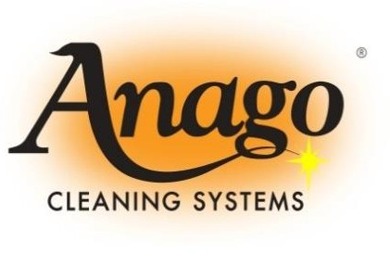

**ANAGO UNIT FRANCHISE AGREEMENT**

**Between MSJC, Inc.,**

**(a Delaware corporation) (We/Us/Our)**

**and**

**(You/Your)**

**Dated: , 20**

# TABLE OF CONTENTS

ARTICLE 1 - APPOINTMENT 1

Section 1.1 Grant of Unit Franchise 1

Section 1.2 No Protected Territory 2

Section 1.3 Nature Of Relationship 2

ARTICLE 2 - OUR DUTIES 2

Section 2.1 Assignment of Accounts 2

Section 2.2 Anago Orientation Program 6

Section 2.3 Loan of the Manual 6

Section 2.4 Lists, Forms and Schedules 7

Section 2.5 Equipment and Supplies 7

Section 2.6 Assistance in Initial Set-Up and First Time Cleaning 7

Section 2.7 Continued Assistance and Support 7

Section 2.8 License of Proprietary Marks and Proprietary Property 9

Section 2.9 Duties Only to You 9

Section 2.10 Our Right to Delegate Duties 9

ARTICLE 3 - FEES AND PAYMENTS 10

Section 3.1 Types of Fees 10

Section 3.2 Payment Schedule 15

ARTICLE 4 - YOUR DUTIES 15

Section 4.1 Operational Requirements 15

Section 4.2 Hiring, Training and Appearance of Employees 16

Section 4.3 Management of the Anago Unit Franchise 16

Section 4.4 Approved Specifications and Sources of Supply 17

Section 4.5 Sales of Products and Services to Your Affiliates 18

Section 4.6 Compliance with Laws, Rules and Regulations 18

Section 4.7 Tax Payments; Contested Assessments 18

Section 4.8 Client Surveys; Client List 18

Section 4.9 Inspections 19

Section 4.10 Notices to Us 19

Section 4.11 Operational Suggestions 19

Section 4.12 Liquidated Damages for Sale of Prohibited Products or Services 20

Section 4.13 Cessation of Service to Clients Only 20

ARTICLE 5 - PROPRIETARY PROPERTY 21

Section 5.1 Your Use of the Proprietary Property 21

Section 5.2 Infringement by You 21

Section 5.3 Claims Against the Proprietary Property 22

Section 5.4 Your Indemnification 22

Section 5.5 Our Right to Modify the Proprietary Marks 22

Section 5.6 Ownership; Inurement Solely to Us 22

ARTICLE 6 - THE MANUAL AND OTHER CONFIDENTIAL INFORMATION 22

SECTION 6.1 IN GENERAL 23

Section 6.2 Confidential Use 23

Section 6.3 Periodic Revisions 23

Section 6.4 Prior Information 24

ARTICLE 7 - ADVERTISING 24

Section 7.1 Local Advertising 24

Section 7.2 Advertising Fund 24

ARTICLE 8 - ACCOUNTING AND RECORDS 26

Section 8.1 Records 26

Section 8.2 Reports and Statements; Confidentiality 26

Section 8.3 Audit by Us 26

Section 8.4 Your Name, Home Address and Telephone Number 26

ARTICLE 9 - INSURANCE 27

Section 9.1 Types and Amounts of Coverage 27

Section 9.2 Evidence of Insurance 28

Section 9.3 Our Right to Participate in Claims Procedure 28

Section 9.4 Waiver of Subrogation 28

Section 9.5 Effect of Our Insurance 28

Section 9.6 Your Failure to Maintain Insurance 28

Section 9.7 Group Insurance 28

ARTICLE 10 - TRANSFER OF INTEREST 29

Section 10.1 Transfer by Us 29

Section 10.2 Your Transfer 29

Section 10.3 Transfer Upon Death or Disability 31

ARTICLE 11 - DEFAULT AND TERMINATION 32

Section 11.1 Termination by You 32

Section 11.2 Termination by Us - Without Notice 32

Section 11.3 Termination by Us - After Notice 33

Section 11.4 Termination by Us - After Notice and Right to Cure 34

ARTICLE 12 - YOUR OBLIGATIONS UPON TERMINATION OR EXPIRATION 35

Section 12.1 Cease Operations 35

Section 12.2 Payment of Outstanding Amounts 35

Section 12.3 Discontinuance Use of Name 35

Section 12.4 Unfair Competition 35

Section 12.5 Return of Materials 36

Section 12.6 Return of Equipment 36

Section 12.7 Liquidated Damages for Premature Termination 36

ARTICLE 13 - YOUR INDEPENDENT COVENANTS 36

SECTION 13.1 DIVERSION OF BUSINESS; COMPETITION AND INTERFERENCE 36

Section 13.2 Independent Covenants 38

ARTICLE 14 - INDEPENDENT CONTRACTOR AND INDEMNIFICATION 38

Section 14.1 Independent Status 38

Section 14.2 Indemnification 38

ARTICLE 15 - REPRESENTATIONS AND WARRANTIES 39

Section 15.1 No Reliance 39

Section 15.2 Our Representations 39

Section 15.3 Your Representations 39

Section 15.4 Receipt of FDD 40

Section 15.5 Receipt of Completed Unit Franchise Agreement 40

ARTICLE 16 - TERM 41

Section 16.1 Term 41

Section 16.2 Option to Obtain Successor Anago Unit Franchise Agreement 41

ARTICLE 17 - DEFINITIONS 42

Section 17.1 Definitions 42

Section 17.2 Other Definitional Provisions 46

ARTICLE 18 - GENERAL PROVISIONS 46

Section 18.1 Release of Claims 46

Section 18.2 Amendments 47

Section 18.3 Modification of the System 47

Section 18.4 Binding Effect 47

Section 18.5 Notices 47

Section 18.6 Headings 48

Section 18.7 Severability 48

Section 18.8 Waivers 48

Section 18.9 Enforcement Costs 49

Section 18.10 Jurisdiction and Venue 49

Section 18.11 Arbitration 49

Section 18.12 Remedies Cumulative 51

Section 18.13 Effectiveness; Counterparts 52

Section 18.14 Consents, Approvals and Satisfaction 52

Section 18.15 Governing Law 52

Section 18.15 Interpretation 52

Section 18.17 Survival 53

Section 18.18 Force Majeure 53

Section 18.19 Liability of Multiple Unit Franchisees 53

Section 18.20 Third Parties 53

Section 18.21 Equitable Relief 53

Section 18.22 Right of Parties 54

Section 18.23 Limitations of Claims 54

Section 18.24 Waiver of Punitive Damages Claims 54

Section 18.25 Waiver of Jury Trial 54

Section 18.26 Recitals 54

Exhibit 1 - ORIENTATION ACKNOWLEDGEMENT 1

Exhibit 2 - LIST OF OFFICE AND MARKETING MATERIALS 1

Exhibit 3 - LIST OF SUPPLIES 1

Exhibit 4 – MINOR EQUIPMENT 1

Exhibit 5 - MAJOR EQUIPMENT 1

Exhibit 6 - ACCOUNT ASSUMPTION AGREEMENT 1

Exhibit 7 - PROMISSORY NOTE 1

Exhibit 8 – GUARAm 3NTEED PAYMENT OPTION 1

Exhibit 9 - Confidentiality / Non-Competition Agreement 1

Exhibit 10 - PERSONAL GUARANTY 1

Exhibit 11- FRANCHISE INSURANCE REQUIREMENTS 1

Exhibit 12 – ASSIGNMENT & ASSUMPTION AGREEMENT 1

Exhibit 13 – ADDENDUM TO THE FRANCHISE AGREEMENT AS REQUIRED BY MARYLAND LAW 1

**ANAGO UNIT FRANCHISE AGREEMENT**

**THIS ANAGO UNIT FRANCHISE AGREEMENT** (“**Agreement**”) is signed on this

day of , 20 , between MSJC, Inc., ("**We**," "**Us**," "**Our**" or “**Subfranchisor**”) a Delaware corporation, and , [an individual] or [a State corporation OR limited liability company] ("**You**" or "**Your**").

# BACKGROUND

1. Anago Cleaning Systems, Inc. (“**ACS**”), a Florida corporation, owns a distinctive System, including certain Proprietary Property and Proprietary Marks, to be used in the operation of commercial service businesses providing janitorial and other approved services under the trade name "Anago." ACS has granted a license to Anago Franchising, Inc. (“**AFI**” or “**Franchisor**”), a Florida corporation, to sublicense the use of the System to subfranchisors and their franchisees.
2. We and AFI entered into a subfranchise rights agreement (the “**Subfranchise Rights Agreement**”) under which AFI granted Us the right to operate as an Anago subfranchisor and to grant Anago Unit Franchises in the state of Maryland, in the counties of Anne Arundel, Baltimore, Calvert, Charles, Harford, St. Mary’s and Baltimore City. (our “**Subfranchise Territory**”).
3. You desire to operate a Unit Franchise subject to the terms of this Agreement and to receive the benefits We provide to You under this Agreement.
4. We have reviewed Your application and have decided to award an Anago Unit Franchise to You as evidenced by this Agreement.
5. You understand that ACS and AFI are not parties to this Agreement and have no obligation to You.
6. All defined terms having the meaning given to them in Section 17.1 or when first

used.

The parties agree as follows:

**ARTICLE 1 - APPOINTMENT** **SECTION 1.1 GRANT OF UNIT FRANCHISE.**

We grant You the right, and You undertake the obligation, to operate 1 Anago Unit Franchise under the System, subject to the terms of this Agreement.

## Section 1.2 No Protected Territory.

You are not obtaining any exclusive or protected territory. You may only operate your Unit Franchise anywhere within the counties of Anne Arundel, Baltimore, Calvert, Charles, Harford, St. Mary’s and Baltimore City (the “**Area**”) under the name Anago. You cannot operate your Unit Franchise outside the Area. We may open and operate Company Units and franchise the Anago Unit Franchise to other Unit Franchisees or engage in any other method of distribution in Our complete discretion whenever, however and wherever We determine, including within the Area. You must designate your own Premises within the Area from which you will manage and administer Your Unit Franchise. If You do not operate Your Anago Unit Franchise out of Your residence but instead occupy a business premises, such business premises and lease agreement will be subject to our prior written approval, which will not be unreasonably withheld.

## Section 1.3 Nature Of Relationship.

The parties expressly agree that this Agreement is an independent contractor relationship. Nothing in this Agreement shall be deemed to constitute or otherwise create an employment, partnership, joint venture or other formal business entity of any kind and the rights and obligations of the parties shall be as expressly set forth herein. We require only that you complete the work assigned to your Unit Franchise and, while we might make suggestions or recommendations, from time to time, we do not direct or control the manner and means in which you perform the tasks necessary to complete the work or the hours you set aside to perform the work.

# ARTICLE 2 - OUR DUTIES

We will provide You with the following assistance and services necessary for the operation of Your Anago Unit Franchise, if You are not in default under this Agreement:

## Section 2.1 Assignment of Accounts.

Accounts secured by Us through a contract with a Client will be assigned to You until the contract with the Client is terminated, cancelled, or transferred, or any situation arises whereby You errantly cease service to the Account. All Accounts we assign to You will originally be between Us and the Client, but You will sign a joinder to or, at our option, an assignment of the contract with the Client. In either event, you will become a party to the contract, but in either case, we make clear that, as between the Client and Us, we remain primarily responsible for the performance of the contract and that you, as an additional party to the contract, will be responsible for providing the janitorial and other services covered by the contract. We will have the right to revoke the joinder or require that you re-assign the contract to us on termination or expiration of this Agreement or sooner if Your assignment to the Account is revoked because of Your failure to perform as described in this Agreement. All payments made by a Client under any Account, even those which You have joined or which have been assigned to You, will be sent directly to Us. You will receive the gross monthly revenues from the Account less the fees owed to Us as stated in Section 3.1 and any other liability You may have to Us. You are not permitted to offer, exchange or transfer Accounts that have been assigned to Your Unit Franchise. For Accounts We assign to You, You are not permitted to perform or invoice for janitorial or other services offered through

Your Unit Franchise directly to those Accounts or to perform or invoice the Account for such services outside of the contract. You may however solicit and negotiate additional business with Clients assigned to You, but if the additional business is for commercial janitorial services or commercial day porter services described in this Agreement, any contract for such additional services will be originally signed between the Client and Us, subject to assignment or your joinder as described in this paragraph. The contract for the additional services will be processed in the same manner as contracts We initiate, including with respect to invoicing and collecting payment for the additional services. All Accounts We assign to You or to which you become a party by joinder must be serviced in accordance with the times, frequency of service and cleaning specifications as determined by the Client.

You acknowledge and agree that we or AFI may negotiate contracts with third parties that provide that their products and services will be the only such products or services that are offered by the Anago System. If we notify you that such a contract has been executed, you agree that you will offer only that third party’s products or services and will not provide any products or services to Clients that are competitive with that third party’s products or services.

1. **Offering Period of Initial Business**. We will offer to You Accounts generating Gross Monthly Billing under the Program You select in Subsection 3.1(a) within the time period described, after the conditions described below have been satisfied. These Accounts will not be offered nor will the Initial Offering Period begin until You have satisfied the following conditions:
   1. You have successfully completed the Anago Orientation Program having obtained an 85% or better on the business operations examination.
   2. Our orientation officer has certified You as qualified to operate an Anago Unit Franchise.
   3. You have signed an orientation acknowledgement in the form attached as Exhibit 1 to this Agreement.
   4. You have proof of all necessary business licenses, tax registrations, insurance and permits and have forwarded copies to Us.
   5. You have purchased, leased or currently own the major equipment described in Exhibit 5 and have furnished proof of purchase (for example, serial numbers and sales slips) to Us.
   6. You have formed your Corporation or LLC business entity. You have received registration of your fictious name and EIN number and delivered copies to Our office.
   7. You have opened a commercial business checking account in the name of your Corporation or LLC business entity with your fictitious name listed and delivered a voided check to Our office.

You are under no obligation to accept Initial Business offered. Our obligation is only to "offer" Initial Business to You within the Initial Offering Period. Should You decline an offer, You must sign a written statement stating that You have declined the offer. A refusal to sign a statement of decline is a material breach under this Agreement and We then have the option of immediately terminating this Agreement. All declined offers will satisfy Our obligation to offer those portions of Initial Business within the Initial Offering Period. Should You decline all Initial Business offered during the Initial Offering Period, then We have the right to terminate this Agreement. If We terminate this Agreement, We will keep all fees You paid to Us and, if You financed a portion of the Initial Fee, the unpaid portion will be forgiven. If We do not exercise the right to terminate this Agreement and You have financed a portion of the Initial Fee, the unpaid balance becomes immediately payable.

If We are unable to secure and offer You the full amount of Initial Business within the time frame allocated for the Initial Offering Period in the Program You purchase, an amount equal to 3.00 times the amount of Initial Business not offered to You will be refunded. You agree and understand that You will not be entitled to any other remedies for our failure to offer the full amount of Initial Business during the Initial Offering Period and this Agreement shall remain binding and in full effect. Any refund will be first applied to any outstanding balance on Your Promissory Note You owe Us, with the remaining sum, if any, paid to You. A refund under this provision will fulfill Our obligations to offer any remaining portion of the Initial Business.

You understand that each Account offered to You as Initial Business may vary in type, size, number of cleans per week and gross amounts paid for the service. You understand that each Account offered to You as Initial Business may be located anywhere within the Area.

1. **Assignment of Additional Business**. Upon Your completion of the obligations under Subsection 2.1(a), We may offer to You additional Accounts of varying amounts if You are not in default under this Agreement and We determine that You are capable of servicing additional Accounts. You are under no obligation to assume these additional Accounts. If We offer additional Accounts and You desire to assume these additional Accounts, You must comply with the following:
   1. You must demonstrate that You are in compliance with the covenants contained in the Policies and Procedures section of the Unit Franchise Operating Manual.
   2. You must sign an Account Assumption Agreement in the form attached as Exhibit 6 to this Agreement.
   3. You must have sufficient employees, equipment, supplies and working capital to insure proper servicing of the Account.
   4. You must pay, in addition to Royalties, Administration Fees and Advertising Contributions, if any, any other payments such as the optional group insurance

and bonding programs, and C-Fees as stated in Subsection 3.1 (f).

## Replacement of Initial Business.

1. If You lose an Initial Account due to circumstances beyond your control or an Initial Account transfer due to circumstances beyond Your control (such as an Account going out of business or ceasing business for more than 7 days due to a natural disaster) within the first year of the initial Term, We will replace the remaining portion of such Account with another Account or combination of Accounts equal to the remaining portion of the annual amount for such Account: For example;

If You are owed and provided an Initial Business account totaling $1,000 (A) per month that on an annual basis would equal $12,000 (B) of Initial Business as intended and You were to lose that Account for no fault of Your own after 6 (C) months then We will have fulfilled $6,000 (D) of the Initial Business leaving a balance still owed to You of $6,000

(E). We will replace that remaining $6,000 without C-Fees being charged to You with another Account or Accounts equaling $500 (F) per month also on an annual basis. (See Illustration 1 below)

|  |  |  |  |  |
| --- | --- | --- | --- | --- |
| I/B Owed  Monthly (A) |  | Service Months |  | I/B Owed  Annual (B) |
| $1,000 | X | 12 | = | $12,000 |
| I/B Provided (A) |  | Service Months (C) |  | I/B Provided (D) |
| $1,000  I/B Still Owed Annual (E) | X | 6  Service Months 12 | =  I/B Per | $6,000  Month Owed (F) |
| $6,000 | ÷ |  | = | $500 |
|  |  | Illustration 1 |  |  |

1. If You lose an Initial Account or an Initial Account transfer for the following reasons:
   1. Your poor service; or
   2. The Client's dissatisfaction;

within the first year of the contract’s Term, We will replace the remaining portion of this Account with another Account or combination of Accounts equal to the remaining portion of the annual amount in the same manner as described in paragraph (i) and Illustration 1 provided, You attend and successfully complete Corrective Measures classes (fees from $0

- $500 apply) and have been certified by Our Orientation Officer as qualified to resume normal Unit Franchise operations. Upon notification by Us of Your requirement to attend Corrective Measures classes, Your Initial Offering Period, if still in effect, will be suspended until You have been certified by Our Orientation Officer as qualified to resume

normal Unit Franchise operation. There is no specific time period in which We are obligated to offer this replacement business.

1. If You lose an Initial Account or an Initial Account transfer for the following reasons:
   1. You or Your employee’s theft or willful destruction of a Client's property;
   2. Abandonment of service without notice to Us;
   3. Use or selling of illegal drugs while performing services;
   4. Use of alcoholic beverages while performing services;
   5. Use of the Client’s equipment without approval of the Client;
   6. Change of the service terms without notifying us;
   7. Continuing to service an Account after We have terminated the Account;
   8. Your failure to meet background requirements that may be requested by the Client; or
2. Any other Event of Default has occurred, whether caused by you or your employees; then, We have no obligation to replace the Account and may elect to terminate this Agreement and keep all fees You paid, with the right to demand immediate payment of all amounts owed to Us.

## Section 2.2 Anago Orientation Program.

We will provide the Anago Orientation Program for You (or one of your owners, if you are a legal entity) and two other individuals designated by You within 30 days of the Agreement Date. One of the individuals who attends the Anago Orientation Program must personally guaranty Your obligations under this Agreement if You are a legal entity. The Anago Orientation Program consists of 7 classroom sessions and 3 on-site sessions at one of Our existing Account buildings. Each classroom and on-site session is a maximum of 8 hours. The Anago Orientation Program covers the following items: general office cleaning, restroom cleaning, floor maintenance, customer relations, and contract sales. The Orientation is provided by the use of video films, lectures and "hands on" applications by Our experienced staff. Your employees may attend certain sessions of the Anago Orientation Program as We designate. There is no additional fee for Initial Orientation. You are responsible for any expenses incurred by You and Your employees in attending the Initial Orientation, including costs of transportation, lodging, meals and any wages paid to your employees.

## Section 2.3 Loan of the Manual.

We will loan to You one (1) registered copy of the Unit Franchise Operating Manual (with revisions as required). Our practice is to deliver the Manual to You shortly before completing the Anago Orientation Program. We will advise you of any changes made by the Franchisor to the Manual. You agree to comply with any and all changes that are designated therein as mandatory. You may, at your discretion, adopt any changes that are designated therein as “suggested” or “recommended.” If there is any conflict between Your and Our copy of the Manual, the copy we maintain at Our offices will control.

## Section 2.4 Lists, Forms and Schedules.

We will provide to You:

1. A list of required equipment, supplies, materials, inventory and other items necessary to open and operate Your Anago Unit Franchise;
2. An initial set of forms, including the standard brochure and various operational forms, standardized periodic reporting forms for reporting performance, evaluation, inspection and communication; and
3. A schedule of items that may be purchased or leased from Us or a designated or approved System supplier.

## Section 2.5 Equipment and Supplies.

You must use Your own tools, equipment, and supplies to perform the services required under the contract with the Account. We will provide to You office and marketing materials as stated in Exhibit 2, cleaning supplies as stated in Exhibit 3 and minor equipment as stated in Exhibit 4. (The cleaning supplies and minor equipment described in Exhibits 3 and 4 are included in the Initial Fee for programs I through X+. Purchasers of programs 0 and 500 must purchase the cleaning supplies and minor equipment separately. Purchasers of program VII or higher will receive two (2) complete sets of the cleaning supplies and minor equipment described in Exhibits 3 and 4). If at the time of purchase, you have your own supplies equal to the supplies listed in Exhibits 3 and 4, you may request an equipment waiver, which will reduce Your Initial Fee. All Your existing supplies are subject to Our approval and must meet the standards and specifications of the Anago system. The replenishment of these materials and supplies will be at the expense of Your business.

## Section 2.6 Assistance in Initial Set-Up and First Time Cleaning.

We will provide to You experienced field support and accompany You during the initial set-up and first-time cleaning of the very first Account You service pursuant to this Agreement.

## Section 2.7 Continued Assistance and Support.

Upon the opening of Your Anago Unit Franchise, We will provide to You the following:

1. **Invoicing and Accounting Services.** You have agreed to retain us as your agent to directly invoice the Accounts that are assigned to you or with respect to which you sign a joinder, and you agree to forward to Us any Client payments sent or given directly to You. We will invoice the Accounts monthly for the cost of services and supplies You render under the contract with the Account. We will accept payments from the Accounts we assign to You and maintain those revenue Records for You. Money due You from servicing the Accounts we assign to You will reflect deductions of Royalty Fees, Administration Fees, Advertising Contributions, C-Fees, Note Payments and all other amounts You owe to Us or Our Affiliates and out-of-pocket costs (including attorneys’ fees and court costs) We incur in enforcing payment of Accounts. On or

around the 25th of each month following the month in which services were rendered, We will mail to You all monies collected as recorded in the “Due Owner” column of the Owners Report (monthly statement), less monies due Us in accordance with this Agreement. If amounts billed to the Accounts we assign to You are unpaid, You will incur the loss of nonpayment except in instances where We have guaranteed in writing payments to You. We will take action to enforce payment at Your discretion and expense. We may also initiate action on Our own to recover unpaid amounts of Our fees that would have been collected if the Account had paid as agreed. Failure to forward any funds You receive to the Anago office will result in a Handling Fee of $100 per payment you fail to forward.

We will only be responsible for the invoicing or collection of any monies due from Accounts assigned to you or to with respect to which you sign a joinder.

1. **Supply Sources.** We will continue to investigate supply sources for better pricing. Although You are not required to purchase any cleaning equipment or supplies from Us, We may be able to obtain lower prices on supplies and equipment and will direct You to that supplier without any obligation on Your part to purchase from them.
2. **Field Visits.** You understand and acknowledge that detail of the System is essential to the Anago brand and all Franchised Units in order to (i) develop and maintain quality brand standards, (ii) increase the demand for services sold by Franchised Units and (iii) protect Anago’s name and goodwill. In an effort to further these interests We have the right to perform periodic quality control visits to each building You clean. All brand standards will be inspected and recommendations will be made to You. Our representative will operate from the local Anago office and will be available during normal
3. **Assistance with Business Development.** We will, at Our discretion and subject to availability, continue to provide You with estimating expertise, custom proposals and references in order to assist development of Your Unit Franchise’s business.
4. **Assistance with Clients' Services.** You understand that You are the primary contact for the customer with respect to service complaints and/or requests; however, Our local office will accept service calls from Anago Accounts assigned to You and relay these service calls to You in a timely manner.
5. **Telephone Hotline.** We will maintain a telephone "hotline" for informational assistance and emergencies for You and the contact personnel of Accounts assigned to You.
6. **Local Advertising.** We will provide advice on Local Advertising. All advertising bearing Anago marks or logos must receive prior written approval from Us.
7. **Promotional Literature.** We will make available to You promotional literature of the Anago System and all pertinent new developments in the janitorial and related service industries including procedures for improved efficiency to the extent actually known by Us.
8. **Periodic Assistance.** We may provide advisory assistance in the operation and promotion of the Anago Unit Franchise as We deem advisable. Advisory assistance may include continuing education and assistance, communication of new developments, improvements in equipment and supplies, and new techniques in advertising, service and management relevant to the operation of Your Anago Unit Franchise through multimedia and service manuals.
9. **Continuing Education.** In order to maintain the highest standards and goodwill for the Anago System, the Proprietary Marks and Franchisees We may provide additional training programs, seminars or continuing education classes at Our principal business facility. If any continuing education is recommended for You by the Regional Office because You have received an unusually high number of complaints from Clients, We may suspend all further business offerings to You until We are satisfied that the deficiencies have been corrected.
10. **Corrective Measures.** If You receive unsatisfactory inspection reports from Us and fail to promptly remedy the deficiencies, We may require those of Your representatives that we specify to attend corrective measures classes as soon as reasonably possible. You are solely responsible for all expenses associated with these programs including the then prevailing standard Orientation fee We charge for these programs and all travel, meals and lodging costs of Your attendees. If You fail the Anago Orientation Program, You must attend corrective measures classes in the areas the Orientation Officer feels are necessary for You to successfully complete the Anago Orientation Program. If You lose or are transferred from an Initial Business Account due to non-performance or Client dissatisfaction, at our discretion we may require You to attend corrective measures classes in the areas of deficiency (fees apply).

## Section 2.8 License of Proprietary Marks and Proprietary Property.

Subject to the terms of this Agreement (including, without limitation, those contained in Article 5), We grant You a license to use the "Anago" trade name and the other Proprietary Marks and Proprietary Property solely in connection with the operation of Your Unit Franchise.

## Section 2.9 Duties Only to You.

All of Our obligations under this Agreement are only to You. No other party is entitled to rely on, enforce, or obtain relief for breach of the obligations either directly or by subrogation.

## Section 2.10 Our Right to Delegate Duties.

You agree to Our right to delegate duties under this Agreement to a Designee approved by the Franchisor. You must perform Your duties with the Designee to the extent We request, as You must do with Us.

**ARTICLE 3 - FEES AND PAYMENTS** **SECTION 3.1 TYPES OF FEES.**

In consideration of Our signing this Agreement, You must pay to Us the following fees, in addition to any others required under this Agreement, all payable in United States currency at Our principal office:

1. **Initial Fee.** You must pay to Us an Initial Fee payable upon signing this Agreement. The Initial Fee is fully earned by Us on receipt and, except as expressly provided otherwise in this Agreement, is nonrefundable upon signing this Agreement. The Initial Fee is uniform as to all Unit Franchisees currently purchasing a Unit Franchise selecting the same Program. The amount of the Initial Fee is based on the Program You select from the 12+ Programs available. The Initial Fee ranges from $5,440 to $31,500 if paid in cash, or $6,400 to $31,500 with down payments ranging from $1,500 to $24,000 if financed. You have selected Program number

, and have chosen to:

### Initial One:

[ ] pay the entire Initial Fee in cash, or [ ] finance a portion of the Initial Fee.

Should a part of the Initial Fee be financed, the scheduled monthly payments for the amount financed will begin 120/150/180+ days after the beginning of the Initial Offering Period or when You have been offered Initial Business totaling at least 50% of the Initial Business due You under this Agreement. All financing will be at a 14% interest rate.

1. **Royalty Fee**. You will pay a continuing monthly nonrefundable Royalty Fee during the Term of 10% of collected monthly Gross Revenues. We will retain the Royalty Fee from the payments Clients make and remit the balance to You.
2. **Administration Fee.** You will also pay a continuing monthly nonrefundable Administration Fee during the Term of 8% of collected monthly Gross Revenues, to reimburse Us for Our costs as your agent, and disbursement of funds from Accounts we assign to You. We will retain the Administration Fee from the payments Clients make and remit the balance to You.
3. **Advertising Contribution**. You must pay us a monthly Fund (as defined in Section 7.2) advertising contribution of 2% of monthly Gross Revenues. We reserve the right to increase the advertising contributions provided the increased monthly advertising contribution will not exceed 2% of monthly Gross Revenues. Each advertising contribution is due on the same date and calculated for the same periods as the Royalty, and will be payable in the same manner.
4. **Insurance Program Fees**. If You elect to participate in Our insurance program, if available, rather than purchase on Your own the insurance required under ARTICLE 9, You agree to pay Us a fee for our efforts (currently 8%, which is comprised of 5% for General Liability & 3% for Workers’ Compensation of monthly Gross Revenues), plus $2.00 per invoice per client

serviced. You are still liable for a charge of 2% of Gross Revenues for insurance administration and policy verification.

1. **C-Fees.** For the assignment and assumption of any additional Accounts We offer to You and You accept under Subsection 2.1(b), You will pay to Us a non-refundable fee ("C- Fee"). The C-Fee is currently equal to 3.0 times the Gross Monthly Billing of additional Accounts, but we reserve the right, on 30 days’ notice to You, to increase it to 5.0 times the Gross Monthly Billing of additional Accounts. The C-Fee and is payable in full at the time of the assumption of the Account or may be financed by Us at Our sole discretion under the Terms listed below in this Section 3.1(f) (Subsections (i) through (xv)).
   1. For any additional Account We offer to You and You accept having Gross Monthly Billing of up to and including $2,000, the C-Fee is payable: (a) 20% upon assumption of the Account; and (b) the balance payable in 11 equal monthly installments including interest at 14% per year.
   2. For any additional Account We offer to You and You accept having Gross Monthly Billing from $2,001 up to and including $3,000, the C-Fee payable: (a) 20% upon assumption of the Account; and (b) the balance payable in 11 or 17 equal monthly installments including interest at 14% per year. Should, for any reason, the Client contract not be renewed after 12 months, and the financing was for 17 months, the remaining balance is immediately due.
   3. For any additional Account We offer to You and You accept having Gross Monthly Billing of $3,001 and above the C-Fee is repayable as negotiated by the parties as stated in the Account Assignment & Assumption Agreement. For example, if for any reason, the Client contract is not renewed after 12 months, and the financing was for 18 months, the remaining balance would be immediately due.
   4. If the C-Fee is paid in full at the time of assumption, the C-Fee will be reduced by 15%.
   5. If the C-Fee is paid in full within 90 days of assumption, no interest charges will accrue.
   6. The C-Fee of One-Time Services, Initial Cleans or Extra Work on additional Accounts We secure will be equal to 20% of the gross fee charged to the Client and will not be financed.
   7. If You voluntarily relinquish an additional Account that You have assumed, after 10 business days' written notice to Us of Your intent to relinquish, any C-Fee payment still due will be canceled if We are able to have another Unit Franchisee assume the Account and the Client does not cancel within 60 days after the transfer date; otherwise, the C-Fee remains due.
   8. If You lose an additional Account for the reasons stated in either

Subsections 2.1(c)-(ii)-(iii) or if You cease service to the Account (for more than 2 days without at least 10 days’ written notice and Our consent) or if You abandon Your Anago Unit Franchise and the C-Fee was financed, the entire unpaid amount becomes immediately due upon loss of such Account or abandonment of Your Unit Franchise. If the C-Fee amount You owe after loss, transfer or abandonment of an Account cannot be precisely determined due to fluctuating monthly payments, then an average will be taken of the prior months for which You provided services to the additional Account before the time of loss, transfer or abandonment.

* 1. C-Fee payments are discontinued if the Client cancels the service contract through no fault of yours. C-Fees are non-refundable. However, credits for C-Fee payments will be made if the Client cancels the services contract within 180 days from the date of commencement. Any credit toward additional contract C-Fees is limited to 15% of paid C- Fees calculated for the contract and is at Our sole discretion; provided that You can verify that the contract was canceled through no fault of yours. The difference between the amount You have paid in C-Fees and the amount of credit given will be deemed earned by Us. No C-Fee credits are given if You desire to cease servicing the Client or if the contract is canceled as a direct result of Your Unit Franchise’s fault.
  2. On buildings with varying occupancy levels you will pay a monthly C-Fee based on amount of square footage cleaned.
  3. Should an additional Account request an increase in services and the monthly gross billings increase, additional C-Fees may be charged in our sole discretion.
  4. There is no C-Fee assessed when You obtain an Account solely through Your own marketing and sales efforts, without assistance from the Regional Office (excluding the preparation of the actual bid proposal).
  5. Partial C-Fees may be assessed at 50% of normal schedule if You need a Regional Office representative to assist with the bid pricing or to close the sale.
  6. All C-Fee credits must be requested in writing within 30 days after termination of an Account.
  7. Accounts that must be transferred from You to another Franchisee will incur

the full month’s C-Fee.

1. **Operations Fee.** If We elect to procure service to an Account You are currently servicing in order to comply with the Account's requirements or You are unable or unwilling to provide the services, You will be assessed an Operations Fee of $50 plus any labor and materials cost.
2. **Account Transfer Fees.** If a Client gives notice of pending cancellation or requests a transfer due to poor performance on Your part, or poor Client relations, We will assign the Account to another Unit Franchisee or if We have received 3 or more complaints from a Client

or Our Brand Standards Department within any 30-day period concerning Your performance and We elect to transfer the Account, an Account Transfer Fee of $100 will be assessed. If the transferred Account requires additional work to bring the cleanliness up to acceptable standards, You will be given an opportunity to provide labor and materials, at Your expense and You will be assessed an Additional Account Transfer Fee of $50 or a total of $150. If You cannot or elect not to provide labor and materials, We will procure the necessary labor and materials to the Client and deduct the expense from monies due You. If We receive 3 or more complaints during a 30-day period, We may, at Our sole discretion, transfer the Account and assess an Account Transfer Fee of $100. If inspections by Our Brand Standards department show a continued lack of proper service and/or poor quality of service, then We have the right to transfer the Account without notice and assess a $100 Account Transfer Fee. All other transfers will be assessed a $50 Account Transfer Fee.

1. **Standards Enforcement Fee**. If, regardless of discovery through a Client complaint or a Brand Standards department inspection, a lack of performance is found, We will notify You immediately and You will have 2 hours to respond to the complaint. If We are unable to make contact with You and Our Brand Standards department must respond to the complaint, a Standards Enforcement Fee of $50.00 will also be assessed to You. If a complaint is made known to You by Our Brand Standards department and You fail to correct the deficiency to Our or the Client’s satisfaction on or before Your next contractually scheduled visit, Our Brand Standards department will correct the deficiency. You will be assessed all costs We incur to correct the complaint.
2. **Handling Fee.** Client payments sent or given directly to You must be forwarded to the Anago Regional Office for processing. Failure on Your part to forward any payments will result in a Handling Fee charge of $100 for each payment You fail to forward to Us.
3. **Advance Payment Fee.** If We advance collected funds, but the funds are not yet payable to You, You will pay a processing fee of $25. If We loan You uncollected funds, You will pay a processing fee of $25 plus interest at the rate of 18% per annum until fully paid.
4. **Technology Fee.** We reserve the right, at the direction of AFI and upon written notice to You, to initiate a monthly technology licensing fee (“Technology Fee”) equal to up to 1.5% of Your monthly Gross Revenues during the preceding month. You agree to pay the Technology Fee, once initiated, for the remainder of the Term. We pay the Technology Fee we receive from you to AFI in consideration for computer system hardware and/or the development, license, and/or use of proprietary or third-party software, whether for AFI’s, Our or Your use in connection with technology services provided by AFI or Us to you.
5. **Credit Card Charges.** If any Accounts assigned to You pay by credit card or other method that involves a discount or charge to the payee, We will charge You the amount assessed by the credit card processor, currently 6.15% of the billed amount. This amount is subject to change based on increases of third-party charges. The Franchisee will be notified on the 20th of every month if there are any client payments by credit card payments and the amount charged by the processing bank.
6. **Guaranteed Payment Option.** This is an optional program in which We pay You for unpaid Client services. If You choose to participate You pay Us 5% of Your total Gross Revenues. (see Exhibit 8).
7. **Corrective Measures Fees.** If You receive unsatisfactory inspection reports from Us and fail to promptly remedy the deficiencies, We may require You and Your representatives to attend refresher corrective measures classes as soon as reasonably possible. You are solely responsible for all expenses associated with these programs including Our then prevailing standard Corrective Measures Fee ($0.00 to $500.00, as set by Us or Our Affiliate). You will be responsible for all travel, meals and lodging costs of Your attendees. If You fail the Anago Orientation Program, You must attend corrective measures classes in the areas the Orientation Officer feels are necessary for You to successfully complete the Anago Orientation Program. If You lose or are transferred from an Initial Business Account due to non-performance or Client dissatisfaction, in our discretion we may require You to attend corrective measures classes in the areas of deficiency.
8. **Insurance Coverage (Failure of Franchisee to maintain coverage).** If You fail to maintain the insurance required by this Agreement, We may obtain the required insurance on your behalf (though we have no obligation to do so) and charge You the insurance program fees described in Section 3.1(e).
9. **Deficiencies.** If You do not satisfy Your obligations under this Agreement, We may (in our sole discretion) perform Your obligations for You. You must reimburse Us for Our costs incurred in performing Your obligations.
10. **Testing and/or Inspection of unapproved products and/or services.** You are required to purchase or lease equipment, supplies advertising materials and other products and services used for the operation of Your Anago Unit Franchise only from authorized manufactures, contractors and other suppliers who demonstrate, to Our continuing reasonable satisfaction: (i) the ability to meet Our reasonable standards and specifications for the items; (ii) possess adequate quality controls and capacity to supply Your needs promptly and reliably; and (iii) have been approved in writing by Us and not later disapproved. Fee is set and not to exceed reasonable cost of inspection and actual testing (estimated $100-$500).
11. **Fee for Lost Manual.** Upon the theft, loss or destruction of the Manual, a replacement copy will be loaned to You at a fee of $500. A partial loss or failure to update the Manual is considered a complete loss.
12. **Return of Keys Fee.** When your Franchise Agreement expires or terminates, you must immediately give us or the customer (as each customer decides) all keys, security passes, security codes, and other means of access to your customers’ premises. You also must do this if you are to stop servicing any customer. Failure to return keys will result in a $500 a day fine until all keys have been returned. If a key is lost and cannot be returned, You will be charged the full cost of the replacement for each key lost and/or for the re-keying /reprogramming any locks. If a key is lost and cannot be returned, You will be charged the full cost of the replacement for each key lost and/or for the re-keying /reprogramming any locks.

## Section 3.2 Payment Schedule.

The Royalty Fee, Administration Fee, Advertising Contributions, Insurance Fee and C-Fee will be deducted by Us by the 25th day of each month during the Term for the Gross Revenues derived during the previous month. We will mail You a check of the net Gross Revenues within 5 days after making the deductions. You will be paid up to the last day of actual service to the Client if the Account is lost or transferred. All other amounts due to Us from You will be paid at this time. If no time is specified, these amounts are due upon receipt of an invoice from Us. Any payment We do not actually receive on or before the due date is overdue.

# ARTICLE 4 - YOUR DUTIES

## Section 4.1 Operational Requirements.

You agree to operate the Anago Unit Franchise in conformity with all mandatory uniform methods, standards and specifications required in the Unit Franchise Operating Manual or otherwise, to ensure that the highest degree of quality and service is uniformly maintained. You agree to:

1. Open and maintain a separate commercial bank account for the Anago Unit Franchise;
2. Maintain an internet e-mail connection and purchase a cellular phone as specified in the Manual;
3. Perform all janitorial and other approved facilities-related services and honor all Anago Accounts You assume;
4. Comply with the procedures and Systems we mandate from time to time whether in the Manual or otherwise;
5. Not service or solicit any business under the Anago name until You have satisfied the conditions in Subsection 2.1(a);
6. Maintain in sufficient supply (as We require in the Manual or otherwise in writing) and use at all times, only inventory, equipment, materials, advertising methods and formats, and supplies that conform with Our standards and specifications, if any, at all times sufficient to meet the anticipated volume of business, and to refrain from deviating from these requirements without Our written consent;
7. Adhere to the highest standards of honesty, integrity, fair dealing and ethical conduct in all
8. aspects of the operation of Your Anago Unit Franchise;
9. Sell or offer for sale under the Anago System only the products and services that meet Our standards of quality and quantity; have been approved for sale in the Manual or otherwise in writing by Us at retail to Clients; not sell any items for redistribution or resale; sell or offer for sale all approved products and services; refrain from any deviation from Our standards and specifications for providing or selling the products and services without Our written consent; and discontinue selling and offering for sale under the Anago system any products and services that We disapprove in writing at any time;
10. If You believe or receive information that indicates that one of Our employees or agents has or may have engaged in any act of sexual or racial harassment or discrimination, or any other act prohibited by law, You agree to report the incident to Us within 48 hours;
11. Set up a separation corporation or approved legal entity to operate Your Anago Unit Franchise, within 30 days of signing this Agreement;
12. Not subcontract out services of any type to any Anago Accounts You assume. All Anago Accounts must be serviced only by You or Your employees; and
13. Comply with any maximum or minimum pricing we may periodically set, but only for those products and services offered by Unit Franchises under and as part of the Anago System (we do not limit your ability to set your own prices for work you perform outside of the Anago System). If we impose such a maximum or minimum price for any product or service, you may charge any price for the product or service up to and including our designated maximum price or down to and including our designated minimum price. The designated maximum and minimum prices for the same product or service may, at our option, be the same.

## Section 4.2 Hiring, Training and Appearance of Employees.

You will maintain a competent, conscientious staff and employ the minimum number of employees necessary to meet the anticipated volume of business and to achieve the goals of the System. You are solely responsible for determining who You employ and all of the essential terms and conditions of their employment, including their compensation, their training, the number of hours and when they work, the duties they are assigned to perform, the supervision of their performance, the rules regarding how they perform their duties, how and why You discipline them, all decisions regarding termination of their employment, and any working conditions related to their health and safety. You are also solely responsible for following all applicable regulations and laws applicable to the operation of Your Anago Unit Franchise. You recognize, however, that Individual Accounts may dictate specific service hours, methods, or staffing requirements. It is your responsibility to determine the staff and staffing levels and qualifications you need in order to satisfy the Accounts’ requirements in that regard. You will take all steps necessary to ensure that Your employees keep a neat appearance and comply with any dress code We require, subject to the requirements of facility managers/Clients. We are not responsible for any claim made by Your employees or contractors, and You agree to indemnify and hold Us harmless from any such claims as set forth more fully herein. You are solely responsible for payment of Your employee’s wages earned for services performed on an Anago Account; failure to comply is a material default under this Agreement.

## Section 4.3 Management of the Anago Unit Franchise.

1. If You are not incorporated at the time You sign this Agreement, You must incorporate and assign all rights and responsibilities under this Agreement to Your corporation or other approved legal entity for the operation of Your franchise within 30 days of signing this Agreement. You may not commence any work or provide any services as an Anago Unit Franchise until this Agreement has been assigned to Your legal entity.
2. You must appoint, subject to our approval, one of Your owners who will devote his or her best efforts to the full exploitation and management, day-to-day supervision, and operation of the Anago Unit Franchise.

## Section 4.4 Approved Specifications and Sources of Supply.

1. **Purchases from Us or Our Affiliates.** We do not allow You to use Our tools, equipment or supplies to perform the work of Your Unit Franchise. You must own Your own tools, equipment and supplies necessary to perform the work for which the Account has contracted. However, You must purchase only from Us or an approved supplier the items stated in Exhibits 3, 4, and 5 (The items described on Exhibits 3 and 4 are included in the Initial Fee for programs I through X+. Purchasers of programs 0 and 500 will not receive these supplies as part of the Initial Fee and must purchase them separately). This is in addition to Your ongoing needs for cleaning supplies and other items that We require, if implemented on a System-wide basis.
2. **Authorized Specifications and Suppliers.** You must purchase or lease equipment, supplies, advertising materials, and other products and services used for the operation of the Anago Unit Franchise only from authorized manufacturers, contractors and other suppliers who demonstrate, to Our continuing satisfaction: the ability to meet Our standards and specifications for these items; possess adequate quality controls and capacity to supply Your needs promptly and reliably; and have been approved in writing by Us and not later disapproved. We may approve a single supplier for any brand and may approve a supplier only as to a certain brand or brands. In approving suppliers for the System, We may take into consideration factors like the price and quality of the products or services and the supplier's reliability. We may concentrate purchases with 1 or more suppliers to obtain the lowest prices and/or the best advertising support and/or services for any group of Franchised Units or Company Units within the System. Approval of a supplier may be conditioned on requirements on the frequency of delivery, standards of service, warranty policies including prompt attention to complaints, and concentration of purchases, as stated above, and may be temporary, pending Our additional evaluation of the supplier. We in no way warrant the use of approved vendors or supplies when they are utilized outside the Anago System. We may designate a supplier where a Franchisee may go and buy supplies and charge the supplies to the House Account. If you use the House Account to purchase supplies and elect to have your purchases deducted from your statement each month, we will charge you a financing fee of 5.25% of the amount charged.
3. **Approval of New Specifications and Suppliers.** If You propose to purchase or lease any equipment, supplies, advertising materials, or other products or services, for use within the Anago System, from an unapproved supplier, You must submit to Us a written request for approval, or request the supplier to do so. We will have the right to require, as a condition of Our approval that Our representatives be permitted to inspect the supplier's facilities, and that samples from the supplier be delivered, at Our option, either to Us or to an independent, certified laboratory We designate for testing. We are not liable for damage to any sample that results from the testing process. You will pay a charge not to exceed the reasonable cost of the inspection and the actual cost of the testing. We reserve the right, at Our option, to re-inspect the facilities and products of any approved supplier and continue to sample the products at the supplier's expense and to revoke approval upon the supplier's failure to continue to meet Our standards and specifications. We may

also require as a condition to Our approval, that the supplier present satisfactory evidence of insurance, for example, product liability insurance, protecting Us and Our Unit Franchisees against all claims from the use of the item within the System.

## Section 4.5 Sales of Products and Services to Your Affiliates.

All sales of products and services to Your affiliates, if any, must be on terms regularly applicable to Your nonaffiliated Clients, and in all cases must be arm's length.

## Section 4.6 Compliance with Laws, Rules and Regulations.

You will comply with all federal, state, and local laws, rules and regulations, and will timely obtain, maintain and renew when required all permits, certificates, or licenses necessary for the proper conduct of the Anago Unit Franchise under this Agreement, including qualification to do business, fictitious, trade or assumed name registration, occupational licenses, and OSHA requirements. You will provide copies of all inspection reports, warnings, certificates and ratings, issued by any governmental entity during the Term on the conduct of the Anago Unit Franchise that indicates Your material noncompliance with any applicable law, rule or regulation, to Us within 2 days of Your receipt of these items. We accept no responsibility for any of Your operations, janitorial or otherwise.

## Section 4.7 Tax Payments; Contested Assessments.

You will promptly pay when due all taxes required by any federal, state or local tax authority including unemployment taxes, withholding taxes, income taxes, tangible commercial personal property taxes, real estate taxes, intangible taxes and all other indebtedness You incur in the conduct of the Anago Unit Franchise. You will pay to Us an amount equal to any sales tax, goods and services taxes, gross receipts tax, or similar tax imposed on Us for any payments to Us required under this Agreement, unless the tax is measured by or involves the net income or Our corporate status in a state. If We pay any tax for which You are responsible, You will promptly reimburse Us the amount paid. If there is any bona fide dispute as to liability for taxes assessed or other indebtedness, You may contest the validity or the amount of the tax or indebtedness in accordance with procedures of the taxing authority or applicable law. However, You will not permit a tax sale or seizure by levy or signing or similar writ or warrant, or attachment by a creditor, to occur against any assets used in the Anago Unit Franchise.

## Section 4.8 Client Surveys; Client List.

You will present to Clients all Performance Evaluation forms We require and will participate and/or request Our Clients to participate in all marketing surveys performed by or for Us. You will maintain a Current Client list containing each Client's name, address, telephone number and zip/postal code and supply a copy of the list to Us on a quarterly basis. You must participate in any process We develop to record all Client information. We own all Client lists of Your Unit Franchise. This list is Our Confidential Information and will not be disclosed by You to any third party.

## Section 4.9 Inspections.

You understand and agree that for the protection of the System and Proprietary Marks that quality control is necessary to ensure we and all our Franchisees not only continue growing but deliver the best quality of service. Therefore, You will permit Us and/or Our representatives to enter Your Premises or buildings where You are providing services at any time for purposes of conducting inspections. You will cooperate fully with Us and/or Our representatives in inspections by rendering assistance as we or they reasonably request and by permitting us or them, at our or their option, to observe how You are rendering the services, to confer with Clients and Your employees (provided, however, that if We notice any deficiencies in Your employees’ performance, We will notify You of the deficiencies and You, in turn, will correct such deficiencies as described below). We may also remove samples of any products, supplies and materials in amounts reasonably necessary to return to Our office for inspection and record-keeping. The inspections may be conducted without notice at any time. The inspections will be performed in a manner that minimizes interference with the operation of the Anago Unit Franchise. We may videotape the inspections. Upon notice from Us, and without limiting Our other rights under this Agreement, You will take all steps necessary to correct immediately any deficiencies detected during inspections, including immediately stopping use of any equipment, advertising, materials, products, supplies or other items that do not conform to Our then-current requirements. If You fail or refuse to correct any deficiency, We have the right, without You claiming to the contrary, to enter Your Premises or office without being guilty of trespass or any other tort, for the purposes of making or causing to be made all corrections as required, at Your expense, payable by You upon demand.

## Section 4.10 Notices to Us.

1. You must notify Our local office of any Anago Client complaint within 2 hours of actual receipt of the complaint.
2. You must also notify Us in writing within 5 days of any of the following events:
   1. The start of, any action, suit, counter suit or other proceeding against You or any of Your employees;
   2. Your, or any of Your employees', receipt of any notice of noncompliance with any law, rule or regulation; or
   3. The issuance of any order, writ, injunction, award or decree of any court, agency or other governmental instrumentality against You or any of Your employees.
3. You will provide Us with any information We request, within 5 days of request, about the progress and outcome of events.

## Section 4.11 Operational Suggestions.

You acknowledge and agree that, as between You and Us, We and our licensors are the sole owner of all right, title, and interest in and to the System and any Confidential Information.

You are encouraged to submit suggestions in writing to Us for improving elements of the System, including products, services, equipment, service format, advertising, procedures and any other information relevant to the System. You agree that all such suggestions and any improvements, developments, derivative works, enhancements or modifications to the System and any Confidential Information (collectively, “**Innovations**”) made or created by You, Your employees or Your contractors, whether developed separately or in conjunction with Us, shall be owned solely by Us and our licensors. We have no obligation to use any Innovations and no obligation to provide compensation for any Innovations. You may not use any Innovations inconsistent with Your obligations under this Agreement without Our written consent. You represent, warrant, and covenant that Your employees and contractors are bound by written agreements assigning all rights in and to any Innovations developed or created by them to You. To the extent that You, Your employees or Your contractors are deemed to have any interest in such Innovations, you hereby agree to assign, and do assign, all right, title and interest in and to such Innovations to Us. To that end, You shall execute, verify, and deliver such documents (including, assignments) and perform such other acts (including appearances as a witness) as We may reasonably request for use in applying for, obtaining, perfecting, evidencing, sustaining, and enforcing such ownership rights in and to the Innovations, and the assignment thereof. Your obligation to assist Us with respect to such ownership rights shall continue beyond the expiration or termination of this Agreement. If we are unable for any reason, after reasonable effort, to secure your signature on any document needed in connection with the actions specified in this Section 4.11, You hereby irrevocably designate and appoint Us and Our duly authorized officers and agents as Your agent and attorney in fact, which appointment is coupled with an interest and is irrevocable, to act for and on Your behalf to execute, verify, and file any such documents and to do all other lawfully permitted acts to further the purposes of this Section 4.11 with the same legal force and effect as if executed by You. The obligations of this Section 4.11 shall survive any expiration or termination of the Agreement.

## Section 4.12 Liquidated Damages for Sale of Prohibited Products or

**Services.**

You agree that the offer to sell or the sale of unauthorized or prohibited products and services within the Anago System or operation of Your Unit Franchise will result in damages to Us. You agree these damages will be measured as $100 for each day that You offer or sell unauthorized or prohibited products or services, payable to Us upon demand. These damages are in addition to Our other rights including Our right to strictly enforce or terminate this Agreement as provided in this Agreement and obtain injunctive relief, except to the extent any other rights are excluded by law in light of this Section. The parties agree that a precise calculation of the full extent of the damages that We will incur from the offer or sale of unauthorized products and services is difficult to determine and We and You desire certainty in this matter and agree that the liquidated damages are reasonable and are not a penalty.

## Section 4.13 Cessation of Service to Clients Only.

You will surrender, as directed by the Regional Office or the Client, all keys, codes and pass cards to Our Clients' facilities, after the completion of the last scheduled day of service. You will remove only equipment and supplies belonging to You.

**ARTICLE 5 - PROPRIETARY PROPERTY** **SECTION 5.1 YOUR USE OF THE PROPRIETARY PROPERTY.**

You may use the Proprietary Property only in accordance with standards and specifications We determine. You agree that:

1. You will use the Proprietary Property only for the operation of the Anago Unit Franchise;
2. You will use the Proprietary Marks as the sole service mark identifications for the Anago Unit Franchise and will display prominently the Proprietary Marks on and/or with all materials We designate and authorize, and in the manner, We require;
3. You will not use the Proprietary Property as security for any obligation or indebtedness;
4. You will comply with Our instructions in filing and maintaining any required fictitious, trade or assumed business name registrations for the "Anago" trade name, for example, John Jones d/b/a "Anago" or ABC, Inc. d/b/a "Anago;"
5. You will sign all documents We or Our counsel deems reasonably necessary to obtain protection for the Proprietary Property and Our interest in the property;
6. You shall not register or use any domain name or URL that contains, uses or displays the words “Anago Cleaning Systems” or any portion thereof, or the initials “ACS,” or any Proprietary Marks, or other related or confusingly similar words or symbols, unless You first receive Our written consent. You may not use Proprietary Mark or any derivation of the Proprietary Marks on the Internet, in any electronic advertising or on social media, without Our prior written consent. You may not use any other trade name or marks at your Unit Franchise business, or in connection with your Unit Franchise business without Our express written consent;
7. If You do not operate Your Anago Unit Franchise out of Your residence but instead occupy a business premises, You will maintain a suitable sign or graphics package at, or near the front of the Premises, on any pylon sign, building directory or other area identifying the Premises only as "Anago." The signage must conform in all respects to Our requirements except to the extent prohibited by local governmental restrictions or landlord regulations; and
8. You will exercise caution when using the Proprietary Property to ensure that the Proprietary Property is not jeopardized in any manner.

## Section 5.2 Infringement by You.

You agree that the use of the Proprietary Property outside the scope of this Agreement, without Our written consent, is an infringement of Our rights in the Proprietary Property. You agree that during the Term, and after the expiration or termination of this Agreement, You will

not, directly or indirectly, commit an act of infringement or contest or aid in contesting the validity of, or Our right to, the Proprietary Property, or take any other action in derogation of Our rights.

## Section 5.3 Claims Against the Proprietary Property.

If there is any claim of infringement, unfair competition or other challenge to Your right to use any Proprietary Property, or if You become aware of any use of, or claims to, any Proprietary Property by persons other than ACS, AFI, Us or Our Unit Franchisees, You will promptly (within 7 days) notify Us in writing. You will not communicate with anyone except Us and Our counsel on any infringement, challenge or claim except under judicial process. We have sole discretion as to whether We take any action on any infringement, challenge or claim, and the sole right to control any litigation or other proceeding involving any infringement of, challenge or claim to any Proprietary Property. You must sign all documents, render all assistance, and do all acts that Our attorneys deem necessary or advisable in order to protect and maintain Our interest in any litigation or proceeding involving the Proprietary Property or otherwise to protect and maintain Our interests in the Proprietary Property.

## Section 5.4 Your Indemnification.

We will indemnify You against and will reimburse You for all damages You are held liable for in any proceeding from Your use of any Proprietary Property in accordance with this Agreement, but only if You: (i) have timely notified Us of the claim or proceeding in accordance with this Section; (ii) have otherwise complied with this Agreement; and (iii) allow Us sole control of the defense and settlement of the action in accordance with this Section.

## Section 5.5 Our Right to Modify the Proprietary Marks.

If We deem it advisable to modify or discontinue the use of any of the Proprietary Marks and/or use 1 or more additional or substitute names or marks, including due to the rejection of any pending registration or revocation of any existing registration of any of the Proprietary Marks, or due to the rights of senior users, You are obligated to do so at Your sole expense within 30 days of Our request.

## Section 5.6 Ownership; Inurement Solely to Us.

You agree that: (i) You have no ownership or other rights in the Proprietary Property, except as expressly granted in this Agreement; and (ii) We are the authorized sub-licensor of the Proprietary Property. You agree that all good will associated with the Anago Unit Franchise inures directly and exclusively to AFI's benefit and is AFI's exclusive property except through profit received from the operation or possible permitted sale of the Anago Unit Franchise during the Term. If You secure in any jurisdiction any rights to any of the Proprietary Marks (or any other Proprietary Property) not expressly granted under this Agreement, You will immediately notify Us and immediately assign to AFI all of Your right, title and interest to the Proprietary Marks (or any other Proprietary Property) not expressly granted under this Agreement.

# ARTICLE 6 - THE MANUAL AND OTHER CONFIDENTIAL INFORMATION

## SeCtion 6.1 In General.

To protect Our reputation and goodwill and to maintain uniform standards of operation under the Proprietary Marks, You will conduct Your Anago Unit Franchise in accordance with the mandatory provisions of the Unit Franchise Operating Manual. Those provisions of the Manual are deemed an integral part of this Agreement.

## Section 6.2 Confidential Use.

1. You will treat and maintain the Confidential Information as Our confidential and trade secrets. The Manual will be kept in a secure area. You will strictly limit access to the Confidential Information to Your employees, to the extent they have a "need to know" in order to perform their jobs. You will report the theft, loss or destruction of the Manual immediately to Us. Upon the theft, loss or destruction of the Manual, We will loan to You a replacement copy for a fee as described in Section 3.1(r).
2. You agree that, during and after the Term, You, Your owners and employees will:
   1. not use the Confidential Information in any other business or capacity, including any Competitive Business or any derivative or spin-off of the Anago concept;
   2. maintain the absolute secrecy and confidentiality of the Confidential Information during and after the Term;
   3. not make unauthorized copies of any portion of the Confidential Information disclosed or recorded in written or other tangible form; and
   4. adopt and implement all procedures We require to prevent unauthorized use or disclosure of, or access to, the Confidential Information.
3. You must require all persons whom You permit to have access to the Manual or any other Confidential Information to sign Our form of confidentiality Agreement.

## Section 6.3 Periodic Revisions.

We may change the contents of the Manual. You will comply with each new or changed provision that is designated therein as “mandatory” beginning on the 30th day (or any longer time We specify) after written notice from Us. Revisions to the Manual will be based on what We in Our sole discretion, deem is in the best interests of the System, Us and Our Unit Franchisees, including to promote quality, enhance goodwill, increase efficiency, decrease administrative burdens, or improve profitability. You agree that because complete and detailed uniformity under many varying conditions may not be possible or practical, We reserve the right, in Our sole discretion and as We deem in the best interests of all concerned in any specific instance, to vary standards for any Unit Franchisee due to the peculiarities of the particular site or circumstances, density of population, business potential, population of trade area, existing business practices or any condition that We deem important to the successful operation of a Unit Franchise. You are not

entitled to a similar variation under this Agreement. You will ensure that Your copy of the Manual contains all updates You receive from Us. In any dispute as to the contents of the Manual, the Terms contained in Our master copy of the Manual We maintain at Our home office are controlling.

## Section 6.4 Prior Information.

You agree that all Confidential Information received before the Agreement Date was unknown to You except through Our disclosure and that the marketing practices and operating procedures We develop and franchise to You for the operation of the Anago Unit Franchise are important for the success of the System. To the extent You receive any Confidential Information after the Agreement Date, and You do not object in writing to Us within 30 days after You receive the Confidential Information that any of the information comprising the Confidential Information should not be considered Confidential Information, then You irrevocably waive Your right to make any objection. You agree that this representation is a material inducement for Us to enter into this Agreement, and any breach is an Event of Default.

# ARTICLE 7 - ADVERTISING

## Section 7.1 Local Advertising.

You must submit to Us for approval, all materials to be used for Local Advertising of Your Anago Unit Franchise, unless they have been approved before or they consist only of materials We provided. All materials on which the Proprietary Marks are used must include the applicable designation service mark SM, trademark TM, registered trademark ® or copyright ©, or any other designation We specify. If You have not received the written or oral disapproval of materials submitted within 10 days from the date We received the materials, the materials are deemed approved. We may require You to withdraw and/or discontinue the use of any promotional materials or advertising, even if previously approved, if in Our judgment, the materials or advertising may injure or be harmful to the System. We must make this requirement in writing, and You have 5 days after receipt of notice to withdraw and discontinue use of the materials or advertising. The submission of advertising to Us for approval does not affect Your right to determine the prices at which You sell Your products or services. You may independently, and entirely separate from any advertising You conduct for Your Anago Unit Franchise, advertise Your availability to perform cleaning, janitorial and other services for other non-Anago clients, but You may not use, refer to, or incorporate into any such advertising the Anago Proprietary Marks or System or Your position as an Anago franchisee. No advertising for such services shall satisfy Your advertising obligations under this Agreement.

## Section 7.2 Advertising Fund.

We have established an advertising and marketing fund for Anago Unit Franchises (the “**Fund**”). We and/or AFI will have the sole discretion over the concepts, materials, media, type, nature, scope, frequency, place, form, copy, layout and content of all national, regional and local advertising paid out of the Fund. The Fund will be maintained and administered by Us, AFI, or Our Designee as follows:

1. The Fund is intended to maximize general public recognition and acceptance of the Anago trademarks and System for the benefit of all Franchisees within the System, and neither We, nor AFI is obligated to make expenditures for You which are equivalent or proportionate to Your contribution or to ensure that You benefit directly or pro-rata from the placement of advertising or marketing.
2. The Fund, all contributions to the Fund, and any earnings by the Fund, are used exclusively to meet the costs and expenses of maintaining, administering, directing, conducting and preparing advertising, marketing, public relations or promotional programs and materials, and any other activities which We and/or AFI believes will enhance the image of the System, including the costs of preparing and conducting media advertising campaigns; direct mail advertising; marketing surveys and other public relations activities; employing advertising and/or public relations agencies; purchasing promotional items, conducting and administering visual merchandising, promotions and merchandising programs; and providing promotional and other marketing materials and services. Advertising may be regional or national, in the following types of media: print, internet, radio or television. The Fund may also be used to provide rebates or reimbursements to You for local expenditures on products, services or improvements, approved in advance by Us or AFI, which We or AFI believe promote general public awareness and favorable support for the franchise System.
3. All sums that You contribute to the Fund will be accounted for separately from Our other funds and will not be used for any of Our general operating expenses. However, We may use the advertising contributions to pay for the costs, expenses and overhead incurred by Us and/or AFI in activities related to the direction, implementation and administration of the Fund, including costs of personnel for creating and implementing advertising, merchandising, promotional and marketing programs. Neither the Fund nor its earnings will belong to Us or AFI. We do not owe any fiduciary obligation to You for administering the Fund or any other reason. Separate bookkeeping accounts will be maintained for the Fund. A statement of operations of the Fund will be prepared annually and will be made available to You at Your request. We may opt to have the Fund audited annually, at the Fund’s expense, by an independent certified public accountant.
4. If all contributions to and earnings by the Fund are not expended during the taxable year in which the contributions and earnings are received, all expenditures in the following taxable year or years are made first out of accumulated earnings from previous years, next of Our earnings in the current year and finally from contributions.
5. We are not required to spend any amount on advertising in Your Area of Operation.
6. We have the right, but no obligation, to use collection agents and institute legal proceedings, at the Fund’s expense, to collect contributions owed to the Fund. We also may forgive, waive, settle, and compromise all claims by or against the Fund. Except as expressly provided in this Section 7.2, We assume no direct or indirect liability or obligation to You for collecting amounts due to, maintaining, directing, or administering the Fund. Neither You nor any other Unit Franchisee is a third-party beneficiary of the Fund nor has any right to enforce any obligation to contribute to the Fund.
7. We and/or AFI may at any time defer or reduce contributions of a franchisee and,

upon 30 days’ prior notice to You, reduce or suspend contributions to one or more Funds and their operations for one or more periods of any length and terminate (and, if terminated, reinstate) any one or more of the Funds. If We terminate a Fund, We will spend all remaining monies in such Fund in Our sole discretion.

**ARTICLE 8 - ACCOUNTING AND RECORDS** **SECTION 8.1 RECORDS.**

You will maintain accurate Records for the operations of the Anago Unit Franchise. Records must be segregated from all others (business and personal) not concerning the Unit Franchise. You will preserve the Records for at least 10 years from the dates of their preparation (including after the termination or expiration of this Agreement).

## Section 8.2 Reports and Statements; Confidentiality.

1. **Monthly Reports.** You will submit to Us by the 20th day of each month during the Term, in the form We require, accurate Records reflecting the information We require. If You must collect and remit sales taxes, You must also supply to Us copies of Your sales tax returns.
2. **Annual Financial Statements.** We may request that You prepare and submit an annual balance sheet and income statement, within 90 days of the end of the fiscal year prepared in accordance with Generally Accepted Accounting Principles. Each annual statement must be accompanied by an unqualified review opinion from an independent certified public accountant acceptable to Us, and must be signed by You or by Your Treasurer or Chief Financial Officer attesting that the financial statements are correct and fairly present Your financial position at and for the times indicated. You will also supply to Us, if requested, copies of Your federal and state income tax returns at the time these returns are filed with the appropriate tax authorities. The financial statements and/or other periodic reports described above must be prepared to segregate the income and related expenses of the Anago Unit Franchise from those of any other business that You conduct.
3. **Confidentiality.** All information will remain confidential, except that You give permission to Us to release any information to Your landlord, lenders or prospective landlords and lenders, and to include information in any document under federal or state franchise laws about You or the Anago Unit Franchise.

## Section 8.3 Audit by Us.

We and Our representatives have the right at all reasonable times to examine and copy, at Our expense, Your Records. We have the right, at any time, to have an independent audit made of Your Records.

## Section 8.4 Your Name, Home Address and Telephone Number.

You agree that, under federal and state franchise registration and disclosure laws and other applicable laws, We may be required to disclose Your name, home address and telephone number

and You agree to the disclosure of Your name, home address and telephone number. You must notify Us of any change in Your name, home address and telephone number within 10 days of the change. You release Us and Our officers, directors, stockholders, agents and legal successors and assigns from all causes of action, suits, debts, covenants, agreements, damages, judgments, claims and demands, in law or in equity, that You ever had, now have, or that You later may have from Our disclosure of Your name, home address and telephone number.

## ARTICLE 9 - INSURANCE Section 9.1 Types and Amounts of Coverage.

You must obtain and maintain insurance, covering Your Anago Unit Franchise, at Your expense, as We require, in addition to all other insurance that may be required by applicable law, Your landlord, lender or otherwise. You are responsible for payment of all deductibles, should a claim arise. All policies must be written by an insurance company reasonably satisfactory to Us with a best rating of "A" or better, and must include at a minimum:

1. Commercial general liability insurance and completed operations coverage in the amount of $1,000,000 per person/per occurrence for bodily injury and property damage combined with a general aggregate of $2,000,000, and naming Us as an additional insured in each policy;
2. Workers’ compensation insurance in accordance with state law covering bodily

injury by accident or disease in an amount not less than $500,000 for each employee;

1. Automobile liability insurance. You agree to require that vehicles used by Your employees in the Anago Unit Franchise as well as yourself have coverage, with a combination of primary and excess limits of at least $100,000/$300,000;
2. Surety bond of $50,000; and
3. All other insurance, and in the amounts, We reasonably require for Our and Your protection.

We may periodically adjust the amounts of coverage required under the insurance policies and require different or additional kinds of insurance at any time, including excess liability insurance, to reflect inflation, identification of new risks, changes in law or standards of liability, higher damage awards, or other relevant changes in circumstances, if the changes are required throughout the System including any Company Units. (See Exhibit 10)

## Section 9.2 Evidence of Insurance.

We may periodically adjust the amounts of coverage required under the insurance policies and require different or additional kinds of insurance at any time, including excess liability insurance, to reflect inflation, identification of new risks, changes in law or standards of liability, higher damage awards, or other relevant changes in circumstances, if the changes are required throughout the System including any Company Units. (See Exhibit 10) We must be named as an additional insured to any insurance policy you obtain for Your Business.

## Section 9.3 Our Right to Participate in Claims Procedure.

We, or Our insurer, have the right to participate in discussions with Your insurance company or any claimant (with Your insurance company) regarding any claim. You agree to adopt Our reasonable recommendations to Your insurance carrier regarding the settlement of any claims.

## Section 9.4 Waiver of Subrogation.

Insofar as and to the extent that this Section may be effective without invalidating it or making it impossible to secure insurance coverage obtainable from responsible insurance companies doing business in the state where the Anago Unit Franchise is located (even though an extra premium may result), the parties agree that, for any loss that is covered by insurance then being carried by them, their respective insurance companies have no right of subrogation against the other.

## Section 9.5 Effect of Our Insurance.

Your obligation to maintain the policies in the amounts required is not limited in any way by reason of any insurance We maintain, nor will Our performance of Your obligations relieve You of liability under the indemnity provisions in this Agreement.

## Section 9.6 Your Failure to Maintain Insurance.

If You fail to maintain the insurance required by this Agreement, We have the right and authority (without any obligation to do so) immediately to procure the insurance and to charge You for the cost of the insurance, plus interest at the maximum rate permitted by law, which charges, together with a reasonable fee for Our expenses in so acting, You agree to pay immediately upon notice.

## Section 9.7 Group Insurance.

If We make available to You insurance coverage through group or master policies, We arrange including property and casualty, workers' compensation, liability and health, life and/or disability insurance, You may participate, at Your expense, in this group insurance program. We may charge a reasonable fee for administering any group insurance program. Our insurance will not cover any losses incurred by Your operations outside the Anago System, which work will be done at Your sole risk. All work done by You outside the Anago System is done solely at Your risk.

**ARTICLE 10 - TRANSFER OF INTEREST** **SECTION 10.1 TRANSFER BY US.**

We have the absolute right to transfer, assign or delegate any of Our rights or obligations under this Agreement to any person without Your consent. We must however have the written consent of the Franchisor to do so. If Our transferee assumes Our obligations under this Agreement and sends to You written notice of the assignment and assumption, You agree within 7 days of a request to sign a release of Us except for any liabilities from which We may not be released under any applicable law. We can also transfer Our stock, engage in public and private securities offerings, merge, consolidate, acquire other businesses including Competitive Businesses, sell all or substantially all of Our assets, borrow money (secured or unsecured), deal in Our assets or otherwise operate Our business without Your consent.

## Section 10.2 Your Transfer.

1. **Personal Rights.** The rights and duties stated in this Agreement are personal to You. We have granted the Unit Franchise in reliance on Your business and personal skill, reputation, aptitude and financial capacity. Accordingly, You agree that, unless otherwise expressly permitted by this Agreement, You will not sell, assign, transfer, convey or give voluntarily, involuntarily, directly or indirectly, by operation of law or otherwise (collectively "transfer") any direct or indirect interest in (1) this Agreement, (2) any Account or interest in any Account assigned to You under this Agreement or with respect to which you sign a joinder, or (3) the Unit Franchise without Our prior written consent (that may be granted or withheld by Us in Our sole discretion). However, Our written consent is not required for: (i) a transfer of less than a 5% interest in a publicly held corporation; or (ii) a transfer of all or any part of Your interest to one of Your other original shareholders or partners. A transfer of 25% or more of the voting or ownership interests in Your corporation, partnership or limited liability company, individually or in the aggregate, directly or indirectly, is, for all purposes of this Agreement, considered Your transfer of an interest in this Agreement. Any purported transfer by You, by operation of law or otherwise in violation of this Agreement, is void and is an Event of Default.
2. **Transfer to Your Corporation.** This Agreement may be assigned to a corporation where You own all of the issued and outstanding capital stock if:
   1. You actively manage the corporation and continue to devote Your best efforts to the full exploitation of the Anago Unit Franchise and to the day-to-day operation and development of the Anago Unit Franchise;
   2. The corporation is newly organized;
   3. The corporation cannot use the name "Anago" in any derivative or form in the corporate name;
   4. An authorized officer of the corporation signs a document in a form We approve, agreeing to become a party bound by all the provisions of this Agreement;
   5. We approve a personal guaranty and agreement not to sell, assign, pledge, mortgage or otherwise transfer or encumber the stock of the corporation;
   6. All stock certificates representing shares bear a legend that they are subject to this Agreement;

(ivii) You pay to Us our then current administrative fee (currently, $250); and

(viii) You and the corporation execute our then current form of Assignment & Assumption Agreement, the current form of which is attached as Exhibit 11 to this Agreement.

1. **No Subfranchising Rights.** You have no right to grant a Subfranchise.
2. **No Encumbrance.** You agree that Your rights under this Agreement and any voting or ownership interest of more than 25% in a corporate, partnership or limited liability company Unit Franchisee (or in any owner of the Unit Franchisee) may not be pledged, mortgaged, hypothecated, given as security for an obligation or encumbered. Any attempted encumbrance is void and is an Event of Default.
3. **Permitted Transfer.** We may consent to a transfer of any interest in this Agreement if the following requirements are satisfied or waived by Us in Our sole discretion:
   1. You are not in default of any provision of this Agreement or any other agreement between You and Us or Our Business Affiliates;
   2. You sign a general release of all claims against Us, Our Business Affiliates, and our and their respective officers, directors, shareholders, representatives, agents, successors and assigns;
   3. The transferee is not involved in a Competitive Business, whether as a franchisor, licensor or as a licensee or franchisee of any chain or system that is similar in nature or in competition with Us, except that the transferee may be Our existing Unit Franchisee;
   4. The transferee pays a transfer fee of the greater of: (a) $2,000, or (b) 10% of the sales price, in lieu of the Initial Fee (the "**Transfer Fee**"). If the transferee is a spouse or child of the transferor, no Transfer Fee will be charged but a reasonable administrative fee (currently $250) will be charged;
   5. The transferee interviews at Our principal office without expense to Us and demonstrates to Our satisfaction that the transferee has the business and personal skills, reputation and financial capacity We require;
4. The transferee satisfactorily completes Our application process;
5. The transferee demonstrates to Our sole satisfaction that he or she has properly assumed and will be able to comply with all of his or her obligations under this Agreement. You will remain liable for all obligations to Us under this Agreement before the effective date of the transfer and will sign all instruments We reasonably request to evidence these liabilities;
6. At the transferee's expense, the transferee completes the Anago Orientation Program then in effect for new Unit Franchisees upon all terms We reasonably require;
7. We are satisfied that the proposed terms of sale or other factors involved in the transfer do not materially reduce the potential ability of the transferee effectively to assume and carry out his or her obligations under this Agreement; and
8. The transferee must sign Our then-current franchise agreement, which may contain terms materially different than this Agreement; and
9. Our approval of any transfer is not a waiver of any future right to approve later transfers.

We have no duty to consider these factors and approval of a proposed transfer is not an expression of opinion of the appropriateness or fairness of the terms of the transfer or the transferee's likelihood of success.

Our consent to a transfer is not a waiver of any claims We may have against You, nor is it a waiver of Our right to demand the transferee's exact compliance with this Agreement. No transfer (even if approved by Us) relieves You of liability for Your conduct before the transfer, including conduct in breach of this Agreement.

## Section 10.3 Transfer Upon Death or Disability.

1. If any Owner of You who holds a 25% or greater voting or ownership interest in You becomes disabled from any cause and is unable to perform his or her obligations under this Agreement for a continuous period in excess of 3 consecutive months, You (or Your legal representative) will within 30 days after the 3 months of disability provide and maintain a replacement satisfactory to Us to perform Your obligations under this Agreement. If a replacement is not provided or maintained as required, We may (but are not obligated to) secure a replacement for You, and You will reimburse Us the costs and expenses We incur in doing so (including the payment of the replacement’s wages and benefits). For all purposes of this Agreement, any period of disability that is interrupted by a return to active work and proper performance of duties under this Agreement for 14 days or less is deemed continuous disability.
2. If any individual referenced in paragraph (a) above dies during the Term, the interests of that individual in a corporate, partnership or limited liability company Unit Franchisee (or in any owner of the Unit Franchisee) or in this Agreement are required to be transferred within 6 months of the death to an approved transferee in accordance with the terms of this ARTICLE.

**ARTICLE 11 - DEFAULT AND TERMINATION** **SECTION 11.1 TERMINATION BY YOU.**

You do not have the right to terminate the Agreement prior to its expiration without written consent from Us.

## Section 11.2 Termination by Us - Without Notice.

1. Subject to applicable law, this Agreement automatically terminates without notice or opportunity to cure on the date of the occurrence of any of the following Events of Default:
   1. if You damage the Anago System through violation of federal, state or local environmental laws;
   2. if You become insolvent or make a general assignment for the benefit of creditors;
   3. You file a petition in bankruptcy or a petition is filed against or consented to by You and the petition is not dismissed within 45 days;
   4. You are adjudicated as bankrupt (Your bankruptcy may not be enforceable under Title 11, United States Code Section 101 et seq.)
   5. a bill in equity or other proceeding for the appointment of a receiver or other custodian for Your business or assets is filed or consented to by You;
   6. a receiver or other custodian (permanent or temporary) of Your business or assets is appointed by any court of competent jurisdiction;
   7. proceedings for a composition with creditors under federal or any state law is begun by or against You;
   8. a final judgment in excess of $5,000 remains unsatisfied or of record for 30 days or longer (unless a *supersedes* bond is filed);
   9. execution is levied against Your operation or property, or suit to foreclose any lien or mortgage against the Premises or Your assets is begun against You and not dismissed within 45 days; or
   10. a substantial portion of Your real or personal property used in the Anago Unit Franchise is sold after levy by any sheriff, marshal or constable.

If any termination or expiration of the Term would violate any applicable law, We may reinstate or extend the Term for the purpose of complying with the laws, for the duration We provide in written notice to You, without waiving any of Our rights under, or otherwise modifying, the Unit Franchise Agreement. To the extent reinstatements or extensions are permitted by Us and/or required by applicable law, You would be required to sign Our then-current form of

Franchise Agreement, which may contain materially different Terms and conditions than Your prior Agreements

Maryland courts may limit our ability to restrict your activity after the Franchise Agreement has ended. The general release required as a condition of assignment / transfer or renewal shall not apply to any liability under the Maryland Franchise Registration and Disclosure Law.

## Section 11.3 Termination by Us - After Notice.

If You are in default We may, at Our option, terminate all rights granted to You under this Agreement, without affording You an opportunity to cure the default, effective immediately upon notice to You, upon the occurrence of any of the following Events of Default:

1. If You cease to perform contracted service to the Accounts for more than 3 consecutive days without Our consent;
2. If You fail or refuse to comply with any mandatory specification, standard or operating procedure We require in this Agreement, in the Manual or otherwise in writing, on the cleanliness or sanitation of the Anago Unit Franchise;
3. If You, or Your officer, director, owner or managerial employee is convicted of a felony, a crime of moral turpitude or any other crime or offense that We reasonably believe is likely to have a material adverse effect on the System, the Proprietary Property, the good will associated with the Proprietary Property, or Our interest in any of the Proprietary Property, unless You immediately and legally terminate the individual as an officer, director, owner and employee;
4. If You deny Us the right to inspect the Anago Unit Franchise or to audit the Records of the Anago Unit Franchise;
5. If You engage in conduct that is harmful to or reflects unfavorably on You or the System in that the conduct exhibits a reckless disregard for the physical or mental wellbeing of employees, Clients, Our representatives or the public at large, including battery, assault, sexual harassment or discrimination, racial harassment or discrimination, alcohol or drug abuse or other forms of threatening, outrageous or unacceptable behavior as determined in Our sole discretion;
6. If You, contrary to this Agreement, purport to encumber or transfer any rights or obligations under this Agreement (including transfers of any interest in You), without Our written consent;
7. If any breach occurs under Sections 6.2 or 13.1 concerning confidentiality and non- competition covenants;
8. If You knowingly maintain false Records, or knowingly submit any false Records

to Us;

1. If You misuse or make any unauthorized use of the Proprietary Property or otherwise materially impair the good will associated with the Proprietary Property or Our rights in the Proprietary Property;
2. If You receive from Us 3 or more Notices of Default for the same or similar defaults during any 12 consecutive months, even if all defaults were cured;
3. If You lose or voluntarily cease service to all Anago contracts You have agreed to service, and subsequently fail to complete corrective measures classes with 90 days of notice to attend corrective measures classes;
4. If You stop service to contracts assigned to You and decline all subsequent offers of contracts by Anago for a period of 360 days after the last date of service to an Anago Client; or
5. If Anago is unable to contact You because You have vacated Your premises and failed to inform the local Anago office pursuant to Section 8.4 of this Agreement.

## Section 11.4 Termination by Us - After Notice and Right to Cure.

If You are in default We may, at Our option, terminate all rights granted to You under this Agreement effective upon delivery of notice to you, following an opportunity to cure the default, as follows: (a) if a serious or imminent threat or danger to public health or safety results from the construction, maintenance or operation of the Anago Unit Franchise and the threat or danger remains uncorrected for 5 days after Your receipt of written notice from Us or a governmental authority. If a cure cannot be reasonably completed in this time, then all reasonable steps to cure must begin within this time, but a cure must be completed promptly within 30 days after receipt of written notice; (b) You violate any health, safety, or sanitation law, ordinance, or regulation and do not correct the failure or refuse to do so within 3 days after written notice from Us or a governmental authority. If a cure cannot be reasonably completed in this time, then all reasonable steps to cure must begin within this time, but a cure must be completed within 30 days after receipt of written notice; and (c) except as otherwise provided above, You have 30 days after delivery from Us of a written Notice of Default specifying the nature of the default to remedy any default other than as stated above, and provide evidence of cure satisfactory to Us.

If any default is not cured within the applicable cure period, or any longer time as applicable law requires, all Your rights under this Agreement terminate without additional notice to You effective immediately upon the expiration of the applicable cure period or any longer time as applicable law requires. In addition to the Events of Default specified in Sections 11.2, 11.3 and 11.4, an Event of Default occurs if You fail to comply with any of the requirements imposed by this Agreement, as it may be revised or supplemented by the Manual, or to carry out this Agreement in good faith. You have the burden of proving You properly and timely cured any default, to the extent a cure is permitted under this Agreement.

# ARTICLE 12 - YOUR OBLIGATIONS UPON TERMINATION OR EXPIRATION

Upon the termination or expiration of this Agreement, the Sections of this ARTICLE apply to the rights and obligations of the parties.

## Section 12.1 Cease Operations.

You will immediately cease to operate the Anago Unit Franchise using the Proprietary Marks or System. You will not, directly or indirectly, use any of the Proprietary Property nor represent yourself as a present or former Unit Franchisee of Us or in any other way affiliate yourself with the System. You will immediately cease using all stationery, signage and other materials containing the Proprietary Marks.

You will cease and desist from using websites, social media accounts, and other printed and electronic identifiers associated with the Unit Franchise or with which the Unit Franchise has been identified. On request, You will direct all persons responsible for or controlling such identifiers to transfer them to Us.

## Section 12.2 Payment of Outstanding Amounts.

We may retain all fees paid under this Agreement except for refunds expressly required in this Agreement. In addition, within 10 days after the effective date of the termination or expiration, or any later dates as We determine that amounts are due to Us, You must pay to Us all amounts owed to Us, Our Affiliates and Your other creditors that are then unpaid.

## Section 12.3 Discontinuance Use of Name.

You will cancel any fictitious, trade or assumed business name registration that contains the Proprietary Marks or any other of Our trademarks, trade names or service marks or colorable imitation thereof. You will furnish Us with evidence of compliance with this obligation to cancel the registration within 30 days after termination or expiration of this Agreement. If You fail to cancel, You appoint Us as Your attorney-in-fact to do so for You and will pay all costs to Us associated with such cancellation.

## Section 12.4 Unfair Competition.

You agree, if You continue to operate or later begin to operate any other business, not to use any reproduction or colorable imitation of the Proprietary Marks, methods of operation or undertake any other conduct either in any other business or the promotion of any other business, that is likely to cause confusion, mistake or deception, or that is likely to dilute Our rights in and to the Proprietary Marks. In addition, You agree not to utilize any designation of origin or description or representation that falsely suggests or represents an association or connection with AFI, Us or any of Our affiliates. This Section does not relieve, directly or indirectly, Your obligations under ARTICLE 13.

## Section 12.5 Return of Materials

You will immediately deliver to Us all tangible Proprietary Property and all other physical property containing the Proprietary Marks in Your possession or control, and all copies and any other forms of reproductions of these materials unless instructed by Us to instead destroy those materials. You agree that all these materials are Our exclusive property.

## Section 12.6 Return of Equipment.

You will return any loaned equipment or You may retain equipment by paying all unpaid lease payments through the end of the lease.

## Section 12.7 Liquidated Damages for Premature Termination.

If termination is the result of Your default, You will pay to Us a lump sum payment (as liquidated damages for causing the premature termination of this Agreement and not as a penalty) equal to the net present value of the total of all Royalty Fees, advertising contributions and Administration Fees that would have become due from the date of termination to the earlier of: (i) 36 months following termination; or (ii) the scheduled expiration date of this Agreement. For this purpose, the Royalty Fees, advertising contributions and Administration Fees shall be calculated based on the average Gross Revenues of your Unit Franchise for the 12 months preceding the termination date. In the event your Unit Franchise has not been in operation for at least 12 months preceding the termination date, then the calculation will be based on the average Gross Revenues of your Unit Franchise for the number of full calendar months your Unit Franchise was in operation.

The parties agree that a precise calculation of the full extent of the damages that We would incur on termination of this Agreement as a result of Your default, due to the loss or interruption of the revenue stream We otherwise would have derived from Your continued operation, would be difficult if not impossible to determine and the parties desire certainty in this matter, and agree that the lump sum payment provided under this Section is reasonable in light of the damages for premature termination that We will incur. You and We agree that the calculation described in this Section is a calculation only of the damages from the loss of the Royalty Fees, advertising contributions and Administration Fees revenue stream and that nothing in this Section shall preclude or limit Us from proving and recovering any other damages caused by Your breach of this Agreement.

**ARTICLE 13 - YOUR INDEPENDENT COVENANTS** **SECTION 13.1 DIV**E**RSION OF BUSINESS; COMPETITION AND INTERFERENCE**

You agree that We would be unable to protect the Confidential Information against unauthorized use or disclosure and would be unable to encourage a free exchange of ideas and information among the Unit Franchisees within the System if Unit Franchisees were permitted to hold interests in any Competitive Janitorial or Facilities-Related Franchised Business. Therefore, You covenant that during the Term, and for 24 months after the termination or expiration of this Agreement or, if you fail or refuse to comply with these restrictions, for 24 months after the date

on which you begin to comply with them (whether or not pursuant to an order issued by a court or arbitrator), except as We otherwise approve in writing, You will not:

1. directly or indirectly, solicit or otherwise attempt to induce, by combining or conspiring with, or attempting to do so, or in any other manner influence any of our Business Affiliates or Current Clients to terminate or modify its business relationship with Us or to compete against Us;
2. directly or indirectly, as owner, officer, director, employee, agent, lender, broker, consultant, lessor, franchisee or in any other capacity be connected with the ownership, management, operation, control or conduct of a Competitive Janitorial or Facilities-Related Franchised Business within our Subfranchise Territory; or
3. interfere with, disturb, disrupt, decrease or otherwise jeopardize Our business or the business of any of Our Unit Franchisees.

If You violate this Subsection and compete with Us, We have the right to require that all sales made by the Competitive Janitorial or Facilities-Related Franchised Business be reported to Us. You will also pay to Us, on demand, a weekly fee of $1,000 without being deemed to revive or modify this Agreement. These payments are liquidated damages to compensate Us for Our damages from Your violation of the covenant not to compete and are not a penalty, and does not preclude Us from seeking other remedies afforded by law, including but not limited to seeking injunctive relief.

You agree that the scope, length of the term and geographical restrictions contained in this Section are fair and reasonable and not the result of overreaching, duress or coercion of any kind. You agree that Your full, uninhibited and faithful observance of each of the covenants in this Section will not cause any undue hardship, financial or otherwise, and that enforcement of each of the covenants in this Section will not impair Your ability to obtain employment commensurate with Your abilities and on terms fully acceptable to You or otherwise to obtain income required for the comfortable support of yourself and Your family, and the satisfaction of Your creditors. You agree that Your special knowledge of the business of an Anago Unit Franchise (and anyone acquiring this knowledge through You) would cause Us and Our Unit Franchisees serious injury and loss if You (or anyone acquiring this knowledge through You) were to use this knowledge to the benefit of a competitor or were to compete with Us or any of Our Unit Franchisees.

You agree and acknowledge that the rights covered by this ARTICLE 13 are unique and special in nature and We will not have an adequate remedy at law in the event of Your failure to abide by the terms of this ARTICLE 13. Therefore, You agree that for any violation or anticipated violation of any covenant contained in this ARTICLE 13, We shall be entitled to a temporary restraining order, temporary and/or preliminary injunction, and/or permanent injunction against You for such violation, whether anticipated or real, without requiring that We provide bond or other security, and We shall be entitled to a decree of specific performance enforcing the terms of this ARTICLE 13. Nothing contained in this ARTICLE 13 shall prohibit Us from pursuing any other legal or equitable remedy available to Us by law.

If any court finally holds that the time or territory or any other provision in this Section is an unreasonable restriction upon You, You agree that the provisions of this Agreement are not rendered void, but apply as to the scope, time and territory or to any other extent as the court may judicially determine or indicate is a reasonable restriction under the circumstances involved.

## Section 13.2 Independent Covenants.

The parties agree that the covenants in ARTICLE 13 are independent of any other provision of this Agreement. You agree that the existence of any claim You may have against Us or any of Our Affiliates, regardless of whether under this Agreement, is not a defense to Our enforcement of these covenants.

# ARTICLE 14 - INDEPENDENT CONTRACTOR AND INDEMNIFICATION

## Section 14.1 Independent Status.

The parties agree that this Agreement does not create a fiduciary relationship between them. You are an independent contractor and unless expressly provided to the contrary, nothing in this Agreement is intended to designate either party an agent, legal representative, subsidiary, joint venture, partner, employee, Affiliate or servant of the other party for any purpose and nothing herein is intended to make Us an employer or co-employer of Your employees, any such relationship being expressly disclaimed. The parties agree that nothing in this Agreement authorizes You to make any Agreement, warranty or representation for Us, nor to incur any debt or other obligation in Our name. Any misrepresentations of the Anago System contract specifications by You will void any contract entered into with the Client.

You will take all affirmative action We request to indicate that You are an independent contractor, including placing and maintaining a plaque in a conspicuous place within the Premises and a notice on all stationery, business cards, sales literature, contracts and similar documents that states that the Anago Unit Franchise is independently owned and operated by You. The content of any plaque and notice is subject to Our written approval.

## Section 14.2 Indemnification.

You are responsible for all losses or damages from contractual liabilities to third persons from the possession, ownership and operation of the Anago Unit Franchise and for all claims and demands for damages to property or for injury, illness or death of persons directly or indirectly resulting from Your actions. You will indemnify Us from all costs, losses and damages (including reasonable attorneys' fees and costs, even if incident to appellate, post judgment or bankruptcy proceedings) from claims brought by third parties involving (a) Your ownership or operation of the Anago Unit Franchise or (b) from Your breach of this Agreement unless caused by Our gross negligence or intentional misconduct. You must also defend, indemnify and hold Us and AFI harmless from and against any claims asserting that AFI or We are the employer or joint or co- employer of You or Your employees. These indemnity obligations continue in full effect even after the expiration or termination of this Agreement. We will notify You of any claims and You will be given the opportunity to assume the defense of the matter. If You fail to assume the defense, We may defend the action in the manner We deem appropriate and You will pay to Us all costs,

including attorneys' fees, We incur in effecting the defense, in addition to any sum that We pay by reason of any settlement or judgment against Us. Our right to indemnity under this Agreement arises and is valid regardless of any joint or concurrent liability that may be imposed on Us by statute, ordinance, regulation or other law.

# ARTICLE 15 - REPRESENTATIONS AND WARRANTIES

## Section 15.1 No Reliance.

This Agreement and all Exhibits to this Agreement constitute the entire Agreement between the parties and supersede any and all prior negotiations, understandings, representations, and Agreements. Nothing in this or in any related Agreement, however, is intended to disclaim the representations We made in the Franchise Disclosure Document that We furnished to You.

**The following provision applies if you or the franchise granted hereby are subject to the franchise registration or disclosure laws in California, Hawaii, Illinois, Indiana, Maryland, Michigan, Minnesota, New York, North Dakota, Rhode Island, South Dakota, Virginia, Washington, or Wisconsin:** No statement, questionnaire, or acknowledgment signed or agreed to by a franchisee in connection with the commencement of the franchise relationship shall have the effect of (i) waiving any claims under any applicable state franchise law, including fraud in the inducement, or (ii) disclaiming reliance on any statement made by any franchisor, franchise seller, or other person acting on behalf of the franchisor.

## Section 15.2 Our Representations.

We make the following representations to You, which are correct upon the signing of this Agreement:

* 1. **Organization**. We are a corporation duly organized, validly existing and in good standing under the laws of Delaware.
  2. **Authorization**. We have the corporate power to sign, deliver, and carry out the terms of this Agreement. We have taken all necessary action for proper authorization. This Agreement has been duly authorized, signed and delivered by Us and is Our valid, legal and binding agreement and obligation in accordance with this Agreement, except as may be limited by applicable bankruptcy, insolvency, reorganization and other laws and equitable principles affecting creditors' rights generally.
  3. **No Violation**. Our performance of Our obligations under this Agreement will not result in: (i) the breach of any term of any contract or agreement that We are a party to or bound by, or be an event that, with notice, lapse of time or both, would result in a breach or default; nor

(ii) result in Our violation of any statute, rule, regulation, ordinance, code, judgment, order, injunction or decree.

## Section 15.3 Your Representations.

You make the following representations to Us, which are true and correct upon signing this Agreement and throughout the Term:

1. **Organization.** If You are a corporation, limited liability company or a general or limited partnership, You are duly organized, validly existing and in good standing under the laws of Your state of organization.
2. **Authorization.** You have the power to sign, deliver, and carry out this Agreement. You have taken all necessary action for proper authorization. This Agreement has been duly authorized, signed and delivered by You and is Your valid, legal and binding agreement and obligation in accordance with this Agreement, except as may be limited by applicable bankruptcy, insolvency, reorganization and other laws and equitable principles affecting creditors' rights generally.
3. **No Violation.** Your performance of Your obligations under this Agreement will not result in: (i) the breach of any term of, or be a default under, any term of any contract, agreement or other commitment that You are a party to or are bound by, or be an event that, with notice, lapse of time or both, would result in a breach or event of default; nor (ii) result in Your violation of any statute, rule, regulation, ordinance, code, judgment, order, injunction or decree.
4. **No Speculative Intent**. You are not obtaining this Unit Franchise for speculative or investment purposes and have no present intention to sell or transfer or attempt to sell or transfer any part of this Agreement or the Anago Unit Franchise.
5. **True Copies.** Copies of all documents You must furnish to Us will be correct copies of the documents, including all amendments or modifications and will contain no misleading or incorrect statement or material omissions.

## Section 15.4 Receipt of FDD.

You agree that You received from Us an FDD for the state where the Anago Unit Franchise will be located and Your state of residence, with all Exhibits and supplements to the FDD, on or before the first personal meeting with Our representatives and at least 14 Calendar Days before:

1. signing this Agreement and any other agreement imposing a binding obligation on You; and
2. any payment by You of any consideration for the sale or proposed sale, of a Unit Franchise.

## Section 15.5 Receipt of Completed Unit Franchise Agreement.

You agree that You received from Us a completed copy of this Agreement (via Exhibit B of the FDD and all related agreements, containing all material terms, (except for the date, signatures and any minor matters not material to the Agreements)), before signing this Agreement.

# ARTICLE 16 - TERM

## Section 16.1 Term.

The Term of this Agreement is 5-years from the Agreement Date, unless sooner terminated under ARTICLE 11. The conditions under which You have the opportunity of obtaining a Successor Anago Unit Franchise Agreement at the expiration of this Agreement are stated in Section 16.2.

## Section 16.2 Option to Obtain Successor Anago Unit Franchise Agreement.

* 1. You are granted unlimited options to obtain a Successor Anago Unit Franchise Agreement for Terms of 5 years each provided the following conditions are met at the time the option is exercised and immediately before the beginning of the Succeeding Term, unless another time is specified below:
     1. You must give Us written notice of Your intention to exercise the option by submitting Your application at least 9 months but not more than 12 months before the end of the Term;
     2. You cannot be in default of any provision of this Agreement or any other agreement between You and Us or Our Affiliates;
     3. You, within 30 days before the end of the Term, must sign and deliver to Us a Successor Anago Unit Franchise Agreement that may materially differ from this Agreement;
     4. You must comply with all other requirements We impose under the Successor Anago Unit Franchise Agreement upon its signing, except that there is no new Initial Fee or renewal fee; and
     5. You must sign a general release of all claims against Us and Our Affiliates, and our and their respective officers, directors, shareholders, agents and employees except for liabilities that We may not require a release from under applicable state law. Pursuant to COMAR 02.02.08.16L, the general release shall not apply to any liability under the Maryland Franchise Registration and Disclosure Law.
  2. If You have not met all of the conditions stated in Subsection 16.2(a), We may elect not to enter into a Successor Anago Unit Franchise Agreement. You may, within 5 days of receipt of notice from Us that We have elected not to enter into a Successor Anago Unit Franchise Agreement, submit a notice to us indicating that you intend to sell your Unit Franchise. Following Our receipt of such notice, you will have at least 180 days (if necessary, we will extend the Term of this Agreement in order to provide you at least 180 days to sell Your Unit Franchise, unless We have grounds to otherwise terminate this Agreement) to sell Your Unit Franchise, subject to Our right of first refusal and our right to approve of any transferee. This transfer must be in compliance with the provisions of Subsection 10.2(e) and all the other applicable provisions of this Agreement.

# ARTICLE 17 - DEFINITIONS

## Section 17.1 Definitions.

As used in this Agreement, the Exhibits attached to this Agreement and all other documents signed incidental to this Agreement and any Exhibits to those documents, the following terms have the following meanings:

“**Account**” means a Client or Current Client.

“**Account Transfer Fee**” means the fee we will assess if We transfer an Account from You to another Anago Unit Franchise as and under the circumstances described in Section 3.1(h) of this Agreement.

“**Administration Fee**” means the fee described in Subsection 3.1(c).

“**Advertising Contributions**” means the payments described in Subsection 3.1(d).

“**Advance Payment Fee**” means if We advance collected funds, but the funds are not yet payable to You, You will pay a processing fee of $25. If We loan You uncollected funds, You will pay a processing fee of $25 plus interest at the rate of 18% per annum until fully paid.

“**Affiliate” / “Business Affiliate**” means a company related to Us, for example, a parent

corporation, brother/sister corporation or subsidiary corporation.

“**Agreement**” means this Anago Unit Franchise Agreement, as it may be amended, supplemented or otherwise modified by an Agreement in writing signed by You and Us under Section 18.2.

“**Agreement Date**” means the date of signing this Agreement.

“**Anago Unit Franchise” / “Unit Franchise**” means the commercial janitorial and facilities-related services business You are authorized to operate under the Marks and System as described in this Agreement.

## “Anago Orientation Program” / “Initial Orientation/Orientation” means the

orientation described in Section 2.2.

“**Business Day**” means a day other than Saturday, Sunday or a U.S. national holiday.

“**C-Fee**” means the fee stated in Subsection 3.1(f).

“**Calendar Days**” means each day upon the calendar whether it is weekend or weekday.

“**Client” / “Current Client**” means the business entity or person who signs a contract to receive services provided by an Anago Unit Franchise.

“**Company Unit**” means an Anago janitorial and facilities-related services business that We or our Affiliate owns and operates under the System.

“**Competitive Janitorial or Facilities-Related Franchised Business” / “Competitive Business**” means a business that is engaged, wholly or partially, directly or indirectly, in (i) providing janitorial or facilities-related services to non-Anago clients as part of a franchised or licensed brand, or (ii) selling franchises of non-Anago janitorial or other facilities-related services businesses.

“**Confidential Information**” means all information, knowledge, know-how and technologies that We designate as confidential, proprietary or trade secrets. Confidential Information includes the Unit Franchise Operating Manual and the Anago Orientation Program.

“**Day Porter**” means a person You provide to a Client for clean-up services during the day, provided You have a contract with the Client for normal janitorial services.

“**Designee**” means 1 or more of Our representatives who are independent contractors and are appointed by Us to perform certain of Our duties under this Agreement as described in ARTICLE 2.

“**Enforcement Costs**” means the costs described in Section 18.9.

“**Event of Default**” means a breach of this Agreement including those situations described in Sections 6.4, 10.2(a), 10.2(d), ARTICLE 11, 15.2(c) and 15.3(c), assuming any requirement for the giving of notice, the lapse of time, or both, or any other condition is satisfied.

“**Extra Work**” means work, whether as part of a multiple occasion contract or a One-Time Service, request by a Client over and above the normal monthly janitorial services contract such as, for example, special carpet cleaning, hard service floor restoration, or any other services that, as an Anago franchisee, you are permitted from time to time to perform for Clients.

“**FDD” / “Franchise Disclosure Document**” means the Franchise Disclosure Documents and all its Exhibits and supplements that You received as a precedent to Your signing this Agreement.

“**Franchised Unit**” means an Anago Unit Franchise owned and operated under the System

by a Unit Franchisee.

“**Franchisee” / “Unit Franchisee**” means the business entity or each person who signs a

Franchise Agreement as the owner of the Franchised Unit.

“**Generally Accepted Accounting Principles**” means those standards, conventions and rules accountants follow in recording and summarizing transactions, and in the preparation of financial statements. Generally Accepted Accounting Principles derive, in order of importance, from: (i) issuances from an authoritative body designated by the American Institute of Certified

Public Accountants (“AICPA”) Council; (ii) other AICPA issuances including AICPA Industry

Guides; (iii) industry practice; and (iv) accounting literature in the form of books and articles.

“**Gross Monthly Billing**” means the gross amount of receipts from services and products

provided by You to all Clients billed before any deductions.

“**Gross Revenues**” means all amounts, in whatever form and however characterized, that are received for or attributed to services provided to Clients, regardless of (1) how or by whom the Client was procured, (2) the type or nature of the service or the frequency with which it is provided, and (3) whether the service is provided by You directly or by Your employees or other contractors, excepting only the amount of any sales taxes that are collected and paid to the taxing authority. Gross Revenues includes the proceeds of any business interruption insurance. Cash refunded and credit given to Clients (except credit for missing cleaning days) and receivables uncollectible from Clients will be deducted in computing Gross Revenues to the extent that the cash, credit or receivables represent amounts previously included in Gross Revenues where Royalty Fees and other amounts were paid. Gross Revenues are deemed received by You at the time the goods, products, merchandise or services from which they derive are delivered or rendered or at the time the relevant sale takes place, whichever occurs first. Gross Revenues consisting of property or services (for example, “bartering” or “trade outs”) are valued at the prices applicable, at the time the Gross Revenues are received, for the products or services exchanged for the Gross Revenues.

“**Handling Fee**” means the fee described in Section 3.1(j) of this Agreement.

“**House Account**” In some cases Anago may designate a supplier where a Franchisee may go and buy supplies and pay cash or charge to the Anago Account.

“**Initial Business**” means the amount of monthly gross billings from Accounts We offer to

You based on the Program You selected.

“**Initial Cleans**” means cleaning done specifically at the start of a new monthly contract

which is billed separately.

“**Initial Fee**” means the fee described in Subsection 3.1(a).

“**Initial Offering Period**” means the period described in Subsection 2.1(a).

“**Local Advertising**” means advertising and promotion You undertake in media directed primarily in Your local market area including television, radio, internet, social media, newspapers, magazines, billboards, posters, handbills, direct mail, yellow pages, sports program booklet advertising, church bulletins, collateral promotional and novelty items (for example, matchbooks, pens and pencils, bumper stickers, calendars) that prominently display the Proprietary Marks, advertising on public vehicles including cabs and buses, the cost of producing materials necessary to participate in these media and agency commissions on the production of the advertising and amounts paid to an approved regional advertising cooperative or to a merchant's association for advertising of which You are a member. Local Advertising does not include payments for permanent on premises signs, lighting, purchasing or maintaining vehicles even though the

vehicles display the Proprietary Marks (except the cost of the materials displayed are included), contributions, sponsorships (unless the Proprietary Marks are prominently displayed by the group or activity receiving the contribution or sponsorship), premium or similar offers including discounts, price reductions, special offers, free offers and sweepstake offers (except that the media costs associated with promoting the premium offers are included), employee incentive programs and other similar payments that We determine in Our sole discretion should not be included in determining whether You met Your obligation for Local Advertising.

“**Manual**” means all manuals produced by, or for the benefit of, Us and loaned to You and

any revisions prepared for the internal use of the Anago Unit Franchise.

“**Note Payments**” means all payments made against any outstanding note signed by You

to Us.

“**Notice of Default**” means the notices described in Section 11.4.

“**One-Time Service**” means a cleaning or other service performed on a single occasion (even if performed multiple times) which is not performed pursuant to or as part of a monthly or other contract for multiple services, and is billed separately.

“**Operations Fee**” means the fee described in Subsection 3.1(g).

“**Premises**” means the entire real property, either owned or leased by You, where the Anago Unit Franchise is located.

“**Program**” means one of the 12+ Programs available for purchase.

“**Promissory Note**” means a form You will sign if You choose to and are accepted by the Us to finance a portion of Your franchise fee.

“**Proprietary Marks**” means the service mark and logo “Anago” and all other trademarks,

service marks, trade names, logos and commercial symbols We authorize as part of the System.

“**Proprietary Property**” means AFI’s, Our or Our affiliates Proprietary Marks, Confidential Information and copyrighted information that You are entitled to use under this Agreement.

“**Records**” means books, financial information, reports, files, correspondence, etc. for the

Anago Unit Franchise.

“**Regional Office/Anago Regional Office**” means the local master subfranchisor from

which You purchased Your Unit Franchise.

“**Royalty Fee/Royalties**” means the fee described in Subsection 3.1(b).

“**Standards Enforcement Fee**” means the fee described in Subsection 3.1(i).

“**Succeeding Term**” means the Term of the Successor Anago Unit Franchise Agreement.

“**Successor Anago Unit Franchise Agreement**” means the form of Unit Franchise Agreement for new Anago Unit Franchisees at the time You elect to enter into an agreement in accordance with Section 16.2.

“**System**” means the business system for operating an Anago janitorial and facilities- related services business, as we may periodically modify it. The System includes uniform standards and procedures for business operations, management and promotion of the Anago unit franchise; promotional programs; Client development and service techniques; and other technical assistance.

“**Term**” means the Term of the Agreement described in Section 16.1.

“**Unit**” means either a Company Unit or a Franchised Unit.

“**Unit Franchisee**” means: (i) if You are a corporation, the individual who owns a majority of the voting and ownership interests in the corporation; (ii) if You are a partnership, the individual who is, or owns a majority of the voting and ownership interests in an entity that is a general partner of the partnership; and (iii) if You are a limited liability company, the individual who owns the majority of the membership interests in the company.

“**You/Your**” means all persons or other legal entities signing the signature page of this

Agreement as Unit Franchisee, jointly and severally.

## Section 17.2 Other Definitional Provisions.

1. All of the terms defined in this Agreement have these defined meanings when used in other documents issued under or delivered under this Agreement unless the context otherwise requires or unless specifically otherwise defined in the other document; and
2. The term “person" includes any corporation, limited liability company, partnership, estate, trust, association, branch, bureau, subdivision, venture, associated group, individual, government, institution, instrumentality and other entity, enterprise, association or endeavor of every kind.

**ARTICLE 18 - GENERAL PROVISIONS** **SECTION 18.1 RELEASE OF CLAIMS.**

By signing this Agreement, You, and each of Your successors under this Agreement, forever release Us and Our Affiliates, Our Designees, franchise sales brokers, if any, or other agents, and their respective officers, directors, representatives, employees and agents, from all claims of any kind, in law or in equity, that may exist as of the Agreement Date under this Agreement or any other agreement between the parties, or involving Our conduct and the conduct of Our Affiliates, Our Designees, franchise sales brokers, if any, or other agents, and their respective officers, directors, representatives, employees and agents on or before the Agreement Date, including all claims, whether presently known or unknown, suspected or unsuspected,

under the Unit Franchise, business opportunity, securities, antitrust or other laws of the United States, any state or locality. According to Section 14-226 of the Maryland Franchise Registration and Disclosure Law, the above representations are not intended to nor shall they act as a release, estoppel or waiver of any liability incurred under the Maryland Franchise Registration and Disclosure Law. This general release shall not apply to any liability under the Maryland Franchise Registration and Disclosure Law.

## Section 18.2 Amendments.

Except as stated in this Agreement, the provisions of this Agreement cannot be amended, supplemented, waived or changed orally, except by a written document signed by the party against whom enforcement of any amendment, supplement, waiver or modification is sought and making specific reference to this Agreement. Only Our President or an appointed representative has the authority to sign an amendment for Us. This Section is expressly limited by the terms of Sections

18.3 and 18.7.

## Section 18.3 Modification of the System.

YOU AGREE THAT AFTER THE AGREEMENT DATE WE MAY MODIFY THE SYSTEM. YOU AGREE TO ACCEPT AND BE BOUND BY ANY MODIFICATIONS IN THE SYSTEM AS IF THEY WERE PART OF THIS AGREEMENT AT THE TIME OF SIGNING THIS AGREEMENT. YOU WILL MAKE ALL EXPENDITURES AND MODIFICATIONS OF THE SYSTEM WE REQUIRE.

## Section 18.4 Binding Effect.

The terms of this Agreement are binding upon, benefit and are enforceable by the parties and their respective personal representatives, legal representatives, heirs, successors and permitted assigns.

## Section 18.5 Notices.

All notices, requests, consents and other communications required or permitted under this Agreement must be in writing (including telex, telecopy and telegraphic communication) and must be (as elected by the person giving the notice) hand delivered by messenger or courier service, telecopy, telecommunicated, or mailed (airmail if international) by registered or certified mail (postage prepaid), return receipt requested, addressed to:

If to Us: With a copy to:

Sue Cashman, President Hal Walter, Esquire

MSJC, Inc., Offit/Kurrman Attorneys at Law 1406 B Crain Hwy. S, Suite 103 300 East Lombard Street Suite 2010 Glen Burnie, MD 21061 Baltimore, MD 21202

If to You:

(Contact information on file.)

or to any other address any party designates by notice complying with the Terms of this Section, and if to You, may be addressed to the Premises. Each notice is deemed delivered: (a) on the date delivered if by personal delivery; (b) on the date of transmission with confirmed answer back if by electronic transmission; and (c) on the date the return receipt is signed or delivery is refused or the notice is designated by the postal authorities as not deliverable if mailed.

## Section 18.6 Headings.

The headings and subheadings in this Agreement are for convenience of reference only, are not to be considered a part of this Agreement and do not limit or otherwise affect in any way the meaning or interpretation of this Agreement.

## Section 18.7 Severability.

1. If any provision of this Agreement or any other agreement entered into under this Agreement is contrary to, prohibited by or invalid under applicable law or regulation, that provision only is inapplicable and omitted to the extent so contrary, prohibited or invalid, but the remainder of this Agreement is not invalidated and is given full effect so far as possible. If any provision of this Agreement may be construed in two or more ways, one that would render the provision invalid or otherwise voidable or unenforceable and another that would render the provision valid and enforceable, that provision has the meaning that renders it valid and enforceable.
2. If any applicable law of any jurisdiction requires a greater notice of the termination of or nonrenewal of this Agreement (if permitted) than is required under this Agreement, or the taking of some other action not required under this Agreement, or if under any applicable law of any jurisdiction, any provision of this Agreement or any of Our requirements is invalid or unenforceable, the notice and/or other action required by that law will be substituted for the comparable provisions of this Agreement. We have the right, in Our sole discretion, to modify any invalid or unenforceable requirement to the extent required to be valid and enforceable. Any modification to this Agreement is effective only in that jurisdiction, unless We elect to give the modification greater applicability, and this Agreement is enforced as originally made and entered into in all other jurisdictions.

## Section 18.8 Waivers.

The failure or delay of any party at any time to require performance by another party of any provision of this Agreement, even if known, will not affect the right of that party to require

performance of that provision or to exercise any right under this Agreement. Any waiver by any party of any breach of any provision of this Agreement is not a waiver of any continuing or later breach of that provision, a waiver of the provision itself, or a waiver of any right under this Agreement. No notice to or demand on any party in any case, of itself, entitles that party to any other notice or demand in similar or other circumstances.

## Section 18.9 Enforcement Costs.

If any legal action or other proceeding is begun for the enforcement of this Agreement, or for an alleged dispute, breach, default or misrepresentation under any provision of this Agreement, the prevailing party is entitled to recover reasonable pre-institution and post-institution attorneys' fees, court costs and all expenses even if not taxable as court costs (including all fees and expenses incident to appellate, bankruptcy and post-judgment proceedings), incurred in the action or proceeding, in addition to any other relief that the party is entitled. Attorneys' fees include paralegal fees, administrative costs, investigative costs, costs of expert witnesses, court reporter fees, sales and use taxes, if any, and all other charges billed by the attorneys to the prevailing party. If, short of filing a legal proceeding or action, We take measures to enforce compliance of Your obligations to pay when due any monies owed under this Agreement or submit when due any reports, information or supporting Records, or for any failure otherwise to comply with this Agreement, You must reimburse Us on demand for all of the costs and expenses (including reasonable attorneys’ fees) We incur in doing so.

## Section 18.10 Jurisdiction and Venue.

Subject to the parties’ obligation to arbitrate under Section 18.11 of this Agreement, We and You agree that all actions arising out of or relating to this Agreement or otherwise as a result of the relationship between You and Us must be commenced exclusively in the state or federal court which is closest to our then current principal place of business (currently, Glen Burnie, MD), and We and You irrevocably consent to the jurisdiction of those courts and waive any objection to either the jurisdiction of or venue in those courts.

## Section 18.11 Arbitration.

We and You agree that all controversies, disputes, or claims between us or our affiliates, and our and their respective shareholders, officers, directors, agents, and employees, on the one hand, and you (and your owners, guarantors, affiliates, and employees), on the other hand, arising out of or related to:

* 1. this Agreement or any other agreement between you (or any of your owners) and us (or any of our affiliates);
  2. the relationships created by this Agreement and claims involving or that you might assert against AFI, ACS, their affiliates or their owners, officers, directors, employees or agents (including any claims related to vicarious liability, employment or joint employment);
  3. the scope or validity of this Agreement or any other agreement between you (or

any of your owners) and us (or any of our affiliates) or any provision of any of such agreements (including the validity and scope of the arbitration provision under this Section, which we and you acknowledge is to be determined by an arbitrator, not a court); or

* 1. any System Standard;
  2. must be submitted for binding arbitration, on demand of either party, to the American Arbitration Association. The arbitration proceedings will be conducted by one arbitrator and, except as this Section otherwise provides, according to the then-current Commercial Arbitration Rules of the American Arbitration Association. All proceedings will be conducted at a suitable location chosen by the arbitrator in or within 50 miles of our then-current principal place of business (currently, Glen Burnie, MD). All matters relating to arbitration will be governed by the Federal Arbitration Act (9 U.S.C. §§ 1 et seq.). Judgment upon the arbitrator’s award may be entered in any court of competent jurisdiction.

The arbitrator has the right to award or include in his or her award any relief which he or she deems proper, including, without limitation, money damages (with interest on unpaid amounts from the date due), specific performance, injunctive relief, and attorneys’ fees and costs, provided that the arbitrator may not declare any of the trademarks owned by us or our affiliates generic or otherwise invalid or, except as expressly provided in this Section, award any punitive, exemplary, or multiple damages against any party to the arbitration proceeding (we and you hereby waiving to the fullest extent permitted by law any such right to or claim for any punitive, exemplary, or multiple damages against any party to the arbitration proceedings).

We and you agree to be bound by the provisions of any applicable contractual or statutory limitations provision, whichever expires earlier. We and you further agree that, in any arbitration proceeding, each party must submit or file any claim which would constitute a compulsory counterclaim (as defined by Rule 13 of the Federal Rules of Civil Procedure) within the same proceeding. Any claim which is not submitted or filed as required will be forever barred. The arbitrator may not consider any settlement discussions or offers that might have been made by either you or us.

We and you agree that arbitration will be conducted on an individual basis and that an arbitration proceeding between us and our affiliates, or our and their respective shareholders, officers, directors, agents, and employees, on the one hand, and you (or your owners, guarantors, affiliates, and employees), on the other hand, may not be: (i) conducted on a class-wide basis, (ii) commenced, conducted or consolidated with any other arbitration proceeding, or (iii) brought on your behalf by any association or agent. Notwithstanding the foregoing, if any court or arbitrator determines that all or any part of the preceding sentence is unenforceable with respect to a dispute, controversy or claim that otherwise would be subject to arbitration under this Section, then all parties agree that this arbitration clause shall not apply to that dispute, controversy or claim and that such dispute, controversy or claim shall be resolved in a judicial proceeding in accordance with the dispute resolution provisions of the Agreements.

Despite our and your agreement to arbitrate, we and you each have the right in a proper case to seek temporary restraining orders and temporary or preliminary injunctive relief from a

court of competent jurisdiction; provided, however, that we and you must contemporaneously submit our dispute, controversy or claim for arbitration on the merits as provided in this Section.

You and we agree that, in any arbitration arising as described in this Section, requests for documents shall be limited to documents that are directly relevant to significant issues in the case or to the case’s outcome; shall be restricted in terms of time frame, subject matter and persons or entities to which the requests pertain; and shall not include broad phraseology such as “all documents directly or indirectly related to.” You and we further agree that no interrogatories or requests to admit shall be propounded. With respect to any electronic discovery, you and we agree that:

1. production of electronically stored information need only be from sources used in the ordinary course of business. No such documents shall be required to be produced from back-up servers, tapes or other media;
2. the production of electronically stored information shall normally be made on the basis of generally available technology in a searchable format which is usable by the party receiving the documents and convenient and economical for the producing party. Absent a showing of compelling need, the parties need not produce metadata, with the exception of header fields for email correspondence;
3. the description of custodians from whom electronically stored information may be collected shall be narrowly tailored to include only those individuals whose electronically stored information may reasonably be expected to contain evidence that is material to the dispute; and
4. where the costs and burdens of electronic discovery are disproportionate to the nature of the dispute or to the amount in controversy, or to the relevance of the materials requested, the arbitrator shall either deny such requests or order disclosure on condition that the requesting party advance the reasonable cost of production to the other side, subject to allocation of costs in the final award as provided herein.

In any arbitration arising out of or related to this Agreement, each side may take no more than three depositions. Each side’s depositions are to consume no more than a total of 15 hours, and each deposition shall be limited to 5 hours. There are to be no speaking objections at the depositions, except to preserve privilege.

The provisions of this Section are intended to benefit and bind certain third-party non- signatories and will continue in full force and effect subsequent to and notwithstanding the expiration or termination of the Agreements.

Any provisions of this Agreement below that pertain to judicial proceedings shall be subject to the agreement to arbitrate contained in this Section.

## Section 18.12 Remedies Cumulative.

Except as otherwise stated in this Agreement, no remedy in this Agreement for any party is intended to be exclusive of any other remedy. Each remedy is cumulative and is in addition to every other remedy given under this Agreement, now or later existing, at law, in equity, by statute or otherwise. No single or partial exercise by any party of any remedy under this Agreement precludes any other exercise of any other remedy.

## Section 18.13 Effectiveness; Counterparts.

This Agreement is not effective or binding and enforceable against Us until it is accepted by Us at Our home office and signed by one of Our authorized representatives. You are advised not to incur any expenses for opening the Anago Unit Franchise until You have received a final signed copy of this Agreement from Our home office. This Agreement may be signed in counterparts, each is deemed an original, but all together are the same instrument. Confirmation of signing by telex, telecopy, or telefax of a facsimile signature page is binding upon any party to the confirmation.

## Section 18.14 Consents, Approvals and Satisfaction.

Whenever Our consent or approval is required under this Agreement, consent or approval will not be unreasonably withheld or delayed unless specifically stated in this Agreement to the contrary. All consents or approvals required of Us are not binding upon Us unless the consent or approval is in writing and signed by one of Our authorized representatives. Our consent or approval, whenever required, may be withheld if You are in default under this Agreement. Where Our satisfaction is required under this Agreement, unless the Agreement expressly states otherwise, the satisfaction is determined in Our sole discretion.

## Section 18.15 Governing Law.

Except to the extent governed by the United States Trademark Act of 1946 (Lanham Act, 15 U.S.C. §§ 1051 *et seq*. or the United States Arbitration Act, 9 U.S.C. §§ 1 *et seq.*), this Agreement and any other agreement between the parties and all transactions contemplated by this Agreement and any other agreement between the parties are governed by the laws of the state of Maryland without regard to principles of conflicts of laws.

## Section 18.16 Interpretation.

Each of the parties agrees that they have been or have had the opportunity to have been represented by their own counsel throughout the negotiations and at the signing of this Agreement and all other documents signed incidental to this Agreement. None of the parties can, while this Agreement is effective or after its termination, assert that any provisions of this Agreement or any of the other documents should be construed against the drafter of this Agreement or any of the other documents.

## Section 18.17 Survival.

All of the parties' obligations that expressly or by their nature survive the expiration or termination of this Agreement continue in full force after the expiration or termination of this Agreement until they are satisfied or by their nature expire.

## Section 18.18 Force Majeure.

Neither party is liable for loss or damage or in breach of this Agreement if the failure to perform the obligations results solely from the following causes beyond his, her or its reasonable control, specifically: (a) compliance with any applicable law; or (b) war, strikes, natural disaster or acts of God. Any delay resulting from any of these causes extends performance accordingly or excuses performance as reasonable, except that these causes do not excuse payments of amounts owed to Us for any reason.

## Section 18.19 Liability of Multiple Unit Franchisees.

If You consist of more than 1 person, all persons are jointly and individually liable for Your obligations under this Agreement.

## Section 18.20 Third Parties.

Except as provided in this Agreement to the contrary for Our Affiliates or Unit Franchisees, nothing in this Agreement, whether express or implied, is intended to confer any rights under this Agreement on any persons (including other Anago Unit Franchisees) other than the parties and their respective personal representatives, other legal representatives, heirs, successors and permitted assigns. Except as provided in this Agreement to the contrary for any of Our Designees, nothing in this Agreement is intended to relieve or discharge the obligation of any third persons to any party to this Agreement, nor will any provision give any third persons any right of subrogation or action over or against any party to this Agreement. However; Franchisee acknowledges and agrees that AFI is an intended third-party beneficiary of this Agreement, including without limitation, the provisions of this Agreement which relate to dispute resolution and payment of fees by Unit Franchisee to Subfranchisor, and that AFI has the right (but not the obligation) to enforce any provision of this Agreement as though it were a party hereto.

## Section 18.21 Equitable Relief.

You agree that the Anago Unit Franchise is intended to be 1 of a large number of businesses identified by the Proprietary Marks in selling to the public the products and services associated with the Proprietary Marks, and therefore the failure on the part of a single Unit Franchisee to comply with the Terms of his or her Unit Franchise Agreement is likely to cause irreparable damage to Us and damages at law would be an inadequate remedy. You agree that upon Your breach or threatened breach of any of the terms of the Agreement, We are entitled to an injunction restraining the breach and/or to a decree of specific performance, without showing or proving any actual damage, together with recovery of reasonable attorneys' fees and costs incurred in obtaining equitable relief. This equitable remedy is in addition to all rights that We have by virtue of any of Your breaches of this Agreement. We are entitled to seek this relief without the posting of any

bond or security and, if a bond is nevertheless required by a court of competent jurisdiction, the parties agree that the sum of $1,000 is a sufficient bond.

## Section 18.22 Right of Parties.

If You default in performing any of Your obligations under this Agreement, We have the right (but not the obligation) to perform Your obligations and be reimbursed by You for the actual costs of so performing, together with accrued interest permitted under this Agreement on overdue amounts. Interest accrues beginning on the 10th day after Our demand for reimbursement.

## Section 18.23 Limitations of Claims.

ANY CLAIMS ARISING UNDER THE MARYLAND FRANCHISE REGISTRATION AND DISCLOSURE LAW MUST BE BROUGHT WITHIN 3 YEARS AFTER THE GRANT OF THE FRANCHISE. OTHERWISE, ALL CLAIMS, EXCEPT FOR MONIES DUE TO US UNDER THIS AGREEMENT, RELATING TO THE RELATIONSHIP BETWEEN THE PARTIES ARE BARRED UNLESS AN ACTION OR LEGAL OR ARBITRATION PROCEEDING IS FILED AND TIMELY SERVED UPON THE OPPOSING PARTY WITHIN 12 MONTHS FROM THE DATE YOU OR WE KNEW OR SHOULD HAVE KNOWN OF THE FACTS CREATING THE CLAIM, EXCEPT TO THE EXTENT ANY APPLICABLE LAW OR STATUTE PROVIDES FOR A SHORTER PERIOD OF TIME TO BRING A CLAIM, OR AS OTHERWISE REQUIRED BY LAW.

## Section 18.24 Waiver of Punitive Damages Claims.

THE PARTIES WAIVE TO THE FULLEST EXTENT PERMITTED BY LAW, ANY RIGHT TO ALL PUNITIVE OR EXEMPLARY DAMAGES AGAINST THE OTHER AND AGREE THAT UPON A DISPUTE BETWEEN THEM, EACH IS LIMITED TO THE RECOVERY OF ACTUAL DAMAGES HE, SHE OR IT SUSTAINS.

## Section 18.25 Waiver of Jury Trial.

THE PARTIES WAIVE THE RIGHT TO A TRIAL BY JURY OF ALL CLAIMS MADE BETWEEN THEM WHETHER EXISTING NOW, OR IN THE FUTURE, INCLUDING ALL CLAIMS, DEFENSES, COUNTERCLAIMS, CROSS CLAIMS, THIRD PARTY CLAIMS AND INTERVENOR'S CLAIMS INVOLVING THE SALE, NEGOTIATION, SIGNING OR PERFORMANCE OF THE TRANSACTIONS INVOLVING THIS AGREEMENT.

## Section 18.26 Recitals.

The recitals set forth above are true and correct and are hereby incorporated into and made a part of this Agreement.

The parties have signed and delivered this Agreement on the Agreement Date.

# UNIT FRANCHISEE:

|  |  |  |
| --- | --- | --- |
| By: |  |  |
| Print Name: |  |  |
| Title: |  |  |

**INDIVIDUALLY**: the undersigned agrees to abide by all restrictive covenants contained in this Agreement

By:

Print Name:

# SUBFRANCHISOR:

MSJC, CORP. D/B/A ANAGO OF BALTIMORE

By:

Print Name:

Title:

## Exhibit 1 - ORIENTATION ACKNOWLEDGEMENT

I, , have completed the Anago Orientation Program as provided under Section 2.2 of the Unit Franchise Agreement and have reviewed the following activities in the Unit Franchise Operating Manual as outlined below:

## Pre-Opening Procedures

* + Overview of Legal Entities
  + Licenses, Permits, and Taxes
  + Orientation
  + Initial Inventory and Supplies
  + Bank Accounts
  + Insurance Coverage
  + Pre-Opening Checklist

## Personnel

* + Non-Joint Employer Status
  + Employment Law Basics
  + OSHA
  + Preparing to Hire Your First Employee
  + Job Responsibilities and Ideal Employee Profiles
  + Recruiting Employees
  + Job Applications
  + Interviewing Job Applicants
  + Background Checks on Job Applicants
  + Miscellaneous Hiring Issues
  + New Employee Paperwork
  + Additional Steps in Hiring Process
  + Uniforms – Dress Code
  + Recommended Franchisee Employee Training
  + Personnel Policies
  + Paying your Employees
  + Employee Morale / Motivation
  + Performance Evaluations
  + Employee Discipline
  + Resignation / Termination
  + Summary of Good Employee Management Practices
  + Getting Legal Help with Employment Law Issues

## Policies and Procedures

* + Orientation
  + Start-Up and Operation
  + Financial Procedures
  + Business Management
  + Service Management
  + Recommended Operating Guidelines

## Daily Operating Procedures

* + Days /Hours of Operation
  + Customer Service Procedures
  + General Cleaning Procedures
  + Team Cleaning
  + Inventory Management

## Floor Care

* + Floor Care Safety
  + Floor Care – Resilient
  + Floor Care – Carpet
  + Floor Care – Stone & Finished Aggregate
  + Floor Care – Masonry
  + Floor Care – Stairs

## Safety and Security

* + General Safety Tips
  + Security
  + Preventing Accidents and Injuries
  + Reporting Accidents & Claim Process
  + Crisis Management Policy
  + Tips for Reducing Your Workers’ Compensation Insurance Costs
  + Workers’ Compensation Issues
  + Workers’ Compensation Audits
  + Ten Most Common Workplace

Injuries

* + - Fire Safety
    - Robbery/Burglary
    - First Aid

## Biohazards

* + Blood Borne Pathogens
  + OSHA Definitions
  + Intent of the Exposure Control Plan
  + Exposure Determination / Assignment of Categories to Employees
  + Compliance – Universal Precautions
  + Compliance – Engineering Controls
  + Compliance – Work Practice Controls
  + Compliance Personal Protective Equipment
  + General Biohazard Area Safety
  + Golden Rule
  + Hepatitis B Vaccination, Post- Exposure Evaluation and Follow Up
  + Labels and Signs
  + Record Keeping

## Financial Reports

* + Royalty Payment
  + Financial Statements
  + Income Sources
  + Expense and Owner Accounts
  + Required Reports
  + Taxes
  + How to Succeed in Business
  + Documentation

## Bidding and Estimating

* + Basic Bid Factors
  + Other Bid Factors
  + Measuring Square Footage
  + Cleaning What Has Been Measured
  + Production Rates by Industry Type
  + Bidding Formulas
  + Smart Clean Bidding
  + Bidding Exercises

Franchisee Signature Instructor Signature

Date Date

**Exhibit 2 - LIST OF OFFICE AND MARKETING MATERIALS PROVIDED TO YOU**

|  |  |  |
| --- | --- | --- |
|  | | Approx. |
| Business cards* | 500 | $40.00 |
| Marketing brochures | 75 | 50.00 |
| T-Shirts | 3 | 45.00 |
| Anago Inspection Sheets | 20 | 15.00 |
| Anago Message Reply | 20 | 15.00 |
| Anago Performance Evaluations | 20 | 15.00 |
| Unit Franchise Operating Manual | 1 | 500.00 |

# TOTAL OFFICE AND MARKETING MATERIALS $680.00

These items are estimates only.

*500 business cards are provided for one individual (not one franchise), additional business cards, or if multiple names are desired, business cards must be purchased separately.

## Exhibit 3 - LIST OF SUPPLIES

THE FOLLOWING LIST OF SUPPLIES IS INCLUDED IN THE INITIAL FEE UNDER THE UNIT FRANCHISE AGREEMENT FOR PROGRAMS I THROUGH X+. PURCHASERS OF PROGRAMS 0 AND 500 WILL NOT RECEIVE THESE SUPPLIES AND MUST PURCHASE THEM SEPARATELY.

PURCHASERS OF PROGRAM VII OR HIGHER WILL RECEIVE TWO (2) COMPLETE SETS OF SUPPLIES.

Supplies and equipment may be purchased from any source. If at the time of purchase, you have your own supplies equal to the supplies listed below, you may request an equipment waiver, which will reduce your initial fee. All supplies are subject to approval and must meet the standards and specifications of the Anago system.

APPROX. APPROX.

# SUPPLIES* UNIT COST TOTAL

1 Disposable Gloves-Pair

5 Microfiber Wave Pocket

1 Economy Bowl Mop White

1 CADDY PACK ( 4 spray bottles with chemicals in caps)

1 Microfiber wave dust

1 All Purpose Cleaner/Gal

1 Window Cleaner

1 Stainless Steel Cleaner/Can

1 Soft Scrub Cleaner/Qt.

1 Bowl Cleaner/Qt.

1 Carpet Stain Remover

# APPROXIMATE TOTAL COST $ 190.00

* The items listed may be substituted and changed depending on the availability and/or changes in cleaning industry standards.

## Exhibit 4 – MINOR EQUIPMENT

THE FOLLOWING LIST OF MINOR EQUIPMENT IS INCLUDED IN THE INITIAL FEE UNDER THE UNIT FRANCHISE AGREEMENT FOR PROGRAMS I THROUGH X+. PURCHASERS OF PROGRAMS 0 AND 500 WILL NOT RECEIVE THE MINOR EQUIPMENT LISTED BELOW AND MUST PURCHASE THEM SEPARATELY.

PURCHASERS OF PROGRAM VII OR HIGHER WILL RECEIVE TWO (2) COMPLETE SETS OF MINOR EQUIPMENT.

# QUANTITY ITEM

1 Back Pack Vacuum

1 6 Gallon Mop Bucket with Lid

1 Brute Mobile and Wheels

1 Dust mop 24” Complete Microfiber

1 Telescoping Mop Handle

1 Pocket Mop Frame

1 Microfiber Glass Cleaning Pad with Foam

1 Toilet Bowl Brush

1 Wisk Broom/Toy Broom

1 Lobby Dust Pan Plastic

2 Microfiber Dust Mop Blue & Red

4 Red Pocket Mop Heads

4 Blue Pocket Mop Heads

4 Green Pocket Mop Heads

# TOTAL MINOR EQUIPMENT $570.00

* The items listed may be substituted and changed depending on the availability and/or changes cleaning industry standards.

1

FDD - MSJC, Inc. - Exhibit 4 - 2025

## Exhibit 5 - MAJOR EQUIPMENT

You must lease or purchase the major equipment before You will be offered Initial Accounts.

|  |  |  |
| --- | --- | --- |
|  | APPROX. |  |
| 1 | Floor Machine (buffer) 17"-20" | $700.00 - $1,600.00 |
| 1 | Wet/dry vacuum | $450.00 - $750.00 |
| 1 | Hand Held Vacuum | $100.00 - $150.00 |
| 1 | Cellular phone w/internet, email, and SMS | $500.00 - $1,250.00 |

**Major Equipment Total $1,750.00 - $3,750.00**

## Exhibit 6 - ACCOUNT ASSUMPTION AGREEMENT

# FRANCHISE OWNER - ACCOUNT ASSIGNMENT & ASSUMPTION AGREEMENT

PID:

Contract Name:

Site Address:

Approx. Sq.Ft.:

Monthly Amt:

Cost of Supplies included in Monthly Amt: $ Cost of Day Porter included in Monthly Amt: $

**Assignment of Account:** Pursuant to your Franchise Agreement (“FA”), between Subfranchisor (“us”) and the undersigned Unit Franchisee (“you”), we hereby assign the Service Procurement Agreement (“SPA”) described above to you. You agree that (a) the SPA is not further assignable by you to any third party except pursuant to such third-party’s purchase of your Anago business in accordance with the FA, and (b) on expiration or termination of the FA, the SPA will, automatically and without further action on your part, be deemed assigned to us.

**Account Acceptance:** You acknowledge that you have received, read and completely understand the Service Procurement Agreement (SPA) and this Account Assignment & Assumption Agreement (“AAAA”) and agree the price stated above is fair and reasonable. You agree to assume and perform all obligations under the SPA and to adhere to the Client’s cleaning schedule. You represent that you have sufficient working capital to purchase all supplies and equipment necessary to perform under the SPA. You understand that this AAAA is subject to the terms of the FA, including the payment of all fees, as per the FA. By signing this Agreement, you hereby appoint us as your agent to liaise with Client on your behalf and to collect under the SPA all sums due you from the Client and to retain from such collections your C-Fees, if any, in accordance with Subsection 3.1(f) of the FA as well as any other sums due to us and to remit the balance to you.

|  |  |  |
| --- | --- | --- |
|  | **To be used only for Accounts offered as Initial Business** |  |
| 1. | Portion of Monthly Amt applied to Initial Business for Franchisee: | $ |
|  | **To be used only for Accounts offered as Additional Business** |  |
| 1. | Portion of Monthly Amt applied to C-Fee for Franchisee: | $ |
| 2. | Select a C-Fee payment option: |  |
|  | [ ] Cash - C-Fee paid in full at assumption (15% Discount) |  |

[ ] 90 Days - C-Fee paid in full within 90 days (0% Interest) **OR** ( ) 120 Days – C-Fee paid in full within 120 days (0% Interest) [ ] Financed - C-Fee Financed over 12-18 months (with interest) *Accounts of $2000.00 or greater, may be extended to 18 months.

1. C-Fee Payment Method:

[ ] Cash/Check (attach copy of receipt or deposit) **OR** [ ] Month to start deduction:

1. Down Payment % (if applicable):
2. Number of Months to Finance (excluding Down Payment):

**Client Keys:** Number of Keys: You hereby accept responsibility for all keys to the Clients’ premises and agree to secure the premises as directed by the Client upon completion of services. Upon termination of your FA or expiration or termination of the SPA, you shall return all electronic or other keys as directed by the Client or us. Failure to promptly comply could result in the need to re-key or otherwise change the electronic or manual locks at the Client’s premises; and you shall be solely responsible for the total cost of doing so.

**Special Considerations:** Enter any specific requirements for accepting this Account (e.g., client requested chemicals/equipment, background checks, etc.)

**RELEASE OF CLAIMS** On behalf of yourself and your current and former agents, principals, employees, representatives, legal representatives, accountants, and successors and assigns (the “Releasing Parties”), you hereby release us, Anago Franchising, Inc., Anago Cleaning Systems Inc., and our and their respective current and former members, agents, principals, officers, directors, shareholders, employees, representatives, legal representatives, accountants, subsidiaries, divisions, predecessors, and successors and assigns (the “Released Parties”), of and from any and all manner of obligation, debt, liability, tort, covenant, contract, agreement, undertaking, and account, and any and all claims or causes of action, statutory or common law, that you or any other Releasing Party had, has, or may have, through the date of this AAAA, known or unknown, including but not limited to any and all claims or causes of action arising under or related to whatever rights and claims you or they had, have, or may have under any applicable labor and/or employer legislation (the "Released Claims"), excepting only your prospective obligations under the FA and any claims or rights of actions which cannot be released under applicable law. You warrant and represent that you and the other Releasing Parties have not assigned or otherwise transferred any claim or cause of action released by this Paragraph. You further warrant and represent that you are not the subject of any bankruptcy proceeding. You acknowledge and agree that you may hereafter discover facts different from, or in addition to, those facts known to you, or which you now believe to be true with respect to the Released Claims. You nevertheless, agree that the release set forth in this AAAA has been negotiated and agreed on, that it is intended to include and does include in its effect, without limitation, all claims which you and the other Releasing Parties do not know or suspect to exist, and that this release expressly contemplates the extinguishment of all such claims. Nothing in this release purports to or releases or waives any rights or causes of actions that the Releasing Parties may have under the franchise legislation applicable in the jurisdiction within which the Anago Franchise operates.

**COMPANY: UNIT FRANCHISEE:**

**XXXX, Inc. dba Anago of XXXX**

**Sign: Sign: Print Name: Print Name: Title: Title: Date: Date:**

# FRANCHISE OWNER SPECIALTY SERVICE - ACCOUNT ASSIGNMENT & ASSUMPTION AGREEMENT

## To be used only for Extra Work/Initial Clean/One-Time Service

PID:

Contract Name:

Site Address:

Approx. Sq.Ft.:

Specialty Service Amt: $

**Assignment of Account:** Pursuant to your Franchise Agreement (FA), between Subfranchisor (“us”) and the undersigned Unit Franchisee (“you”), we hereby assign the Extra Work/Initial Clean/One-Time Service (“Specialty Service”) described above to you. You agree that (a) the Specialty Service is not further assignable by you to any third party except pursuant to such third-party’s purchase of your Anago business in accordance with the FA, and (b) on expiration or termination of the FA, the Specialty Service will, automatically and without further action on your part, be deemed assigned to us.

**Account Assumption:** You acknowledge that you have received, read and completely understand the Specialty Service and this Account Assignment & Assumption Agreement (AAAA) and agree the price stated above is fair and reasonable. You agree to assume and perform all obligations under the Specialty Service and to adhere to the Client’s cleaning schedule. You represent that you have sufficient working capital to purchase all supplies and equipment necessary to perform under the Specialty Service. You understand that this AAAA is subject to the terms of the FA, including the payment of all fees, as per the FA. By signing this Agreement, you hereby appoint us as your agent to liaise with Client on your behalf and to collect under the Specialty Service all sums due you from the Client and to retain from such collections your C-Fees, if any, in accordance with Subsection 3.1(f) of the FA as well as any other sums due to us and to remit the balance to you.

.

1. Select the C-fee percentage to charge the Franchise Owner (refer to Franchise Owner's FA for specific information): [ ] 15% [ ] 20% [ ] Other: %

**Client Keys:** Number of Keys: You hereby accept responsibility for all keys to the Clients’ premises and agree to secure the premises as directed by the Client upon completion of services. You shall return all electronic or other keys as directed by the Client or Subfranchisor. Failure to promptly comply could result in the need to re-key or otherwise change the electronic or manual locks at the Client’s premises; and you shall be solely responsible for the total cost of doing so.

**Special Considerations:**

**RELEASE OF CLAIMS** On behalf of yourself and your current and former agents, principals, employees, representatives, legal representatives, accountants, and successors and assigns (the “Releasing Parties”), you hereby release us, Anago Franchising, Inc., Anago Cleaning Systems Inc., and our and their respective and former members, agents, principals, officers, directors, shareholders, employees, representatives, legal representatives, accountants, subsidiaries, divisions, predecessors, and successors and assigns (the “Released Parties”), of and from any and all manner of obligation, debt, liability, tort, covenant, contract, agreement, undertaking, and account, and any and all claims or causes of action, statutory or common law, that you or any other Releasing Party had, has, or may have, through the date of this AAAA, known or unknown, including but not limited to any and all claims or causes of action arising under or related to whatever rights and claims you or they had, have, or may have under any applicable labor and/or employment legislation (the "Released Claims"), excepting only your prospective obligations under the FA and any claims or rights of actions which cannot be released under applicable law. You warrant and represent that you and the other Releasing Parties have not assigned or otherwise transferred any claim or cause of action released by this Paragraph. You further warrant and represent that you are not the subject of any bankruptcy proceeding. You acknowledge and agree that you may hereafter discover facts different from, or in addition to, those facts known to you, or which you now believe to be true with respect to the Released Claims. You nevertheless, agree that the release set forth in this AAAA has been negotiated and agreed on, that it is intended to include and does include in its effect, without limitation, all claims which you and the other Releasing Parties do not know or suspect to exist, and that this release expressly contemplates the extinguishment of all such claims. Nothing in this release purports to or releases or waives any rights or causes of actions that the Releasing Parties may have under the franchise legislation applicable in the jurisdiction within which the Anago Franchise operates.

**COMPANY: UNIT FRANCHISEE:**

**XXXX, Inc. dba Anago of XXXX Sign: Sign: Print Name: Print Name: Title: Title: Date: Date:**

## Exhibit 7 - PROMISSORY NOTE

U.S. $ Date: , 20

# FOR VALUE RECEIVED,

("You" or "Your") promise to pay to the order of MSJC, Inc., d/b/a “Anago of Baltimore”, a Delaware corporation (“we” or “us”), at our offices at 1406 B Crain Hwy. SW, Suite 103 Glen Burnie, MD 21061, ( or at another place We or the holder designates in writing), the principal sum of U.S. $ (the "Loan"), or any lesser sum outstanding at the time when payment is due under this Note, in lawful money of the United States of America, together with interest accruing on this Note from the date of this Note at the rates and time provided in this Note, calculated on the daily principal balances outstanding. The Loan represented by this Note is subject to the Terms of the Anago Unit Franchise Agreement dated the same date as this Note between You and Us (the "Unit Franchise Agreement"). All capitalized terms not defined in this Note have the same meaning as contained in the Unit Franchise Agreement.

## Interest Rate and Payments.

You promise to pay interest, in arrears, (calculated on the basis of a 360-day for the actual number of days elapsed) on the daily principal balances outstanding from the date of this Note at a rate per annum equal to % per annum. The loan is repayable in monthly installments of principal and interest of $ , beginning upon the earlier of: (i) 120/150/180+ days from the date of this Note; (ii) the date You assume Accounts totaling 50% or more of the Gross Monthly Billing stated in the Unit Franchise Agreement, or (iii) the date You have been offered, but have declined Accounts, that if assumed and performed would have produced the Gross Monthly Billing stated in the Unit Franchise Agreement, and on the same day of each later month. The entire unpaid principal and accrued interest, if any, matures and becomes payable upon the occurrence of an Event of Default under the Unit Franchise Agreement or a default under this Note. All payments under the Note will be in accordance with the Unit Franchise Agreement.

## Late Charge; Default Interest Rate.

A late charge equal to 5% of any installment of interest or principal that is not paid within 10 days of the date when the payment becomes payable must be included with any late payment. At any time when an Event of Default exists or on the maturity of this Note, the interest rate under this Note is the lesser of: (i) 18% per annum; or (ii) the maximum rate of interest permitted by applicable law (the "Default Interest Rate"), and is payable **ON DEMAND.**

## Acceleration of Maturity.

If any default in the payment of any interest or principal under this Note continues for 10 days after the payment becomes due or if any other Event of Default occurs under the Unit Franchise Agreement, or any other document delivered to Us for the Unit Franchise or Your other obligation to Us, then We, or the holder of this Note, may elect to declare the entire unpaid principal amount outstanding, together with accrued interest, immediately payable and/or may increase the interest rate under this Note up to the Default Interest Rate.

## Waivers.

You and all endorsers and guarantors of this Note waive demand, presentment, and notice of non-payment, dishonor and protest.

## Attorneys' Fees.

If suit is brought for the collection of payments due under this Note, or if it is necessary to retain an attorney for collection, You and all endorsers and guarantors of this Note agree to pay reasonable attorneys' fees incurred by the holder for making collection, including all fees and costs incident to any appellate, post-judgment and bankruptcy proceedings that may result, regardless of whether the holder of this Note is obligated for the fees.

## Venue.

You agree that Ann Arundel County, Maryland is the proper venue for all legal proceedings involving this Note.

## Governing Law.

The provisions of this Note are construed according to the laws of the state of Maryland.

## Consent to Changes.

All parties liable for repayment of this Note agree that the granting to You or to any other party of any extension of time for the payment of any sums due under this Note, or for the performance of any term in this Note or in any document securing the Loan or the release of You or any other party, or Our agreement not to sue You or any other party, or the suspension of the right to enforce this Note against You or any other party, or the discharge of You or any other party, or the taking or releasing of other or additional security, does not in any way release or affect Your liability and/or of the endorsers or guarantors of this Note. All rights against these parties are expressly reserved.

## Amendment.

This Note cannot be amended or modified nor will any waiver of any provisions of this Note be effective except by an instrument in writing signed by the holder of this Note. You have signed this Note as principal and not as surety or accommodation party.

## Prepayment.

This Note may be prepaid, in whole or in part, at any time without penalty provided that any partial payment will be applied against the principal amount outstanding in inverse order of maturity and will not postpone the due date of any later payment unless We otherwise agree in writing in Our sole discretion.

## Non-assumability.

This Note is not assumable without Our written consent. An assumption may be granted at Our sole discretion and may be denied without regard to a showing of an impairment of Our security or an evaluation of the creditworthiness of the proposed assuming party and regardless of whether We consent to a transfer of the Unit Franchise Agreement.

# WAIVER OF JURY TRIAL

**YOU, BY SIGNING OF THIS NOTE, AND WE, BY ACCEPTANCE OF THIS NOTE, WAIVE THE RIGHT TO A TRIAL BY JURY OF ALL CLAIMS MADE BETWEEN YOU AND US, WHETHER NOW EXISTING OR LATER ARISING INCLUDING ALL CLAIMS, DEFENSES, COUNTERCLAIMS, CROSSCLAIMS, THIRD PARTY CLAIMS AND INTERVENOR'S CLAIMS, INVOLVING THE NEGOTIATION, SIGNING AND PERFORMANCE OF THE TRANSACTIONS TO WHICH THIS NOTE RELATES.**

YOU:

1. **Personal Guaranty.** Your payment of all amounts due under this Note and performance of all obligations hereunder are personally guaranteed by all guarantors that are a party to the Personal Guaranty attached as Exhibit 9 to the Unit Franchise Agreement, which is incorporated hereinto this Note in full by reference.

YOU (MAKER):

**Exhibit 8 – GUARANTEED PAYMENT OPTION**

# GUARANTEED PAYMENT OPTION PLAN CONTRACT (GPO)

**TERMS:**

1. MSJC, Inc. d/b/a Anago of Baltimore shall pay to (Franchisee) on or around the 25th* of each month for all work performed in the prior month under the following conditions:
   1. **Regular Monthly Contract Work**
      1. What We shall pay You for:
         1. All work performed in accordance with the contract.
         2. You shall be paid only for days actually cleaned that month if You are transferred from that Account or it is cancelled.
         3. Increases or decreases in a contract shall be paid or deducted as long as the Client has authorized such items, in writing, and You have performed the work.
      2. What We shall not pay You for:
         1. Any work not billed by Us.
         2. Any amounts paid directly to You by a Client for work performed.
         3. Missed cleans or credits deducted by the Client.
   2. **Extra Work and Initial Cleans (I/C)**
      1. What We shall pay You for:
         1. Extra Work or I/C sold by Us that You perform.
         2. Extra Work or I/C sold by You and authorized, in writing, by the Client, with copy to Us.
      2. What We shall not pay You for:
         1. Any Extra Work or I/C not billed by Us.
         2. Any amounts paid directly to You by a Client for Extra Work or I/C performed.
         3. Extra Work or I/C not completed.
   3. **One-Time Service (1 X Job)**
      1. What We shall pay You for:
         1. One-Time Service sold by Us that You perform.
         2. One-Time Service sold by You and authorized, in writing, by the Client, with copy to Us.
      2. What We shall not pay You for:
         1. Any One-Time Service not billed by Us.
         2. Any amounts paid directly to You by a Client for One-Time Service performed.
         3. One-Time Service not completed.
   4. **Supplies and Day Porter Services**
      1. What We shall pay You for:
         1. Supplies sold by Us and billed separately to the Client on Your behalf.
         2. Supplies sold by You and authorized, in writing, by the Client, with copy to Us.
         3. Additional Day Porter services provided by You with written authorization from the Client, with copy to Us.
      2. What We shall not pay You for:
         1. Supplies or services not billed by Us.
   5. **Other Services**

We shall not pay You for any other services whether directly or indirectly related to janitorial or other permitted service unless prior written consent is obtained from both MSJC, Inc. and the Client.

1. Our responsibility under this contract does not extend to any unpaid invoices prior to the date of execution of this Agreement.
2. Your fee for this option of payment will be 5% (five percent) of Your gross billing for that month.
3. You agree that We shall deduct this fee directly from Your monthly Franchise Statement.
4. You agree that any amount paid to You in error or for work You did not perform must be returned to Us by either direct payment from You or We may deduct those amounts directly from Your next scheduled Franchise Statement.
5. Damages or Client credits that reduce the amount due from the Client are not covered under this Agreement.
6. We shall not charge You back if a Client does not pay Us for services covered under this Agreement. You agree that if a Client is more than 60 days past due for any monthly recurring contract that You shall suspend service until such time as the Client has brought the past due account up to a current paid status. You shall not be paid for recurring Accounts that are in arrears past 60 days.
7. This Agreement shall be in effect for a minimum of one year and automatically renewed each year thereafter under the same terms and conditions. Prior to the end of the term, this Agreement may be cancelled by You with a written notice via certified mail. Upon receipt of notice, such cancellation shall become effective for all services rendered the following month and thereafter.
8. If We determine it is necessary, We may terminate this Agreement at any time. In such case, We shall provide You with a written notice and such cancellation shall become effective for all services rendered the month following receipt of notice and thereafter.

**\*If You request that Your payment be sent by mail, You may receive it on or around the 25th of any given month as We have no control over the timeliness of mail delivery in Your area.**

This Agreement shall be in effect beginning on the first day of , 20 (Effective Date).

**Anago of Baltimore Representative Signatur**e **Franchisee Signature**

**Anago of Baltimore Representative Print Name Franchisee Print Name**

**Title Title**

**Date Date**

# EXHIBIT 9 - CONFIDENTIALITY / NON-COMPETITION AGREEMENT

This agreement is entered into as of the day of 20 , between MSJC, Inc.,

d/b/a Anago of Baltimore (“The Company”) and (“The Franchisee”).

**WHEREAS,** out of respect for the Franchisee’s integrity and abilities the Company is placing trust in the Franchisee by placing him/her in a position where the Franchisee may have access to or may be exposed to Confidential Information; and

**WHEREAS,** the Company’s reputation and present and future competitive position is largely dependent upon the confidentiality of such information and of the non-competition of the franchisee;

## NOW, THEREFORE, the Company and Franchisee agree as follows:

1. **Confidential Information**. Franchisee acknowledges that he/she has learned and will learn Confidential Information, as defined herein, relating to the business and trade secrets conducted by Anago. Franchisee agrees that he/she will not, except in the normal and proper course of his/her business, disclose or enable anyone else to disclose or use, either during the Franchise Term or subsequent thereto for the applicable period of any non- compete pursuant to Paragraph 2, any such Confidential Information without prior written approval from the Company. “Confidential Information” shall include, but not limited to, the following types of information, both existing and contemplated, and regarding the Company; corporate information, including sales or product plans, strategies, tactics, methods, customers, prospects, marketing information or market research data. Confidential Information is limited to that information which is generally not known to the public, is not in the public domain, or available through reference to general library sources. Confidential Information does not include general skills, knowledge and experience acquired by Franchisee before and/or during employment with the Company.
2. **Non-Competition:** During the active term of the Franchise Agreement. Franchisee agrees that during the active term of the agreement, he/she will not engage, directly or indirectly, in any location within a 50-mile radius, in any business of the same nature or similar nature to the business of the Company. Upon Termination of Agreement: Upon termination of the Franchise Agreement, Franchisee will not share any Confidential Information acquired through his/her relationship with the Company.
3. **Severability:** In the event that, notwithstanding the foregoing, any of the provisions of Paragraph 1 or 2 or any other provisions of this Agreement shall be held invalid or unenforceable, the remaining provisions thereof shall nevertheless continue to be valid and enforceable as though the invalid or unenforceable parts had not been included therein.
4. **Superseding Effect:** Entire Agreement. This Agreement supersedes any prior agreements or understandings, oral or written, with respect thereto. It cannot be changed or terminated orally and may be modified only by subsequent written agreement executed by both parties hereto.
5. **Applicable Law.** This agreement shall be governed by and construed in accordance with the laws of the State of Maryland.
6. **Enforceability.** The Franchisee understands that the Company’s competitive position is highly dependent on the Confidential Information. Franchisee further understands that Non-Competitiveness of current and future franchisees is imperative to the Company. Any disclosure or breach of this agreement will cause immediate, irreparable harm to the Company. Any breach or threatened breach of this Agreement, therefore may be presented to either a court or binding arbitrator for enforcement by both injunction and damages.

## Entered into as of the day referenced above.

Franchisee MSJC, Inc., d/b/a Anago of Baltimore

## Exhibit 10 - PERSONAL GUARANTY

PERSONAL GUARANTY BY SHAREHOLDERS OF A CORPORATION, MEMBERS OF A LIMITED LIABILITY COMPANY, OR PARTNERS OF A LIMITED PARTNERSHIP

NAME OF UNIT FRANCHISEE: DATE:

You, the undersigned Guarantor(s) (hereinafter referred to as "GUARANTOR" or “You”),

represent and warrant that You constitute [check whichever statement applies]

[ ] the shareholders of one hundred percent (100%) of the originally issued and outstanding capital stock of the above UNIT FRANCHISEE, a corporation

[ ] one hundred percent (100%) of the members of the above UNIT FRANCHISEE limited liability company ("LLC")

[ ] one hundred percent (100%) of the partners of the above UNIT FRANCHISEE limited or general partnership

organized under the laws of the state of . This Guaranty is incorporated and made a part of a Unit Franchise Agreement between UNIT FRANCHISEE and MSJC, Inc. (hereinafter referred to as "SUBFRANCHISOR"), dated

, and will be attached thereto. If UNIT FRANCHISEE was financed by SUBFRANCHISOR, then this Guaranty is further incorporated and made part of the Promissory Note (the “Note”) attached as Exhibit 7 to the Unit Franchise Agreement, and will be attached thereto.

1. Acknowledgments. You acknowledge and agree that SUBFRANCHISOR has entered into the Unit Franchise Agreement with UNIT FRANCHISEE solely on the condition that each owner of UNIT FRANCHISEE be personally obligated and jointly and severally liable with UNIT FRANCHISEE (and with each other owner of UNIT FRANCHISEE) for the performance of each and every obligation of UNIT FRANCHISEE (and its owners) under the Unit Franchise Agreement, any amendments or modifications to the Unit Franchise Agreement, any extensions or renewals of the Unit Franchise Agreement, and under each and every Agreement ancillary to the Unit Franchise Agreement that has been or hereafter may be entered by UNIT FRANCHISEE with SUBFRANCHISOR (all of the aforementioned Agreements are collectively referred to as the "Anago Agreements").
2. GUARANTOR'S Covenants, Representations and Guaranty. In consideration of and as an inducement to the execution of the Unit Franchise Agreement by SUBFRANCHISOR, You hereby personally, irrevocably and unconditionally:
   1. represents and warrant to SUBFRANCHISOR that the Exhibits/attachments to the Unit Franchise Agreement are accurate and complete;
   2. agrees to guarantee the prompt payment and performance of all Obligations (as hereinafter defined) of UNIT FRANCHISEE to SUBFRANCHISOR and its successors and assigns; and
   3. agrees to be personally bound by, and personally liable for the breach of, each and every provision in the Unit Franchise Agreement and each and every provision in any of the Anago Agreements, as if You were the UNIT FRANCHISEE.

The Term "Obligations" means the payment of all debts, liabilities and obligations of UNIT FRANCHISEE to SUBFRANCHISOR arising under the Anago Agreements, whether direct, indirect, absolute, contingent, matured or un-matured, extended or renewed, wherever and however incurred, together with all costs of collection, compromise and enforcement, including reasonable attorneys' fees, and the prompt performance of each and every covenant, Agreement and condition set forth in any of the Anago Agreements.

1. Waivers by GUARANTOR. You hereby waive:
   1. acceptance and notice of acceptance by SUBFRANCHISOR of the foregoing guaranty;
   2. notices of demand for payment of any indebtedness or nonperformance by UNIT FRANCHISEE of any indebtedness or nonperformance by UNIT FRANCHISEE of any of the Obligations;
   3. presentment or protest of any instrument and notice thereof; and Notice of Default or intent to accelerate with respect to the indebtedness or nonperformance of any of the Obligations;
   4. any right You may have to require that an action be brought against UNIT FRANCHISEE or any other person as a condition of liability;
   5. the defense of the statute of limitations in any action hereunder or for the collection or performance of any Obligation;
   6. any and all rights to payments, indemnities and claims for reimbursement or subrogation that You may have against UNIT FRANCHISEE arising from Your execution of and performance under this Guaranty;
   7. any defense based on any irregularity or defect in the creation of any of the Obligations or modification of the terms and conditions of performance thereof;
   8. any defense based on the failure of SUBFRANCHISOR or any other party to take, protect, perfect or preserve any right against and/or security granted by the UNIT FRANCHISEE or any other party; and
   9. any and all other notices and legal or equitable defenses to which You may

be entitled.

1. Further Agreements and Understandings. You hereby consent and agree that:
   1. Your direct and immediate liability under this Guaranty will be joint and several with UNIT FRANCHISEE and each other GUARANTOR of UNIT FRANCHISEE;
   2. The death or incapacity of any GUARANTOR will not modify, amend or terminate this Guaranty;
   3. If You should die, become incapacitated, become insolvent or make a general assignment for the benefit of creditors, or if a proceeding under the United States Bankruptcy Code or any similar law affecting the rights of creditors generally shall be filed or commenced by, against or in respect of You or any other GUARANTOR hereunder, any and all obligations of the GUARANTOR shall, at SUBFRANCHISOR 's option, immediately become due and payable without notice;
   4. If any payment or transfer to SUBFRANCHISOR which has been credited against any Obligation is voided or rescinded or required to be returned by SUBFRANCHISOR, whether or not in connection with any event or proceeding described in Section 4(c), this Guaranty

will continue in effect or be reinstated as though such payment transfer or recovery had not been made;

* 1. You will render any payment or performance required under the Unit Franchise Agreement and/or any of the Anago Agreements upon demand if UNIT FRANCHISEE fails or refuses punctually to do so;
  2. Your liability hereunder will be construed as an absolute, unconditional, continuing and unlimited obligation without regard to the regularity, validity or enforceability of any of the Obligations, and without regard to whether any Obligation is limited, modified, voided, released or discharged in any proceeding under the United States Bankruptcy Code or any similar law affecting the rights of creditors generally;
  3. Your liability hereunder will not be contingent or conditioned upon SUBFRANCHISOR's pursuit of any remedies against UNIT FRANCHISEE or any other person;
  4. This Guaranty will continue in full force and effect for and as to any extension of or modification or amendment to the Unit Franchise Agreement and/or any other of the Anago Agreements and You waive notice of any and all such extensions, modifications or amendments;
  5. Your liability hereunder will not be diminished, relieved or otherwise affected by any extension of time, credit or other indulgence, or any waiver that SUBFRANCHISOR may from time to time grant to UNIT FRANCHISEE or to any other person, including without limitation, the acceptance of any partial payment or performance, or the compromise or release of any claims (including the release of other owners or guarantors), or the taking of any action by SUBFRANCHISOR which may have the effect of increasing Your obligations, none of which will in any way modify or amend this Guaranty, which will be continuing and irrevocable during the Term of the Unit Franchise Agreement and so long as any performance is or may be owed under any of the Anago Agreements by UNIT FRANCHISEE or its owners and so long as SUBFRANCHISOR may have any cause of action against UNIT FRANCHISEE or its owners; and
  6. Any and all present and future debts and obligations of the UNIT FRANCHISEE to You or any other GUARANTORS are hereby subordinated to the full payment and performance of the Obligations.

1. Submission to Arbitration. You acknowledge that the UNIT FRANCHISEE has, under the Unit Franchise Agreement, agreed to submit disputes to arbitration. You agree that all disputes arising under or involving this Guaranty shall be submitted to arbitration as described in Section 18.11 of the Unit Franchise Agreement.
2. Choice of Law; Jurisdiction and Venue. This Guaranty, and any claims related thereto, shall be governed by and construed in accordance with the laws of the State of Maryland. You hereby irrevocably submit to the jurisdiction of the Anne Arundel County Court (or its successor) in and for Anne Arundel County, Maryland, and any appellate court thereof in any action or proceeding arising out of or relating, directly or indirectly, to the Guaranty. You hereby irrevocably waive, to the fullest extent You may effectively do so, the defense of an inconvenient forum to the maintenance of such action or proceeding and any right to jurisdiction on account of Your place of residence or domicile. You agree that a final judgment in any such action or proceeding shall be conclusive and may be enforced in other jurisdictions by suit on the judgment or in any other manner provided by law.
3. Waiver of Right to Jury Trial. GUARANTOR expressly waives the right to a trial by jury for any claims relating directly or indirectly to this Guaranty and/or the Anago Agreements, the negotiation of the Guaranty and/or the Anago Agreements, or the business relationship relating to or arising out of the Guaranty and/or the Anago Agreements.
4. Severability. If one or more provision contained in this Guaranty shall be invalid, illegal or unenforceable, in any respect under the laws of any jurisdiction, the validity, legality and enforceability of the remaining provisions contained herein shall not in any way be affected or impaired thereby.

By signing below, the undersigned spouse of each Guarantor indicated below, acknowledges and consents to the guaranty given herein by his/her spouse. Such consent also serves to bind the assets of the marital estate to Guarantor’s performance of this Guaranty. We confirm that a spouse who signs this Guaranty solely in his or her capacity as a spouse (and not as an owner) is signing merely to acknowledge and consent to the execution of the Guaranty by his or her spouse and to bind the assets of the marital estate as described therein and for no other purpose (including, without limitation, to bind the spouse’s own separate property).

You now execute this Guaranty on the date shown above

Name:

,

individually

witness Name:

witness

,

individually

Name:

witness

,

individually

witness

witness

Name:

, individually

Name:

,

individually

## Exhibit 11- FRANCHISE INSURANCE REQUIREMENTS

1. **General Provisions**
   1. Policies include a written Waiver of Subrogation.
   2. Clients are automatically added to policy whenever they enter into a signed contract with Subfranchisor.

## Workers Compensation Insurance

Workers Compensation must be procured and maintained in accordance with applicable state law with certain minimum required limits outlined below. No employee of a Unit Franchisee is permitted to enter a Client’s building unless covered by Workers Compensation Insurance.

Minimum Limits

|  |  |
| --- | --- |
| Bodily Injury by Accident Bodily Injury by Disease | $500,000 each accident  $500,000 each employee |
| **III. Bond** | $50,000 |
| **IV. General Liability** |  |
| General Aggregate Limit | $2,000,000 |
| Per Occurrence Limit | $1,000,000 |
| Products and Completed Operations | $2,000,000 |
| Personal and Advertising Injury Limit | $1,000,000 |
| Medical Expense | $ 15,000 |
| Hired & Non-Owned Auto Liability (HNOA)* | $1,000,000 |
| Commercial Umbrella (To follow GL & HNOA) | $1,000,000 |

*Please note that HNOA is NOT Your primary auto insurance. You are required to carry primary auto insurance per Your State’s requirements. Some personal auto insurance policies may not cover You while driving to and from Clients. Please talk to Your local insurance agent to verify that You are covered.

## Additional Coverages

|  |  |
| --- | --- |
| Lost Key Coverage | $100,000 |
| Limited Pollution Coverage | $300,000 |
| Care, Custody & Control | $300,000 |
| Business Income (Actual Sustained Losses) | 12 Months |
| Business Income Dependent Properties | $100,000 |
| Pollutant & Contaminants Cleanup | $50,000 |
| Theft of Customer Property (from other than insured) | $15,000 |
| Loss of Refrigeration | $25,000 |
| Claims Expense | $50,000 |

Contract Penalties $25,000

Employee Dishonesty $50,000

Employee Tools Coverage $25,000

Forgery or Alteration $50,000

Money Orders & Counterfeit Paper Currency $25,000

Fire Department Surcharge $25,000

Fire Device Recharge $25,000

Personal Affects $25,000

# IMPORTANT

**Unit Franchisees must provide proof of every required coverage. If you are not insured through Subfranchisor’s policy or policies, you are required to notify Subfranchisor of any changes or lapse in coverage of your policy or policies.**

**Failure to do so is a material default to your Franchise Agreement. Certificates of Insurance**

**and Declarations Pages typically will not list all of the coverage’s required by Subfranchisor.**

**Upon request, Franchisees may need to provide copies of the entire insurance policy, including all endorsements, in order to provide evidence of that they meet all of the above requirements.**

Additional Insured Language

All policies shall list “Anago Franchising, Inc., Anago Cleaning Systems, Inc., and MSJC, Inc as

Additional Insured”

Certificate Holder

Anago Franchising, Inc. 20 SW 27th Ave.

Suite #300

Pompano Beach, FL 33069

## Exhibit 12 – ASSIGNMENT & ASSUMPTION AGREEMENT

THIS ASSIGNMENT AND ASSUMPTION AGREEMENT (the “Assignment”) is made and entered into this day of by and between MSJC, Inc. (“SUBFRANCHISOR”), (“ASSIGNOR”) and

(“ASSIGNEE”).

BACKGROUND

* 1. SUBFRANCHISOR and ASSIGNOR entered into a certain Unit Franchise Agreement dated (the “Franchise Agreement”), whereby ASSIGNOR was granted the right and undertook the obligation to operate an Anago Unit Franchise in the area identified in the Franchise Agreement (the “Franchised Unit”);
  2. ASSIGNOR has formed ASSIGNEE for the convenience and purpose of owning and operating the Franchised Unit;
  3. ASSIGNOR desires to assign his or her rights and obligations under the Franchise Agreement to ASSIGNEE pursuant to, and in accordance with, the provisions of the Franchise Agreement; and
  4. SUBFRANCHISOR is willing to consent to the assignment of the Franchise Agreement to ASSIGNEE, subject to the terms and conditions of this Assignment, including, without limitation, ASSIGNOR’s agreement to guarantee the performance by ASSIGNEE of its obligations under the Franchise Agreement and to continue to be bound by all the provisions of the Franchise Agreement.

AGREEMENT

In consideration of the mutual covenants contained in this Assignment, and for other good and valuable consideration, the receipt and sufficiency of which is acknowledged, and intending to be legally bound, the parties agree as follows:

1. ASSIGNOR hereby assigns and transfers over to ASSIGNEE all of ASSIGNOR’s rights, title and interest in and to the Franchise Agreement, effective as of the date of this Assignment.
2. ASSIGNEE hereby assumes all of ASSIGNOR’s obligations, assignments, commitments, duties, covenants and liabilities under the Franchise Agreement, and agrees to be bound by and observe and faithfully perform all of the obligations, assignments, commitments and duties of the franchisee under the Franchise Agreement with the same force and effect as if the Franchise Agreement were originally written with ASSIGNEE as franchisee.
3. ASSIGNOR agrees that ASSIGNOR shall continue to be bound by all of the terms, covenants, conditions and obligations of franchisee under the Franchise Agreement, including, without limitation, all non-competition, confidentiality and indemnification obligations, and that nothing contained in this Assignment herein shall be deemed to relieve ASSIGNOR of any of ASSIGNOR’s obligations in the Franchise Agreement. ASSIGNOR further agrees to execute SUBFRANCHISOR’s form of personal guaranty, simultaneously with the execution of this Assignment.
4. This Assignment is entered into in the State of Maryland and shall be construed and interpreted in accordance with its laws, which laws shall control in the event of any conflict of law.
5. This Assignment shall be binding and inure to the benefit of the parties and their respective heirs, successors and assigns.
6. ASSIGNOR and ASSIGNEE acknowledge and agree that they are bound by the

dispute resolution provisions in the Franchise Agreement. ASSIGNOR and ASSIGNEE further agree that they have and will continue to have a substantial relationship with SUBFRANCHISOR at its offices in MSJC, Inc. and that, with the exception of SUBFRANCHISOR’s right to seek injunctive relief in any appropriate jurisdiction as set forth below, any action by or against them arising out of or relating to this Assignment will be commenced, litigated, and concluded only in the state or federal court which is closest to SUBFRANCHISOR’s then current principal place of business (currently MSJC, Inc.). ASSIGNOR and ASSIGNEE irrevocably submit to the jurisdiction of such court and waive any objection they may have to either the jurisdiction or venue of such court. ASSIGNOR and ASSIGNEE further waive any objection that such court is an inconvenient forum. SUBFRANCHISOR shall have the option, at its sole discretion, of bringing any action seeking equitable relief to enforce the terms of this Assignment in any court of competent jurisdiction in order to prevent real or threatened harm, and ASSIGNOR and ASSIGNEE consent to the entry of injunctive relief, including, without limitation, temporary restraining orders and/or preliminary and permanent injunctions without the requirement of bond, according to the usual equity rules in the jurisdiction in which such relief is sought.

1. The Franchise Agreement and this Assignment, and any exhibits thereto or hereto, shall constitute the entire integrated assignment between the parties with respect to the subject matter contained herein and shall not be subject to change, modification, amendment or addition without the express written consent of all the parties.
2. In the event that it becomes necessary for SUBFRANCHISOR to retain the services of legal counsel to enforce the terms of this Assignment, SUBFRANCHISOR shall be entitled to recover all costs and expenses, including reasonable attorneys’, expert and investigative fees, incurred in enforcing the terms of this Assignment.
3. Each party declares that the terms of this Assignment have been completely read and are fully understood and voluntarily accepted by each party, after having a reasonable opportunity to retain, and confer with counsel. This Assignment is entered into after a full investigation by the parties, and the parties are not relying upon any statements or representations not contained in this Assignment.
4. The persons executing this Assignment on behalf of ASSIGNEE acknowledge their authority to do so.
5. The obligations of ASSIGNOR and ASSIGNEE under this Assignment are joint and several.

I HAVE READ THE ABOVE ASSIGNMENT AGREEMENT AND UNDERSTAND ITS TERMS. I WOULD NOT SIGN THIS AGREEMENT IF I DID NOT UNDERSTAND AND AGREE TO BE BOUND BY ITS TERMS.

IN WITNESS WHEREOF, the undersigned have affixed their signatures hereto as of the day and date first written above.

ASSIGNOR: SUBFRANCHISOR:

MSJC, Inc.

BY: BY:

TITLE:

ASSIGNEE:

BY:

## Exhibit 13 – ADDENDUM TO THE FRANCHISE AGREEMENT AS REQUIRED BY MARYLAND LAW

This franchise agreement provides that disputes are resolved through arbitration. A Maryland franchise regulation states that it is an unfair or deceptive practice to require a franchisee to waive its right to file a lawsuit in Maryland claiming a violation of the Maryland Franchise Law. In light of the Federal Arbitration Act, there is some dispute as to whether this forum selection requirement is legally enforceable.

Bankruptcy of the franchisee may not be enforceable under federal bankruptcy law (11 U.S.C. Section 101 et seq.).

Pursuant to COMAR 02.02.08.16L, the general release required as a condition of renewal, sale, and/or assignment/transfer shall not apply to any liability under the Maryland Franchise Registration and Disclosure Law.

Any claims arising under the Maryland Franchise Registration and Disclosure Law must be brought within 3 years after the grant of the franchise.

In accordance with Maryland Franchise Law and pursuant to the determination of the Maryland Securities Division, the Franchisor has elected to post a surety bond in lieu of placing initial fees and other pre-opening payments in escrow.

The surety bond is filed with the Maryland Securities Division and is intended to guarantee the

performance of the Franchisor’s pre-opening obligations to the Franchisee.

This amendment modifies any contrary terms in the Franchise Disclosure Document and the Franchise Agreement. In the event of a conflict between the terms of this Addendum and the Franchise Agreement, the terms of this Addendum shall control with respect to franchises offered or sold in the State of Maryland.

Your Signature

Print Name

, 20 Date

# EXHIBIT C – LIST OF SUBFRANCHISOR’S UNIT FRANCHISEES

The following lists pertain to Our current and former franchisees:

1. **Operational Franchisees.** The following are the business names, addresses, contact information, and Agreement Dates of all our franchisees as of December 31, 2024, who are operational:

|  |  |  |  |  |
| --- | --- | --- | --- | --- |
| **Contact** | **Business Names** | **City St Zip** | **Contact Information** | **Agreement Dates** |
| Mark Queen | Queens Quality Cleaning | Windsor Mills Md 21244 | [Mlife4@Msn.Com](mailto:Mlife4@Msn.Com) | 09-07-06 |
| Julio Aviles | Juliesa | Cockeysville Md 21030 | [Aviles18252@Aol.Com](mailto:Aviles18252@Aol.Com) | 05-10-07 |
| Canute Francis | Canute Francis | Baltimore Md 21230 | [Francan28@Yahoo.Com](mailto:Francan28@Yahoo.Com) | 08-19-10 |
| Thomas Doy | Doy Enterprises | Pasadena Md 21122 | [Mikedoy14@Gmail.Com](mailto:Mikedoy14@Gmail.Com) | 10-08-12 |
| Leonardo Haywood | We Clean It | Baltimore Md 21215 | [Haywoodlenny1217@Gmail.Com](mailto:Haywoodlenny1217@Gmail.Com) | 07-11-13 |
| Brian Williams | Hillside Cleaning Services | Windsor Mill Md 21244 | [Bewilliams89@Gmail.Com](mailto:Bewilliams89@Gmail.Com) | 03-17-14 |
| Lisa Knox | Lisa Knox | Baltimore Md 21216 | [Lsknx50@Gmail.Com](mailto:Lsknx50@Gmail.Com) | 04-28-14 |
| Novlet Davis | Novlet Davis | Randallstown Md 21133 | [Novletcleaning@Gmail.Com](mailto:Novletcleaning@Gmail.Com) | 06-02-14 |
| Jose Pereira | Jap Services | Glen Burnie Md 21060 | [Japservices28gmail.Com](http://japservices28gmail.com/) | 06-02-14 |
| Shedrick Williams | S&Awilliams | Severn Md 21144 | [Swjclean@Verizon.Net](mailto:Swjclean@Verizon.Net) | 02-27-15 |
| Keila Johnson | K&Dcleaning | Windsor Mill Md 21244 | [Keila.Johnson@Crs.Org](mailto:Keila.Johnson@Crs.Org) | 04-11-15 |
| Liliam Whitfill | Liliam's Cleaning Etc.. | Glen Burnie Md 21061 | [Lillianwhitfill@Icloud.Com](mailto:Lillianwhitfill@Icloud.Com) | 04-03-17 |
| Lamont Bell | Honorable Cleaning | Gwen Oak Md 21207 | [Honorablecleaning17@Gmail.Com](mailto:Honorablecleaning17@Gmail.Com) | 05-22-17 |
| Alain Mbimi | Jabirachi | Elkridge Md 21075 | [Alainmbimi@Gmail.Com](mailto:Alainmbimi@Gmail.Com) | 03-15-18 |
| Krystal King | Krystal King | Parkville Md 21234 | [K.King1786@Outlook.Com](mailto:K.King1786@Outlook.Com) | 03-17-18 |
| Douglas Taylor | Dbt Cleaning | Dundalk Md 21222 | [Dbtcleans@Gmail.Com](mailto:Dbtcleans@Gmail.Com) | 06-05-18 |
| Tremayne Pickett | Tremayne Pickett | Baltimore Md 21217 | [Tremayne12@Hotmail.Com](mailto:Tremayne12@Hotmail.Com) | 08-30-18 |
| Hyun Moon | Jy Cleaning Services, Llc | Harmons Md 21077 | [Joe_Lee3366@Hotmail.Com](mailto:Joe_Lee3366@Hotmail.Com) | 10-03-18 |
| Anthony Bethea | Anthony Bethea | Baltimore Md 21229 | [Anthonybethea726@Gmail.Com](mailto:Anthonybethea726@Gmail.Com) | 03-29-19 |
| Malik James | Malik James | Baltimore Md 21213 | [Mjlinkin25@Aol.Com](mailto:Mjlinkin25@Aol.Com) | 03-30-19 |
| Maria Rodas | Katherine Cleaning Services Llc | Glen Burnie Md 21061 | [Marielosrodas26@Hotmail.Com](mailto:Marielosrodas26@Hotmail.Com) | 07-11-19 |
| Robert Robinson | Robert Robinson | Baltimore Md 21217 | [Robby6219@Gmail.Com](mailto:Robby6219@Gmail.Com) | 02-25-20 |
| Christopher Thomas | Eight 18 Professional Services, Llc | Baltimore Md 21085 | [Chris.Athomas@Yahoo.Com](mailto:Chris.Athomas@Yahoo.Com) | 03-09-20 |
| Tracy Edwards | Tracy Edwards | Baltimore Md 21239 | [Traceey22@Yahoo.Com](mailto:Traceey22@Yahoo.Com) | 05-01-20 |
| Candice Watts | 3 Musketeers Superior Service | Baltimore Md 21215 | [3musketeersw@Gmail.Com](mailto:3musketeersw@Gmail.Com) | 09-04-20 |
| Juan C. Zapata | Lopez Cleaning Services Llc | Owings Mills Md 21217 | [Cz96007@Gmail.Com](mailto:Cz96007@Gmail.Com) | 10-12-20 |
| Fidencio Cruz | Fch Cleaning Co., Llc | Halethorpe Md 21227 | [Fchcleaning@Gmail.Com](mailto:Fchcleaning@Gmail.Com) | 01-28-21 |
| Jesse Catalan | Clean Master, Llc | Reisterstown Md 21136 | [Veralycat551@Gmail.Com](mailto:Veralycat551@Gmail.Com) | 07-21-21 |
| Cameron Sparrow | Sparrows Services , Llc | Parkville Md 21234 | 443-835-5889 | 07-22-21 |
| Idalia Sifontes | J&I Cleaning Services,Llc | Owings Mills Md 21117 | [Msifontes1991@Gmail.Com](mailto:Msifontes1991@Gmail.Com) | 01-17-22 |
| Corey Laboard | Laboard, Llc | Clinton Md 20735 | [Laboard.Llc@Gmail.Com](mailto:Laboard.Llc@Gmail.Com) | 01-20-22 |
| Brenda Sanchez | Cami Cleaning Services, LLC | Reisterstown Md 21136 | [Rosmerysanchez27@Hotmail.Com](mailto:Rosmerysanchez27@Hotmail.Com) | 07-09-22 |
| Kwame Ntiamoah | Kn Professional Cleaning, Llc | Columbia Md 21044 | [Kntiamoah40@Gmail.Com](mailto:Kntiamoah40@Gmail.Com) | 09-28-22 |
| Santos Del Cid | Del Cid Cleaning Services | Brooklyn Md 21225 | [Tonidelcid25@Gmail.Com](mailto:Tonidelcid25@Gmail.Com) | 10-20-22 |
| Santiago Villalta | Flower's Unique Cleaning Service, Llc | Westminster Md 21157 | [Villaltas139@Gmail.Com](mailto:Villaltas139@Gmail.Com) | 10-31-22 |
| John Porter | John Porter | Baltimore Md 20705 | [Easyman5616@Gmail.Com](mailto:Easyman5616@Gmail.Com) | 01-31-23 |
| Maria Telleria | Violeta's Cleaning, Llc | Baltimore Md 20705 | [Mariatellerias@Gmail.Com](mailto:Mariatellerias@Gmail.Com) | 05-15-23 |

|  |  |  |  |  |
| --- | --- | --- | --- | --- |
| Santwon Pope | Triple H Cleaning Services, Llc | Baltimore Md 21229 | Triplehcleaningservicellc@Gmail. Com | 07-06-23 |
| Juan Vidaurre | Juan Vidaurre | Baltimore Md 21207 | [Vidaurre7667@Gmail.Com](mailto:Vidaurre7667@Gmail.Com) | 08-16-23 |
| Collins Edusei | Ocelott Consulting Services  ,Llc | Glen Burnie Md 21061 | [Ocelottconsulting@Gmail.Com](mailto:Ocelottconsulting@Gmail.Com) | 08-23-23 |
| Azbil Rodriguez | Bara's Cleaning Service, Llc | Laurel Md 20707 | [Jorgegilarte344@Gmail.Com](mailto:JORGEGILARTE344@GMAIL.COM) | 08-31-23 |
| Reina Salmeron | Salmeron Cleaning Group,Llc | Parkville Md 21234 | [Salmeronr597@Gmail.Com](mailto:Salmeronr597@Gmail.Com) | 09-06-23 |
| Mayra Romero | Susan Cleaning Services, Llc | Halethorpe Md 21227 | [Susana3623@Gmail.Com](mailto:Susana3623@Gmail.Com) | 10-11-23 |
| Mitchell Brown | Mbrown Enterprises, Llc | Baltimore Md 21209 | 443-990-3447 | 10-23-23 |
| Anthony Taylor | Anthony Taylor | Baltimore Md 21207 | [Taylorad26@Gmail.Com](mailto:Taylorad26@Gmail.Com) | 11-16-23 |
| Miguel Aguilar | Miguel Aguilar | Baltimore Md 21202 | 443-698-2013 | 04-12-24 |
| Angelica Ortega | Angelica Maria Ortega | Owings Mills Md 21117 | [Ortegamateo1998@Icloud.Com](mailto:Ortegamateo1998@Icloud.Com) | 05-18-24 |
| Romeo Clara | Romeo Clara | Baltimore Md 21237 | [Jcgonzalez5688@Gmail.Com](mailto:Jcgonzalez5688@Gmail.Com) | 07-12-24 |
| Timothy Lewis | Timothy Lewis | Baltimore Md 21213 | [Tlcgemini416@Gmail.Com](mailto:Tlcgemini416@Gmail.Com) | 08-08-24 |
| Justin Scott | Justin Scott | Baltimore Md 21215 | 443-694-6855 | 08-28-24 |
| Christopher Frederick | Frederick Professional Services,Llc | Pikesville Md 21207 | [Frederickpsllc@Gmail.Com](mailto:Frederickpsllc@Gmail.Com) | 10-22-24 |
| Evelyn Vasquez | Bright Cleaning | Baltimore Md 21207 | [Bright89services@Gmail.Com](mailto:Bright89services@Gmail.Com) | 10-29-24 |
| Wendy Gomez | Gomez J&H Cleaning Services Llc | Parkville Md 21234 | [Wendyelizabeth78@Gmail.Com](mailto:Wendyelizabeth78@Gmail.Com) | 11-20-24 |
| Lesley Torres | Tfs Cleaners | Columbia Md 21044 | 443-804-1143 | 12-17-24 |

1. **Franchises Signed But Not Yet Operational.** The following are the business names, addresses, contact information, and Agreement Dates of all our franchisees as of December 31, 2024, who are not yet operational, but have signed a Franchise Agreement:

|  |  |  |  |  |
| --- | --- | --- | --- | --- |
| **Contact** | **Business Names** | **City St Zip** | **Contact Information** | **Agreement Dates** |
| Ayuk Robinson | Ayuk Robinson | Laurel Md 20724 | 443-254-6863 | 07-25-24 |
| Jeffrey Blackwell | Jeffrey Blackwell | Windsor Mills Md 21244 | 410-702-8682 | 05-17-24 |

1. **Former Franchisees.** The followings are the business names, last known addresses, contact information, Agreement Dates, Termination Dates and Reason Codes for Termination of all Franchisees that have been terminated, canceled, not renewed, or otherwise voluntarily ceased to do business under a Franchise Agreement during the most recently completed fiscal year or who have not communicated with Us within 10 weeks of the effective date of this FDD:

|  |  |  |  |  |  |
| --- | --- | --- | --- | --- | --- |
| **Company Name** | **City St Zip** | **Contact Information** | **Purchase Date** | **Ceased Op** | **Reason Code** |
| Kiwanda | Baltimore Md 21206 | [K-Harrison410@Yahoo.Com](mailto:K-Harrison410@Yahoo.Com) | 02-26-18 | 3/20/24 | I |
| Third Power Cleaning Solutions | Baltimore Md 21207 | [Cam_Nat@Yahoo.Com](mailto:cam_nat@yahoo.com) | 08-10-20 | 1/1/24 | I |
| Rayon Thompson | Baltimore Md 21215 | [Claytonthompson@Yahoo.Com](mailto:Claytonthompson@Yahoo.Com) | 12-01-20 | 9/20/24 | I |
| Brandon Leemore | Essex Md 21221 | [Jawad11875.794@Gmail.Com](mailto:Jawad11875.794@Gmail.Com) | 06-27-22 | 1/1/24 | I |
| Pillar Contracting | Brooklyn Md 21225 | [Pillarcontracting20@Gmail.Com](mailto:Pillarcontracting20@Gmail.Com) | 11-10-22 | 1/1/24 | I |
| Pompa,Llc | Elkridge Md 21075 | [Pompaprisca@Gmail.Com](mailto:Pompaprisca@Gmail.Com) | 04-27-22 | 12/20/24 | Ls |
| Harvey Leemore | Columbia Md 21044 | [Jawad11875.794@Gmail.Com](mailto:Jawad11875.794@Gmail.Com) | 07-23-22 | 12/20/24 | Ls |
| Anita Cleaning Service, Llc | Laurel Md 20724 | [Amalvarado0315@Gmail.Com](mailto:Amalvarado0315@Gmail.Com) | 02-28-23 | 12/20/24 | I |

**Code Reason**

TR Transferred

C Canceled by Franchisor

Term Terminated by Franchisor

NR Not Renewed

RF Reacquired by Franchisor

LS Left the System (Unit Franchisee’s Decision)

I Inactive-No Contact or not accepting work

## EXHIBIT D – FINANCIAL STATEMENTS OF MSJC, Inc.

1

FDD - MSJC, Inc. *-* Exhibit D - 2025

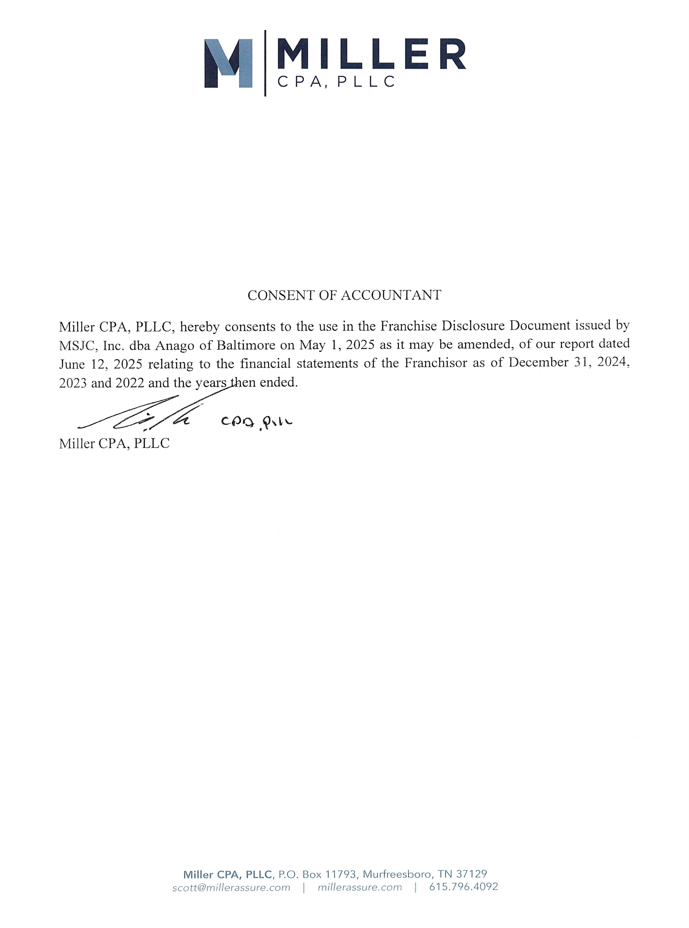

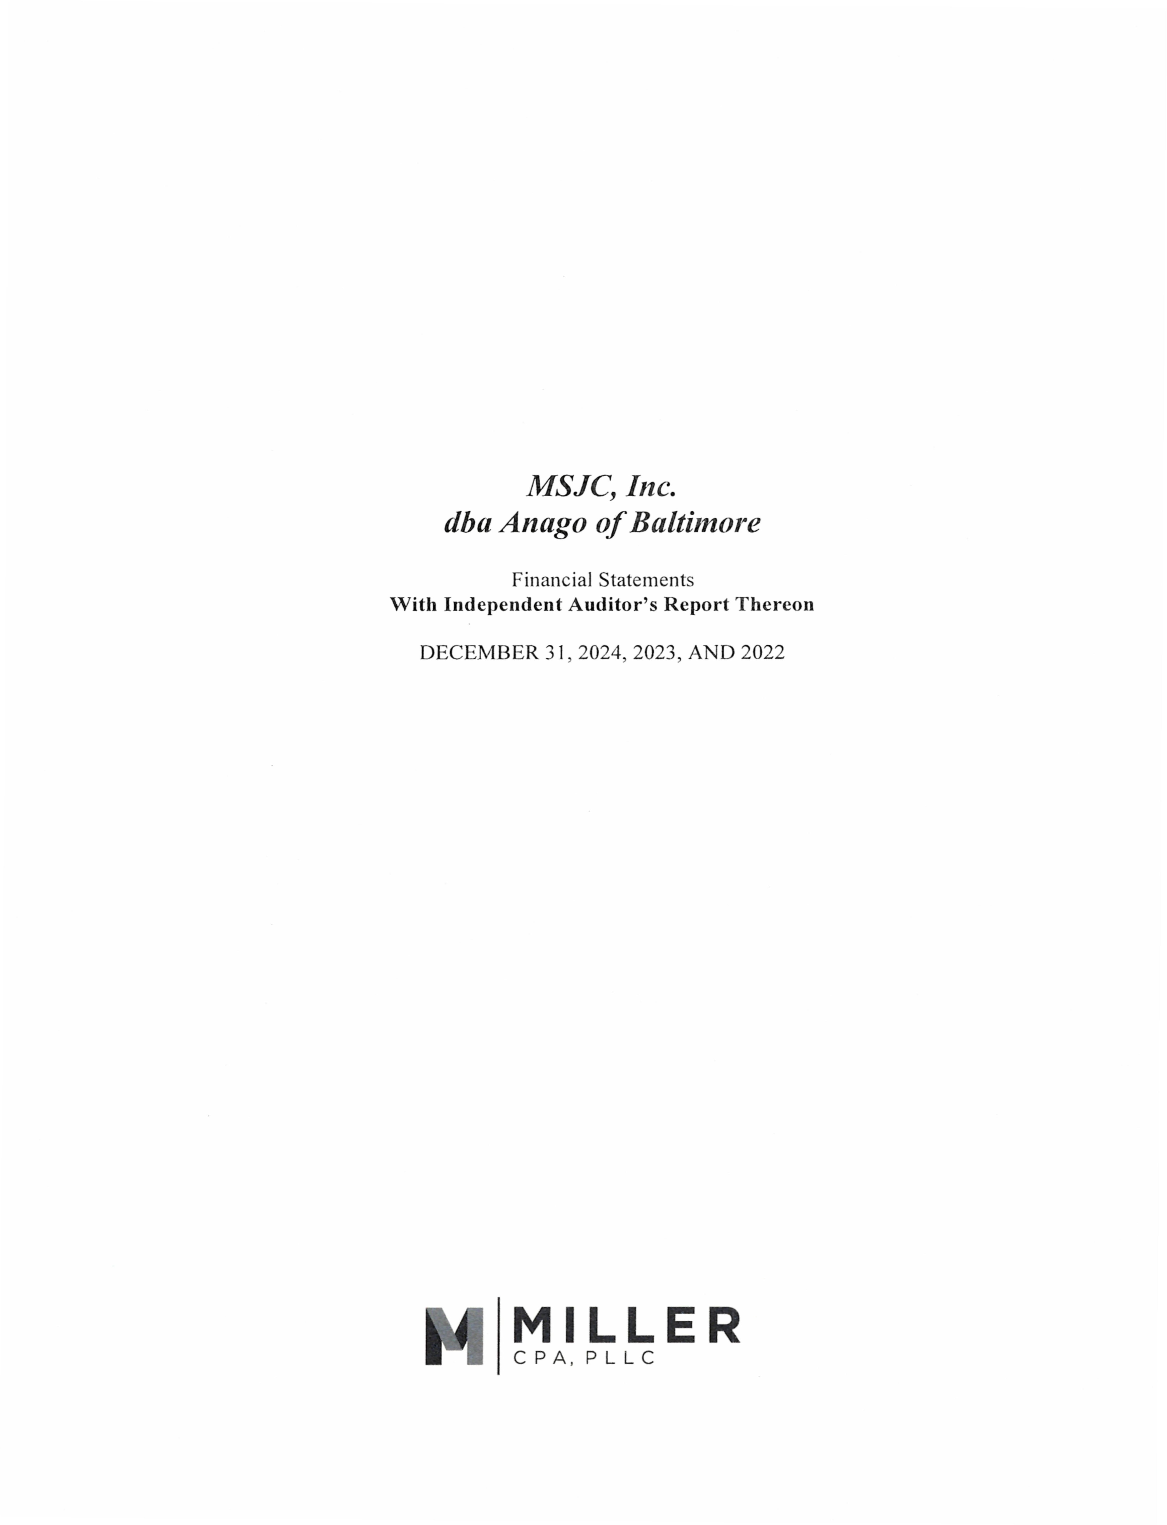

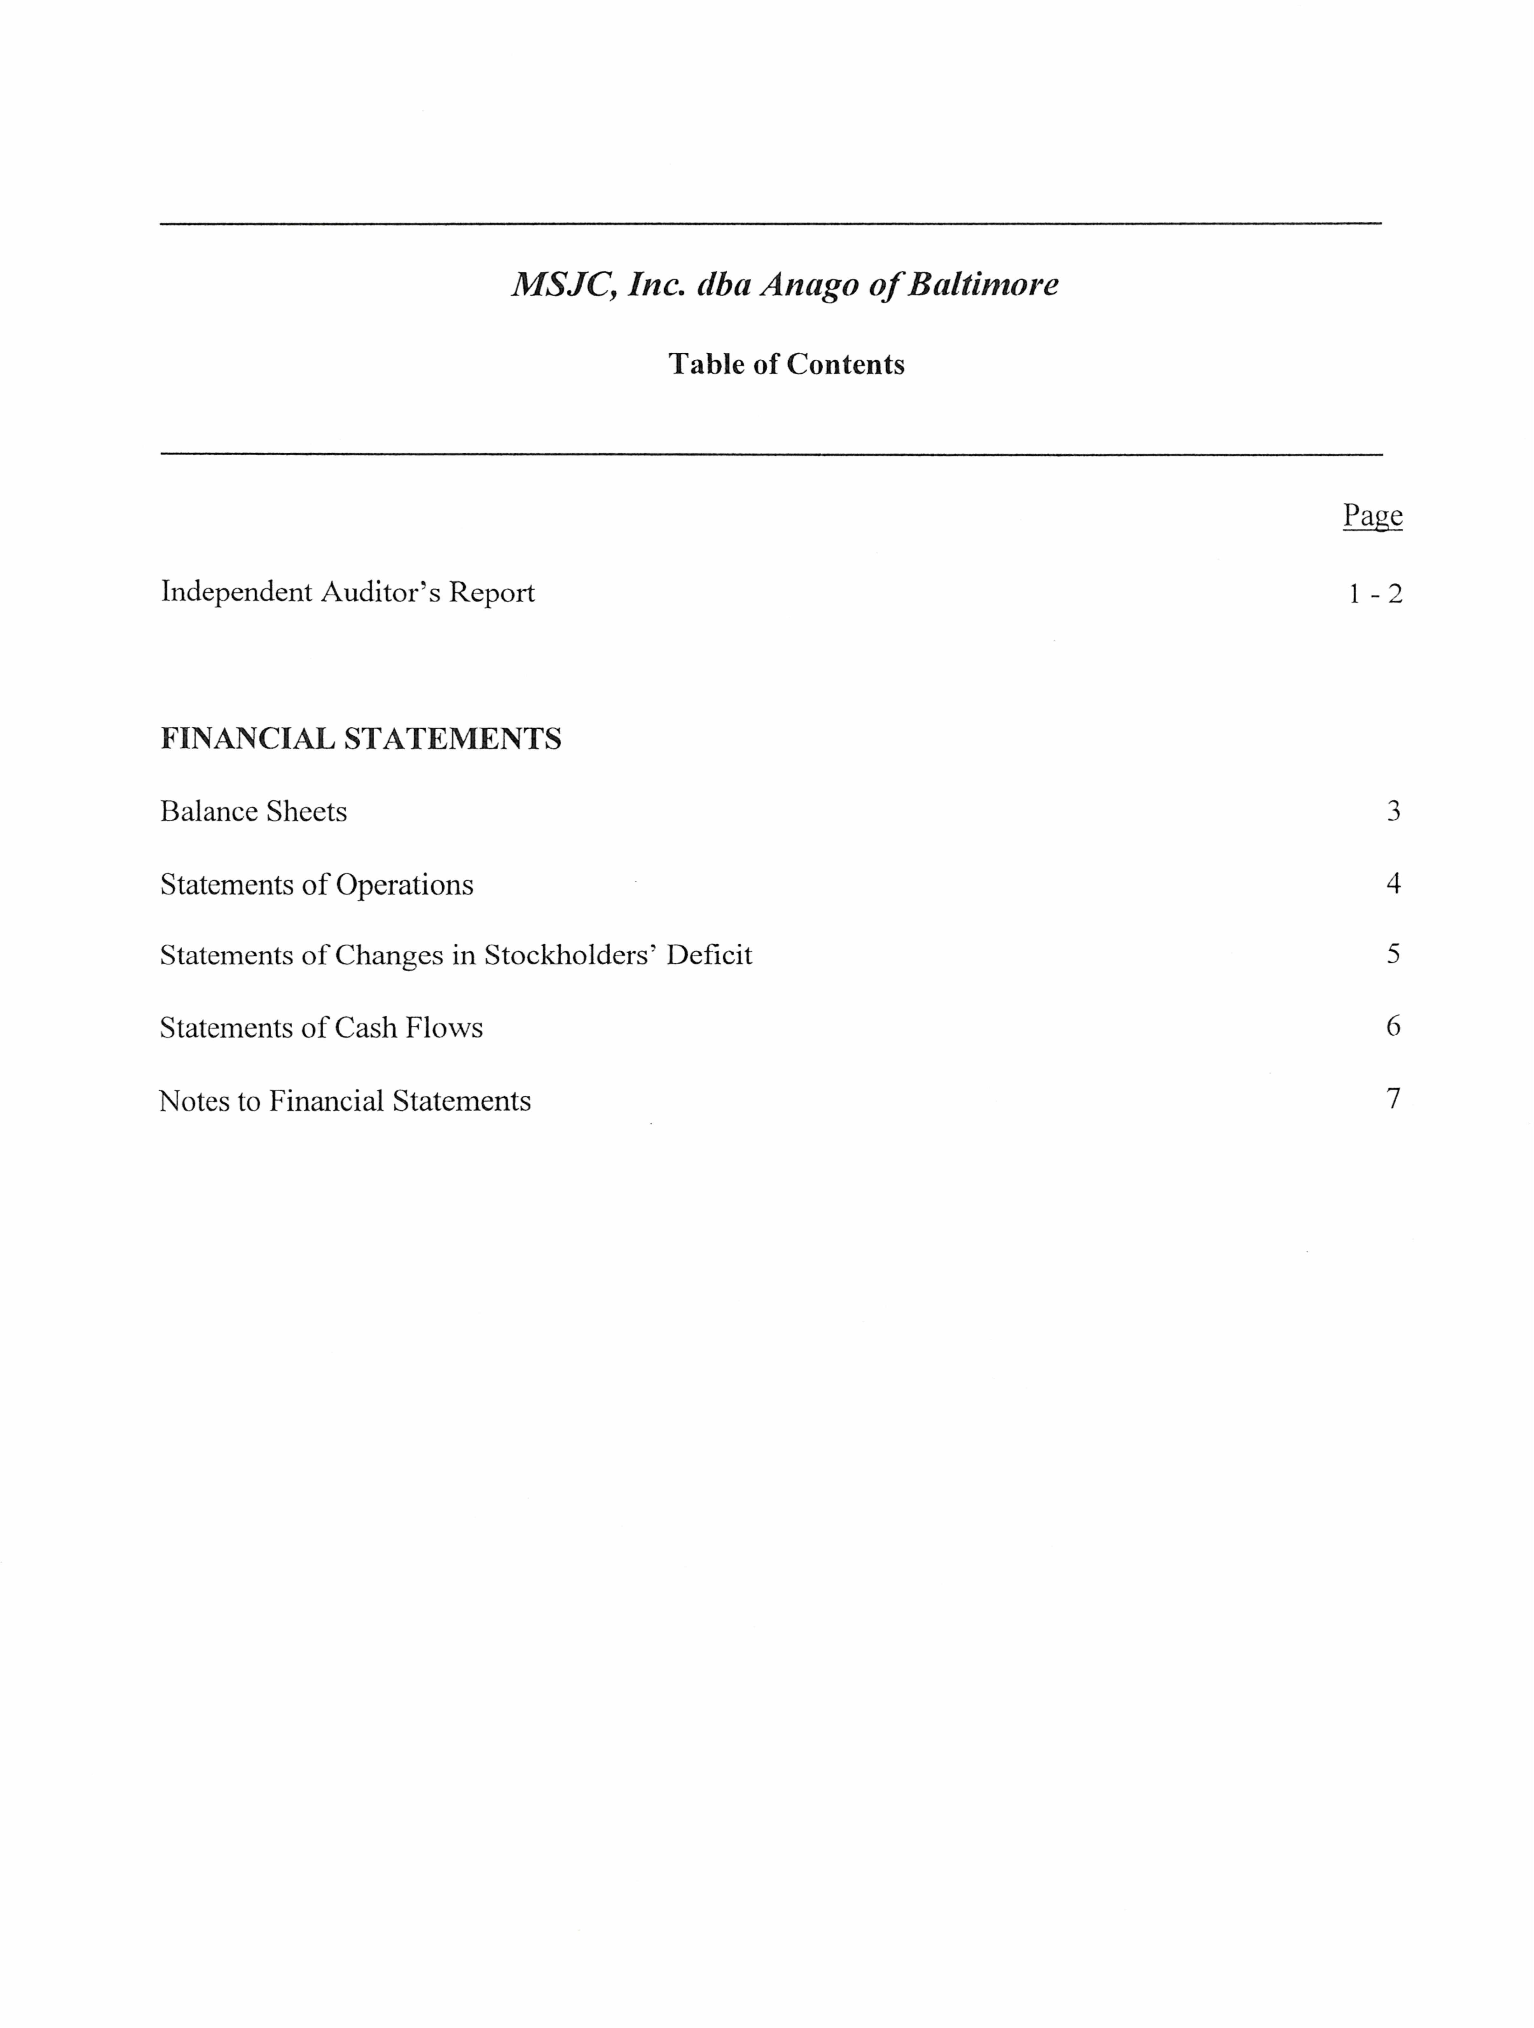

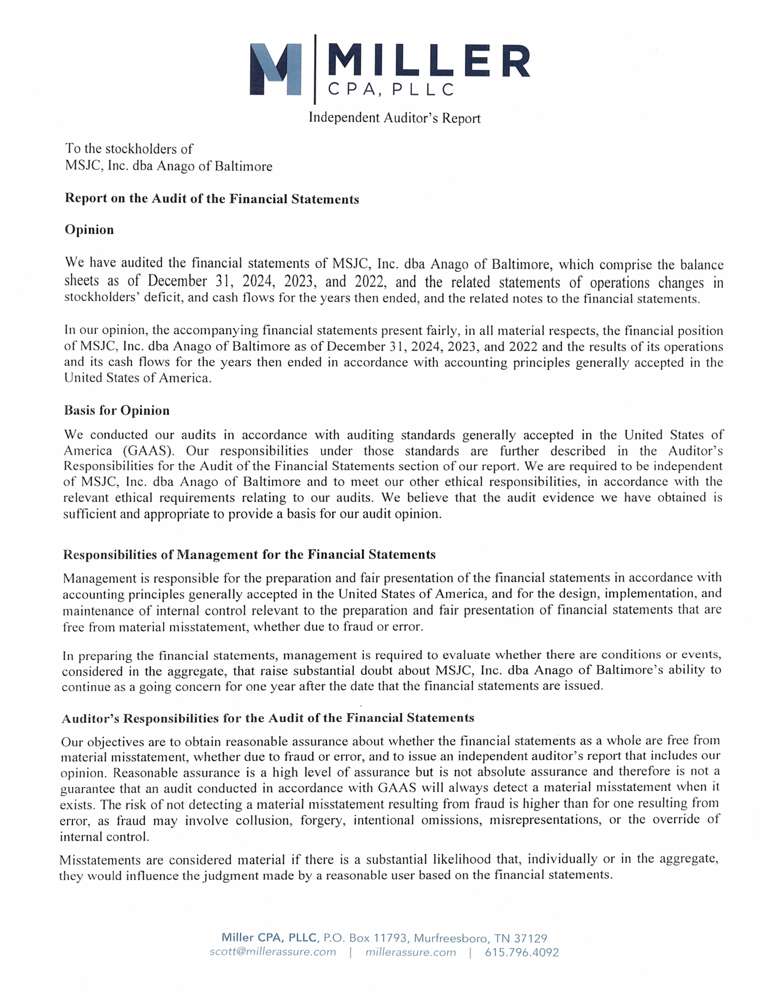

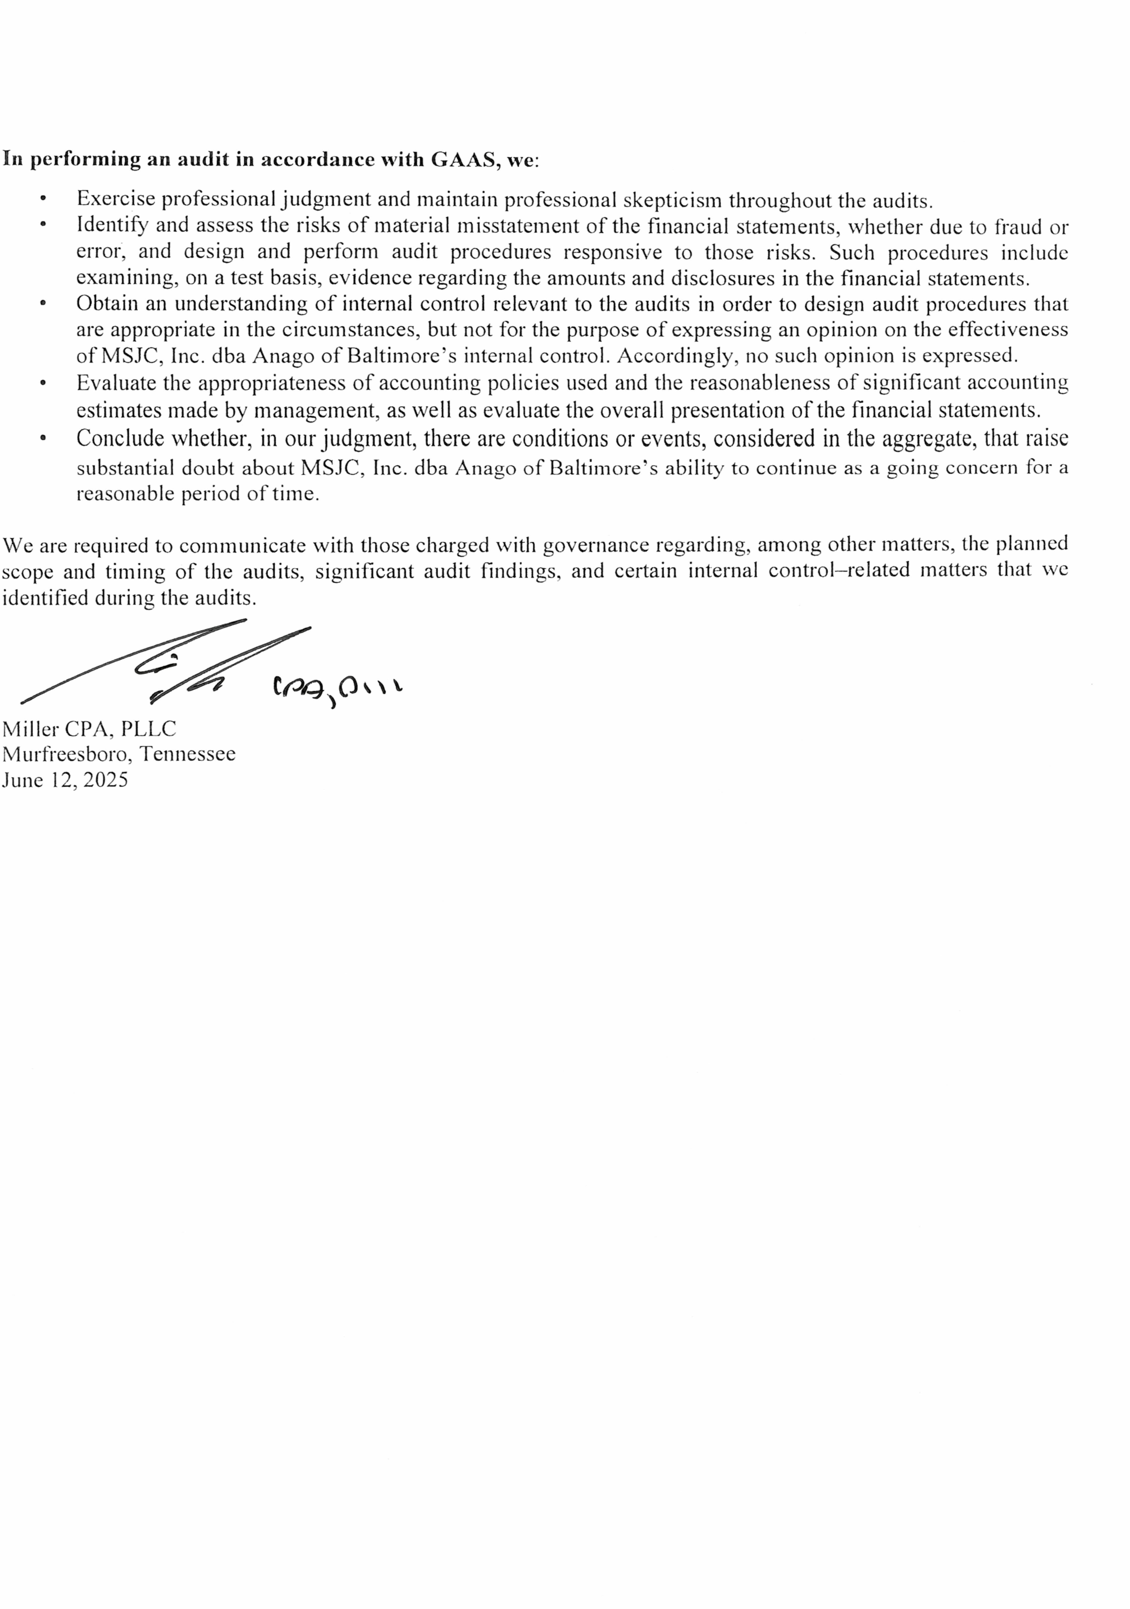

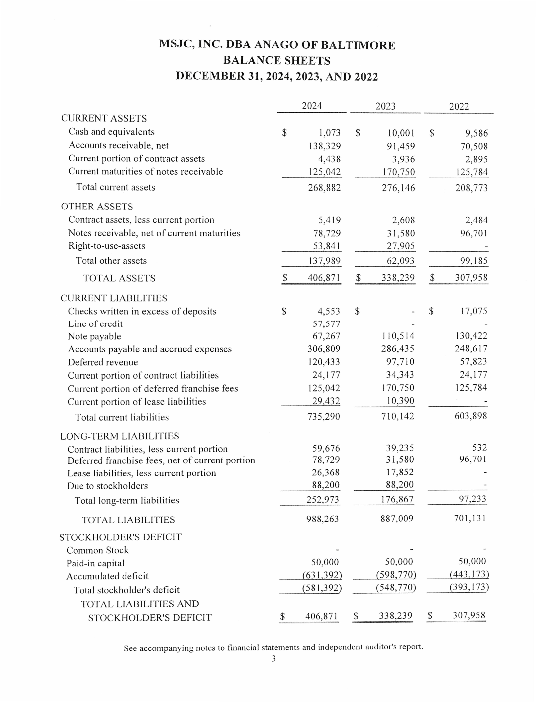

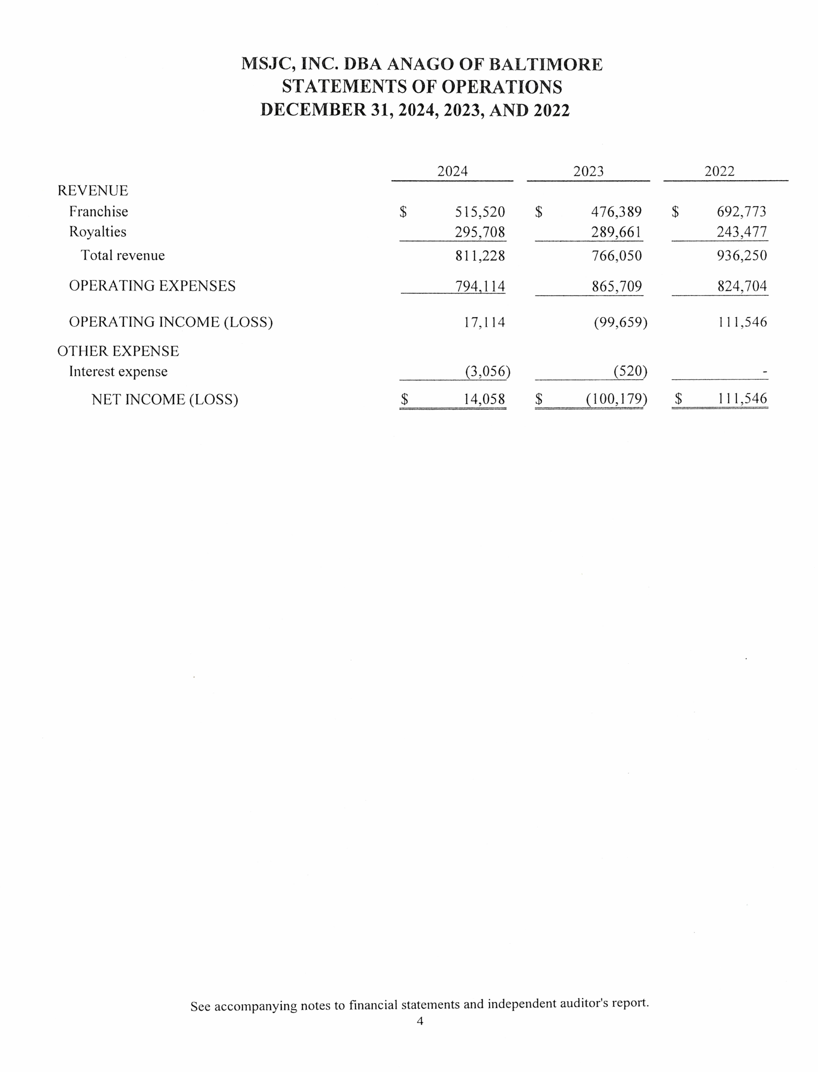

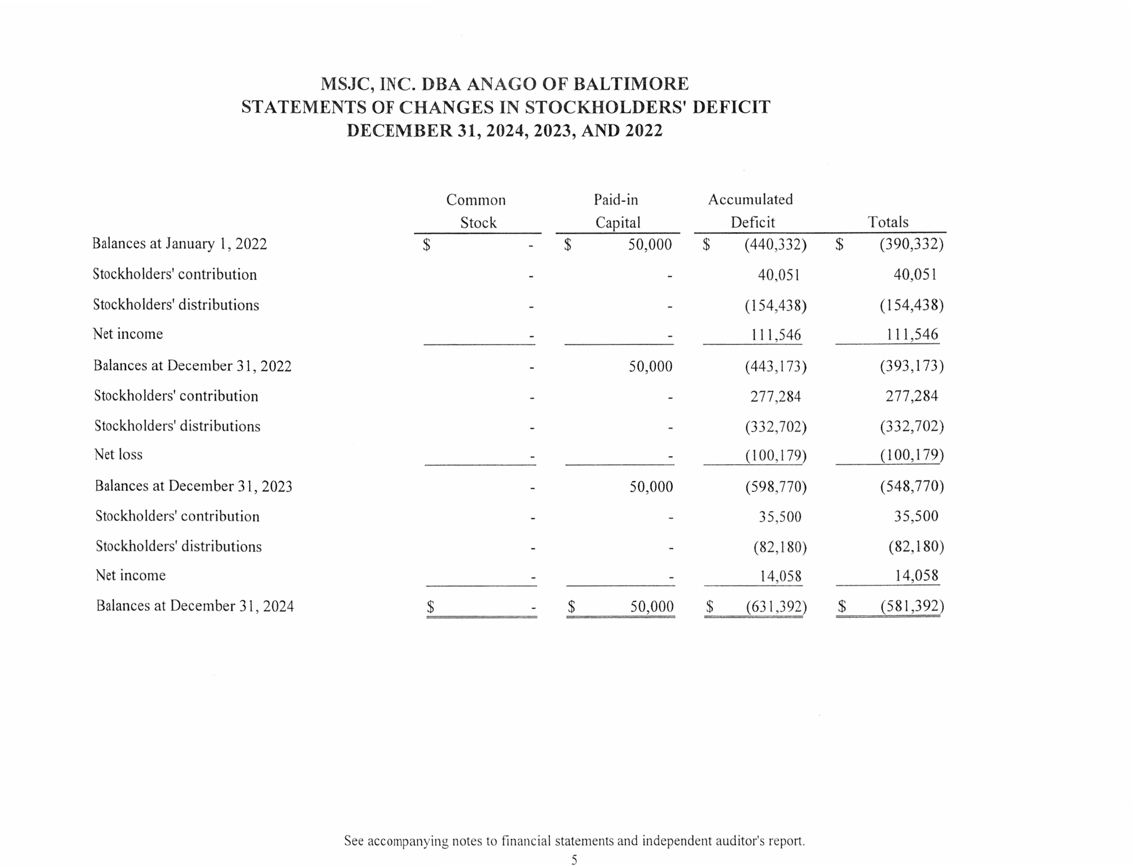

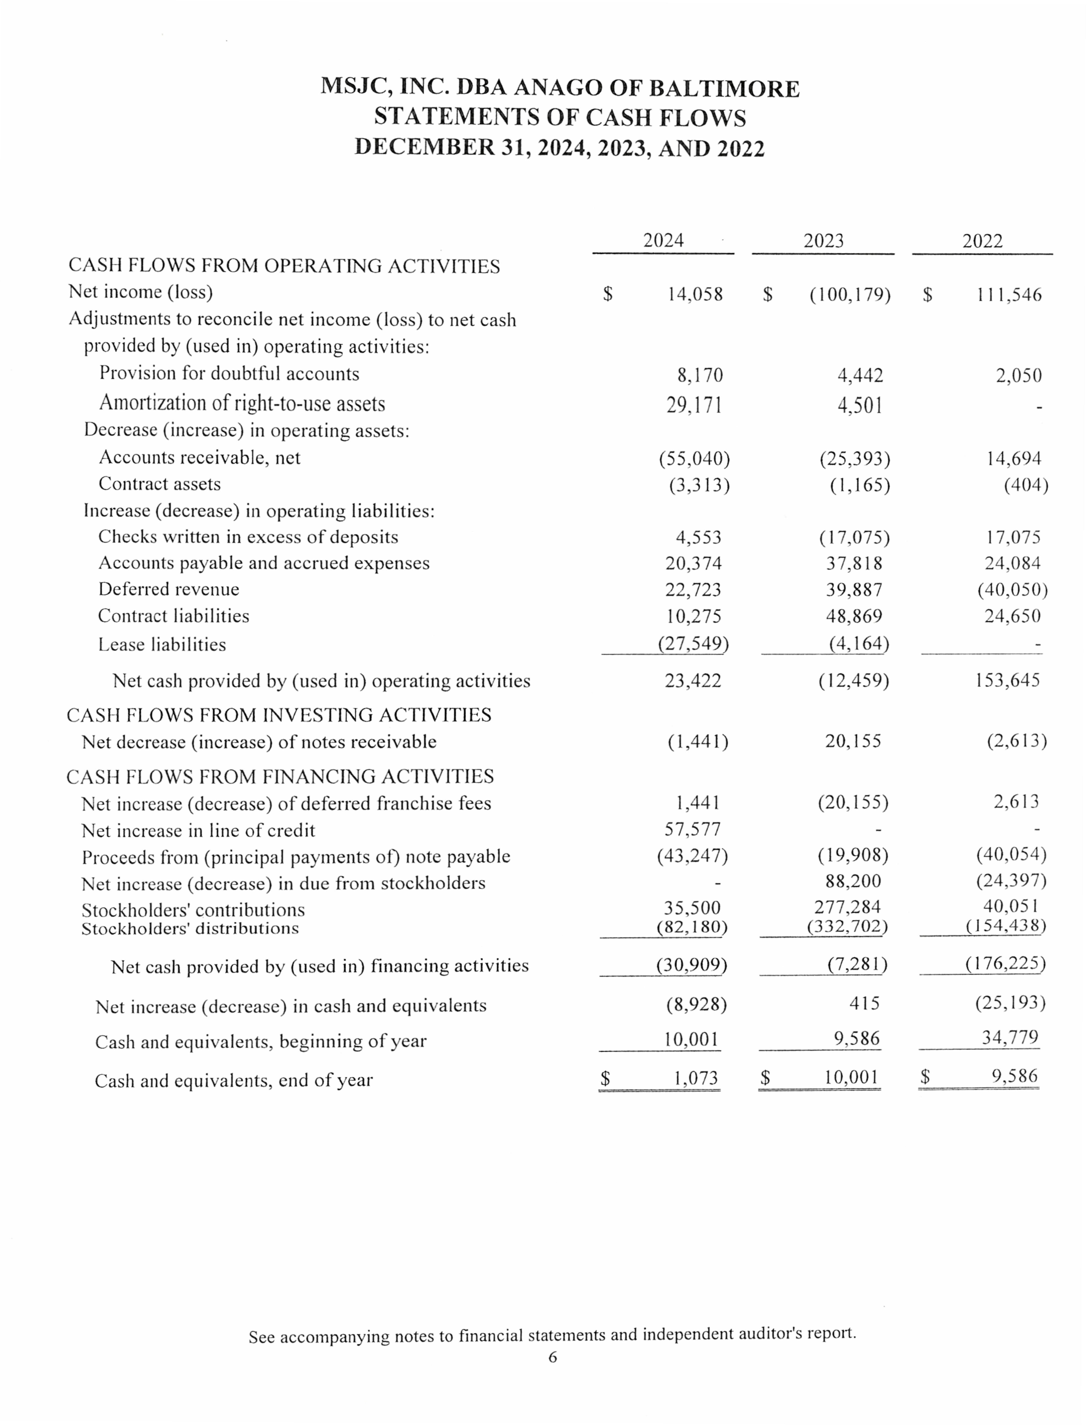

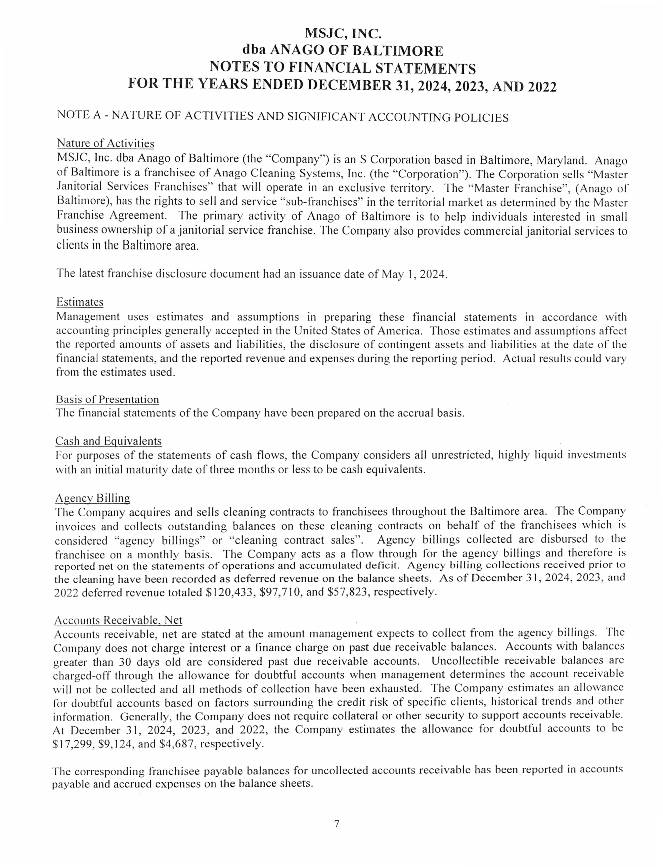

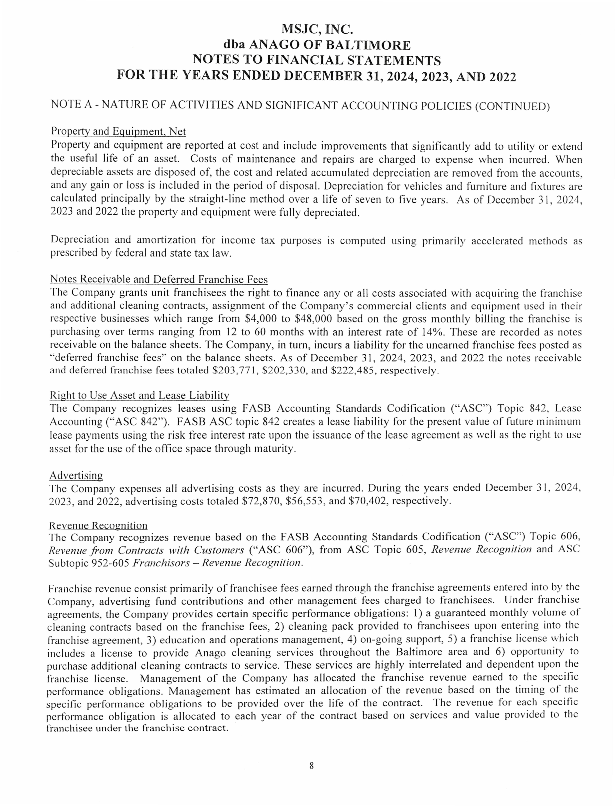

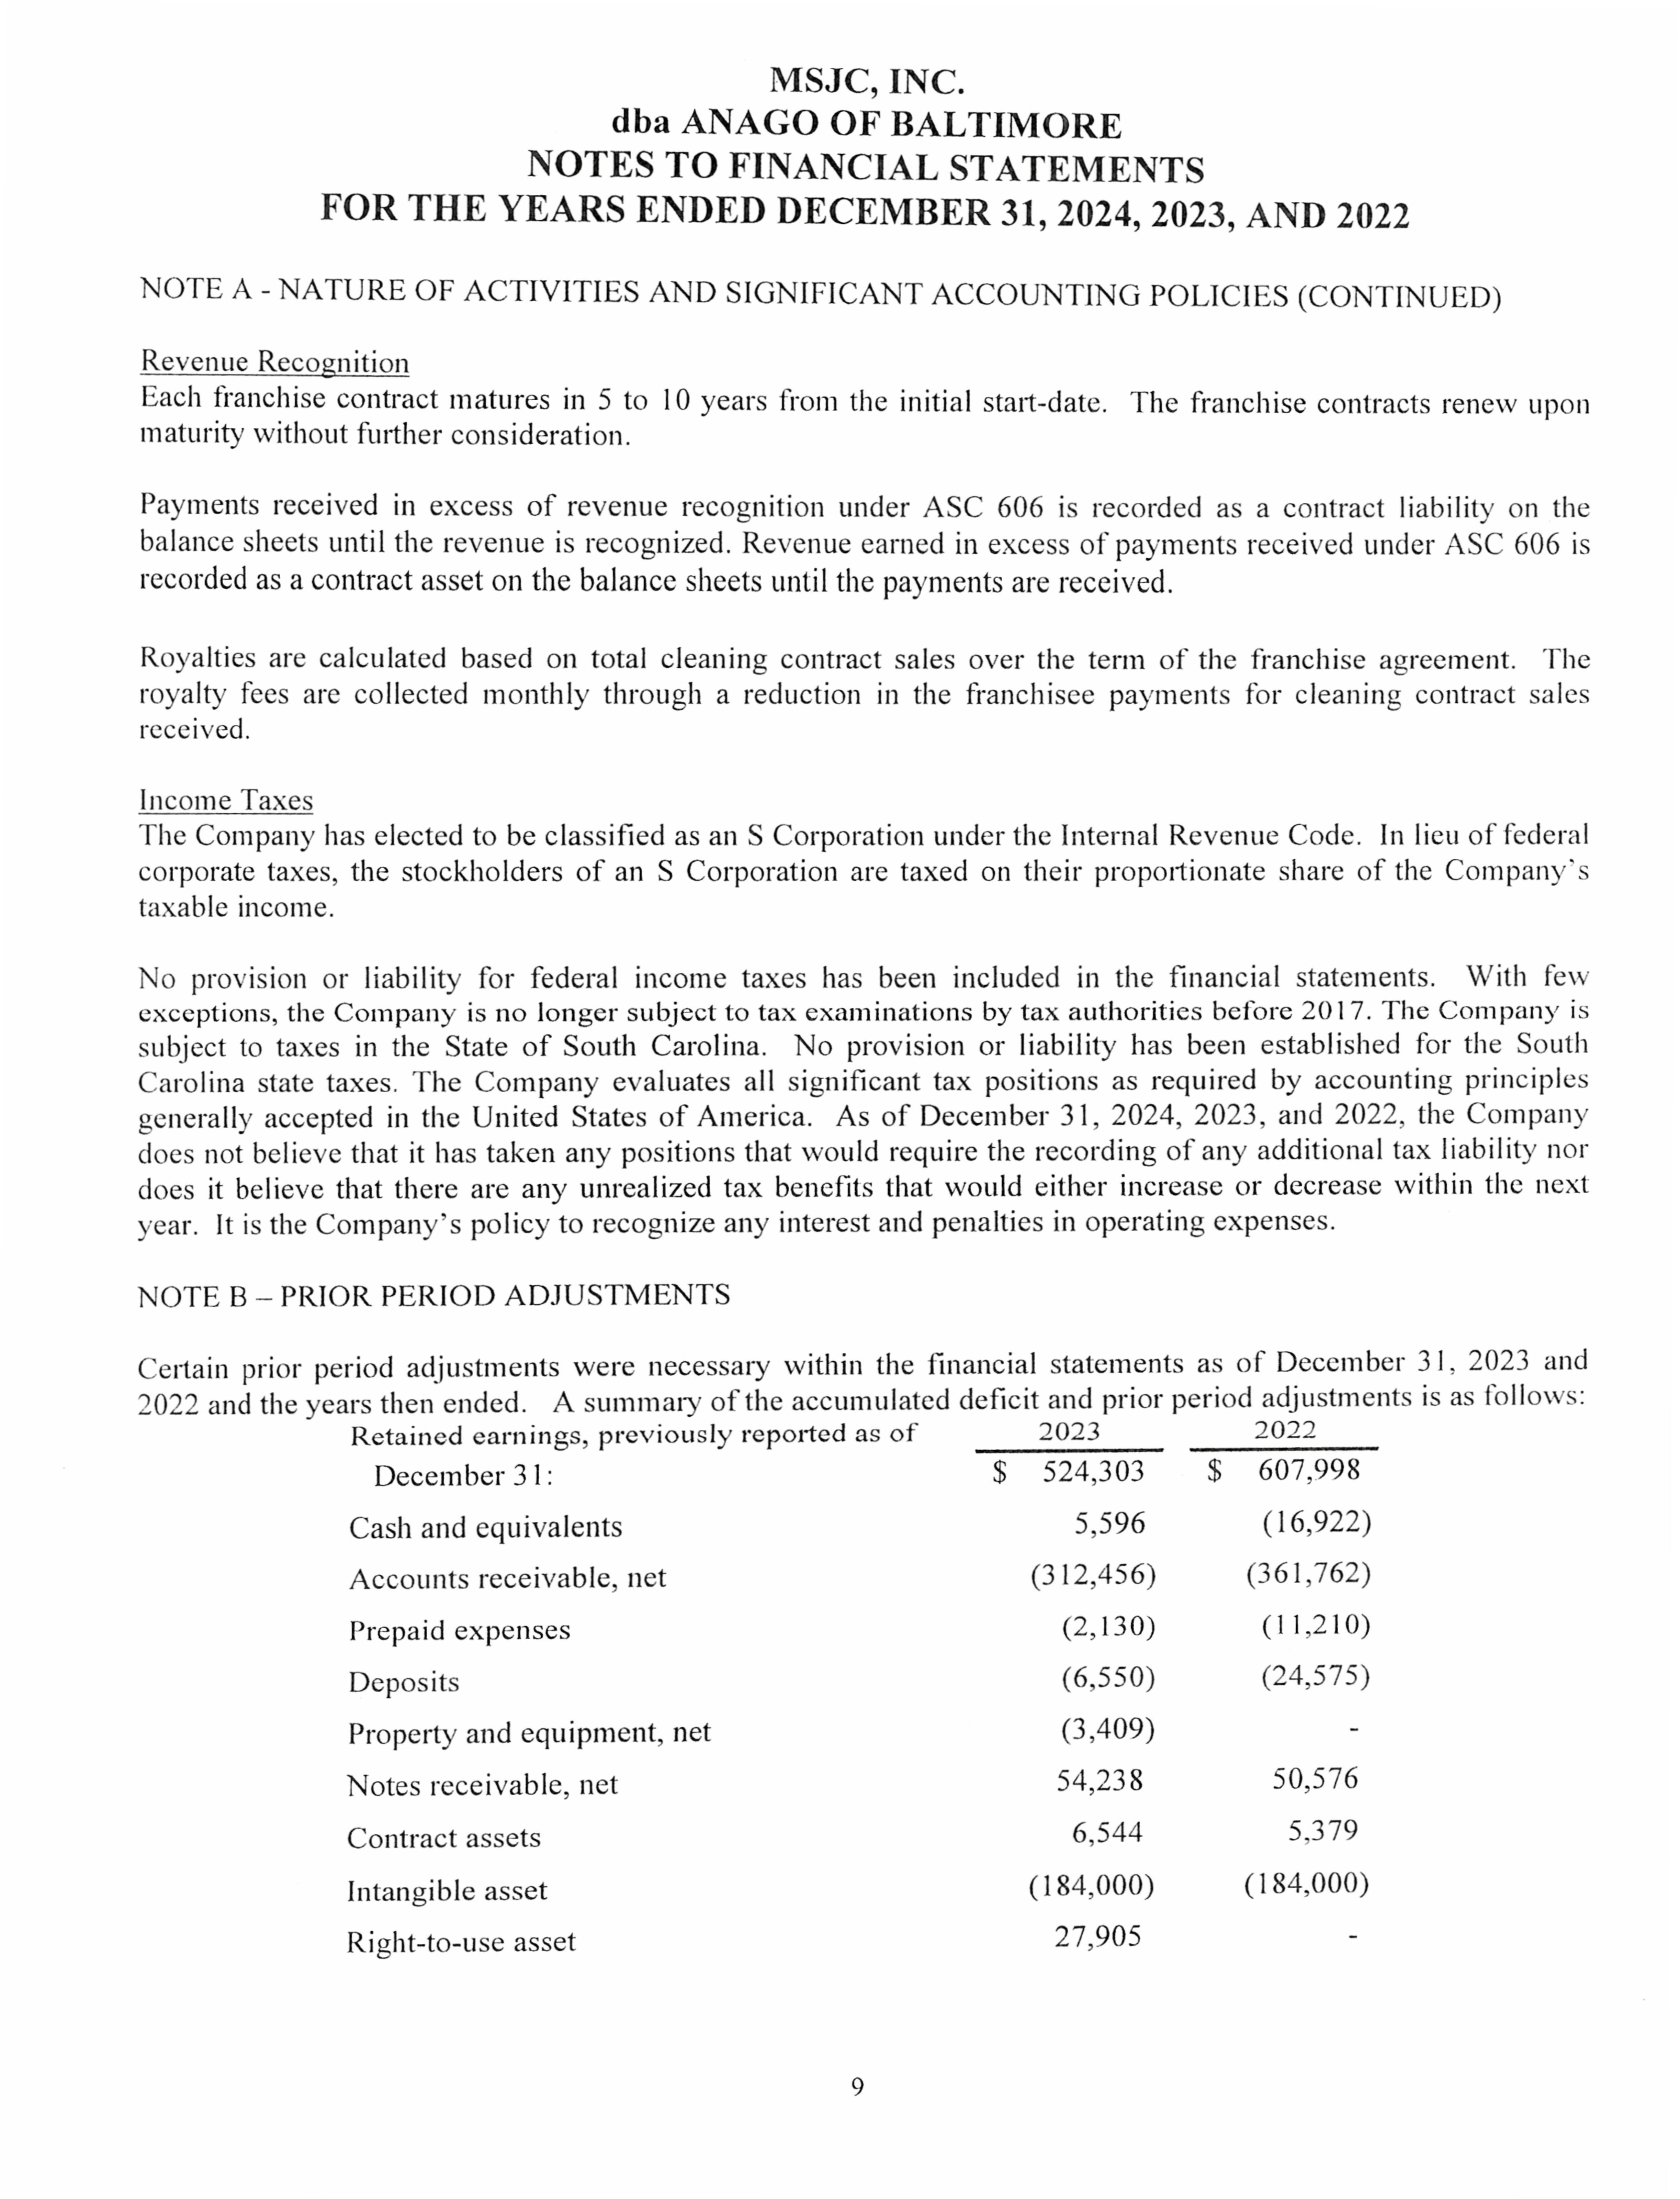

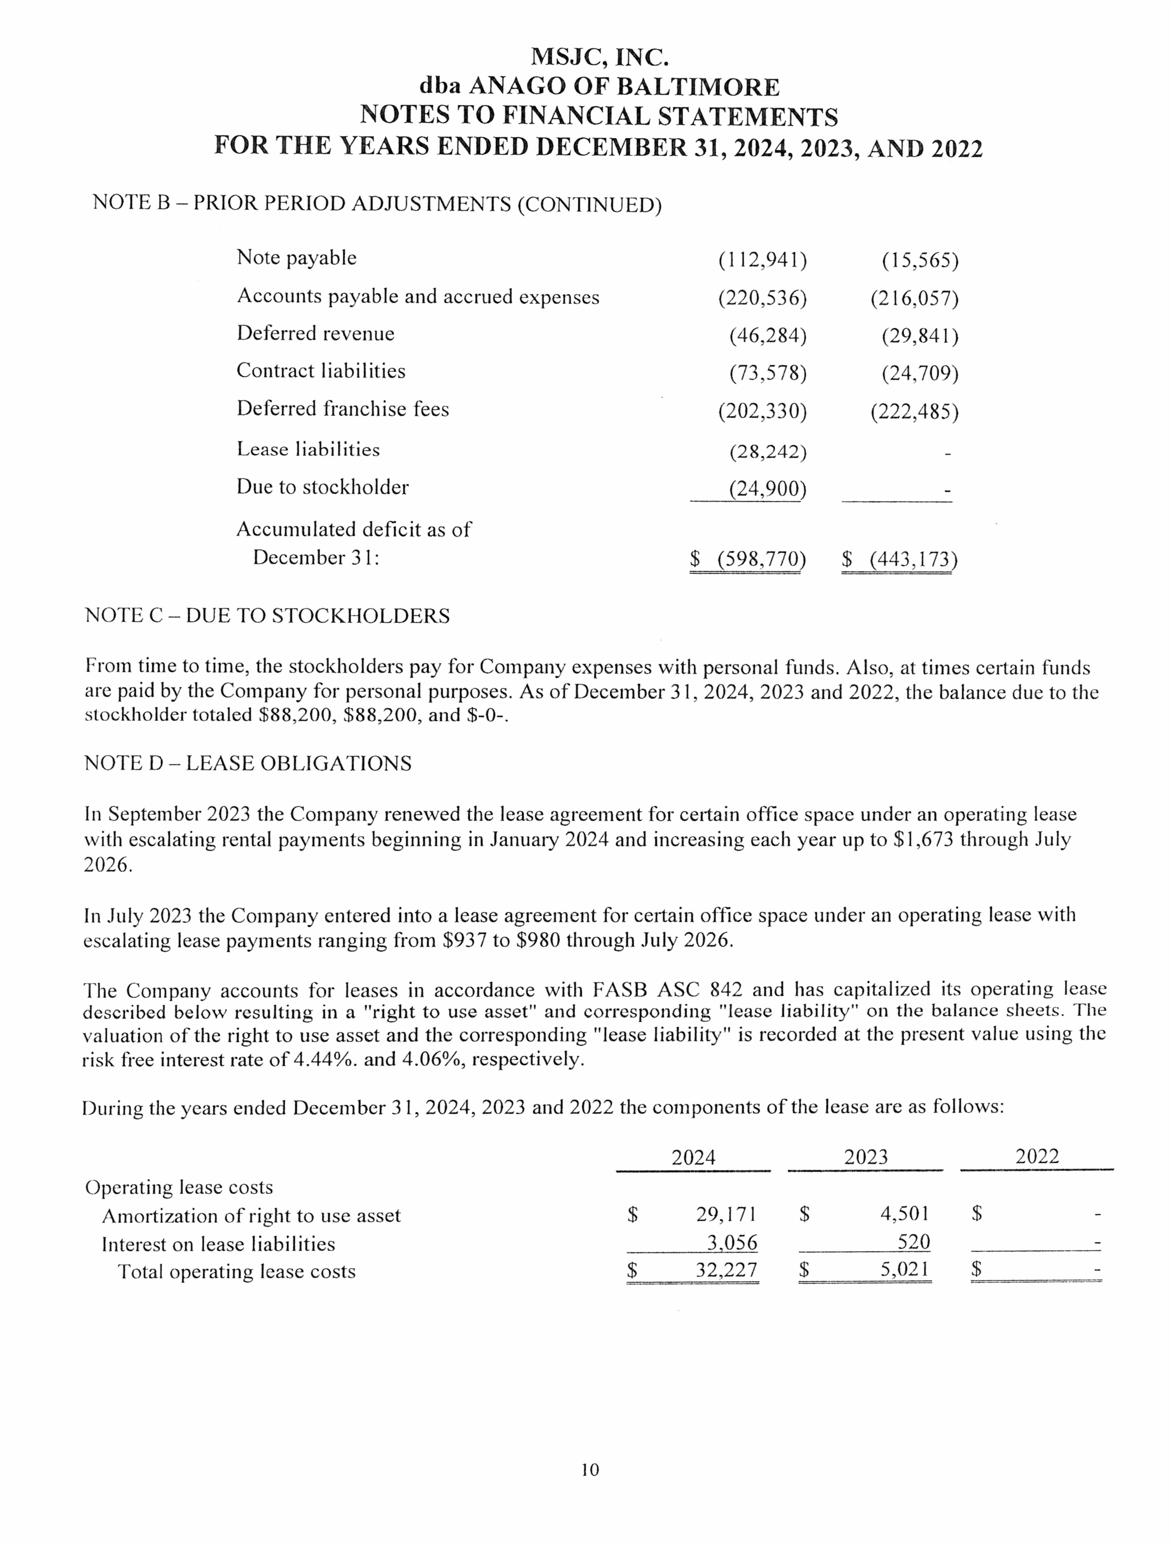

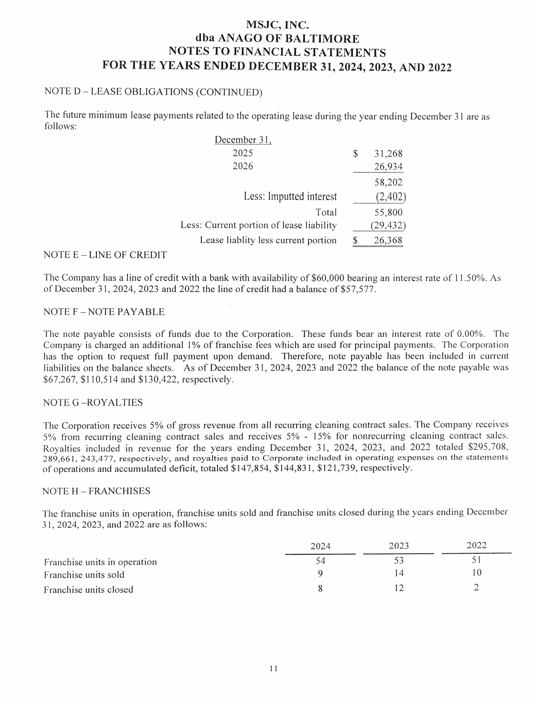

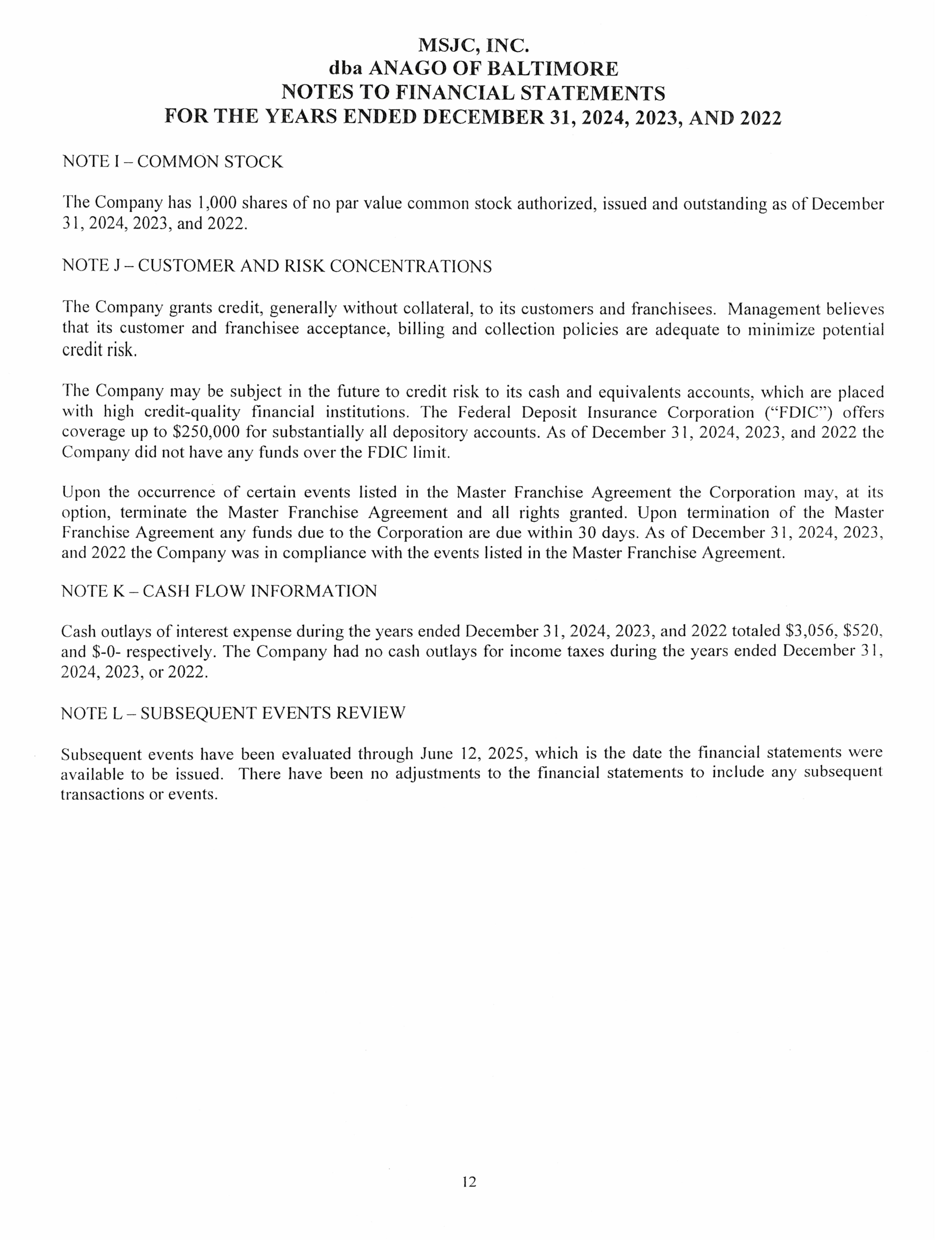

# EXHIBIT E – FINANCIAL STATEMENTS OF ANAGO CLEANING SYSTEMS, INC. AND ANAGO FRANCHISING, INC.

1

FDD - MSJC, Inc. *-* Exhibit E - 2025

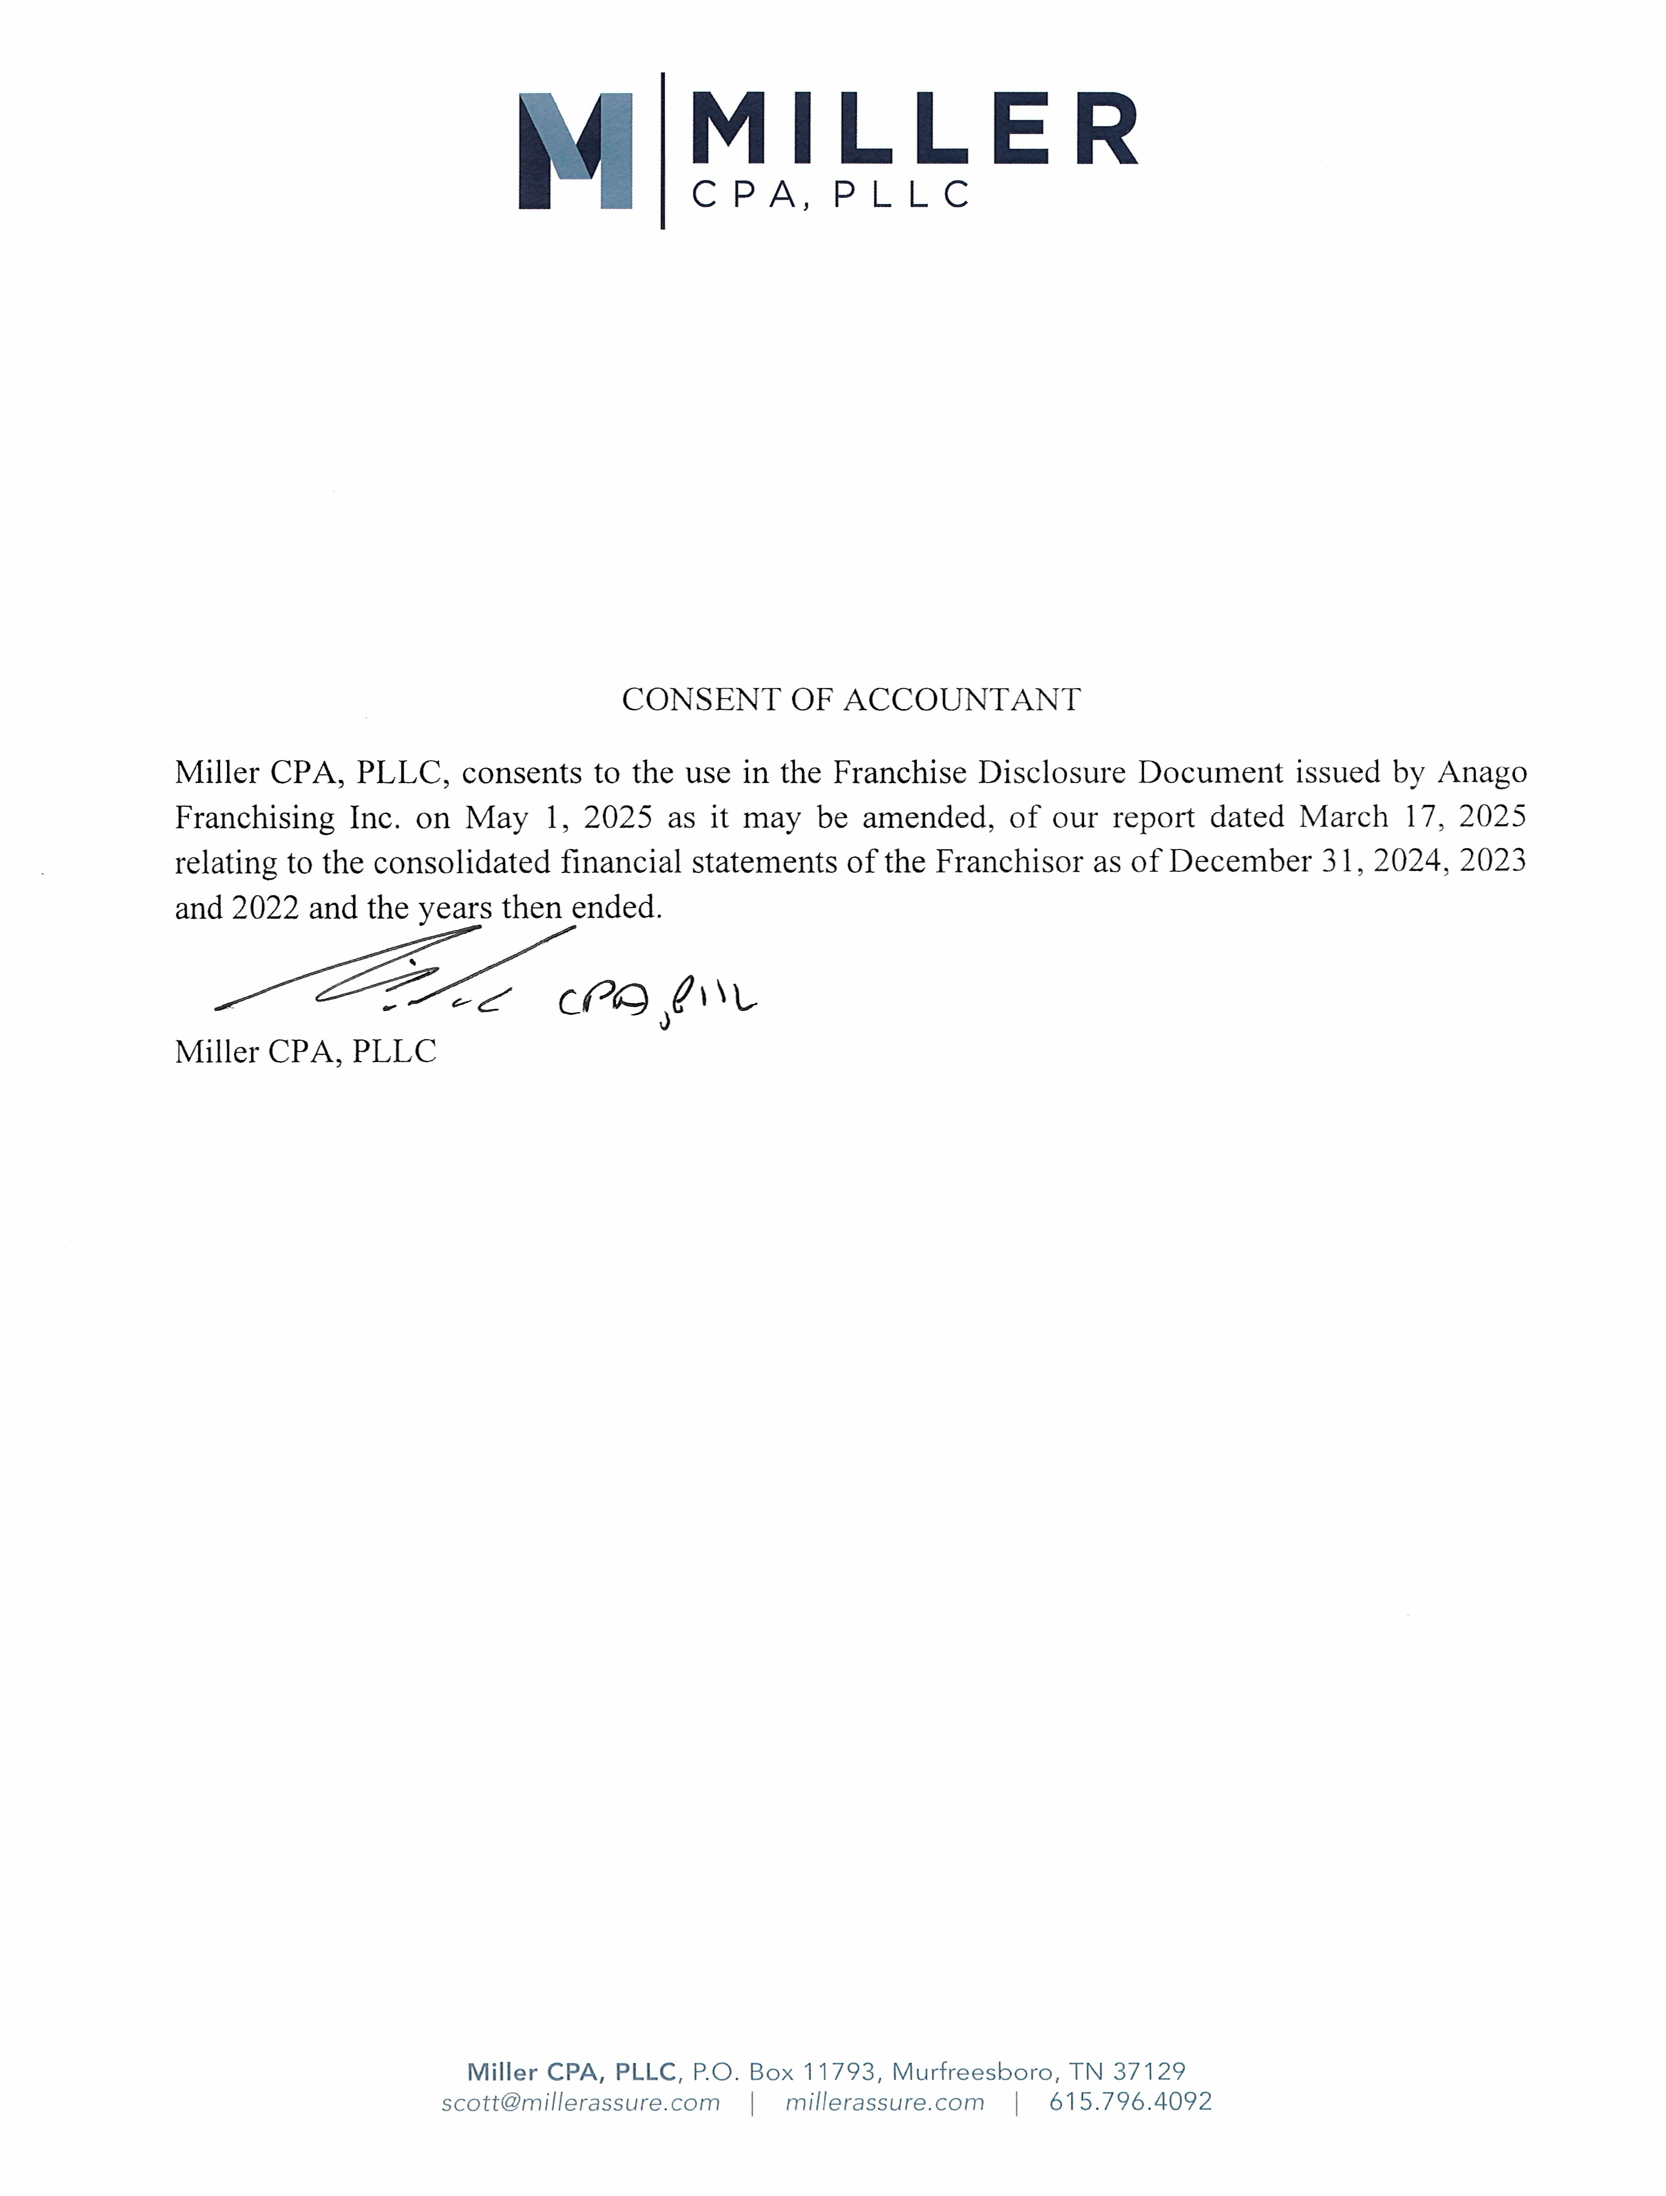

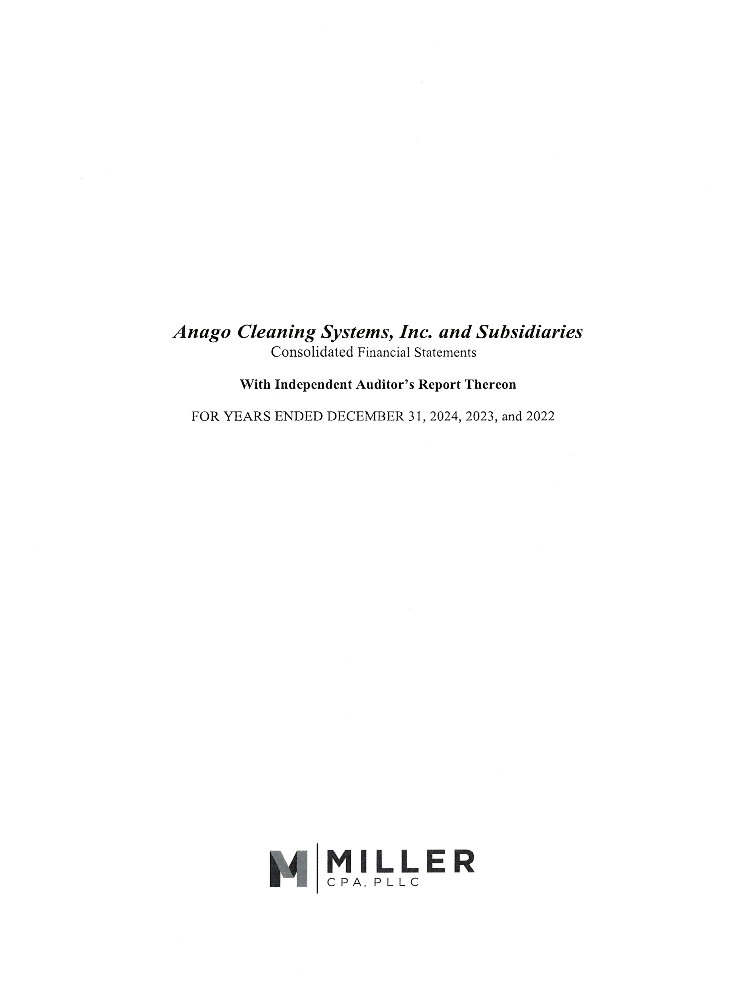

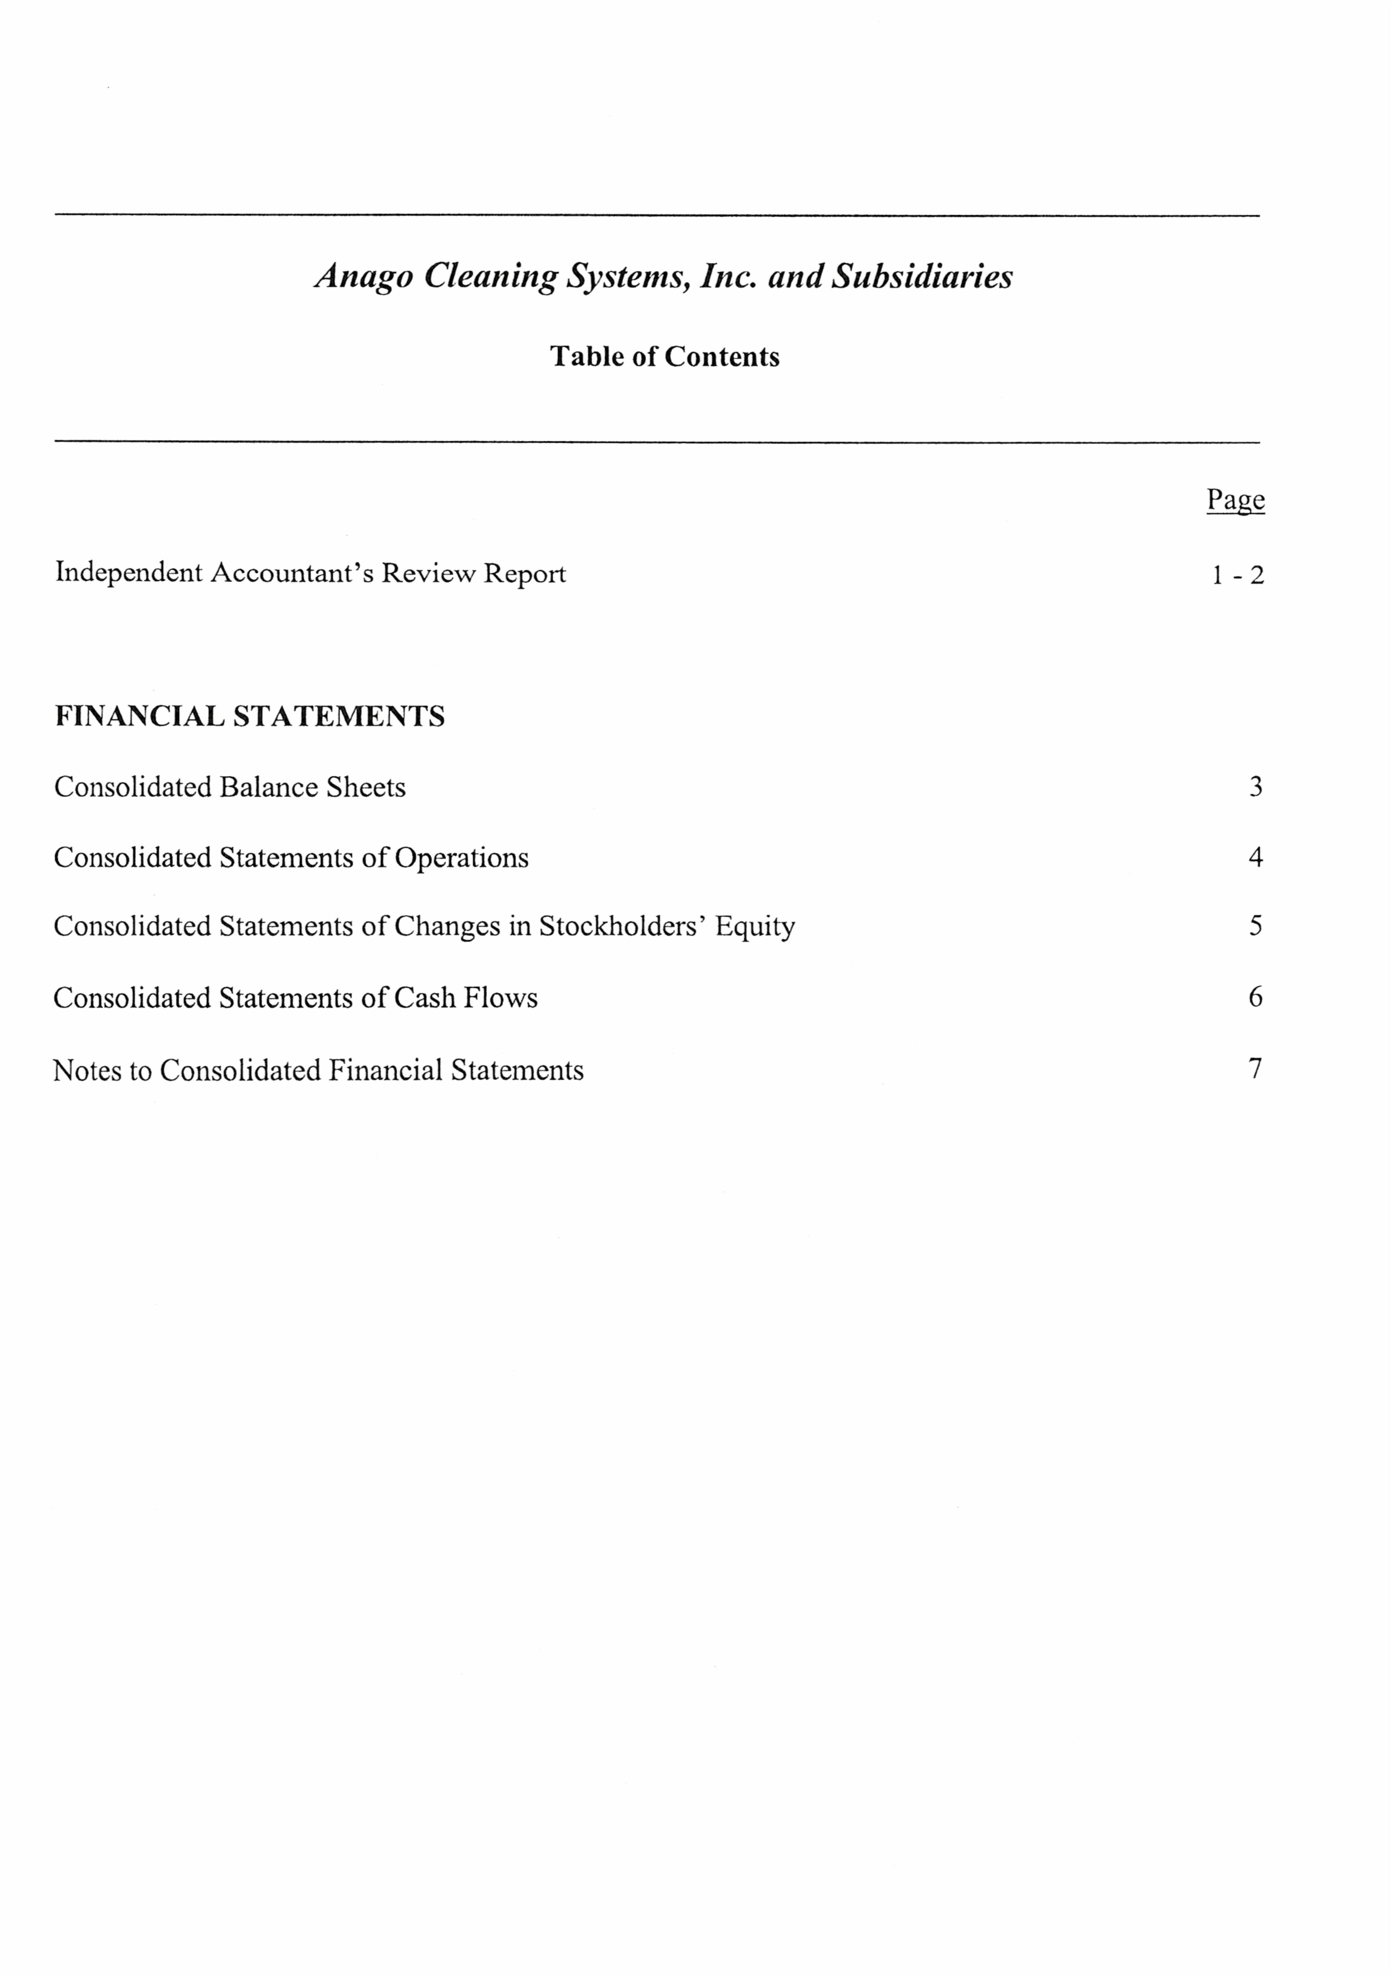

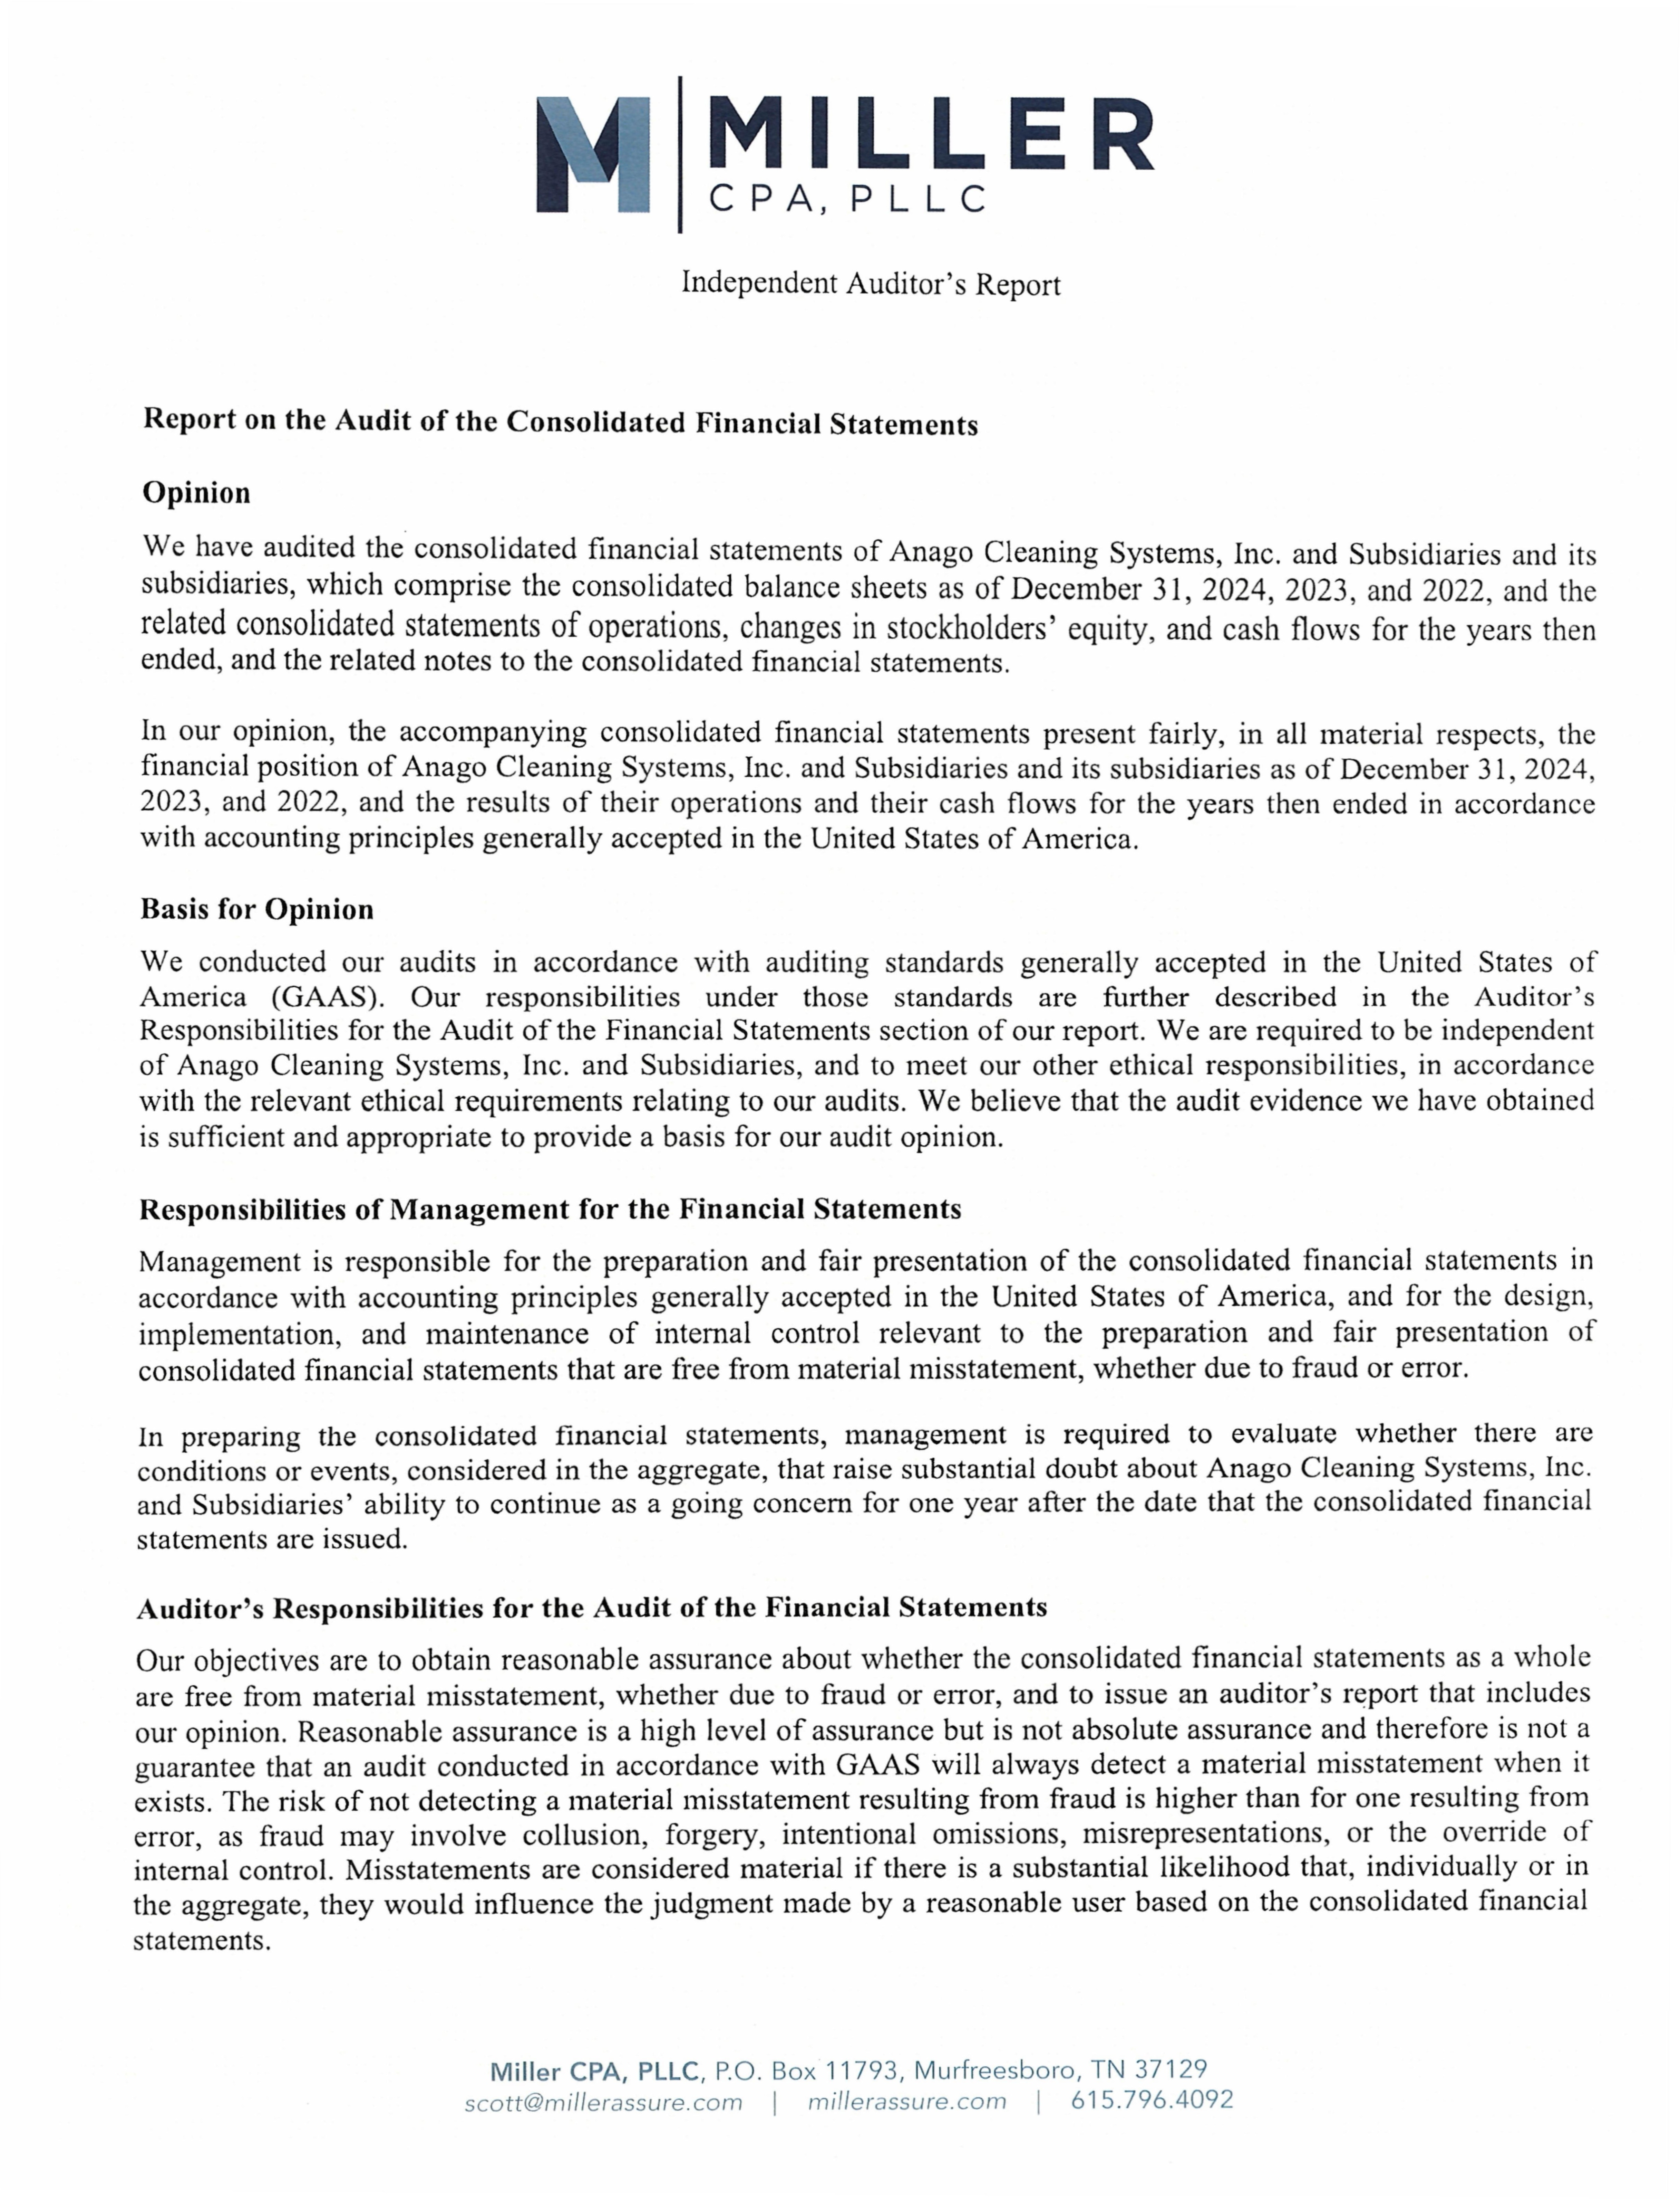

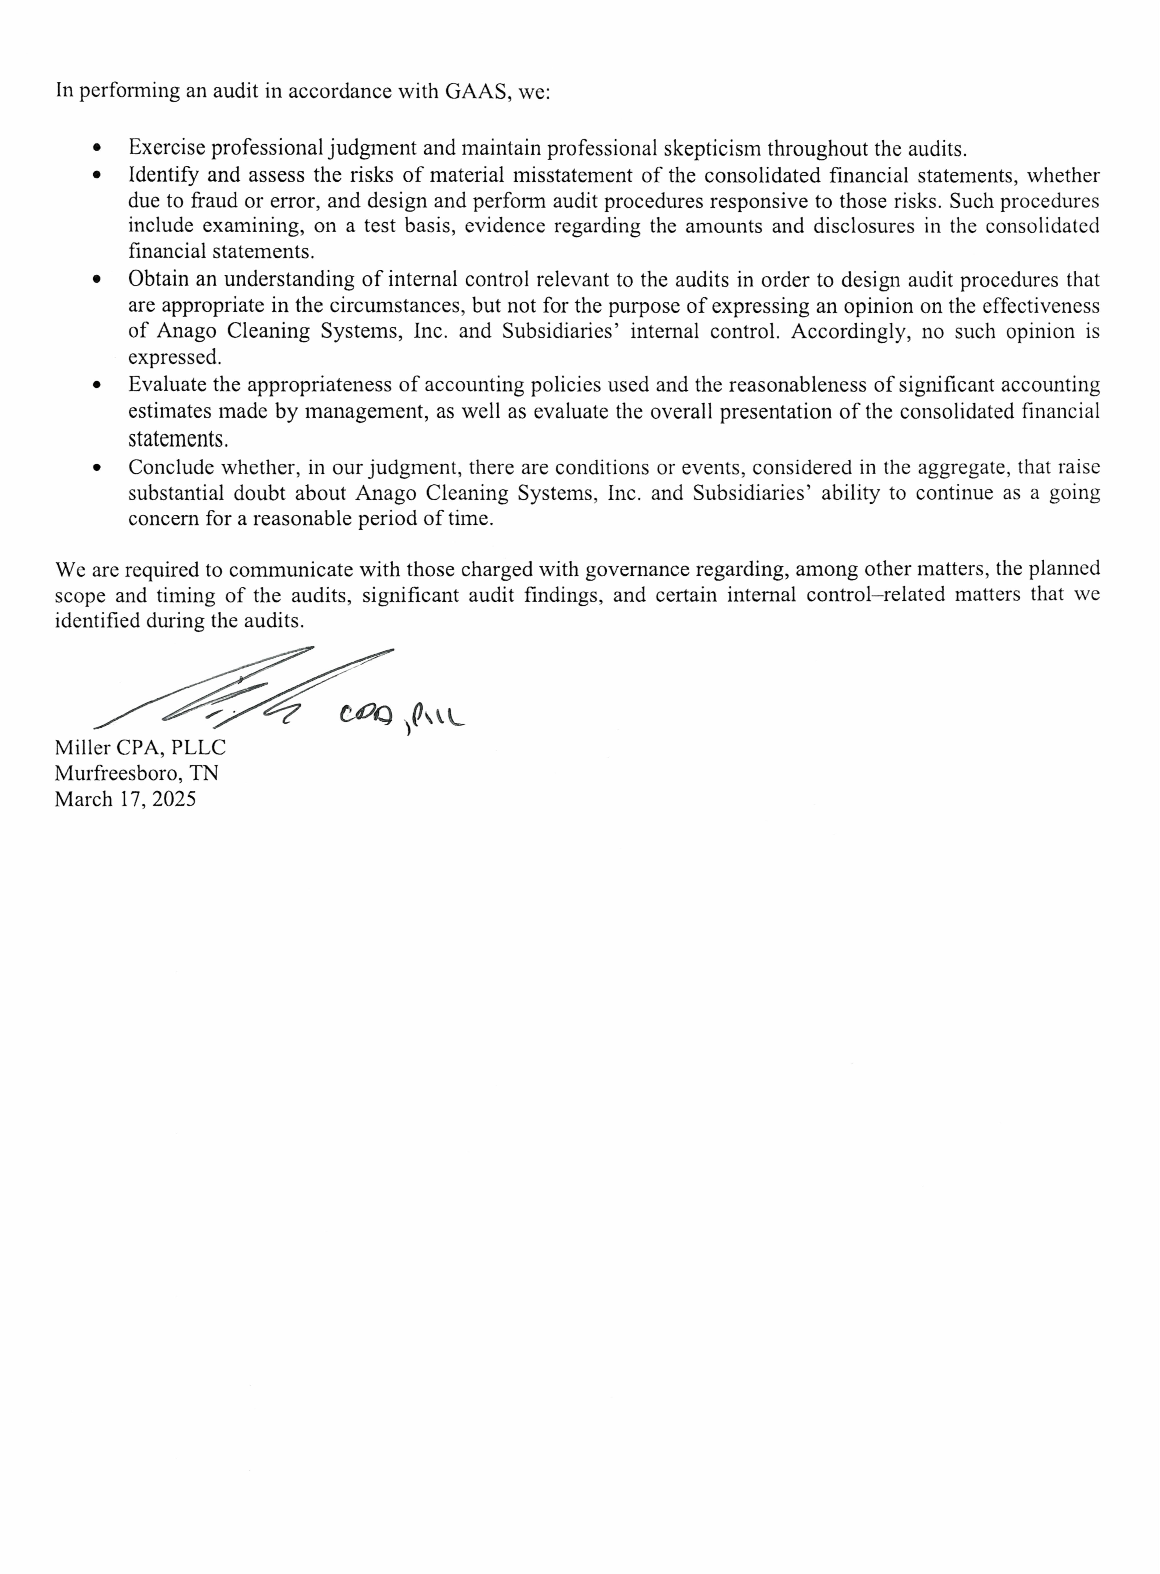

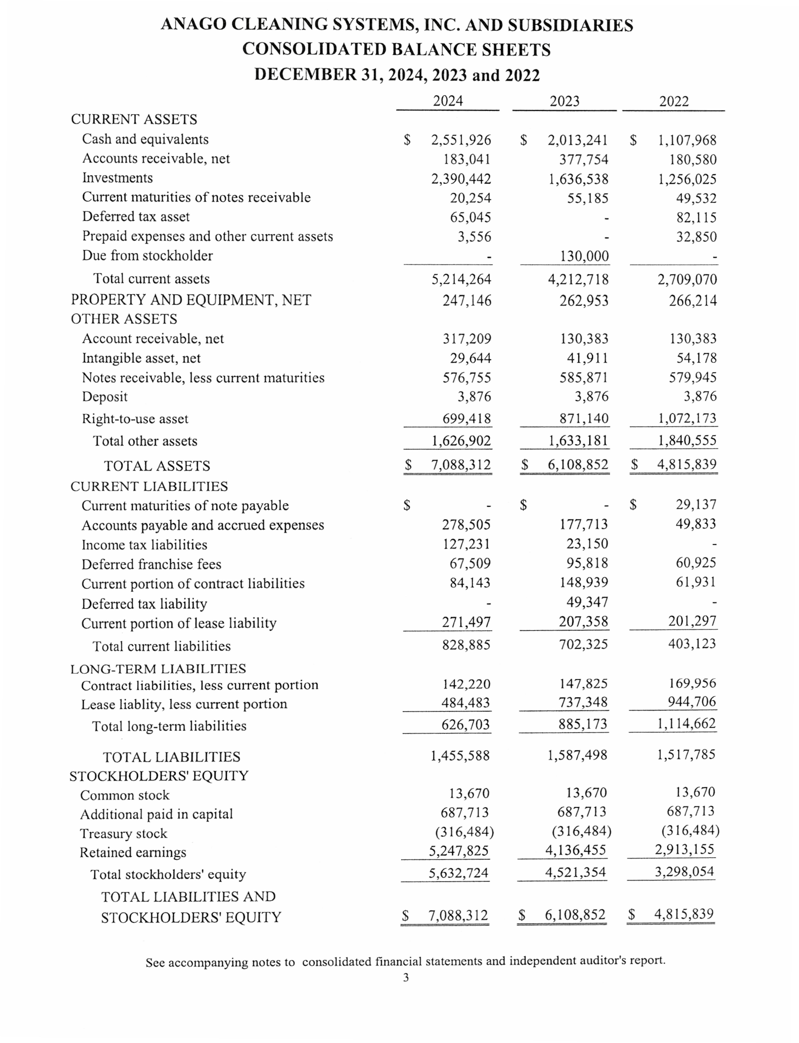

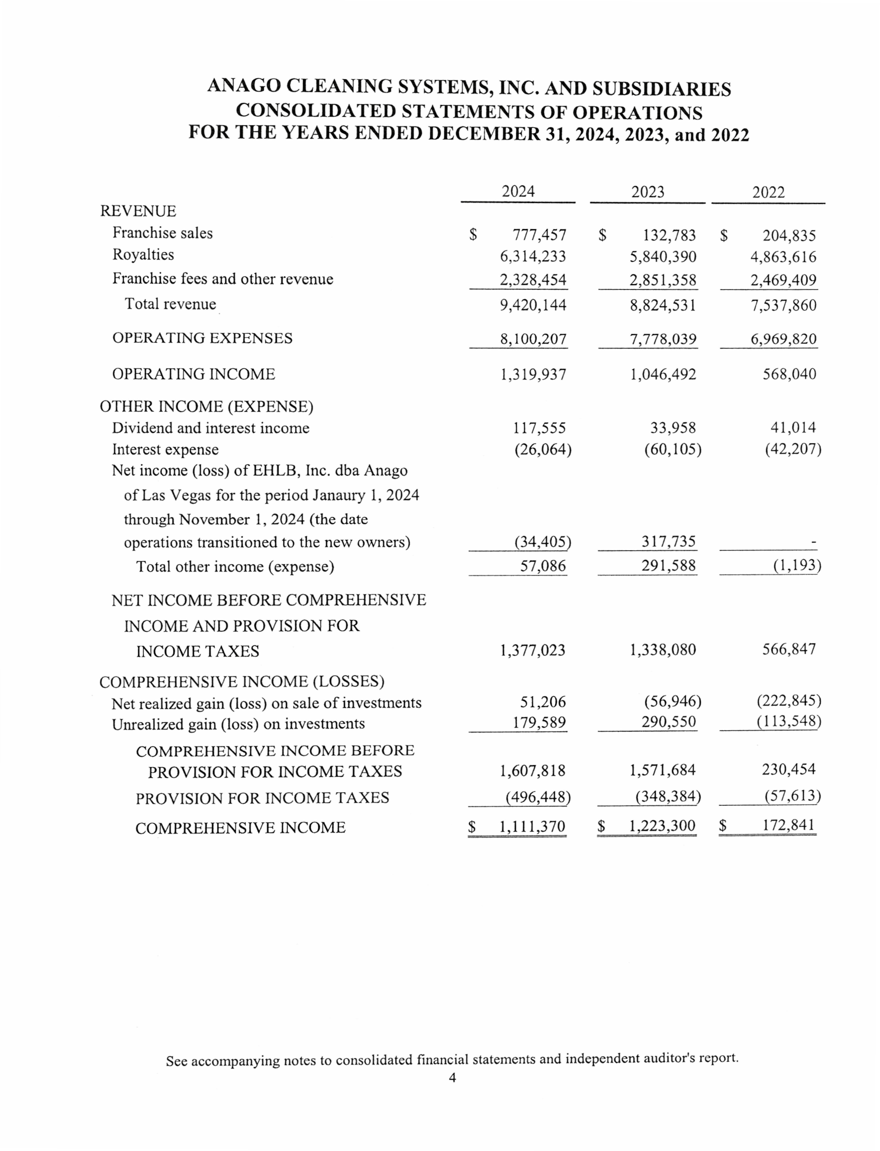

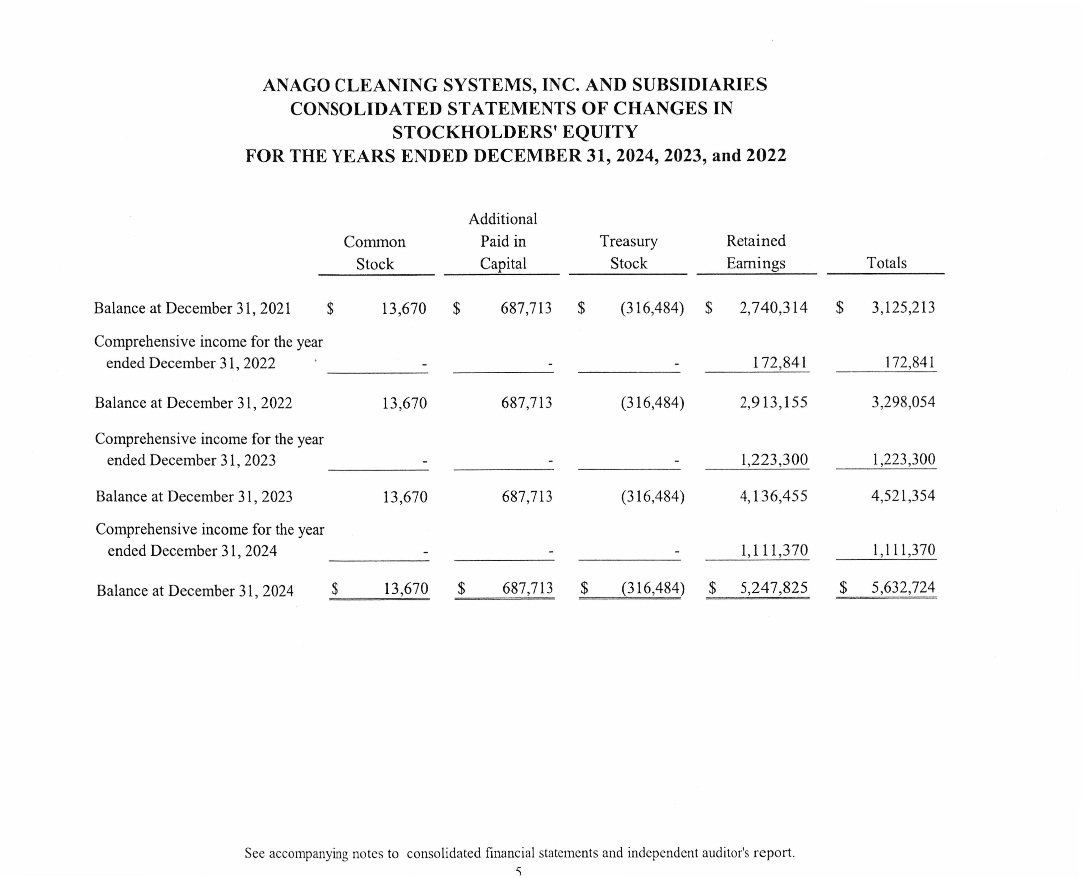

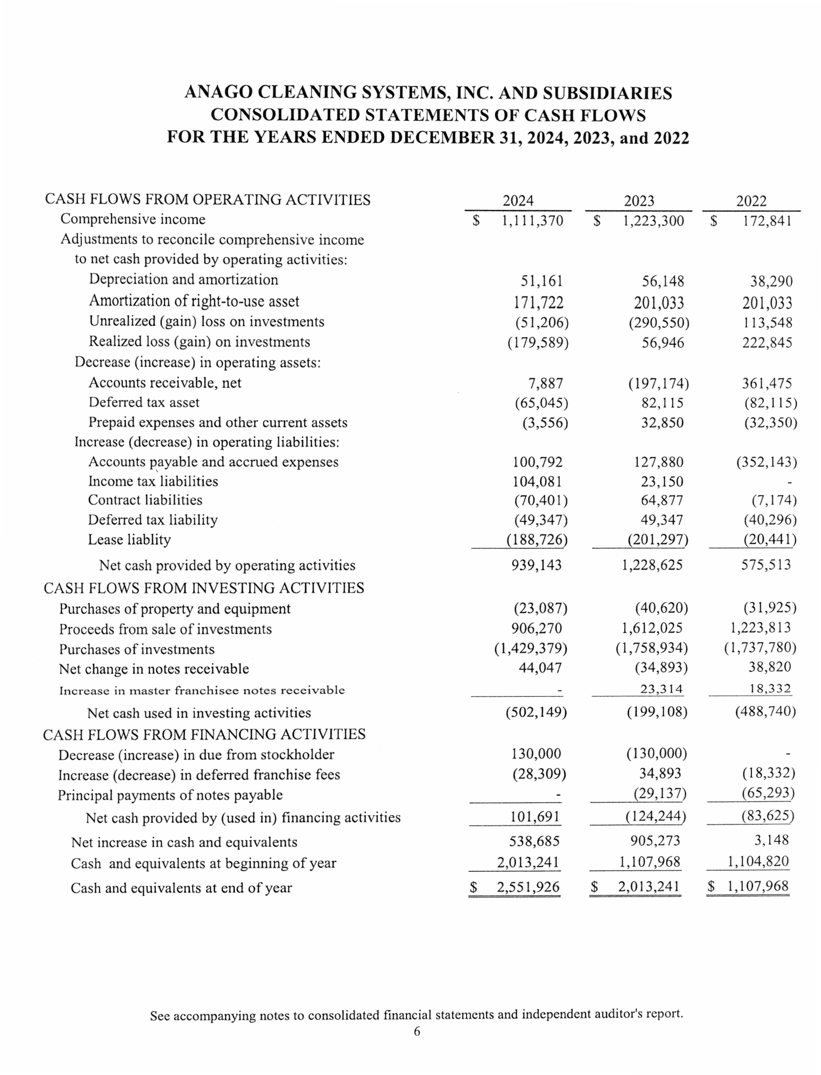

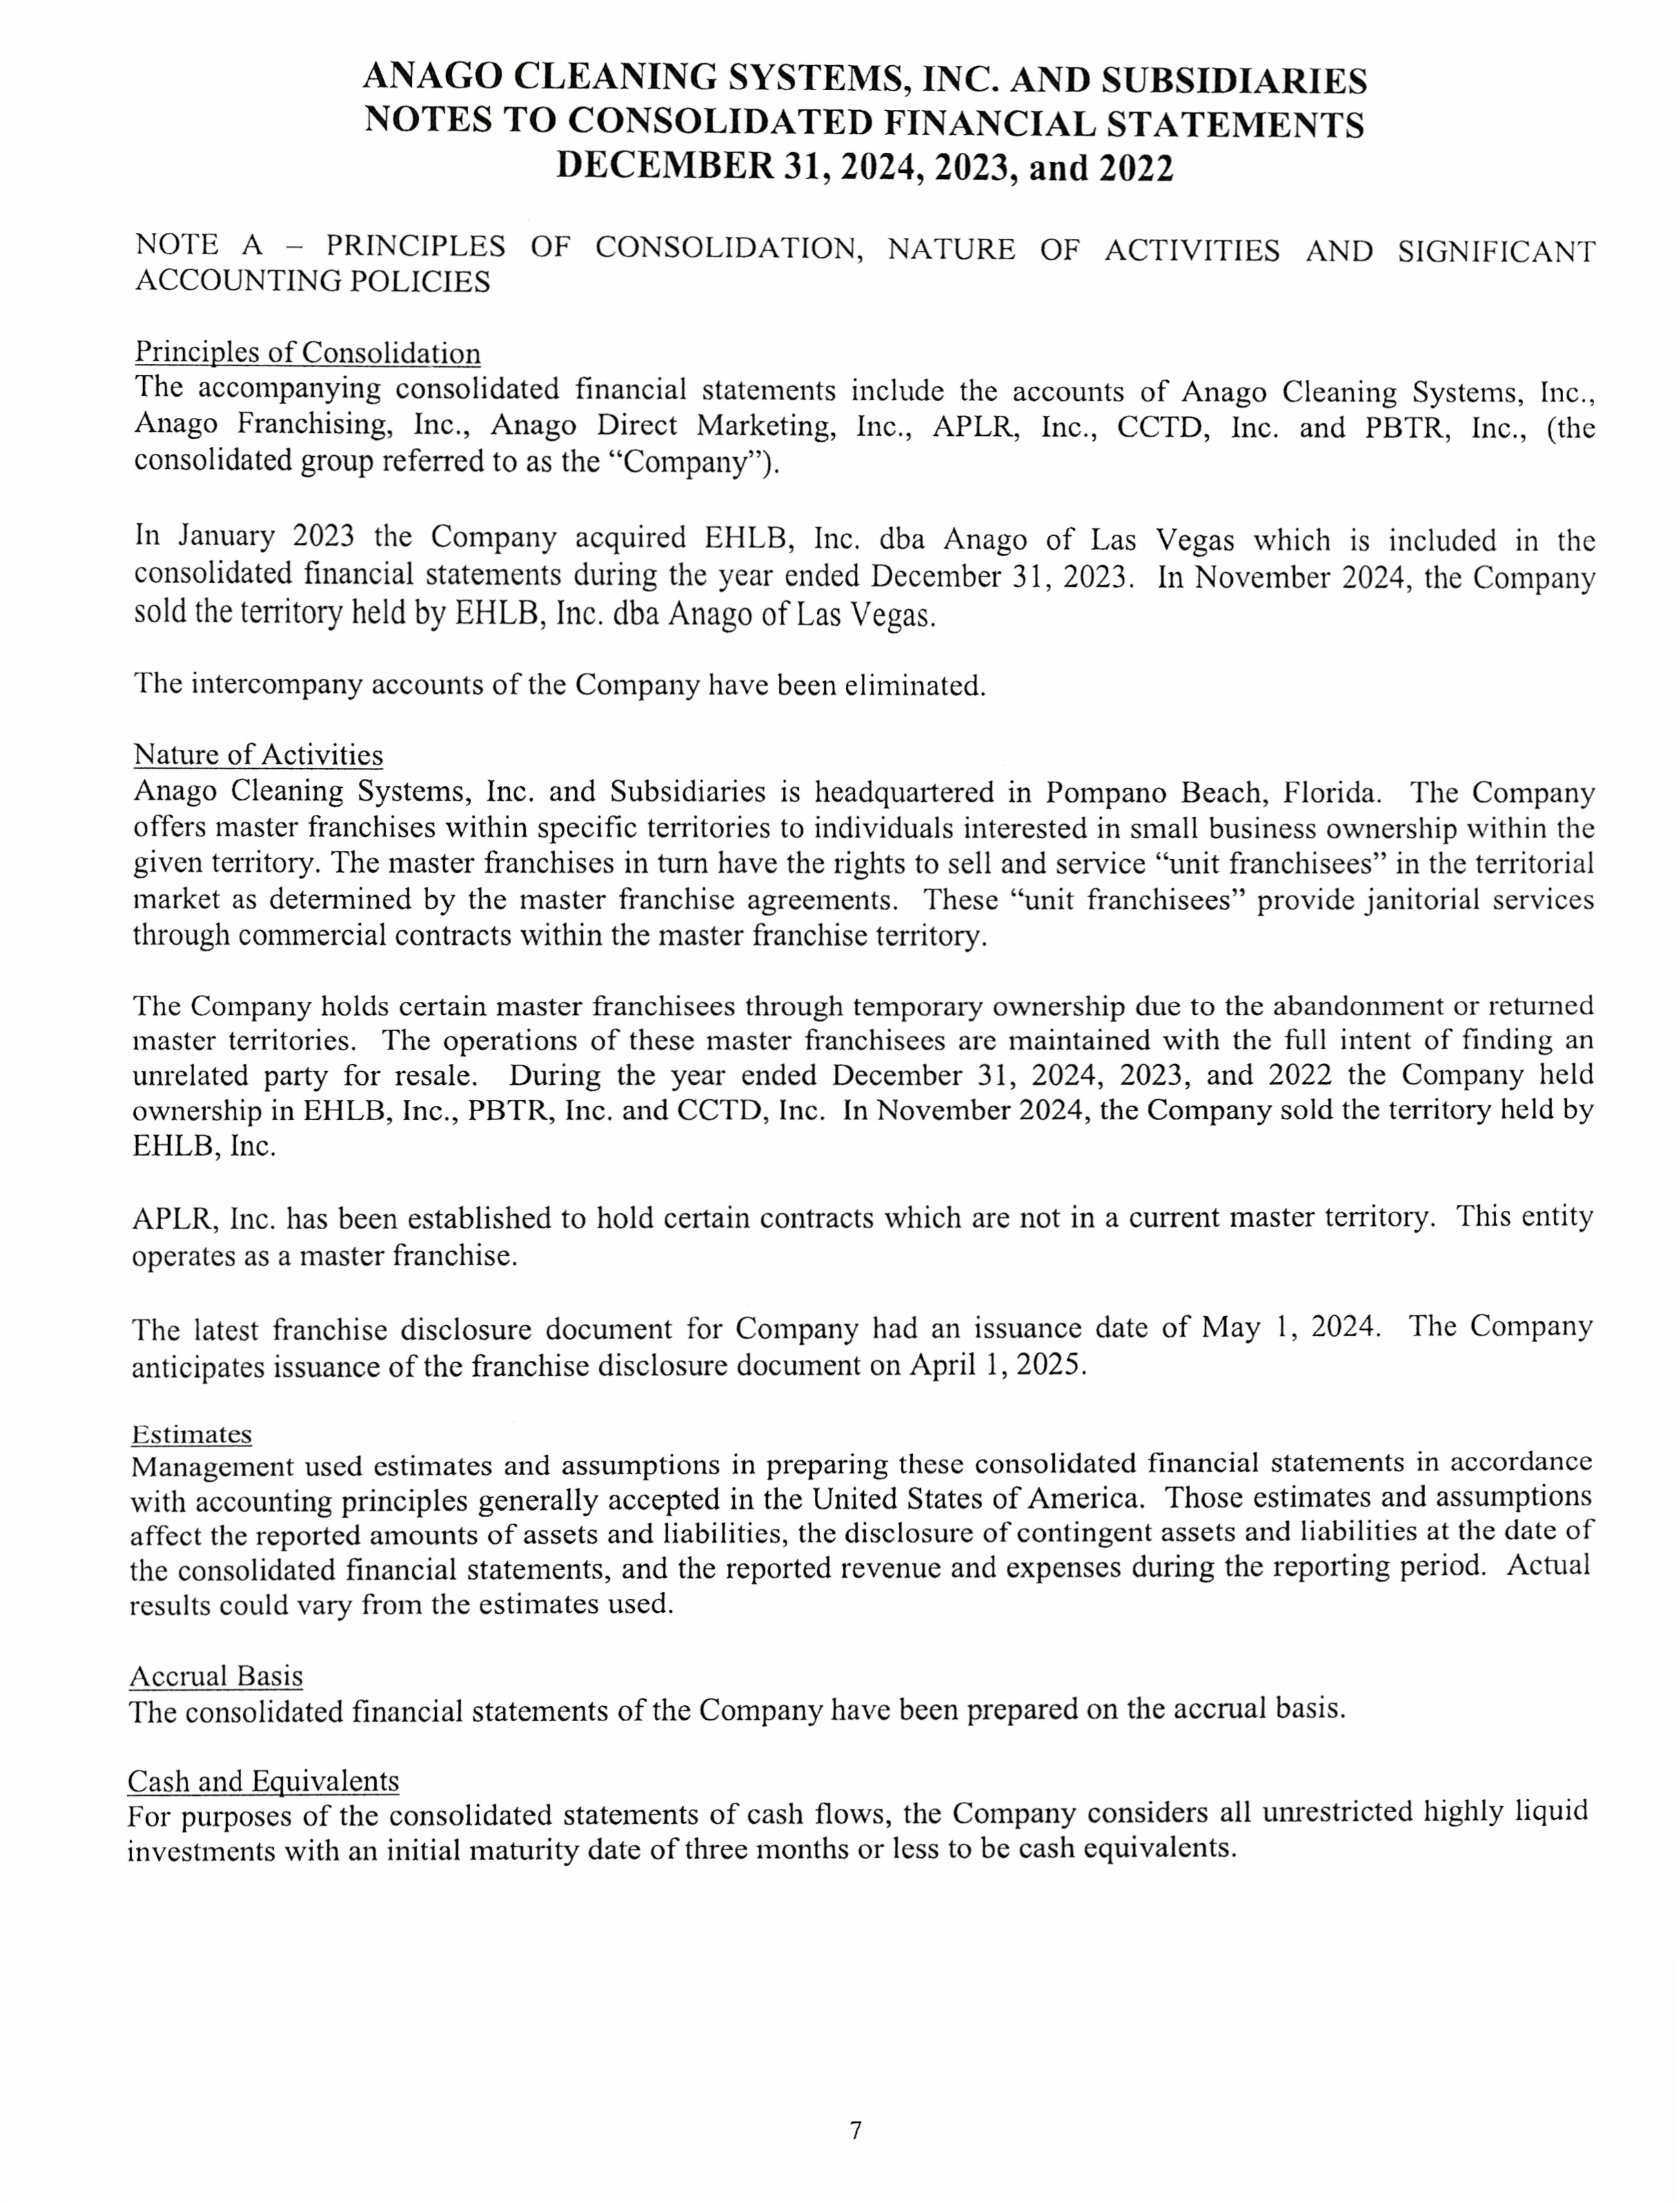

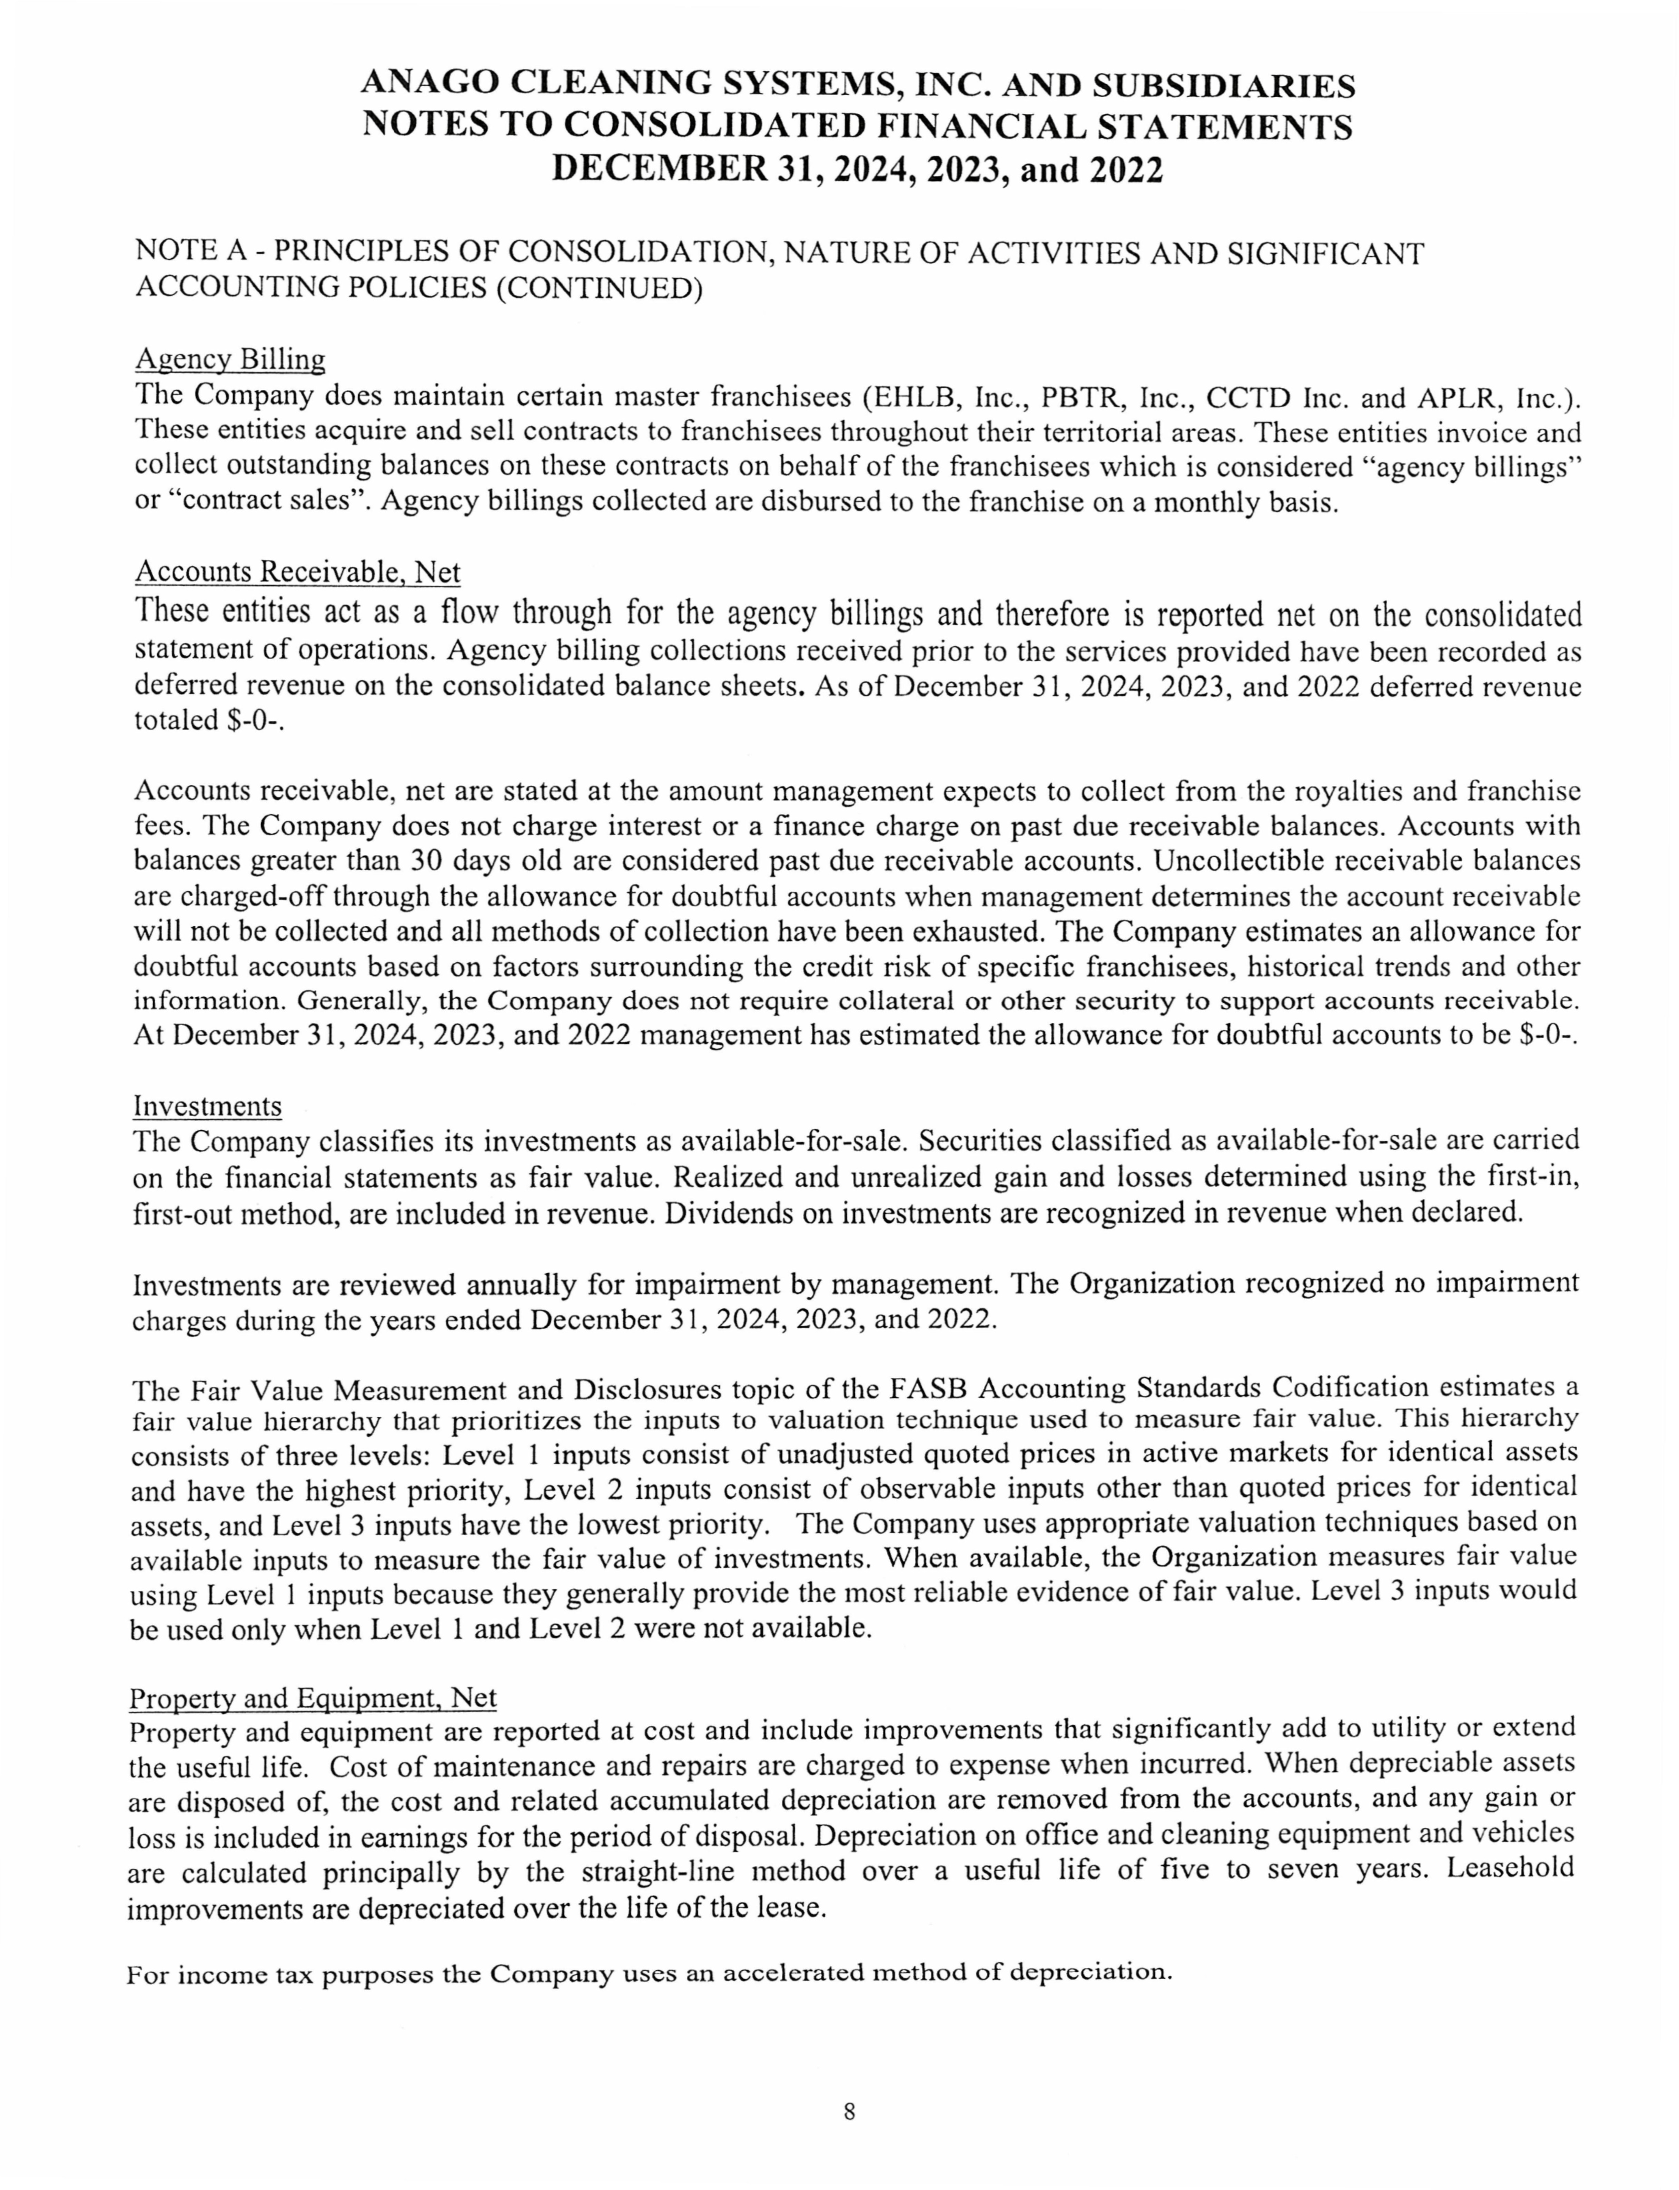

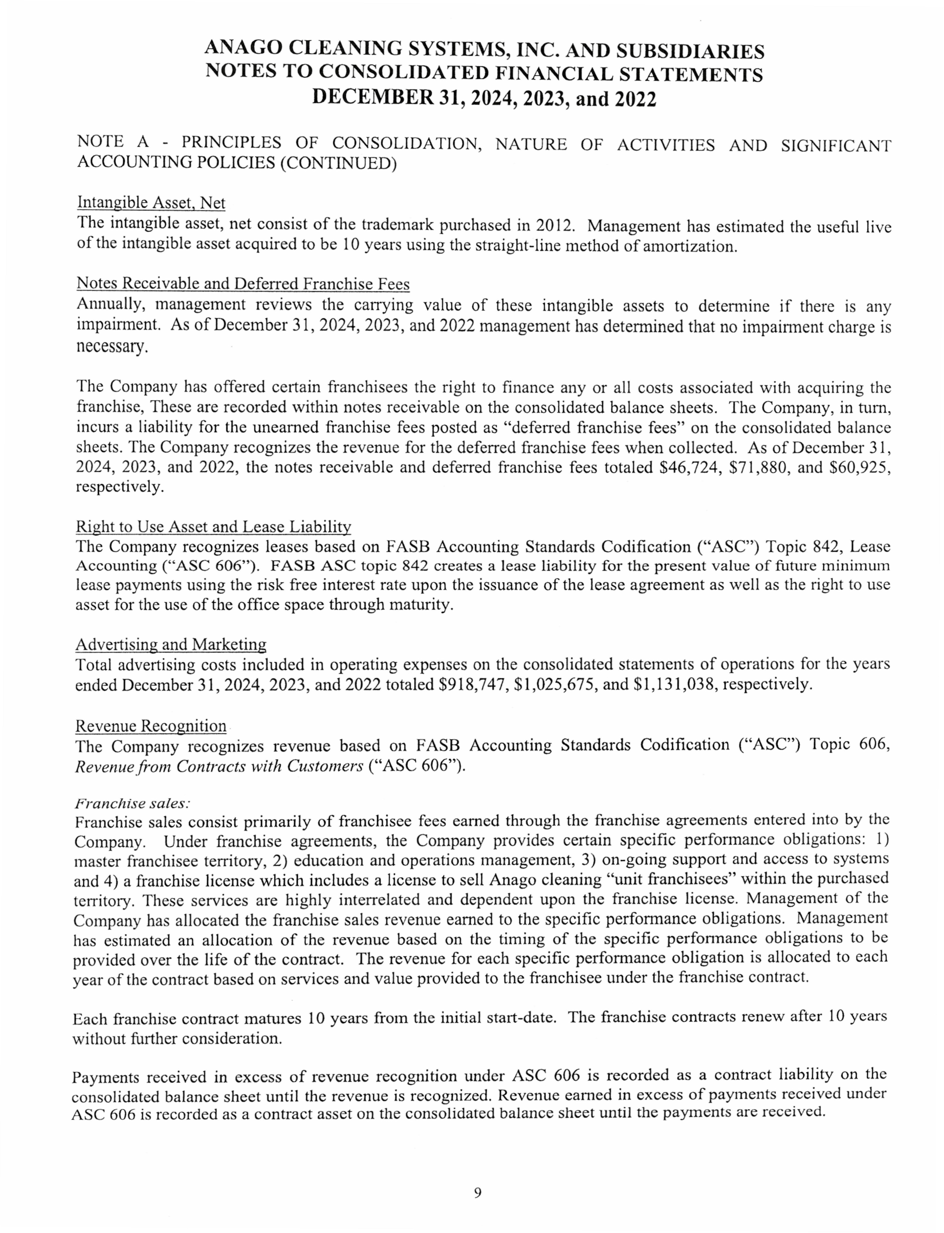

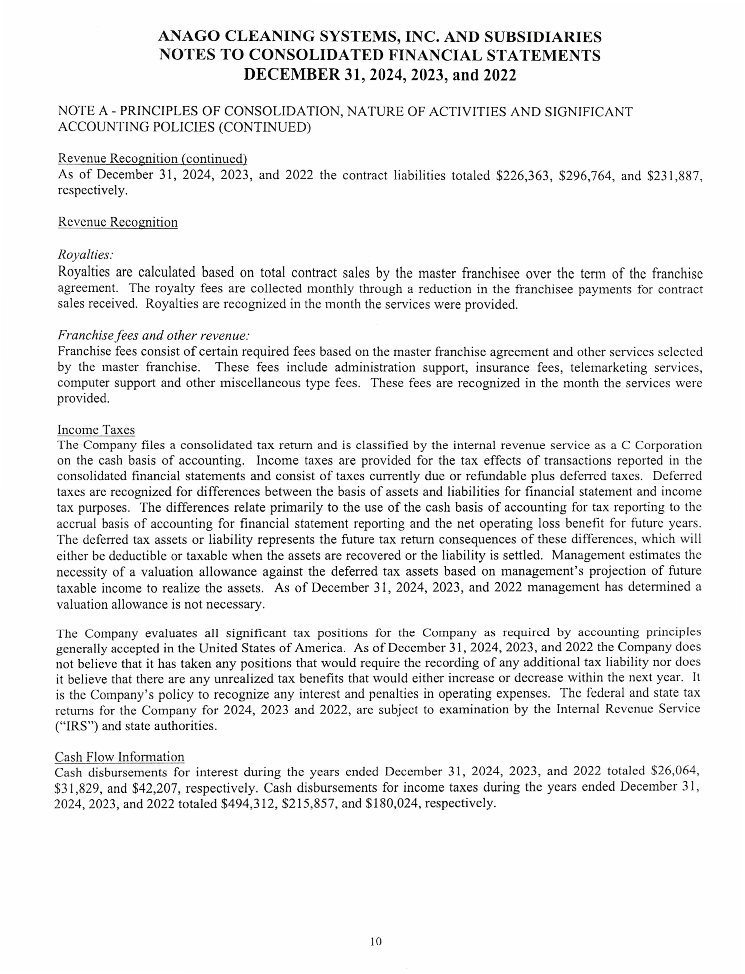

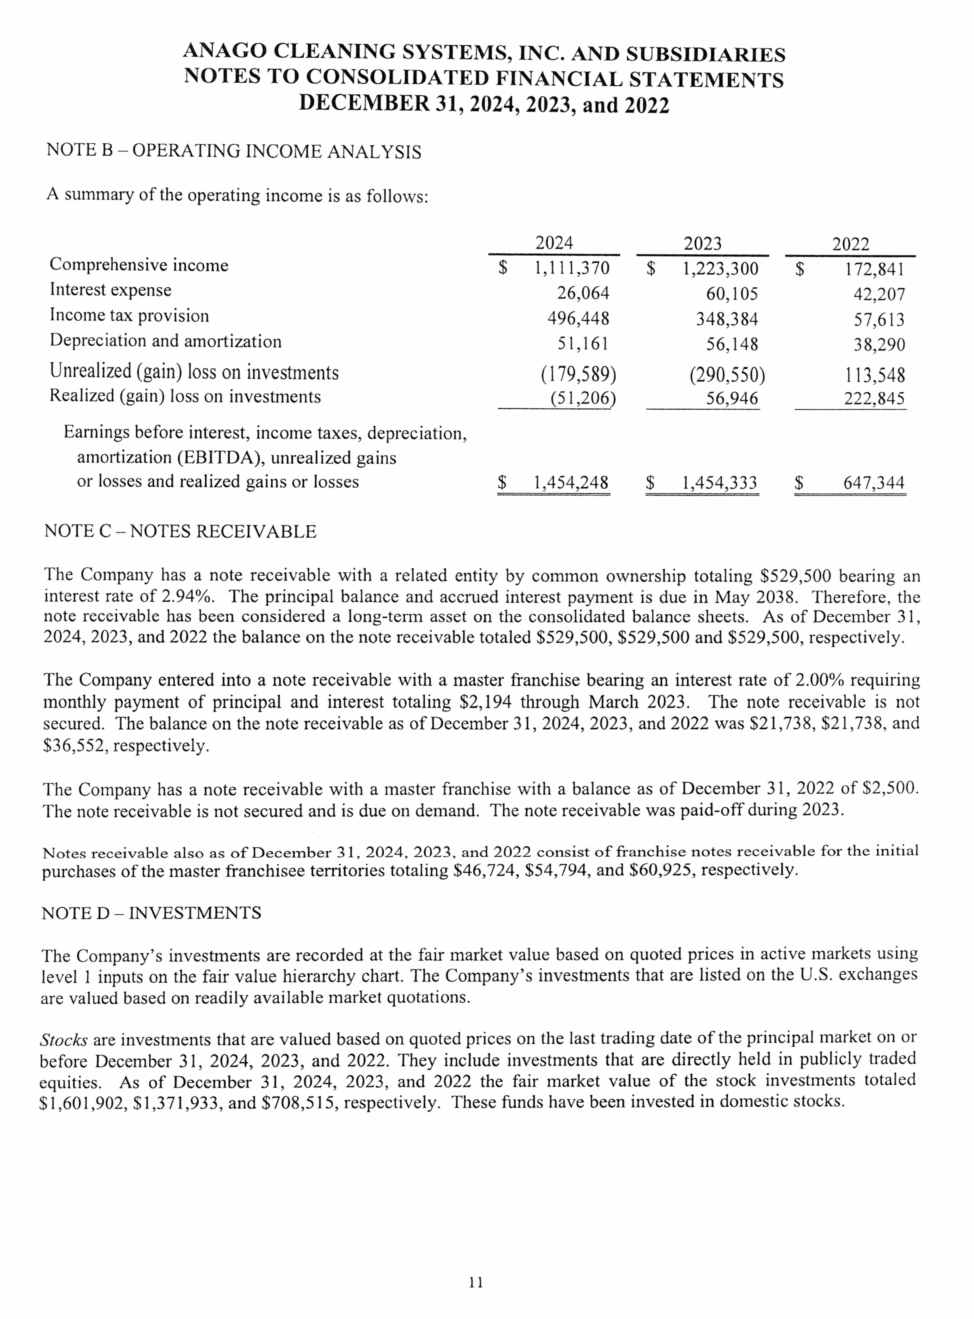

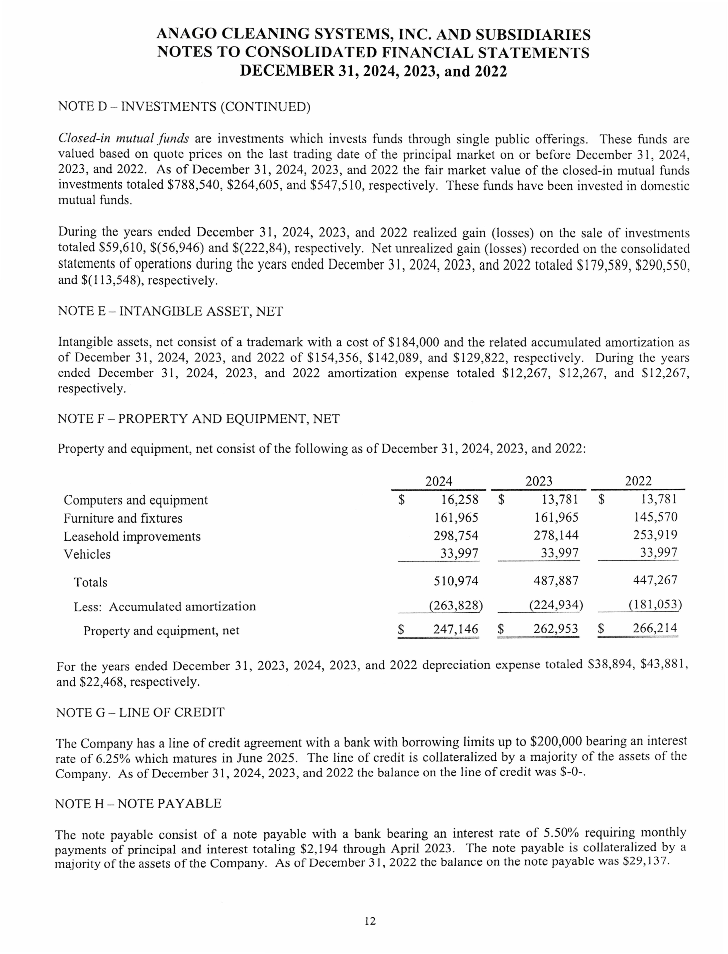

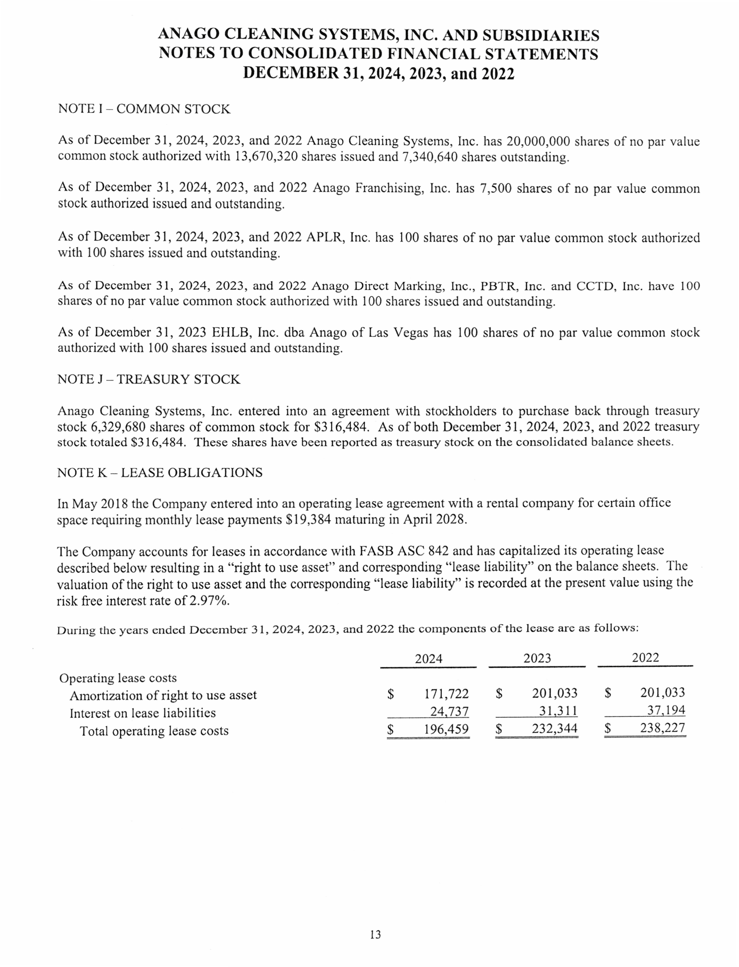

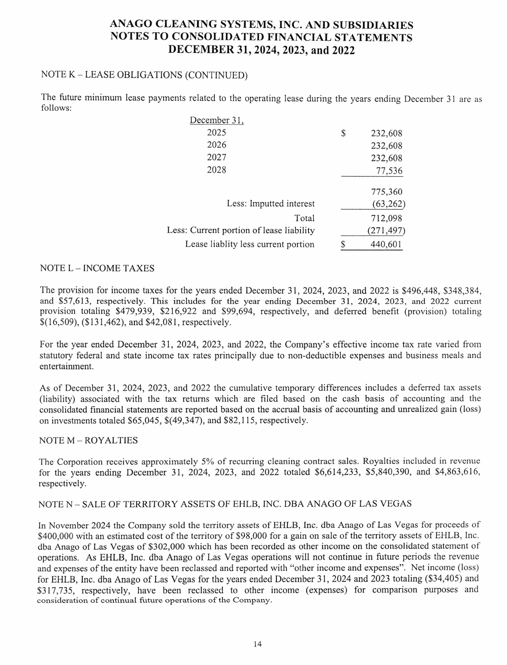

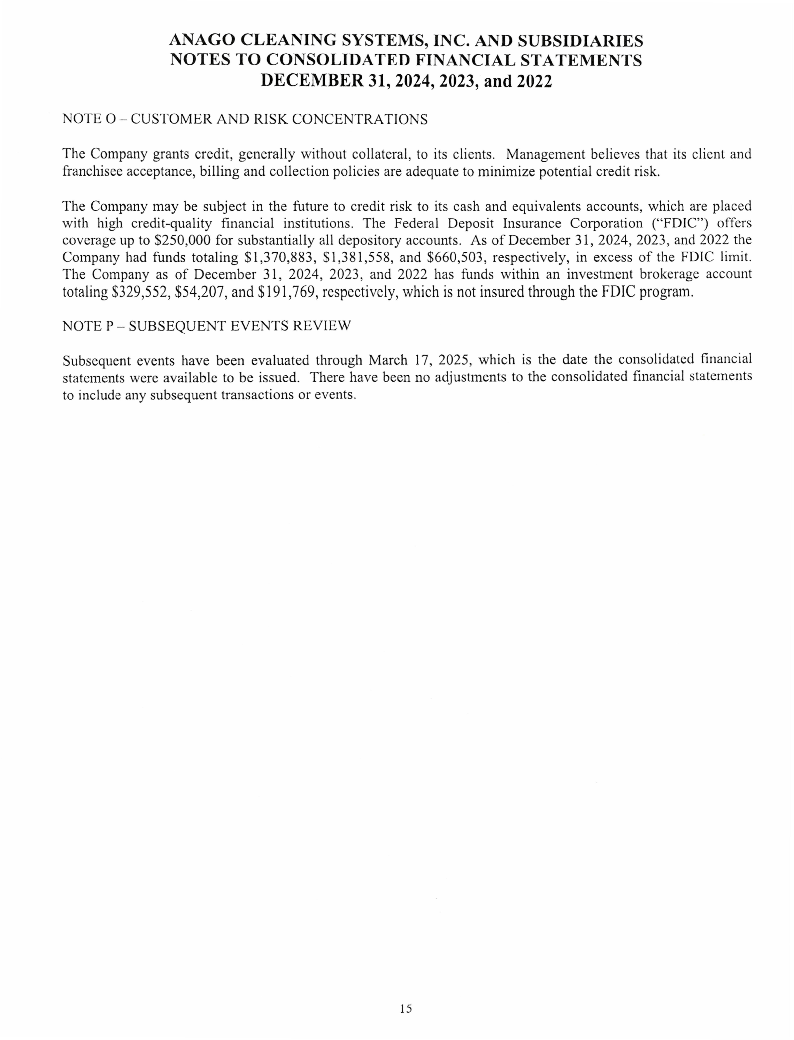

# EXHIBIT F – TABLE OF CONTENTS FOR UNIT FRANCHISE OPERATING MANUAL

|  |  |
| --- | --- |
| **UNIT FRANCHISE OPERATING MANUAL** | |
| **SUBJECT** | **NUMBER OF PAGES** |
| **CHAPTER 1 – INTRODUCTION TO THE MANUAL** | |
| MANUAL ORGANIZATION | 1 |
| OWNERSHIP OF THE MANUAL | 1 |
| PURPOSE OF THIS MANUAL | 1 |
| IMPORTANCE OF CONFIDENTIALITY | 1 |
| ARTIFICIAL INTELLIGENCE (AI) POLICY | 1 |
| KEEPING THE MANUAL CURRENT | 1 |
| SUBMITTING SUGGESTIONS | 1 |
| DISCLAIMER | 1 |
| **TOTAL** | **8** |
| **CHAPTER 2 – INTRODUCTION TO THE FRANCHISE SYSTEM** | |
| WELCOME | 1 |
| A SUCCESSFUL ANAGO UNIT FRANCHISEE | 1 |
| HISTORY OF THE COMPANY | 1 |
| WHO TO CALL | 1 |
| **TOTAL** | **4** |
| **CHAPTER 3 – PRE-OPENING PROCEDURES** |  |
| INTRODUCTION | 4 |
| LICENSES, PERMITS, AND TAXES | 3 |
| ORIENTATION | 1 |
| INITIAL INVENTORY AND SUPPLIES | 2 |
| BANK ACCOUNTS | 2 |
| INSURANCE COVERAGE | 2 |
| PRE-OPENING CHECKLIST | 1 |
| **TOTAL** | **15** |
| **CHAPTER 4 – PERSONNEL** |  |
| INTRODUCTION | 1 |
| NON-JOINT EMPLOYER STATUS | 1 |
| EMPLOYMENT LAW BASICS | 4 |
| OSHA | 2 |

|  |  |
| --- | --- |
| PREPARING TO HIRE YOUR FIRST EMPLOYEE | 1 |
| JOB RESPONSIBILITIES AND IDEAL EMPLOYEE PROFILES | 1 |
| RECRUITING EMPLOYEES | 2 |
| JOB APPLICATIONS | 1 |
| INTERVIEWING JOB APPLICATIONS | 5 |
| BACKGROUND CHECKS ON JOB APPLICANTS | 2 |
| MISCELLANEOUS HIRING ISSUES | 1 |
| NEW EMPLOYEE PAPERWORK | 1 |
| ADDITIONAL STEPS IN HIRING PROCESS | 1 |
| UNIFORMS – DRESS CODE | 2 |
| RECOMMENDED FRANCHISEE EMPLOYEE TRAINING | 8 |
| PERSONNEL POLICIES | 2 |
| PAYING YOUR EMPLOYEES | 2 |
| EMPLOYEE MORALE / MOTIVATION | 3 |
| PERFORMANCE EVALUATIONS | 1 |
| EMPLOYEE DISCIPLINE | 2 |
| RESIGNATION / TERMINATION | 3 |
| SUMMARY OF GOOD EMPLOYEE MANAGEMENT PRACTICES | 1 |
| GETTING LEGAL HELP WITH EMPLOYMENT LAW ISSUES | 1 |
| **TOTAL** | **48** |
| **CHAPTER 5 – POLICIES & PROCEDURES** |  |
| INTRODUCTION | 1 |
| ORIENTATION | 2 |
| START-UP AND OPERATION | 7 |
| FINANCIAL PROCEDURES | 5 |
| BUSINESS MANAGEMENT | 4 |
| SERVICE MANAGEMENT | 6 |
| RECOMMENDED OPERATING GUIDELINES | 1 |
| EPILOGUE | 1 |
| **TOTAL** | **27** |
| **CHAPTER 6 – DAILY OPERATING PROCEDURES** |  |
| INTRODUCTION | 1 |
| DAYS / HOURS OF OPERATION | 1 |
| CUSTOMER SERVICE PROCEDURES | 9 |

|  |  |
| --- | --- |
| GENERAL CLEANING PROCEDURES | 24 |
| TEAM CLEANING | 15 |
| INVENTORY MANAGEMENT | 4 |
| **TOTAL** | **54** |
| **CHAPTER 7 – FLOOR CARE** |  |
| INTRODUCTION | 1 |
| FLOOR CARE SAFETY | 8 |
| FLOOR CARE **–** RESILIENT | 14 |
| FLOOR CARE **–** CARPET | 10 |
| FLOOR CARE – STONE & FINISHED AGGREGATE | 2 |
| FLOOR CARE – MASONRY | 2 |
| FLOOR CARE STAIRS | 1 |
| **TOTAL** | **38** |
| **CHAPTER 8 – SAFETY AND SECURITY** |  |
| INTRODUCTION | 1 |
| GENERAL SAFETY TIPS | 1 |
| SECURITY | 8 |
| PREVENTING ACCIDENTS AND INJURIES | 1 |
| REPORTING ACCIDENTS & CLAIM PROCESS | 1 |
| CRISIS MANAGEMENT POLICY | 1 |
| WORKERS’ COMPENSATION ISSUES | 1 |
| TIPS FOR REDUCING YOUR WORKERS’C OMPENSATION  INSURANCE COSTS | 1 |
| REPORTING ACCIDENTSWORKERS’ COMPENSATION AUDITS | 1 |
| WORKERS’ COMPENSATION ISSUESTEN MOST COMMON WORKPLACE INJURIES | 1 |
| FIRE SAFETY | 1 |
| ROBBERY / BUGLARY | 1 |
| FIRST AID | 3 |
| **TOTAL** | **22** |
| **CHAPTER 9 – BIOHAZARDS** |  |
| INTRODUCTION | 1 |
| BLOODBORNE PATHOGENS | 1 |
| OSHA DEFINITIONS | 2 |
| INTENT OF THE EXPOSURE CONTROL PLAN | 1 |

|  |  |
| --- | --- |
| EXPOSURE DETERMINATION / ASSIGNMENT OF CATEGORIES TO EMPLOYEES | 1 |
| COMPLIANCE – UNIVERSAL PRECAUTIONS | 1 |
| COMPLIANCE – ENGINEERING CONTROLS | 1 |
| COMPLIANCE – WORK PRACTICE CONTROLS | 1 |
| COMPLIANCE PERSONAL PROTECTIVE QUIPMENT | 1 |
| GENERAL BUIHAZARD AREA SAFETY | 2 |
| GOLDEN RULE | 1 |
| HEPATITIS B VACCINATION, POST-EXPOSURE EVALUATION AND FOLLOW UP | 1 |
| LABELS AND SIGNS | 1 |
| RECORD KEEPING | 1 |
| **TOTAL** | **16** |
| **CHAPTER 10 – FINANCIAL REPORTS** |  |
| ROYALTY PAYMENT | 1 |
| FINANCIAL STATEMENTS | 1 |
| INCOME SOURCES | 1 |
| EXPENSE AND OWNER ACCOUNTS | 5 |
| REQUIRED REPORTS | 1 |
| TAXES | 2 |
| HOW TO SUCCEED IN BUSINESS | 1 |
| BOOKKEEPING | 1 |
| PROFIT AND LOSS (P&L) STATEMENT | 1 |
| SAMPLE P&L STATEMENT | 1 |
| BUSINESS FINANCING | 1 |
| LOANS | 1 |
| KEY POINTS TO REMEMBER | 1 |
| FOR FURTHER INFORMATION | 1 |
| REVIEW | 1 |
| DOCUMENTATION | 1 |
| **TOTAL** | **22** |
| **CHAPTER 11 – BIDDING & ESTIMATING** |  |
| INTRODUCTION | 1 |
| BASIC BID FACTORS | 3 |
| OTHER BID FACTORS | 3 |

|  |  |
| --- | --- |
| MEASURING SQUARE FOOTAGE | 3 |
| CLEANING WHAT HAS BEEN MEASURED | 4 |
| PRODUCTION RATES BY INDUSTRY TYPE | 16 |
| BIDDING FORMULAS | 1 |
| SMARTCLEANSM BIDDING | 6 |
| HANDLING CLIENT SALES APPOINTMENTS | 1 |
| BIDDING EXERCISES | 6 |
| MANAGING EXISTING BUSINESS | 1 |
| **TOTAL** | **45** |
| **CHAPTER 12 – MANAGEMENT FORMS AND POLICIES** |  |
| EMPLOYEE RELATIONS | 25 |
| MANAGEMENT FORMS AND POLICIES | 9 |
| PROCEDURES | 5 |
| **TOTAL** | **39** |
| **GRAND TOTAL** | **338** |

|  |  |
| --- | --- |
| **UNIT FRANCHISE OWNER’S GUIDE TO ANAGO**  **PROTECTION+ DISINFECTION** |  |
| CLEANING VS. SANITIZING VS. DISINFECTING | 1 |
| HELPING YOUR CLIENTS | 5 |
| PROTECTING YOUR EMPLOYEES | 1 |
| PROPER CHEMICALS | 1 |
| PROCEDURES & PROTOCOLS | 18 |
| AREA CHECKLIST | 1 |
| RESOURCES AND LINKS | 2 |
| **TOTAL** | **29** |

|  |  |
| --- | --- |
| **UNIT FRANCHISE OWNER’S GUIDE TO ELECTROSTATIC**  **SPRAYING** |  |
| WHAT IS ELECTROSTATIC SPRAYING | 5 |
| TRAINING | 10 |
| PRICING – BIDDING | 11 |
| TIPS & TRICKS | 4 |
| **TOTAL** | **30** |

**EXHIBIT G – ADDENDUM TO THE FRANCHISE DISCLOSURE DOCUMENT AS REQUIRED BY MARYLAND LAW**

This franchise agreement provides that disputes are resolved through arbitration. A Maryland franchise regulation states that it is an unfair or deceptive practice to require a franchisee to waive its right to file a lawsuit in Maryland claiming a violation of the Maryland Franchise Law. In light of the Federal Arbitration Act, there is some dispute as to whether this forum selection requirement is legally enforceable.

The provision in the franchise agreement which provides for termination upon bankruptcy of the franchisee may not be enforceable under federal bankruptcy law (11 U.S.C. Section 101 et seq.).

Pursuant to COMAR 02.02.08.16L, the general release required as a condition of renewal, sale, and/or assignment/transfer shall not apply to any liability under the Maryland Franchise Registration and Disclosure Law.

Any claims arising under the Maryland Franchise Registration and Disclosure Law must be brought within 3 years after the grant of the franchise.

No statement, questionnaire, or acknowledgment signed or agreed to by a franchisee in connection with the commencement of the franchise relationship shall have the effect of (i) waiving any claims under any applicable state franchise law, including fraud in the

inducement,

or (ii) disclaiming reliance on any statement made by any franchisor, franchise seller, or other person acting on behalf of the franchisor. This provision supersedes any other term of any document executed in connection with the franchise.

## State Effective Dates

The following states have franchise laws that require that the Franchise Disclosure Document be registered or filed with the state, or be exempt from registration: California, Hawaii, Illinois, Indiana, Maryland, Michigan, Minnesota, New York, North Dakota, Rhode Island, South Dakota, Virginia, Washington, and Wisconsin.

This document is effective and may be used in the following states, where the document is filed, registered or exempt from registration, as of the Effective Date stated below:

|  |  |
| --- | --- |
| **State** | **Effective Date** |
| California | Not Registered |
| Hawaii | Not Registered |
| Illinois | Not Registered |
| Indiana | Not Registered |
| Maryland | Not Registered |
| Michigan | Not Registered |
| Minnesota | Not Registered |
| New York | Not Registered |
| North Dakota | Not Registered |
| Rhode Island | Not Registered |
| South Dakota | Not Registered |
| Virginia | Not Registered |
| Washington | Not Registered |
| Wisconsin | Not Registered |

Other states may require registration, filing, or exemption of a franchise under other laws, such as those that regulate the offer and sale of business opportunities or seller-assisted marketing plans.

2

FDD #:

# EXHIBIT H – ACKNOWLEDGMENT OF RECEIPT

This disclosure document summarizes certain provisions of the Unit Franchise Agreement and other information in plain language. Read this disclosure document and all Agreements carefully.

If MSJC, Inc. offers You a franchise, it must provide this disclosure document to You 14 Calendar Days before You sign a binding Agreement with, or make a payment to, MSJC, Inc. or an affiliate in connection with the proposed franchise sale, or sooner if required by applicable state law. Under Iowa law, We must give You this disclosure document at the earlier of Our 1st personal meeting or 14 calendar days before You sign an Agreement with, or make a payment to, Us or an affiliate in connection with the proposed franchise sale. Under Michigan law, We must give You this disclosure document at least 10 business days before the execution of any binding franchise or other agreement or the payment of any consideration, whichever occurs first. Under New York law, We must provide this disclosure document at the earlier of the 1st personal meeting or 10 business days before You sign a binding agreement with, or make a payment to, Us or an affiliate in connection with the proposed franchise sale.

If MSJC, Inc. does not deliver this disclosure document on time or if it contains a false or misleading statement, or a material omission, a violation of federal law and state law may have occurred and should be reported to the Federal Trade Commission, Washington, D.C. 20580 and the appropriate state agency identified on Exhibit A.

We, MSJC, Inc. are a Subfranchisor for Anago Franchising, Inc. and Our principle address is 1406 B Crain Highway South, Suite 103, Glen Burnie, MD 21061, Tel: (410) 760-6306. The franchise seller(s) for this offering is/are:

Mark Cashman MSJC, Inc.

1406 B Crain Highway South, Suite 103 Glen Burnie, MD 21061 [mcashman@anagomd.com](mailto:mcashman@anagomd.com)

MSJC, Inc.

1406 B Crain Highway South, Suite 103 Glen Burnie, MD

21061

Issuance Date: June 12th 2025

See Exhibit A for MSJC, Inc.’s registered agents authorized to receive service of process.

I have received a disclosure document dated June 12th 2025 that included the following Exhibits:

A - State Administrators/Agents For Service Of Process E - Financial Statements of Franchisor

B - Anago Franchise Agreement F – Table of Contents for Unit Franchise Operating Manual

C - List of Subfranchisor's Franchisees G – Addendum to FDD – Maryland Law

D - Financial Statements of Subfranchisor H - Acknowledgement of Receipt

Date Signature Printed Name

Date Signature Printed Name

Address

Email Address Phone

Please sign this copy of the receipt, print the date on which You received this disclosure document and return it in person the same day You are disclosed.

(copy #1 - to be returned to the local office)

FDD #:

# EXHIBIT H – ACKNOWLEDGMENT OF RECEIPT

This disclosure document summarizes certain provisions of the Unit Franchise Agreement and other information in plain language. Read this disclosure document and all Agreements carefully.

If MSJC, Inc. offers You a franchise, it must provide this disclosure document to You 14 Calendar Days before You sign a binding Agreement with, or make a payment to, MSJC, Inc. or an affiliate in connection with the proposed franchise sale, or sooner if required by applicable state law. Under Iowa law, We must give You this disclosure document at the earlier of Our 1st personal meeting or 14 calendar days before You sign an Agreement with, or make a payment to, Us or an affiliate in connection with the proposed franchise sale. Under Michigan law, We must give You this disclosure document at least 10 business days before the execution of any binding franchise or other agreement or the payment of any consideration, whichever occurs first. Under New York law, We must provide this disclosure document at the earlier of the 1st personal meeting or 10 business days before You sign a binding agreement with, or make a payment to, Us or an affiliate in connection with the proposed franchise sale.

If MSJC, Inc. does not deliver this disclosure document on time or if it contains a false or misleading statement, or a material omission, a violation of federal law and state law may have occurred and should be reported to the Federal Trade Commission, Washington, D.C. 20580 and the appropriate state agency identified on Exhibit A.

We, MSJC, Inc. are a Subfranchisor for Anago Franchising, Inc. and Our principle address is 1406 B Crain Highway South, Suite 103, Glen Burnie, MD 21061, Tel: (410) 760-6306. The franchise seller(s) for this offering is/are:

Mark Cashman

MSJC, Inc.

1406 B Crain Highway South, Suite 103

Glen Burnie, MD 21061

MSJC, Inc.

1406 B Crain Highway South, Suite 103

Glen Burnie, MD 21061

[mcashman@anagomd.com](mailto:mcashman@anagomd.com)

Issuance Date: June 12th 2025

See Exhibit A for MSJC, Inc.’s registered agents authorized to receive service of process.

I have received a disclosure document dated June 12th 2025 that included the following Exhibits:

A - State Administrators/Agents For Service Of Process E - Financial Statements of Franchisor

B - Anago Franchise Agreement F – Table of Contents for Unit Franchise Operating Manual

C - List of Subfranchisor's Franchisees G – Addendum to FDD – Maryland Law

D - Financial Statements of Subfranchisor H - Acknowledgement of Receipt

Date Signature Printed Name

Date Signature Printed Name

Address

Email Address Phone

Please sign this copy of the receipt, print the date on which You received this disclosure document and return it in person the same day You are disclosed.

(copy #2 - to be retained for Your records)